**PROJECT CHANGE REQUEST FORM**

|  |
| --- |
| **Project Name: Daily Limit CR, Source Code Merging (Revamp & Daily Limit), FTT to include beneficiary iBAN.** |
| **Prepared by: Vincent Devethas** |
| **Date : 16/10/2012** |
| **Change Request No.: IBSCR049** |

|  |
| --- |
| **1. Requestor Information** |

*Fill in with appropriate information or place an “X” next to those that apply:*

**Area of Change:**

|  |  |  |  |  |  |
| --- | --- | --- | --- | --- | --- |
| **Scope** | **[ X ]** | **Schedule** | **[ ]** | **Migration** | **[ ]** |
| **Budget** | **[ ]** | **Quality** | **[ ]** |  |  |

|  |  |  |
| --- | --- | --- |
| **Is this Change the result of a Risk Management Action?** | | |
| **No** **[ ]** | **Yes** **[ ]** | **Risk ID:** |

**Scope of Change:**

|  |  |  |  |  |  |
| --- | --- | --- | --- | --- | --- |
| **Information Site GUI** | **[ ]** | **BVMC** | **[ ]** | **CIB Reports** | **[X]** |
| **Information Site Tools** | **[ ]** | **CORUS** | **[ ]** | **BIB Reports** | **[ ]** |
| **Content** | **[ ]** | **CIB Demo** | **[ ]** | **BIB User Guide** | **[ ]** |
| **Database** | **[ ]** | **BIB Demo** | **[ ]** | **CIB User Guide** | **[ ]** |
| **ESB** | **[ ]** | **OnlineApps IBG Core** | **[ ]** | **BVMC User Guide** | **[ ]** |
| **CIB** | **[X]** | **BIB** | **[X]** | **Others** | **[ ]** |
|  |  |  |  |  |  |

|  |  |
| --- | --- |
| ***Proposed Change Description and References:***  *This proposal is to consolidate a few change requests from KFH as described below:-* | |
| Description:  **Daily Limit Changes**   1. iPay    * Exclude iPay from the Standard Daily Limit validation as the limit will refer to ATM (powercard) limit. 2. Report    * New BVMC report for Daily Limit. 3. Standard Limit for resident and non-resident    * Remove the display of Standard Limit from the Transfer Limit module. 4. Current Limit    * Set default value RM 5,000 as the Current Limit in Transfer Limit module.   **Revamp & Daily Limit**   1. Source Code merging for these two enhancements.   **FTT iBAN**   1. To include a “Beneficiary iBAN Number” field in Open FTT, Registered FTT and Bene FTT Acc Maint Screen. Format of the field is Alphanumeric. 2. Refer to Appendix C for further details. 3. To add “Beneficiary iBAN Number” field to the FTT file and FTT reports for both RIB and BIB | |
| **Justification:** | |
| **Hyperlinks:** |  | |

|  |  |
| --- | --- |
| **Impact of Not Implementing:** |  |
| *Daily Limit – this feature will not applied to IB (Consumer).*  *Source Code merging – Revamp and Daily Limit source code will not merged together.*  *FTT iBAN – There will be no iBAN field in FTT module.* |  |

**Alternatives: f the Change Request**

|  |  |  |  |
| --- | --- | --- | --- |
| **Initial Review Date:** | | | **Assigned To:** |
| *Action* | | | *Comments* |
| **Approval for Impact Analysis** | **[ ]** |  | |
| **Reject** | **[ ]** |  | |
| **Defer Until** | **[ ]** |  | |
| **Express Approval** | **[ ]** |  | |

|  |
| --- |
| **3. Initial Impact Analysis** |

|  |  |  |  |  |  |  |
| --- | --- | --- | --- | --- | --- | --- |
| **Baselines Affected:** | | | | | | |
| **Configuration Items Affected**  **(e.g product specifications):** | | | | | | |
| **Cost / Schedule Impact Analysis Required? *(check one)*** | | | | **Yes [ ]** | **No [ ]** | |
| **Impact on Cost:** | |  | | | | |
| **Impact on Schedule:** | |  | | | | |
| **Impact on Resources:** | |  | | | | |
| **Risk associated with implementing the change:** | |  | | | | |
| **Risk associated with not implementing the change:** | |  | | | | |
| **Final Review Results:** | |  | | | | |
| **Review Date:** | |  | | | | |
| **Priority: *(check one)*** | **High [ ]** | | **Medium [ ]** | | | **Low [ ]** |

|  |
| --- |
| **4. Impact Analysis Results** |

**Specific Requirements Definition:**

|  |  |  |
| --- | --- | --- |
| **Additional Resource Requirements** (insert rows as needed)**:** | ***Man/ Day*** | ***Cost (RM)*** |
| **Daily Limit changes for RIB, FTT Module Enhancement for RIB and BIB, Source Code merging (Revamp & Daily Limit), UAT & Migration Assistant** | ***11*** | ***22,000*** |
|  |  |  |
|  |  |  |
| **Subtotal** | ***11*** | ***22,000*** |
| **Government Tax (6%)** |  | ***1320*** |
| ***Totals*** |  | ***23320*** |

|  |  |
| --- | --- |
| **Impact of Not Implementing the Change:** |  |
| **Alternatives to the Proposed Change:** |  |
| |  | | --- | | **5. Final Recommendation** | | |

**Project C**

|  |
| --- |
| **6. Project Change Request Form / Signatures** |

|  |  |
| --- | --- |
| **Project Name:** | **Daily Limit CR, Source Code Merging (Revamp & Daily Limit), FTT to include beneficiary iBAN** |
| **Project Manager:** |  |

*I have reviewed the information contained in this* Project Change Request Form *and agree:*

|  |  |  |  |
| --- | --- | --- | --- |
| ***Name*** | ***Title*** | ***Signature*** | ***Date***  ***(MM/DD/YYYY)*** |
|  |  |  |  |
|  |  |  |  |
|  |  |  |  |
|  |  |  |  |

*The signatures above indicate an understanding of the purpose and content of this document by those signing it. By signing this document, they agree to this as the formal* Project Change Request Form*.*

**Appendix A**

**Terms & Conditions**

1. This CR is valid for 30 days as stated from the date herein.
2. Change request will be delivered for SIT and/or UAT, respective user is required to sign off User Acceptance Certificate upon completion of UAT prior to production migration.
3. Penril is not responsible, unless stated, for SIT and/or UAT environments and materials (system server, network, test data and etc) which are required for SIT and/or UAT.
4. Migration is to be performed by respective IT team from KFH, Penril shall provide assistance.

**Appendix B – Scope of Work**

|  |  |  |
| --- | --- | --- |
| No | Features | Impacted Module |
|  | Exclude iPay transaction from Standard daily limit | CIB |
|  | Daily Limit Report | CIB Report |
|  | Remove standard daily limit & standard limit non resident | CIB |
|  | Set default the current limit to RM 5,000 to all module in Transfer Limit | CIB |
|  | Merging Revamp and Daily Limit patch | CIB |
|  | To include a “Beneficiary iBAN Number” field in Open FTT, Registered FTT and Bene FTT Acc Maint Screen. | CIB, BIB, CIB Report, BIB Report, FTT file |

**Appendix C – FTT iBAN**

|  |  |
| --- | --- |
| **Originator's Name:** Chooi So Fun  **Project:** Internet Banking  **Project Manager:** Malarvili / Chris Gunn  **Module : KFHOnline**  **Date Raised: 09.10.12**  **Phase :**  **Functional Area : FTT – CIB & BIB** | **Issue ID Number: 2012-033**  **Related Issue ID Number: HD00013424**  **Classification:**  **Priority:** Critical/High/Medium/Low  **Assigned to: Vendor / IT / PMO SA / UPA**  **Actual Closed Date:** |
| **Status:** Open/Assigned/Investigated/Resolved/Approved/Deferred/No Action  *(Circle one)* | |
| **Description :**  To include a “Beneficiary iBAN Number” field in Open FTT, Registered FTT and Bene FTT Acc Maint Screen.  Format = Alphanumeric  *Note: Refer to screen attached for further details* | **Impact:** |
| **Findings/Root Caused (Description):** | **Resolution:** |
| **Estimated Impact :** |  |
| **Recommendation:** | |
| **Accepted :**  **(Vendor / IT / PMO SA / UPA)**  **Date:** | **Accepted (KFHMB Tester):**  **Date:** |

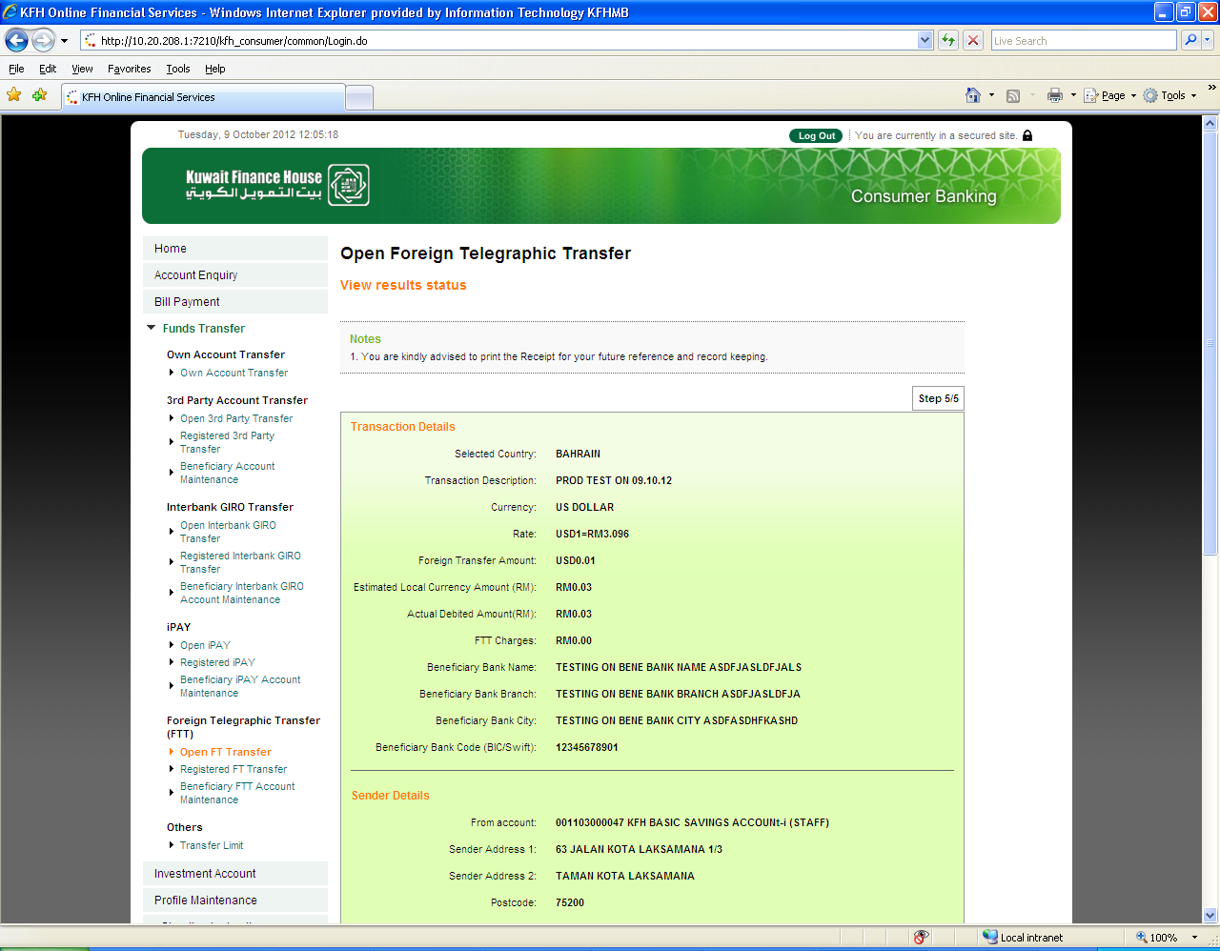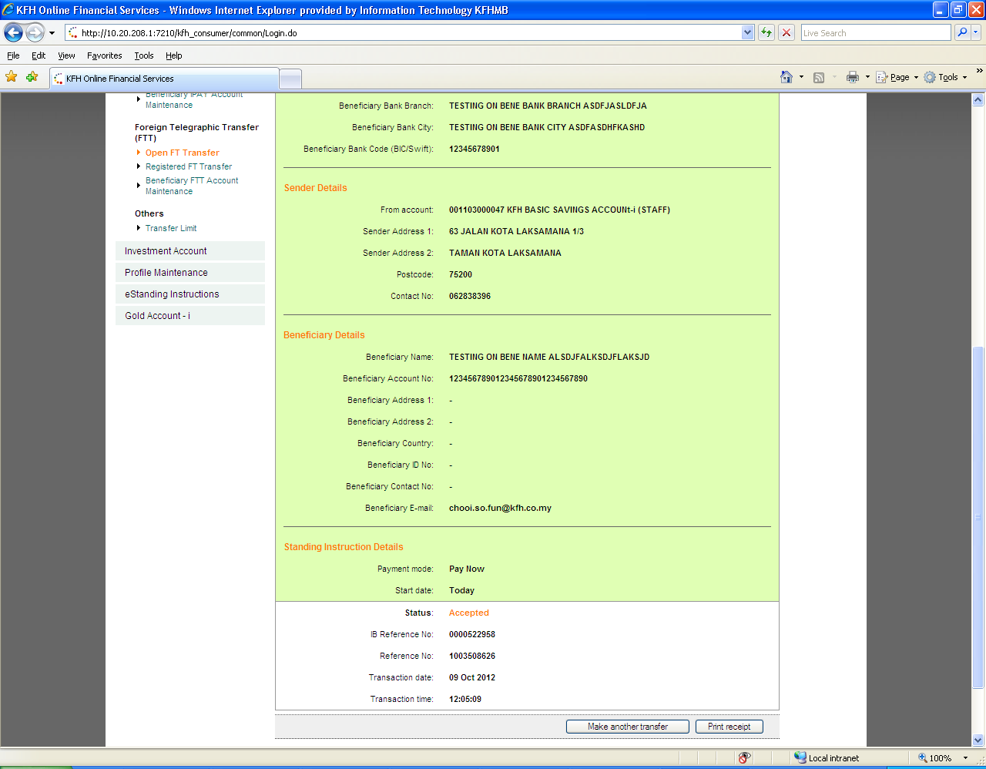

Bene FTT Acc Maint

To add “Beneficiary iBAN No.” field before the “Beneficiary Account No.” field.

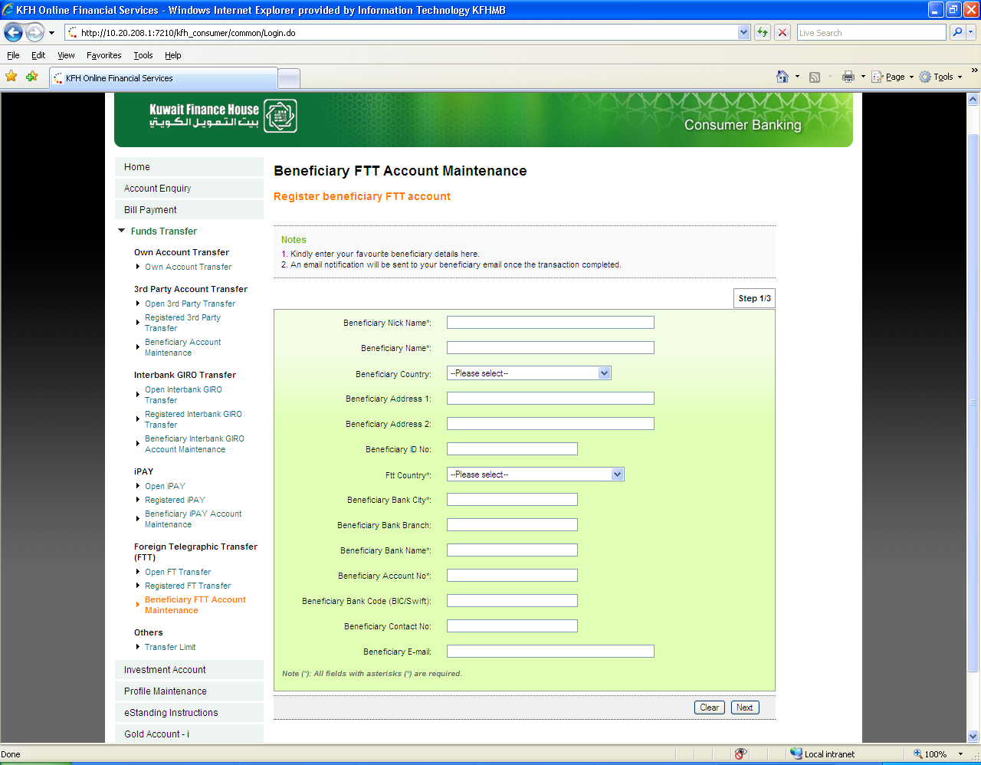

To add “Beneficiary iBAN No.” field before the “Beneficiary Account No.” field.

To add “Beneficiary iBAN No.” field before “Beneficiary Account No.” field.

Format = Alphanumeric