### User Profile Maintenance – Create

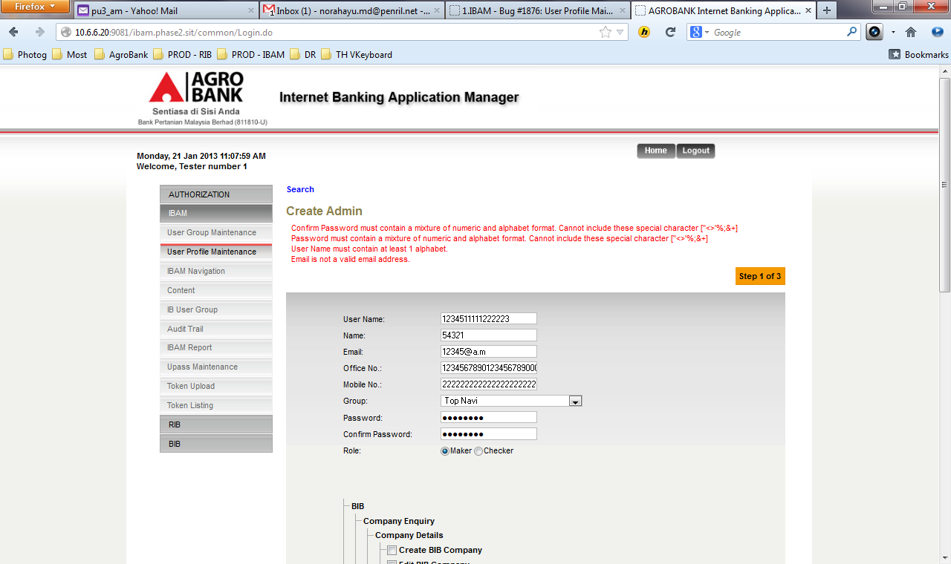

**BRS Requirement:**

|  |  |  |  |  |  |
| --- | --- | --- | --- | --- | --- |
| No | Field | Field Type | Rule | Description | Compulsory |
|  | User ID / User Name | Text Box | Single or combination of 30 chars of numeric, alpha or alphanumeric. | The rule is not parameterized. | Yes |
| 2. | Name | Text Box | Single or combination of 5-16 chars of numeric, alpha, alphanumeric, and/or special character. | The rule is not parameterized. | Yes |
|  | Office No. | Text Box | Min Length 9  Max Length 10  Eg : 03XXXX XXXX | The rule is not parameterized. | Yes |
|  | Mobile No. | Text Box | Min Length 10  Max Length 12  Eg : 013 XXXX XXXX | This is standard feature. | Yes |

1. Standardize Create Admin title to ***User Profile Maintenance - Create***

### User Profile Maintenance – Edit

### Change the validation rules based on the BRS requirement as per above.

1. Name – Field Length 5-16
2. Office No. – Field Length 9-10
3. Mobile No. – Field Length 10-12

### User Profile Maintenance - Lock Result

### No confirmation Page. Admin can suspend and activate the user straight away.

### Standardize with all action have confirmation page.

### User with SUSPEND & LOCKED status > Click on ACTIVATE > System return error message “System is not ready.”

### User Profile Maintenance - Delete

### Change the delete title from User Profile Maintenance - Delete Confirmation to *User Profile Maintenance – Delete*

### System dies at Result page.