CR Resolution

# EB130008 – To remove the ‘Cheque Collection Date’ from check book request screen.

## RIB & BIB

1. Remove ‘Cheque Collection Date’ field from Request Cheque Book flow.

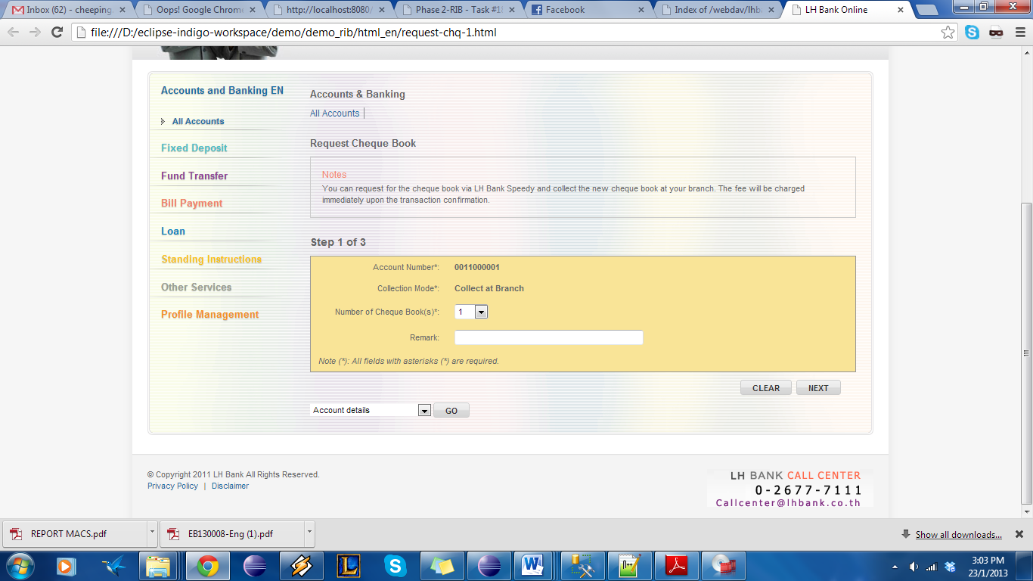

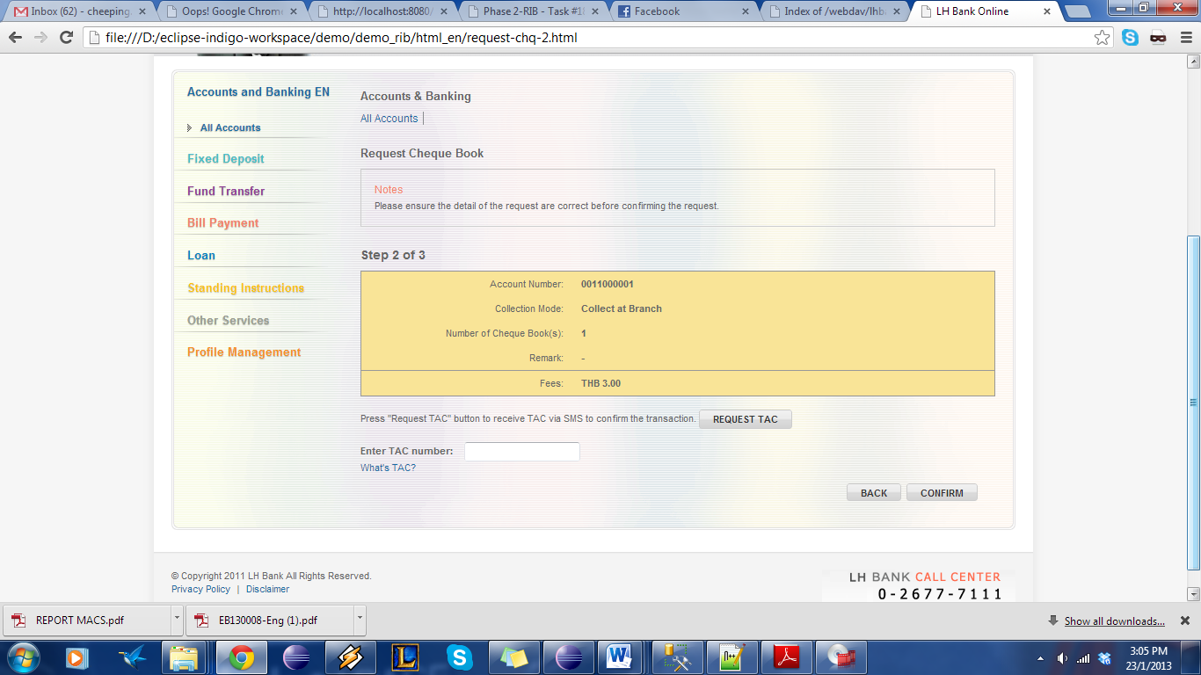

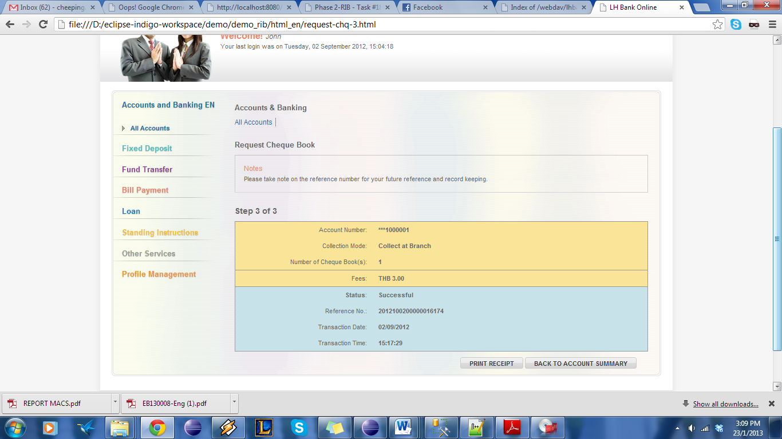

1. On the Host Message to HOST, replace the value from ‘Cheque Collection Date’ with 0

|  |  |
| --- | --- |
| Effort(man-days) | 1 |
| Affected Area | RIB  BIB  User Manual – RIB  User Manual – BIB  Demo – RIB  Demo – BIB |