**PROJECT CHANGE REQUEST FORM**

|  |
| --- |
| **Project Name: Zakat Calculator for Gold Account** |
| **Prepared by: Tan Lee Yong** |
| **Date : 27/05/2010** |
| **Change Request No.: IBCR008** |

|  |
| --- |
| **1. Requestor Information** |

*Fill in with appropriate information or place an “X” next to those that apply:*

**Area of Change:**

|  |  |  |  |  |  |
| --- | --- | --- | --- | --- | --- |
| **Scope** | **[ X ]** | **Schedule** | **[ ]** | **Migration** | **[ ]** |
| **Budget** | **[ ]** | **Quality** | **[ ]** |  |  |

|  |  |  |
| --- | --- | --- |
| **Is this Change the result of a Risk Management Action?** | | |
| **No** **[ X ]** | **Yes** **[ ]** | **Risk ID:** |

**Scope of Change:**

|  |  |  |  |  |  |
| --- | --- | --- | --- | --- | --- |
| **Information Site GUI** | **[ X ]** | **BVMC** | **[ X ]** | **CIB Reports** | **[ ]** |
| **Information Site Tools** | **[ X ]** | **CORUS** | **[ ]** | **BIB Reports** | **[ ]** |
| **Content** | **[ X ]** | **CIB Demo** | **[ ]** | **BIB User Guide** | **[ ]** |
| **Database** | **[ ]** | **BIB Demo** | **[ ]** | **CIB User Guide** | **[ ]** |
| **ESB** | **[ ]** | **OnlineApps IBG Core** | **[ ]** | **BVMC User Guide** | **[ ]** |
| **CIB** | **[ ]** | **BIB** | **[ ]** | **Others** | **[ ]** |
|  |  |  |  |  |  |

|  |  |
| --- | --- |
| ***Proposed Change Description and References:***  *Provide information below concerning the requested change. Create links to any supporting documentation* | |
| **Description:**  Add zakat calculator for gold account under information site. Customer managed to calculate zakat payable amount for gold account based on gold in gram and gold rate. | |
| **Justification:** | |
| **Hyperlinks:** |  | |

|  |  |
| --- | --- |
| **Impact of Not Implementing:** |  |
| **Proposed Change:** |  |

**Alternatives: f the Change Request**

|  |  |  |  |
| --- | --- | --- | --- |
| **Initial Review Date:** | | | **Assigned To:** |
| *Action* | | | *Comments* |
| **Approval for Impact Analysis** | **[ ]** |  | |
| **Reject** | **[ ]** |  | |
| **Defer Until** | **[ ]** |  | |
| **Express Approval** | **[ ]** |  | |

|  |
| --- |
| **3. Initial Impact Analysis** |

|  |  |  |  |  |  |  |
| --- | --- | --- | --- | --- | --- | --- |
| **Baselines Affected:** | | | | | | |
| **Configuration Items Affected**  **(e.g product specifications):** | | | | | | |
| **Cost / Schedule Impact Analysis Required? *(check one)*** | | | | **Yes [ ]** | **No [ ]** | |
| **Impact on Cost:** | |  | | | | |
| **Impact on Schedule:** | |  | | | | |
| **Impact on Resources:** | |  | | | | |
| **Risk associated with implementing the change:** | |  | | | | |
| **Risk associated with not implementing the change:** | |  | | | | |
| **Final Review Results:** | |  | | | | |
| **Review Date:** | |  | | | | |
| **Priority: *(check one)*** | **High [ ]** | | **Medium [ ]** | | | **Low [ ]** |

|  |
| --- |
| **4. Impact Analysis Results** |

**Specific Requirements Definition:**

|  |  |  |
| --- | --- | --- |
| **Additional Resource Requirements** (insert rows as needed)**:** | ***Work Days*** | ***Cost*** |
| **BVMC Content, Information Site GUI** | ***1*** | ***1800*** |
| **Information Site Tools** | ***2*** | ***3600*** |
| **UAT & Migration Assistance** | ***1*** | ***1800*** |
| ***Totals*** | ***4*** | ***7200*** |

|  |  |
| --- | --- |
| **Impact of Not Implementing the Change:** |  |
| **Alternatives to the Proposed Change:** |  |
| |  | | --- | | **5. Final Recommendation** | | |

**Project C**

|  |
| --- |
| **6. Project Change Request Form / Signatures** |

|  |  |
| --- | --- |
| **Project Name:** |  |
| **Project Manager:** |  |

*I have reviewed the information contained in this* Project Change Request Form *and agree:*

|  |  |  |  |
| --- | --- | --- | --- |
| ***Name*** | ***Title*** | ***Signature*** | ***Date***  ***(MM/DD/YYYY)*** |
|  |  |  |  |
|  |  |  |  |
|  |  |  |  |
|  |  |  |  |

*The signatures above indicate an understanding of the purpose and content of this document by those signing it. By signing this document, they agree to this as the formal* Project Change Request Form*.*

**Appendix A**

**Proposed Schedule**

|  |  |  |  |  |
| --- | --- | --- | --- | --- |
| ***Day*** | ***09-11/06*** | ***14-15/06*** | ***16-17/06*** | ***17/06*** |
| Development |  |  |  |  |
| UAT |  |  |  |  |
| Pre Migration |  |  |  |  |
| Migration |  |  |  |  |

**Appendix B**

**Proposed Solution**

Add new content for the calculator

* Add new content in KFH_TOOLS content.
* Allocate Zakat Calculator as the last item under Customer Care > Financial Tools.

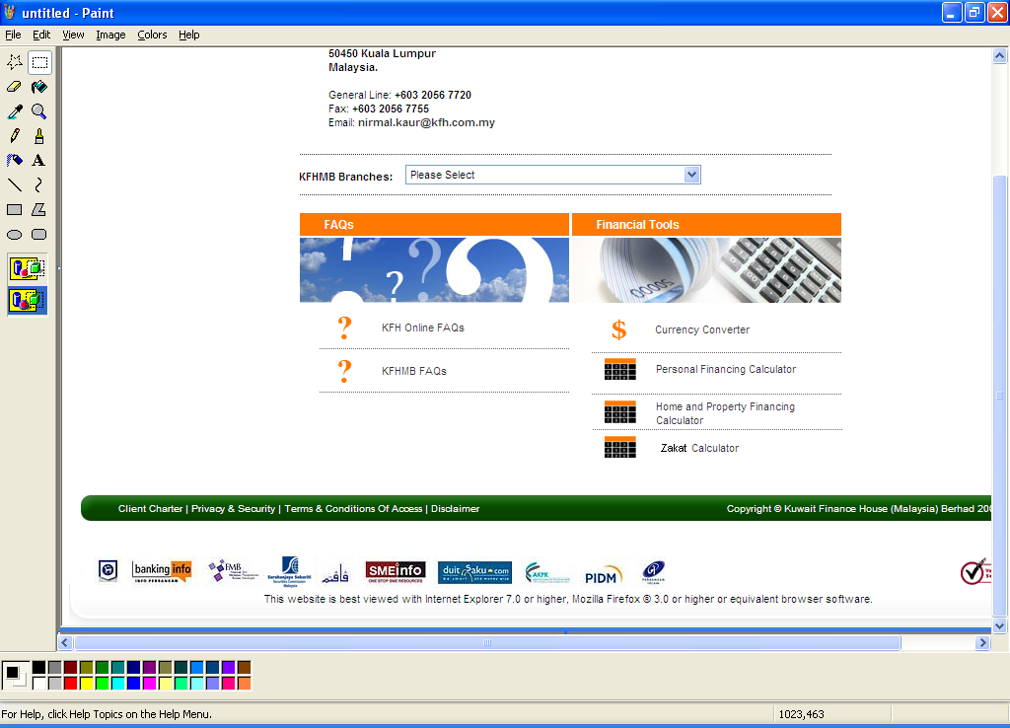

Information Site Enhancement

* Create calculator to calculate zakat payable amount for gold based on the formula below:-

|  |
| --- |
| a) Gold (in gram, minimum 85g) - User input  b) Gold Rate - User Input  c) Gold Value subject to Zakat ( a x b ) - system calculate  d) Zakat Rate (fixed / defaulted to 2.5%)  e) Zakat Payable Amount. ( c x d ) - system calculate |

* Create the calculator GUI

