REQUEST TITLE : Gold Account Calculator at KFH Online (Info Site)
REQUESTOR DETAIL

System : 1) KFHOnline
Requested by : Kamaruddin Damiri / Zahari Ali Signature: …………………………………
Reviewed by : Malarvili Muniandy Signature: …………………………………
Department : PDM
Date Request : ……………………………….
REQUEST DESCRIPTION
No | Item | Description
1 | OBJECTIVE of the Project / Enhancement | - To allow customer to get the Zakat Payable amount for Gold Account, thru calculator provided.
2 | General Overview | - To allow customer to get the Zakat Payable amount for Gold Account, thru calculator provided.
3 | Proposed Process Flow | - Information required:  a) Gold (in gram, minimum 85g) - User input  b) Gold Rate - User Input  c) Gold Value subject to Zakat ( a x b ) - system calculate  d) Zakat Rate (fixed / defaulted to 2.5%)  e) Zakat Payable Amount. ( c x d ) - system calculate  - System calculates the Zakat Payable, based on the formula given (Above), and display.
4 | Charges | NA
5 | Features / Functions | - Calculate the zakat payable amount.
6 | Screen and Design (Include Notes / Messages) | 1. Location under Customer Care \ Financial Tools \ Zakat Calculator  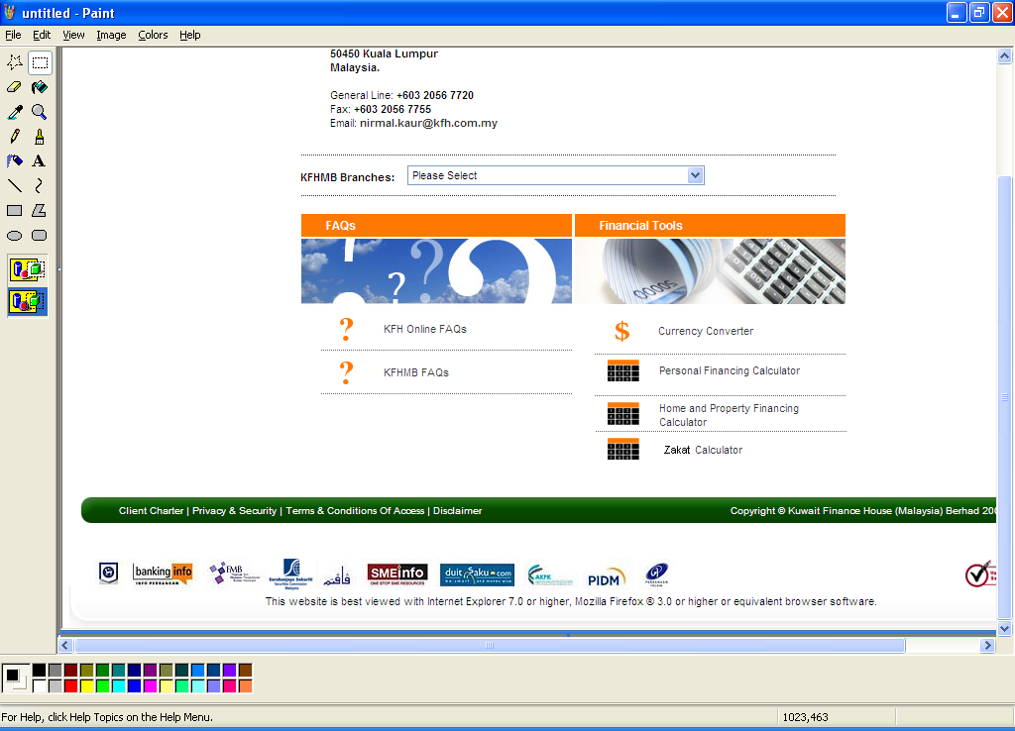  2. Zakat Calculator screen pop-up display:
7 | Reports (new / enhancement) and samples | NA
8 | Audit Trails | NA
9 | BVMC Changes / Enhancements | NA
10 | Back-end processes / enhancements | NA
11 | ATM / OTC | NIL
12 | Timeline | -
13 | Exceptional Handling | NA

