# New Interbank GIRO Transfer

1. There is **NO** Email field in the system but it display in the Trnx Receipt.

# 

1. Segment value **NOT** display at Trnx Receipt.
2. Please remove **Transaction Reference** from the Receipt where I have been informed, the field was just same like Reference No.
3. There is **NO** Email field in the system but it display in the Trnx Receipt.

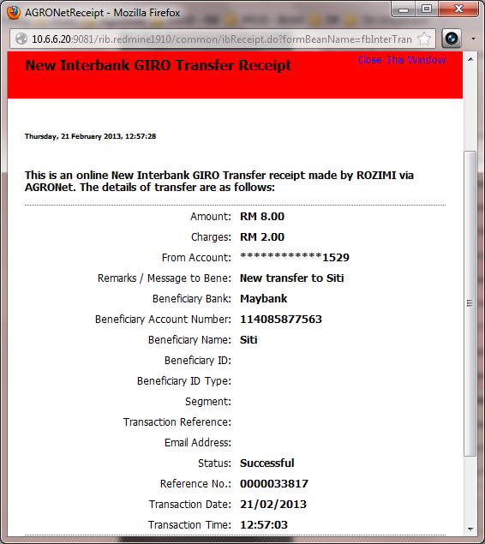

1. Reprint Receipt at AGRONet Trnx History, Segment value display **Null**.

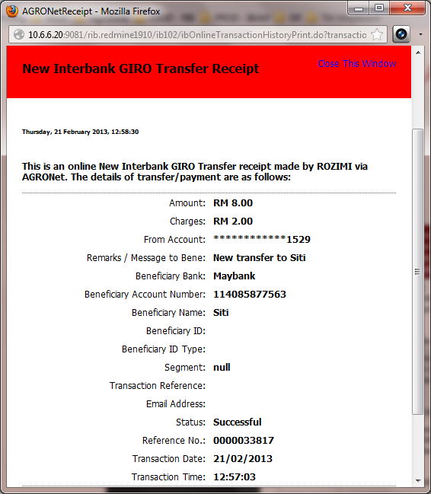

# Favourite Interbank GIRO Transfer

1. There is **NO** Email field in the system but it display in the Trnx Receipt.

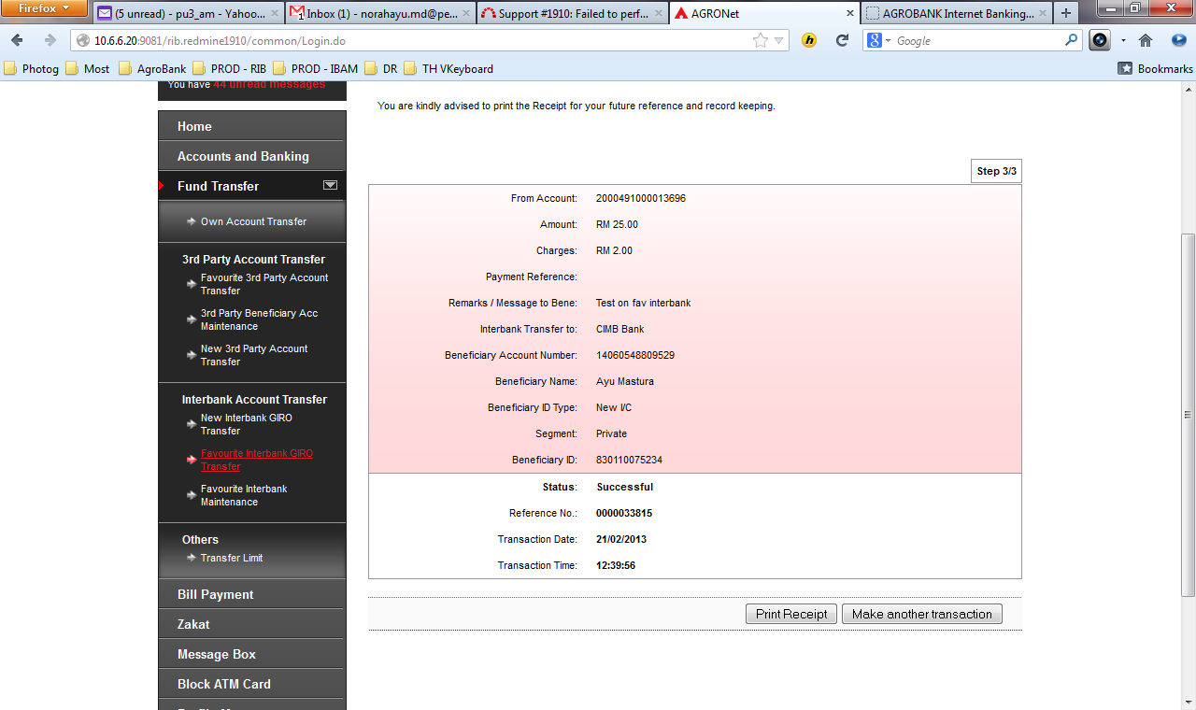

1. Segment value **NOT** display at Trnx Receipt.
2. Please remove **Transaction Reference** from the Receipt where I have been informed, the field was just same like Reference No.
3. There is **NO** Email Address field in the system but it display in the Trnx Receipt.

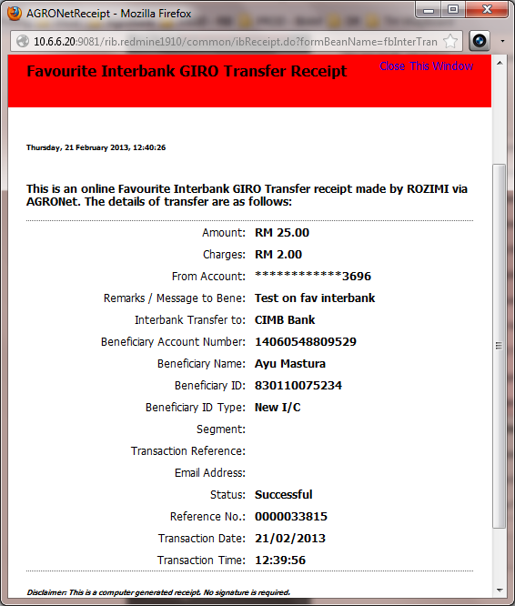

1. Reprint Receipt at AGRONet Trnx History, Segment value display **Null**.

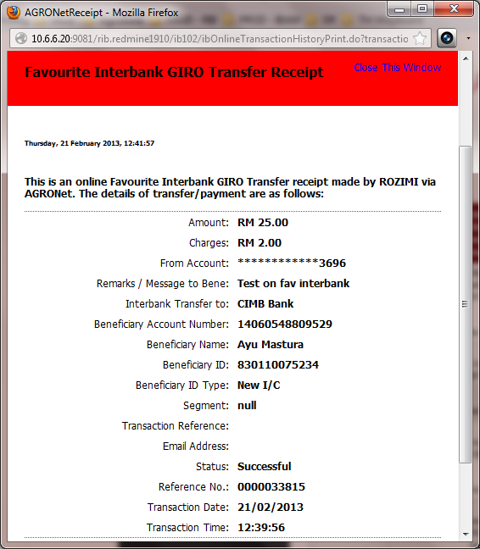

Transaction Type in IBAM mixed up with NON-MONETARY activity.

