Content - Bank Branch

#### Category Name List

#### To sort Category Name List alphabetically.

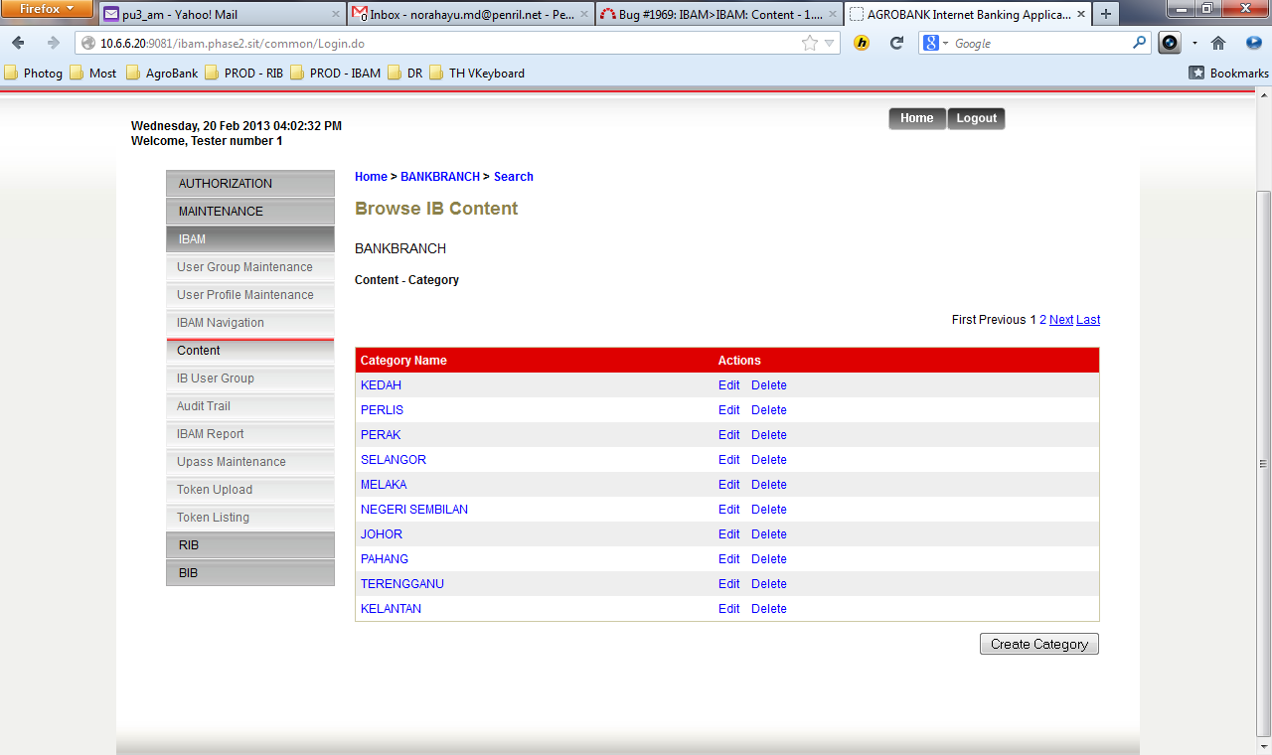

#### Create Category

1. Parent Category (BM) – to add required validation to the field.
2. Error Message not same with Category label. *Error Message:* *Category Name (BM) cannot be as similar as Category Name (EN).*
3. System not allows Parent Category (EN) & (BM) to be same name.

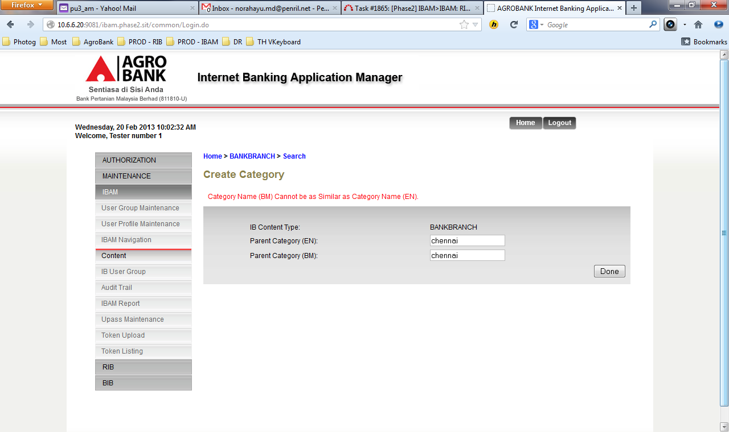

#### Edit Category

1. Unable to edit the Category Name from ***PERAK*** to ***Perak***. *Error Message : Category name already exist*
2. System not allows Parent Category (EN) & (BM) same name*.**Error Message****:*** *Category Name (BM) cannot be as similar as Category Name (EN).*

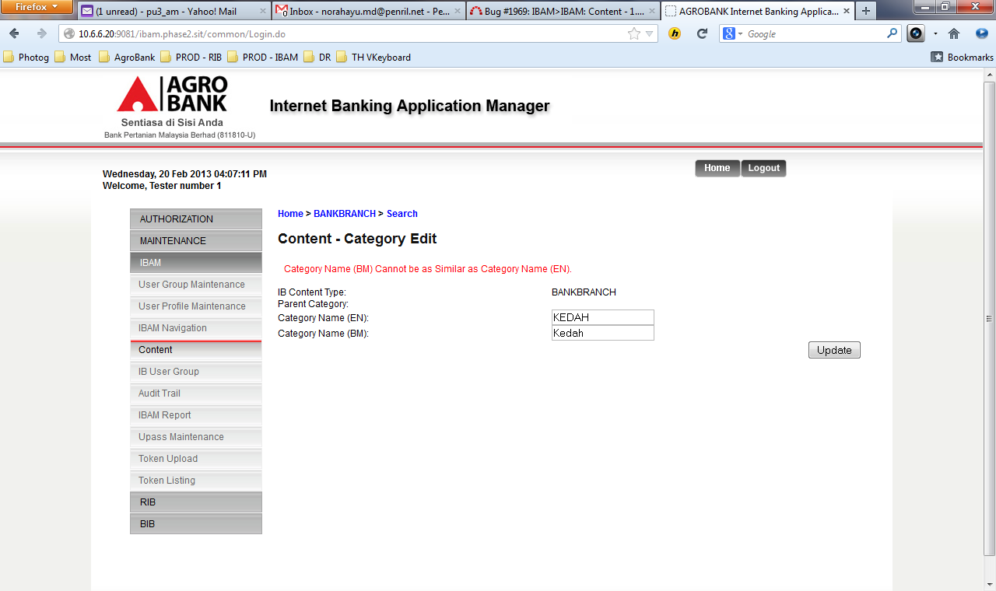

#### Create Sub Category

1. Category Name (BM) – to add required validation to the field.
2. System not allows Parent Category (EN) & (BM) to be same name. *Error Message:* *Category Name (BM) cannot be as similar as Category Name (EN).*

#### Edit Sub Category

1. Unable to edit the Category Name from ***KERTEH*** to ***Kerteh***. *Error Message : Category name already exist*
2. System not allows Parent Category (EN) & (BM) same name.

#### Create Content List

1. Below is the field that NOT meet max length requirement.

|  |  |  |  |  |  |
| --- | --- | --- | --- | --- | --- |
| **No** | **Field** | **Field Type** | **Rule** | **Description** | **Required** |
|  | Branch Code | Text Box | 8 digits. Must use combination of alpha and numeric | Specify the code of a particular branch. | Yes |
|  | ~~Branch Code Duplication Policy~~ | ~~Text Label~~ | ~~If branch code has already been used in the system, it will throw an error through JSP validation.~~ | ~~IBAM System throws a message “Branch Code has been used. Please use another Branch Code.~~ | ~~Yes~~ |
|  | Branch Name | Text Box | 1-64 digits of alpha and/or numeric | Specify the name of a particular branch. | Yes |
|  | Branch Address | Text Box | 1-255 digits of alpha, numeric, and/or special characters.  Consist of 5 lines, each stored at separated column in the database. | Specify the branch location address. | No |
|  | Post Code | Text Box | 5 digits of numeric | Specify the post code of that branch. | No |
|  | Branch Contact No. | Text Box | ~~1-64 digits~~ of numeric and/or symbol (E.g.: +6012)Replace to 11digits | Specify the branch contact no.  Add Sample on the site | No |
|  | Branch Fax No. | Text Box | ~~1-64 digits~~ of numeric and/or symbol (E.g.: +6012) Replace to 11digits | Specify the branch fax no.  Add Sample on the site | No |
|  | Branch Area Code | Text Box | 1-64 digits of alpha and/or numeric | Specify the branch area code. | No |

1. There are the fields that NOT meet Validation Rules.

|  |  |  |  |  |  |
| --- | --- | --- | --- | --- | --- |
| **No** | **Field** | **Field Type** | **Rule** | **Description** | **Required** |
|  | Branch Code | Text Box | 8 digits. Must use combination of alpha and numeric | Specify the code of a particular branch. | Yes |
|  | Branch Code Duplication Policy | Text Label | If branch code has already been used in the system, it will throw an error through JSP validation. | IBAM System throws a message “Branch Code has been used. Please use another Branch Code. | Yes |
|  | Branch Name | Text Box | 1-64 digits of alpha and/or numeric | Specify the name of a particular branch. | Yes |
|  | Branch Address | Text Box | 1-255 digits of alpha, numeric, and/or special characters.  Consist of 5 lines, each stored at separated column in the database. | Specify the branch location address. | No |
|  | Post Code | Text Box | 5 digits of numeric | Specify the post code of that branch. | No |
|  | Branch Contact No. | Text Box | 1-64 digits of numeric and/or symbol (E.g.: +6012) | Specify the branch contact no. | No |
|  | Branch Fax No. | Text Box | 1-64 digits of numeric and/or symbol (E.g.: +6012) | Specify the branch fax no. | No |
|  | Branch Area Code | Text Box | 1-64 digits of alpha and/or numeric | Specify the branch area code. | No |

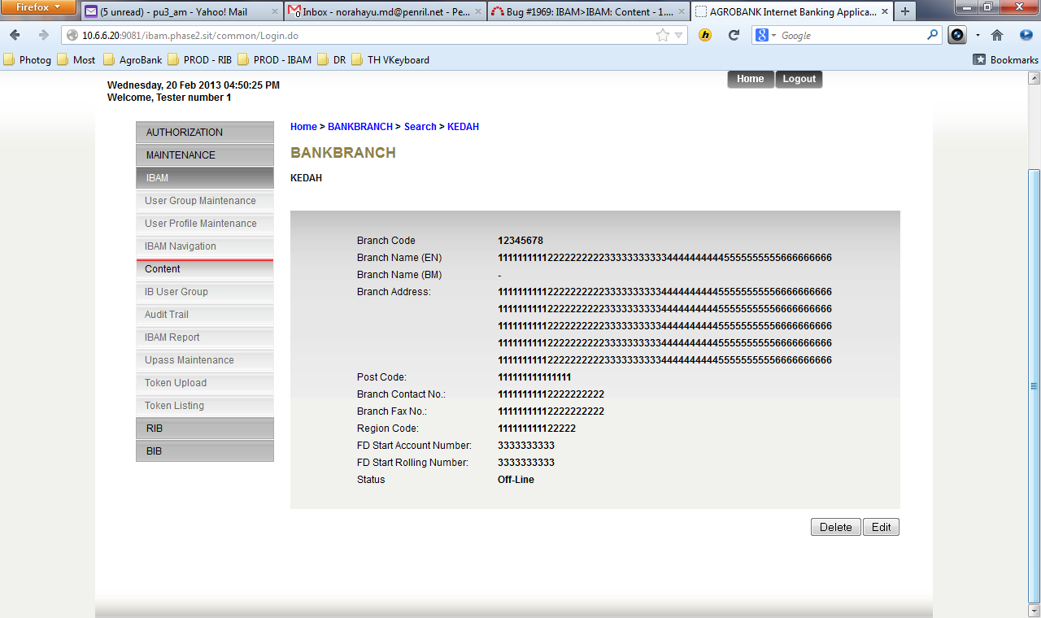

#### Search Content List

Unable to search by ***Search All, Locale*** Page display System Unavailable and Error Exception.

