Content - Payee

## *Create Category*

1. Error Message not same with Category label. *Error Message: Category Name (BM) cannot be as similar as Category Name (EN).*
2. System not allows Parent Category (EN) & (BM) to be same name.

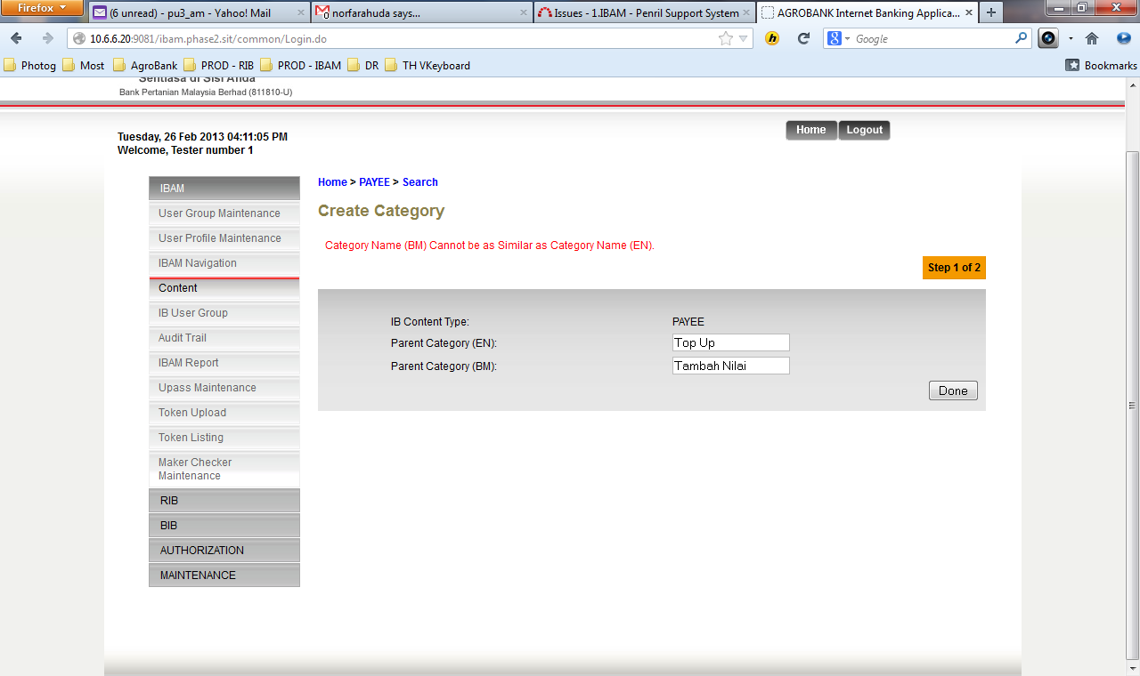

#### Edit Category

1. System not allows Parent Category (EN) & (BM) same name*.**Error Message****:*** *Category Name (BM) cannot be as similar as Category Name (EN).*

|  |  |
| --- | --- |
|  |  |

#### Create Sub Category

1. NO button to create new Sub Category

#### Create Content List

1. Click on Create Content and system throw *SYSTEM UNAVAILABLE.*

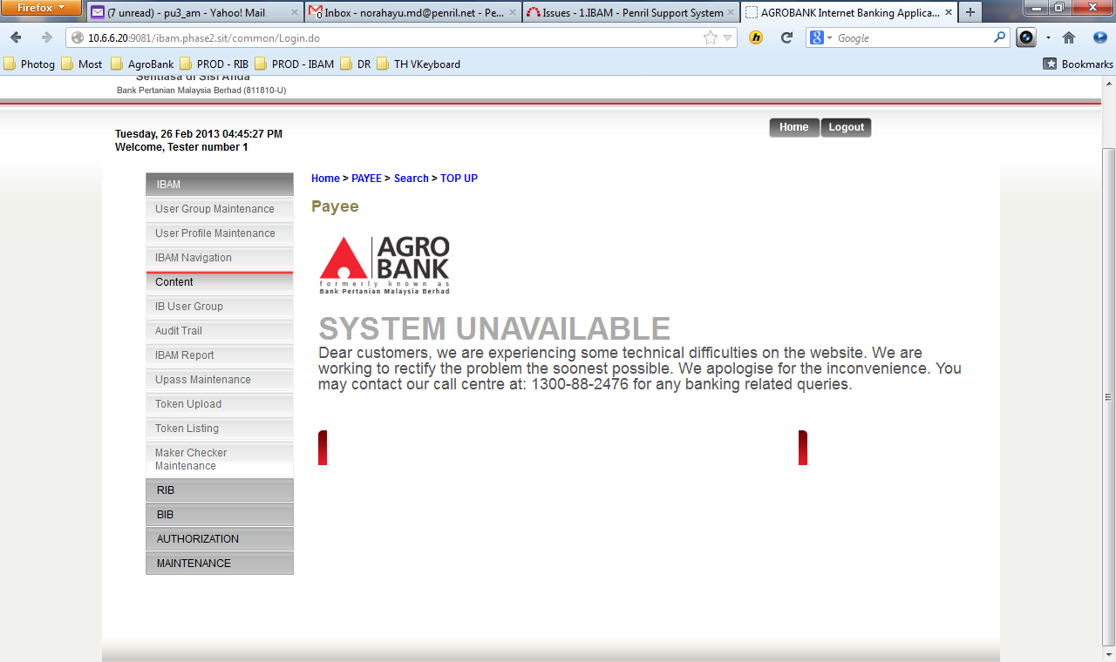

## *Payee Search*

Unable to search by ***Search All Page & Full name*** display. System throws System Unavailable and Error Exception.

