Pindahan Dana

1. Standardize the font type & size

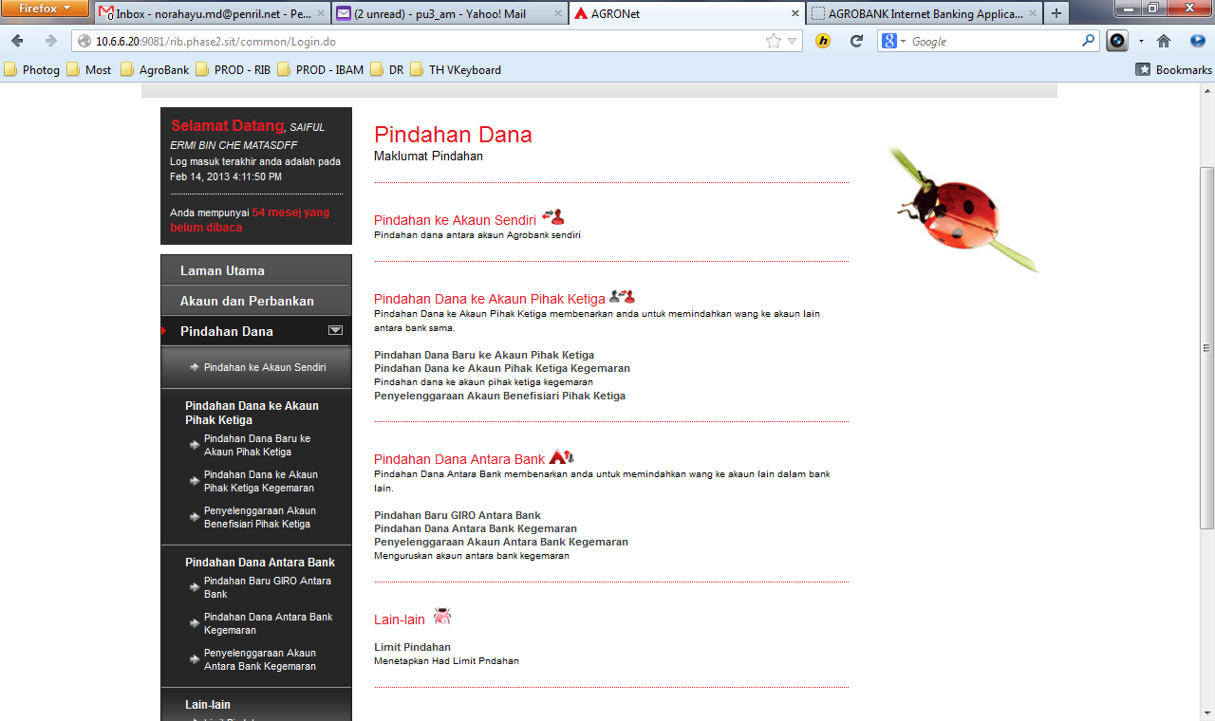

# Pindahan Dana ke Akaun Sendiri

1. Re-arrange button from Sahkan|Kembali to Kembali | Sahkan

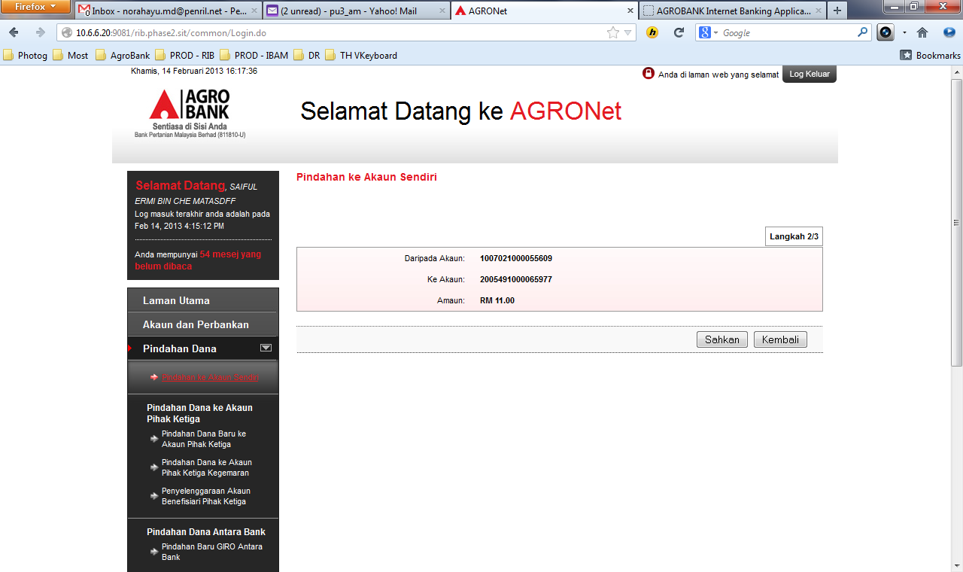

1. Cannot open the PDF file.

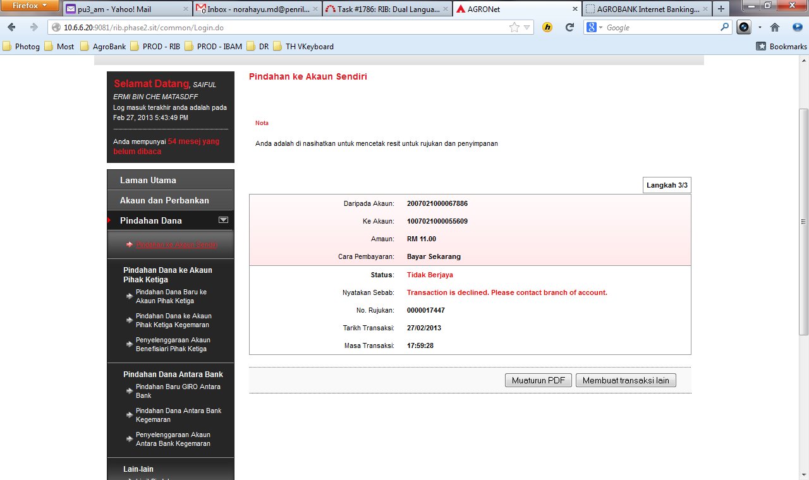

# Pindahan Dana Baru ke Akaun Pihak Ketiga

1. Re-arrange button from Sahkan|Padam to Padam| Sahkan
2. Alamat E-mel Bene is too long.

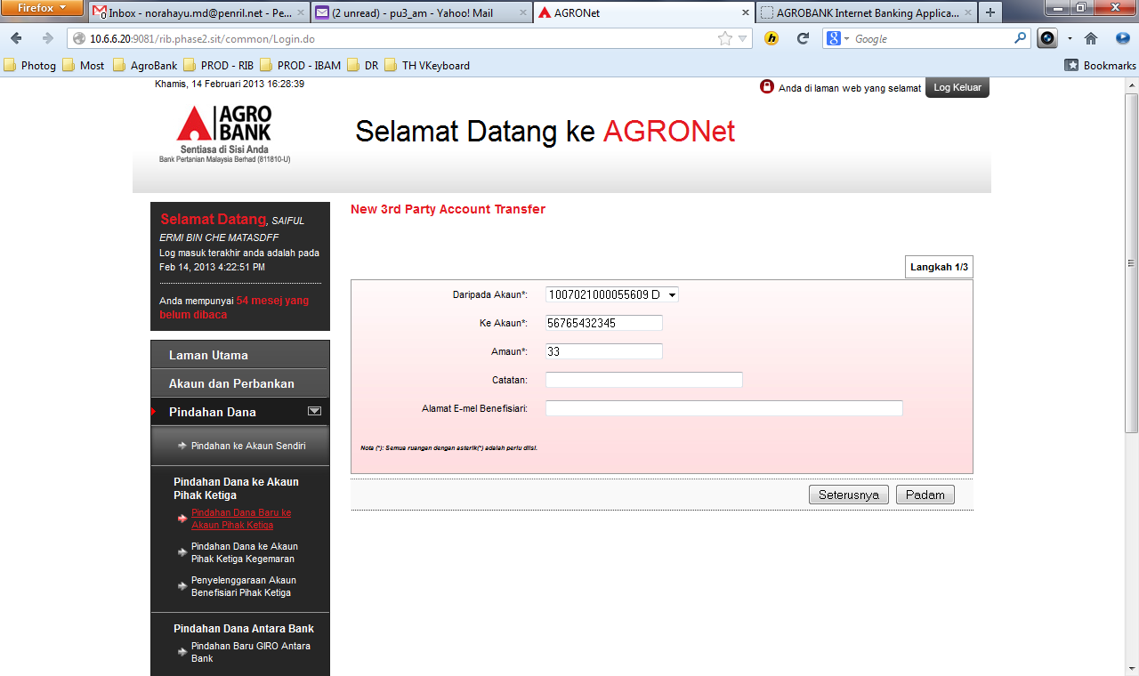

1. Re-arrange button from Sahkan|Padam to Padam| Sahkan
2. To put **Sila masukkan nombor TAC** in new line since there were so crowded in one line.
3. Page Logout after click on Sahkan button.

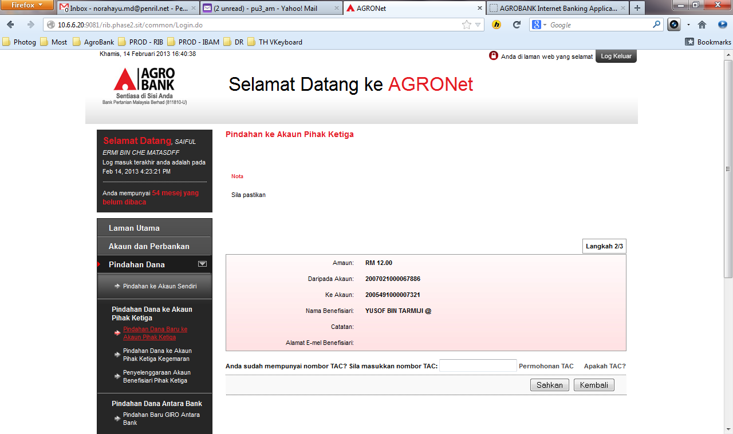

# TAC Notification

1. Change TAC title to BM.
2. Change Nota No.1 to be “Anda dinasihatkan untuk tidak memberi respon kepada ….”
3. Please change telefon mudah alih to Telefon Bimbit.

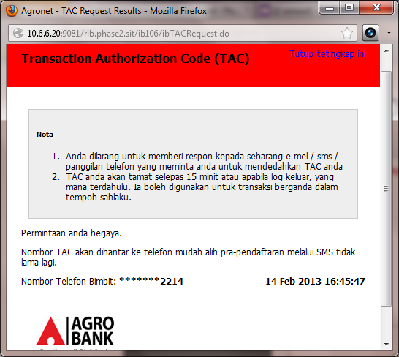

1. Cannot open the PDF file.
2. Nyatakan Sebab value not displays.

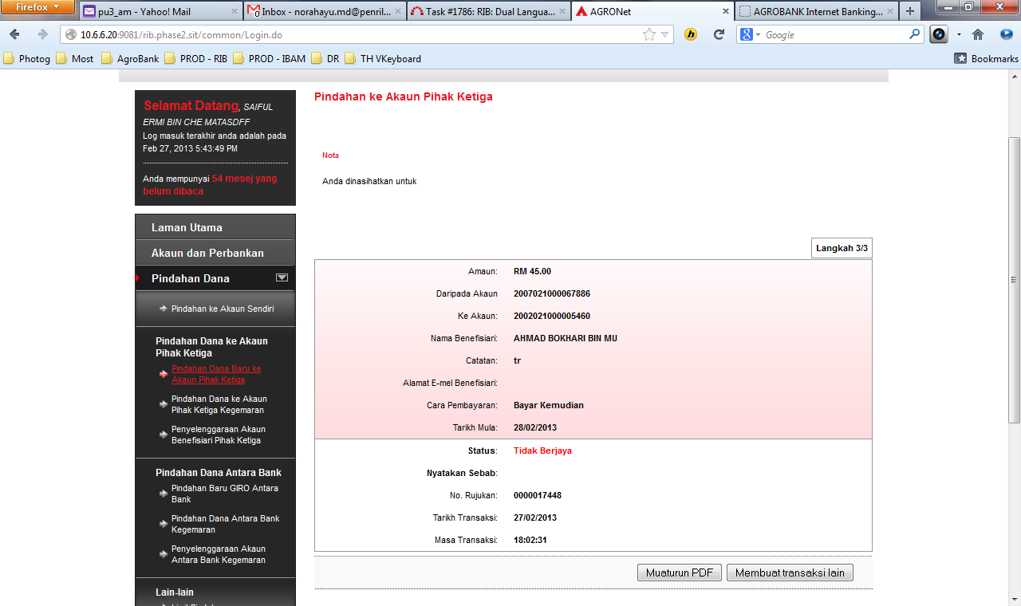

# Pindahan Dana ke Akaun Pihak Ketiga Kegemaran

1. Re-arrange button from Seterusnya|Padam to Padam| Seterusnya

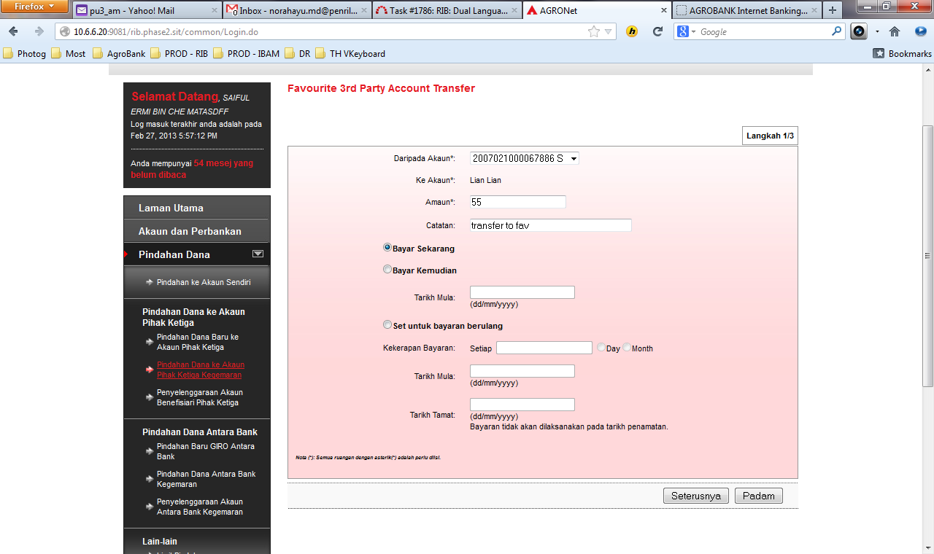

1. Re-arrange button from Seterusnya|Padam to Padam| Seterusnya

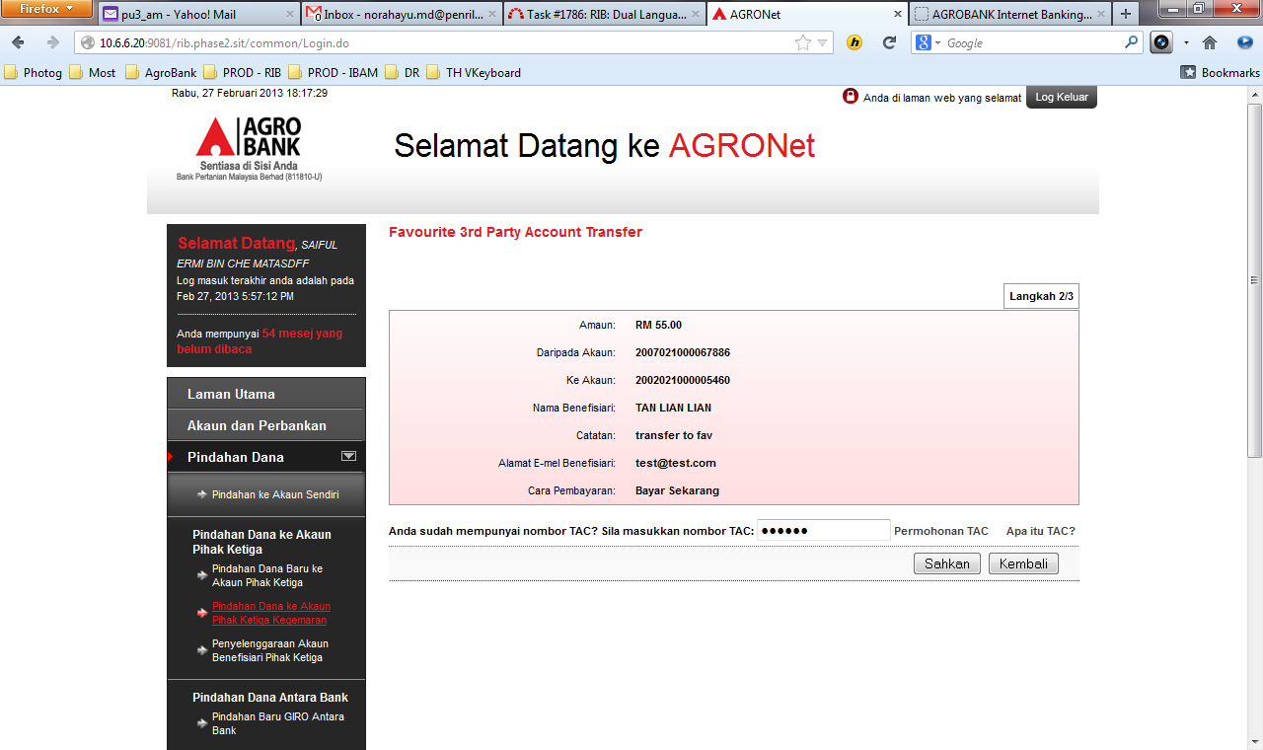

1. Nyatakan Sebab : Change the error message to “Akaun anda tidak mempunyai baki yang mencukupi”.
2. Unable to Download Muat turun PDF.

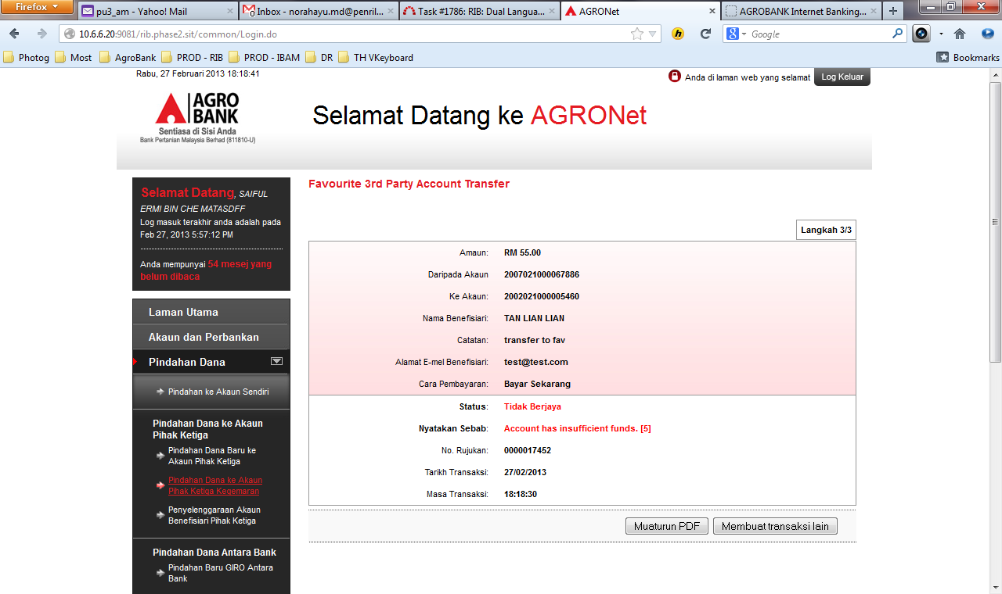

1. NO Reason value for Unsuccessful transaction.

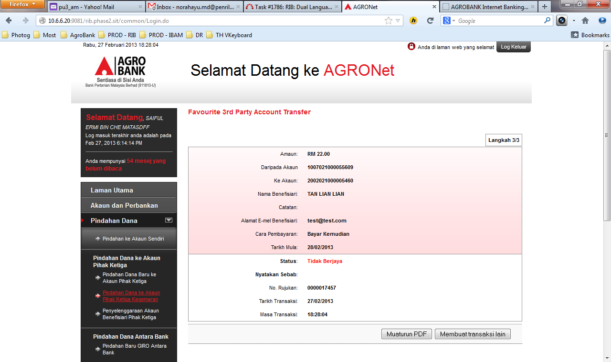

# Penyelenggaraan Akaun Benefisiari Pihak ketiga – Tambah Benefisiari

1. Remove atau among both buttons.

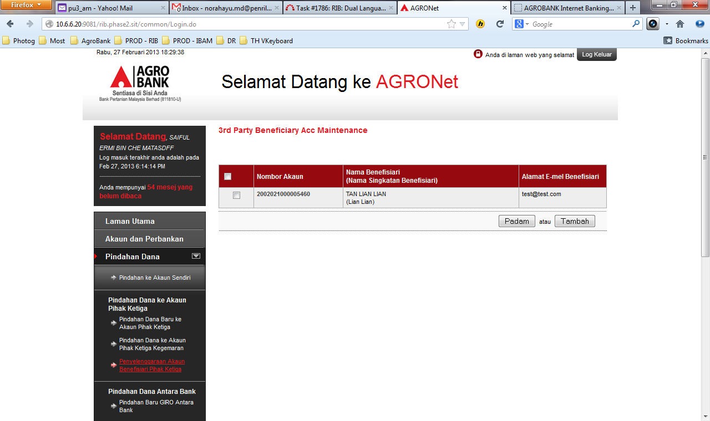

1. Remove atau among both buttons.
2. Bene Email Address field is too long.

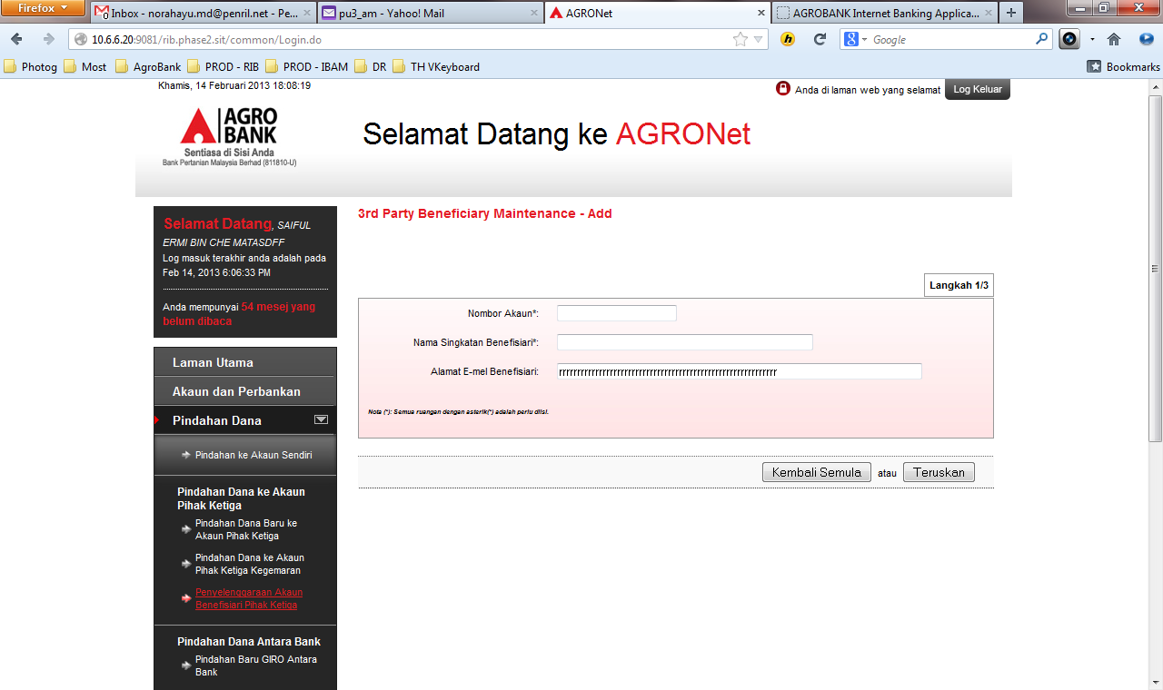

1. Nama Benefisiari value not display.
2. Remove atau among both buttons.
3. System automatically Logout after click on Sahkan button.

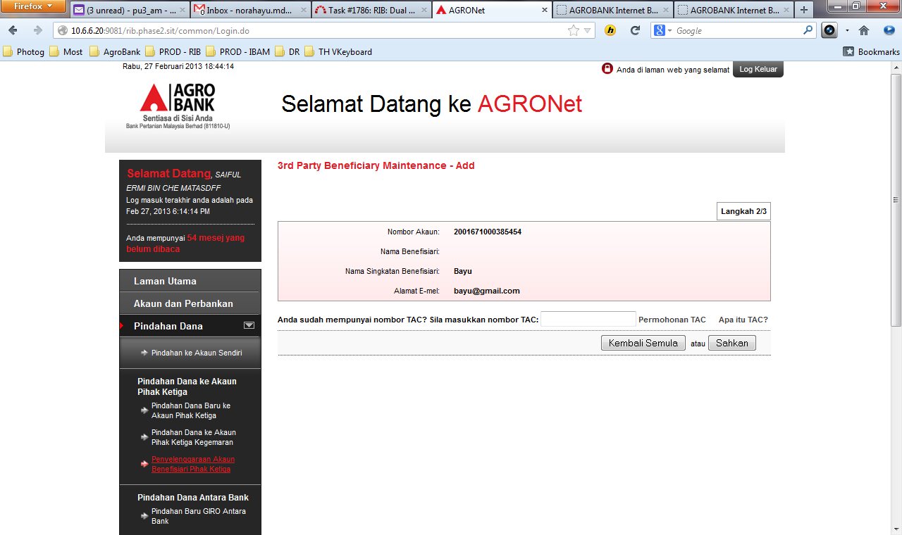

# Kemaskini Nombor Telefon Mudah Alih

1. Kemaskini Nombor Telefon Mudah Alih – Adjust in a proper view. Change it to Telefon Bimbit.
2. Re-arrange button from Sahkan|Padam to Padam| Sahkan.

