## Pindahan Baru GIRO Antara Bank

1. Pindahan Baru GIRO Antara Bank Landing Page display System Unavailable.

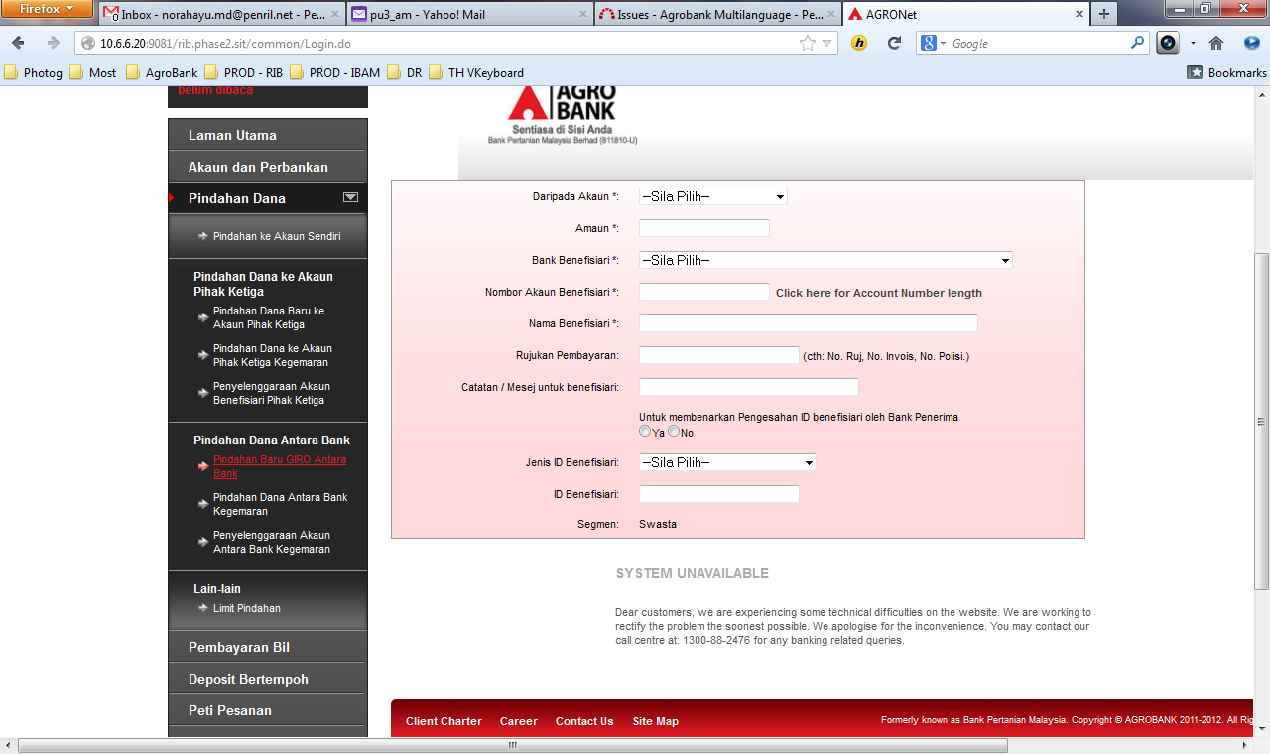

1. Error Message "Cara Pembayaran diperlukan" even though there was NO Cara Pembayaran radio button display.

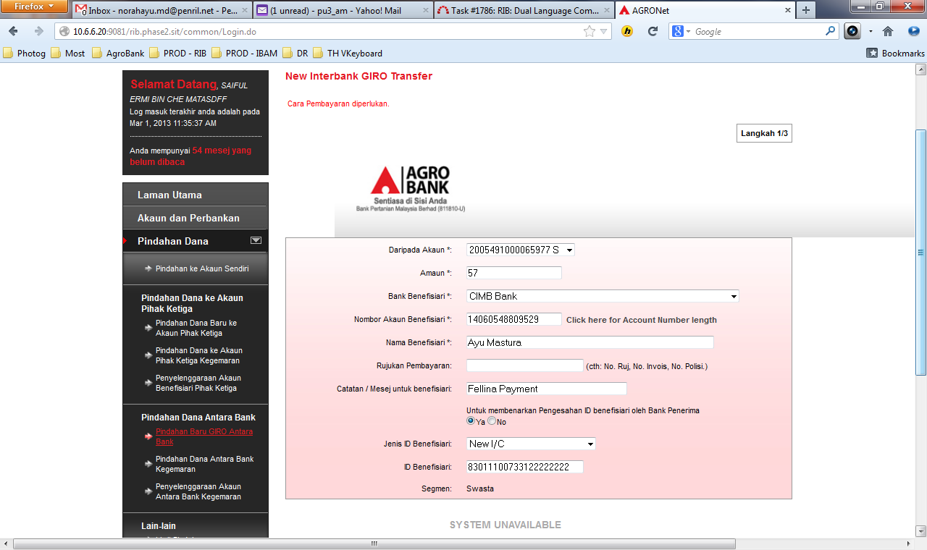

## Pindahan Dana Antara Bank Kegemaran

1. Pindahan Dana Antara Bank Kegemaran Landing Page display System Unavailable.
2. Error Message "Cara Pembayaran diperlukan" even though there was NO Cara Pembayaran radio button display.

