Malayan Banking Berhad



Proposal for Maybank Philippines Internet Banking Project – Phase I

6 August 2010
Our ref: WOS/M2U/20100806/WL01

Prepared By:



Penril Datability (M) Sdn Bhd (816792-X)
Suite A-07-07 Plaza Mon’t Kiara
No. 2, Jalan Kiara, Mon’t Kiara
50480 Kuala Lumpur, Malaysia
Tel: (603) 6201 2622 Fax: (603) 6201 7622

This proposal contains information proprietary to Penril Datability (M) Sdn. Bhd. (Penril) and is provided upon the condition that the information contained herein shall be held in confidence, and the intended recipient shall not disclose to others or utilise the information in whole or in part for purposes other than that intended for under this proposal.

Document Administration
Document Amendment Log
Version No | Date Updated | Description of Change | Updated By  <Name, Dept> | Reviewed By  <Name, Dept> | Approved By <Name, Dept>
1.0 | 06/08/2010 | Initial Creation | Tan Lee Yong, Professional Services, Penril Datability

Table of Contents
1 Introduction 4
2 M2U Transactional Site BV Dependencies 5
3 Proposed Maybank Philippines Transactional Site (MPI) free from BV 6
3.1 Proposed System Components 7
3.2 Retail Banking Features 7
3.3 Corporate & SME Banking Features 8
3.4 Java Message Service (JMS) handling 8
3.5 Application Server replacement 8
3.6 M2U Components to Be Upgraded 9
4 Assumptions 10
4.1 General Assumptions 10
5 Implementation Schedule 11

Table of Figures
Figure 1 M2U System BV Dependencies Diagram 5
Figure 2 M2U System Free from BV Modules Diagram 7
Figure 3 M2U Component Diagram 9

Table of Tables
Table 1 BV Module Dependency 5
Table 2 BV Dependencies Replacement 6
Table 3 Retail Banking Features 8
Table 4 Corporate & SME Banking Features 8

Introduction

The objective of this project is to customize current Maybank2U’s transactional site for Maybank Philippine’s Internet Banking project. This project scope will encompasses separating the current applications from Broadvision One-to-One Platform. Current M2U transactional applications use BroadVision (“BV”) software which included DCC, BV Alert, BV_SessisionManager, BV User and BV Finance Server (FI).
This document describes the scope and effort needed to remove the BV dependency and replace with more sustainable and maintainable framework; rather than using proprietary solution.

M2U Transactional Site BV Dependencies
Currently, M2U business logic is using BV APIs to manage session, user profile, site navigation, contents, alert message and the FI component.

The below diagram shows all the BV dependencies:-
Figure 1 M2U System BV Dependencies Diagram
The diagram shows that M2U business logic is tightly couple with BV components and some of the components are managed by BV administration module, named DCC.

The below table show all the dependent modules and the usage:-
No | Description
Integration Layer dependency
- M2U is using BV FI as the communication channel with the host
BV Content dependency (DCC)
- M2U is using BV content APIs to retrieve and maintain the site Service Note, Payee Corporations and other parameters
Navigation dependency (DCC)
- M2U is using BV Navigation APIs to control and maintain the site navigation menu
Alert message dependency (DCC)
- M2U is using the BV Alert APIs and BV Qualifier to push message to targeted user
User profile dependency (DCC)
- M2U is using BV User tables and APIs to maintain user profile
Session object dependency
- M2U is using BV Session manager
Table 1 BV Module Dependency

Proposed Maybank Philippines Transactional Site (MPI) free from BV
In order to remove all the BV dependencies, all BV modules must be replaced:-
Description | Existing | New
Integration Layer | BV FI Server | Use Java Message Services (JMS)
Administration | DCC  - Maintain Service Note  - Maintain Payee Corporation  - Maintain site Navigation  - Send Alert Message  - Maintain parameter setting  - Maintain user profile | OnlinesApp Administration Module  - Maintain Service Note  - Maintain Payee Corporation  - Maintain site Navigation  - Secured Mailbox  - Maintain user Access Matrix  - Maintain Check/Maker  - Maintain Tier Pricing and limit  - Maintain others parameter setting  - Maintain user profile  - Audit log enquiry and download  - Report enquiry and download
Session | BV Session | Java session
Application Server | BV Application Server | Oracle WebLogic Application Server
Table 2 BV Dependencies Replacement
In order to meet the MPI project requirement, a few new modules also being introduced:-
- UPASS as the authentication server
- Check/Maker module for Corporate and SME user
- User Access Matrix to control Corporate and SME user accessibility
- Tier Pricing and Limit control

Proposed System Components
The below diagram shows all the BV dependencies has been removed
Figure 2 M2U System Free from BV Modules Diagram

Retail Banking Features

The table below shows all the required retail banking features:-
No | Feature | Description
 | Account Inquiry | Support for SA, CA, FCA, Loans, Time Deposits
 | Transaction History | Enquire last 60 days history
 | Bill Payment | Riding on BancNet billers (through ATM)  Includes Government Payments
 | Intrabank Funds Transfer | Own or 3rd party accounts  Current or future dated
 | Interbank Funds Transfer | To BancNet member banks
 | Time Deposit Placement & Upliftment | Capture request – branch to process
 | Check Services | Check book re-order, stop check, check status inquiry
 | Mobile Prepaid Top Up | Straight through top up to mobile
 | Cash / eCard Top Up
 | Two Factor Authentication | TAC & SMS
Table 3 Retail Banking Features

Corporate & SME Banking Features

The table below shows all the required corporate & SME banking features:-
No | Feature | Description
 | Account Inquiry | With OD limit, Unauthorized Limit (depending on core banking)
 | Check Cutting | Log request via IB, process manual
 | Check Warehousing | Log request via IB, process manual
Table 4 Corporate & SME Banking Features

Java Message Service (JMS) handling
In replacing BV FI with JMS, administrator can configures and administers JMS objects in Java Naming and Directory Interface (JNDI) API namespace. The administrative task can be performed through standard J2EE SDK tool, j2eeadmin, to monitor the message queues.
The same configuration, monitoring and administration also can be performed through the Application Server like Oracle WebLogic Administration Console.

Application Server replacement
The proposed solution is required to run on a J2EE Application Server. We recommend using enterprise application servers like Oracle Weblogics, IBM Websphere.

M2U Components to Be Upgraded

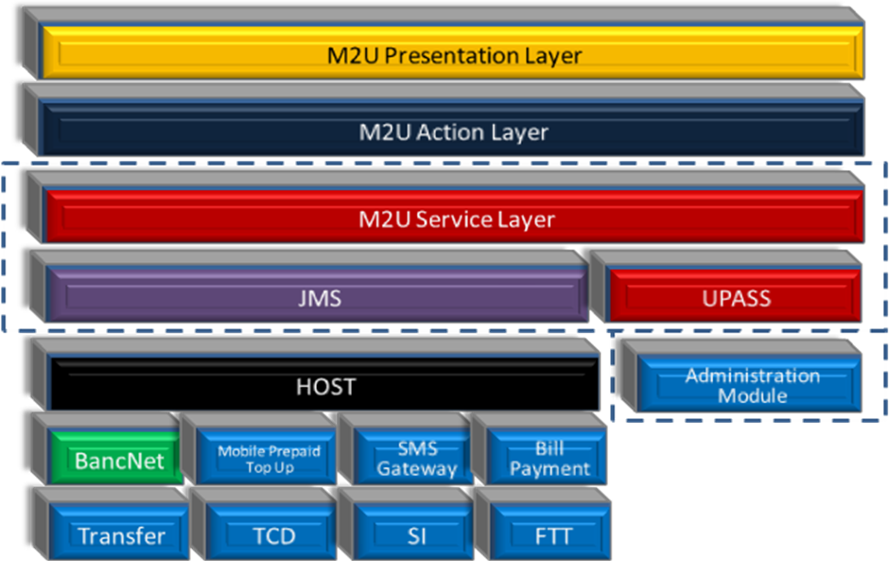
Figure 3 M2U Component Diagram
All the components in the dotted line box will be upgraded to support for the new changes. In short, for this project, only the M2U Service Layer is required to revamp to support the new JMS, UPASS and Administration Module.

Assumptions

General Assumptions
- All the bank account related services are performed at the Maybank host
- All the transactional services are performed at Maybank host
- All the Bill Payment transactional services are performed at Maybank host
- The TAC and SMS service request are performed at Maybank host
- All the transaction using BancNet are performed at Maybank host
- Mobile Prepaid Top Up and Cash / eCard Top Up are performed at Maybank host
- Future and Recurring Payment (Standing Instruction) are performed at Maybank host
- The proposed solution shall not make any changes to the currently M2U business logic flows
- Reporting is not part of this project
- Only support csv and txt report format for the Audit log.

Implementation Schedule

We anticipate it will take 6 months to implement the Internet Banking solution for Maybank Philippines.
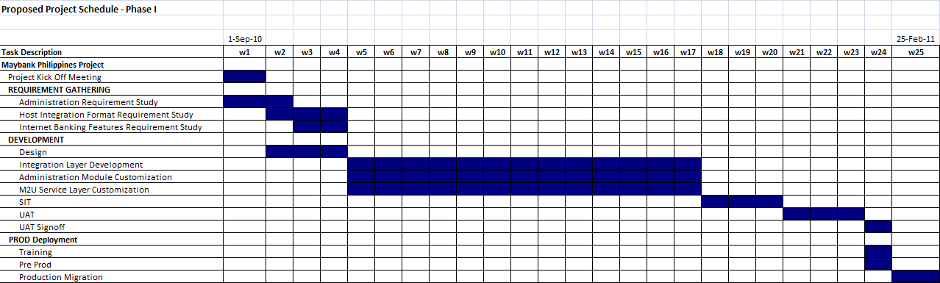
Summary in number of day | Summary in number of man/day
  Activity | Day
  Project Kick Off | 1
  Requirement Gathering & Design | 15
  Development | 65
  SIT | 15
  UAT | 15
  Deployment | 10
  Training | 4
  Activity | Man/Day
  Requirement Gathering & Design | 25
  Development | 215
  SIT | 12
  UAT | 12
  Deployment | 6
  Training | 4

--------------------------------------------------------- | END | --------------------------------------------------------

