Akaun & Perbankan

1. Change Account Details to BM
2. Change GO button to Seterusnya.

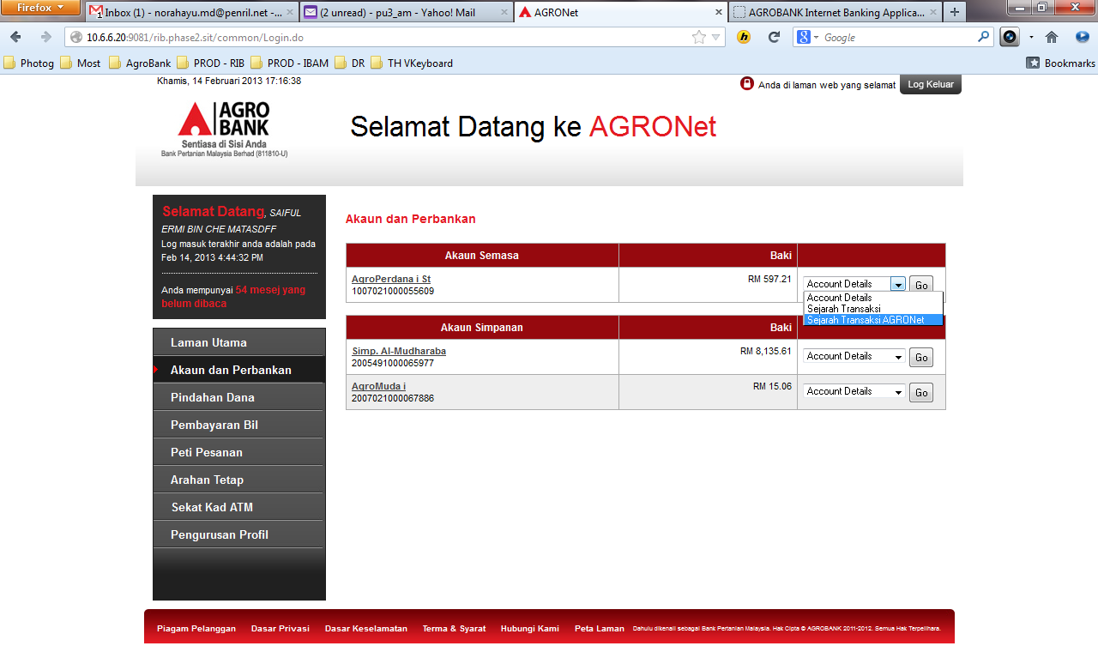

## Account Details

1. Change Status Akaun to BM
2. Change GO button to Seterusnya.

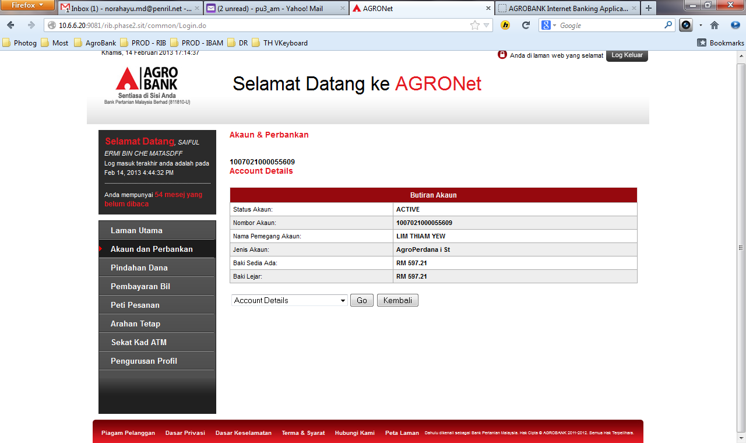

## AGRONet Transaction History

1. NO title below account number. Title – Sejarah Transaksi AGRONet (AGRONet Transaction History)
2. Channel label not in the IBApplicationResources_ms-RIB file.
3. Transaction status change to BM

