## Peti Pesanan

### Peti Masuk - Buang

1. Change New to ***Baru***
2. Unable to delete, system die after click on Confirm& Back button.
3. Change button name from buang to Padam

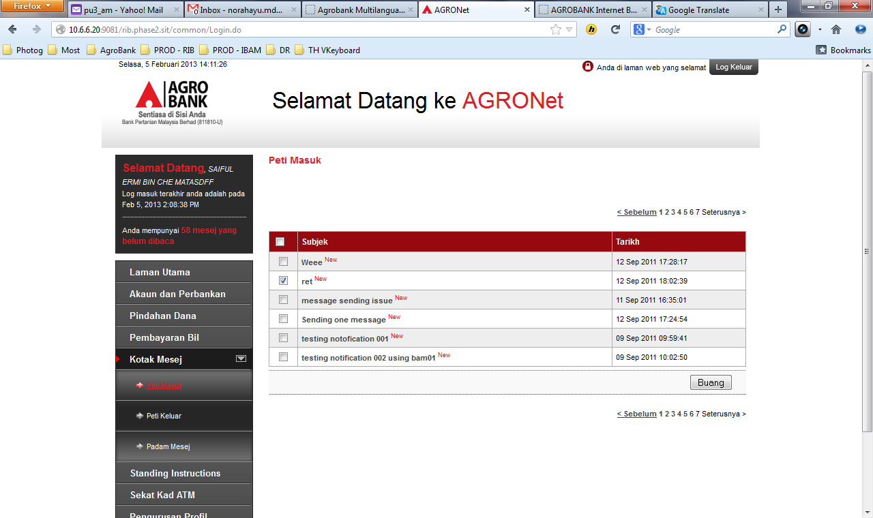

1. Change Secure Mailbox to BM
2. Change Back button to BM
3. Change Confirm button to BM

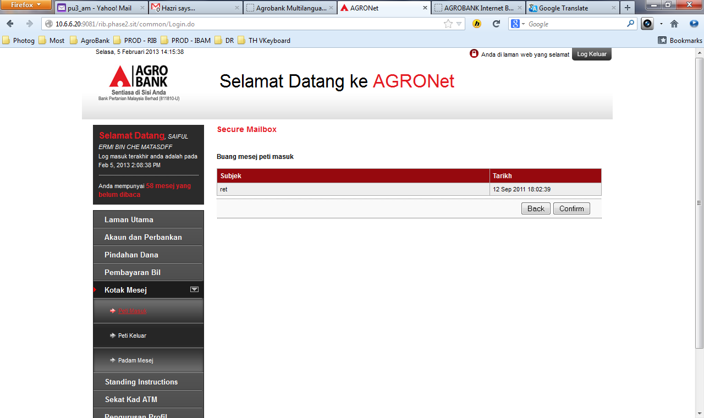

1. Change You have been logged out to BM
2. Change Login to BM

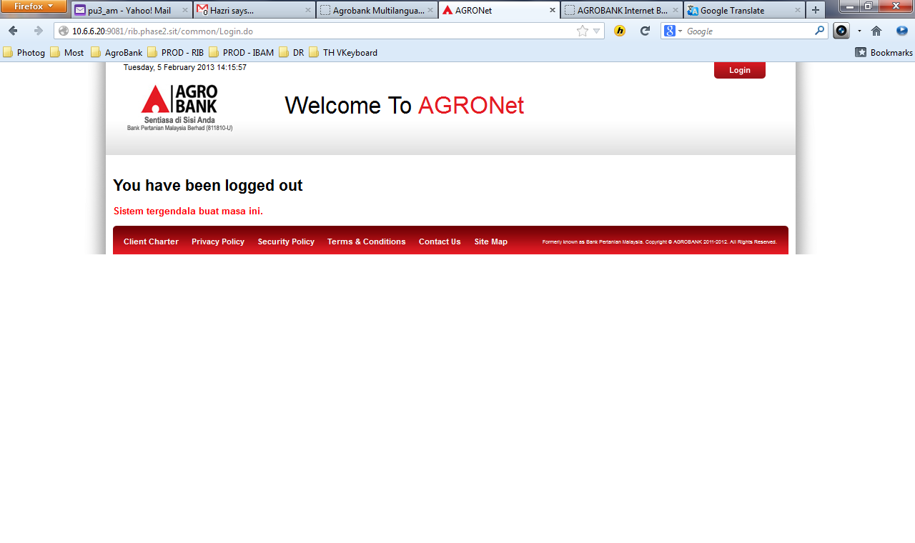

### Peti Masuk - (Details)

1. Wrap text message
2. System die after click on “Kembali ke Peti Masuk”

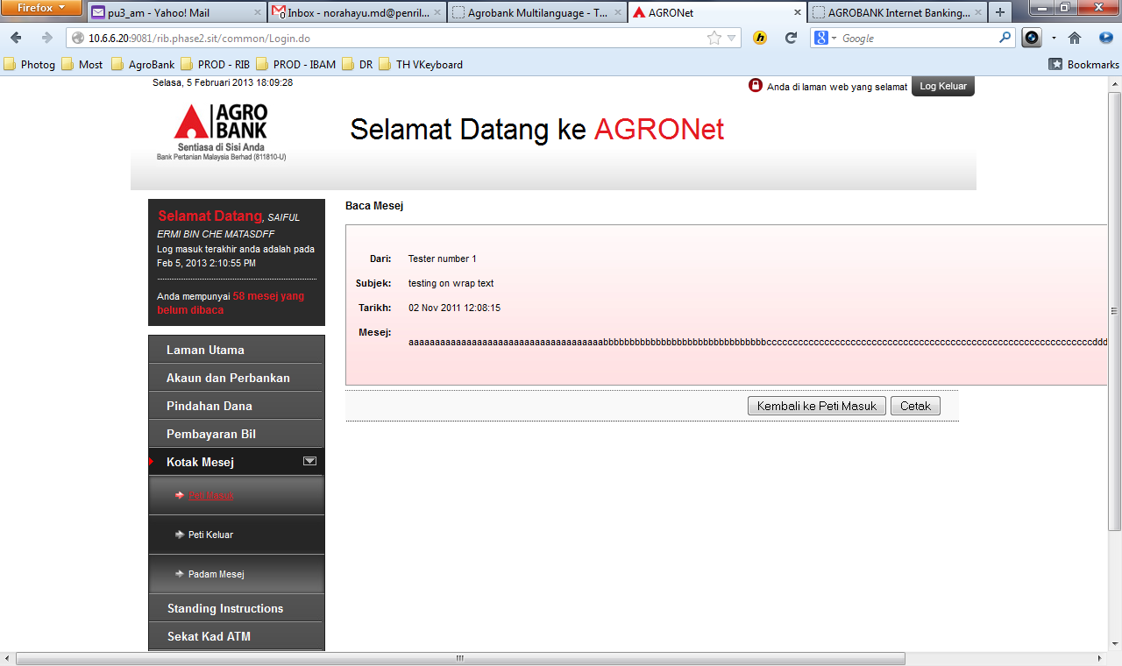

1. Change You have been logged out to BM
2. Change Login to BM



### Lupus – (Padam)

1. Change Trash title to Lupus
2. Change button Restore to BM
3. Change error message to BM

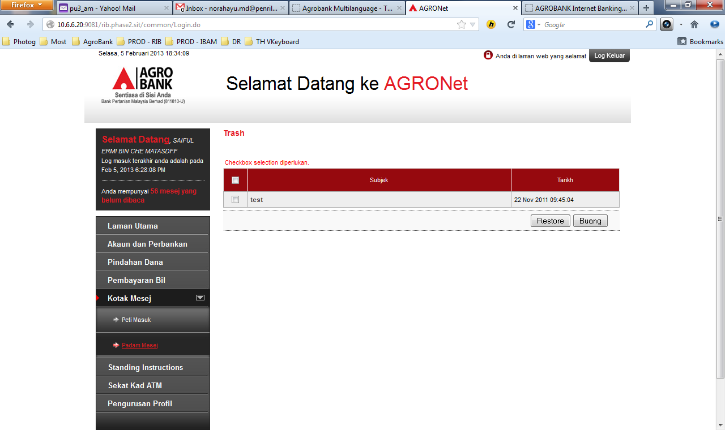

1. Change Secure Mailbox to Kotak Pesanan
2. Change Delete Trash Message to Padam Pelupusan Mesej
3. Change Back & Confirm button n to BM

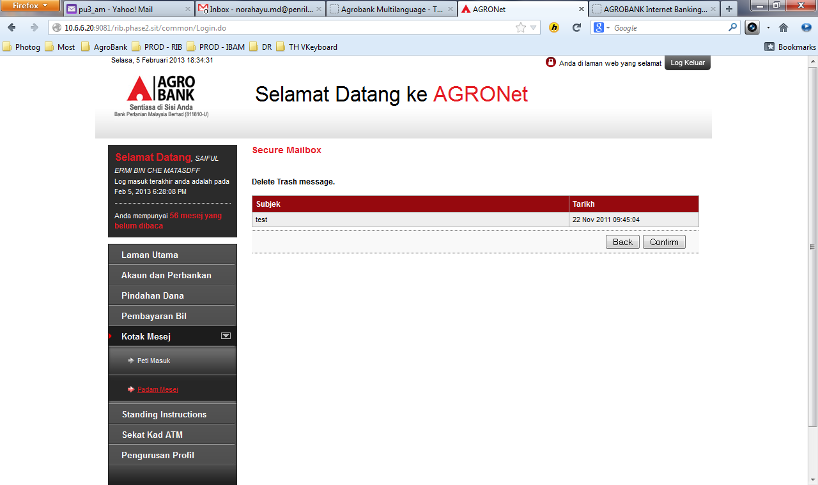

1. Change You have been logged out to BM
2. Change BM header
3. Change BM footer

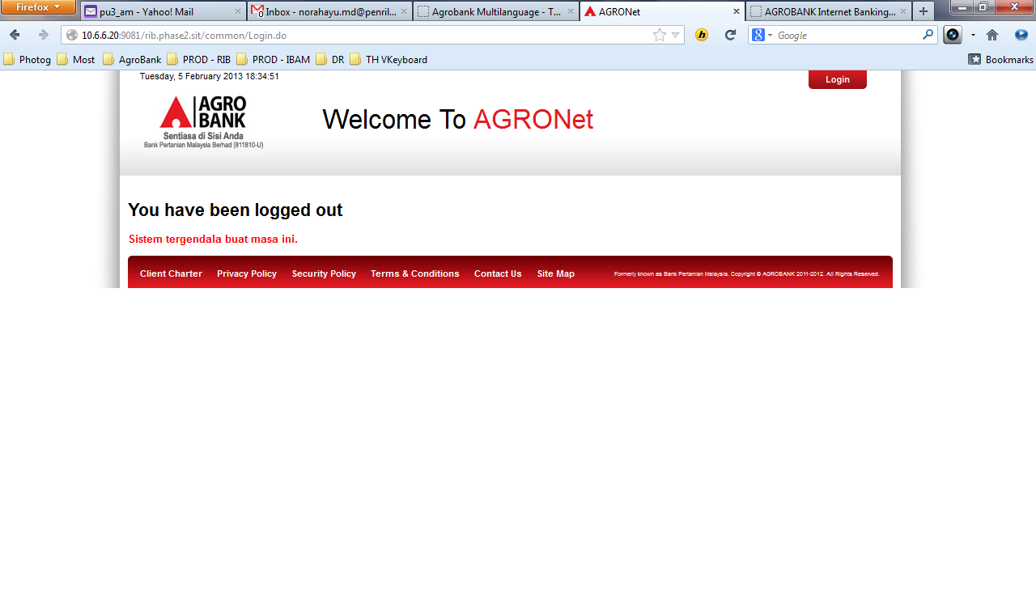

### Simpan Kembali

1. Change Secure Mailbox to Kotak Pesanan
2. Change Restore trash message to BM
3. Change Back & Confirm button to BM

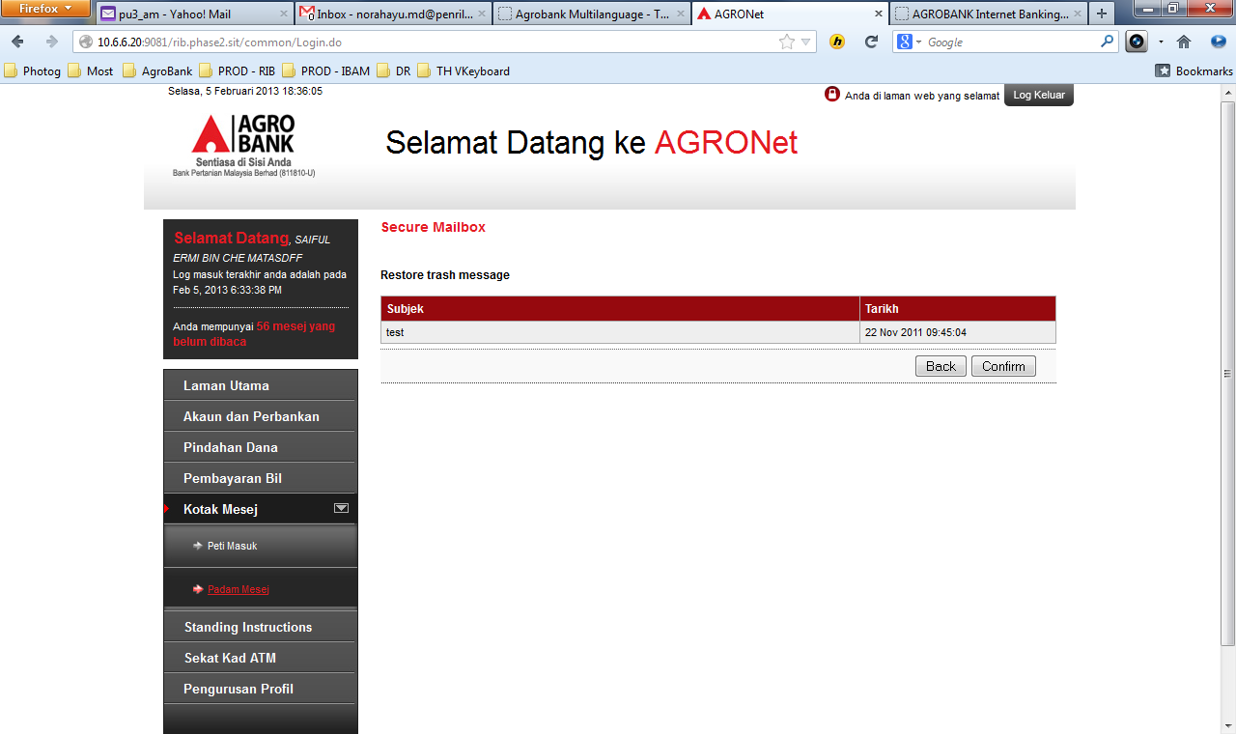

1. Change You have been logged out to BM
2. Change BM header
3. Change BM footer



### Baca Mesej

1. Change Message Details to BM
2. Change Recipient to BM
3. Change back to trash button to BM.

## 