## Log Keluar

**BM Locale**

1. Change Date to BM
2. Change header to BM
3. Change Login to Log Masuk
4. Change You have been logged out to BM
5. Change footer to BM

## 

1. Change Logout to Log Keluar
2. Change Logout Summary to Ringkasan Log Keluar

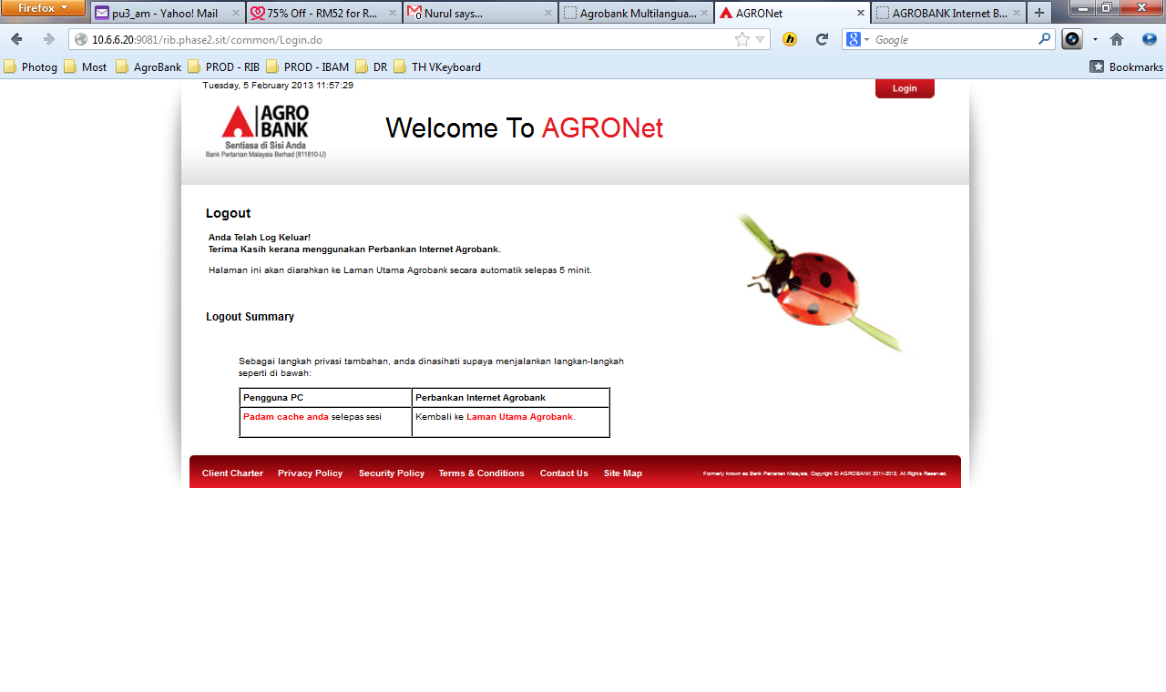

## Pengurusan Profil – Tukar Kata Laluan

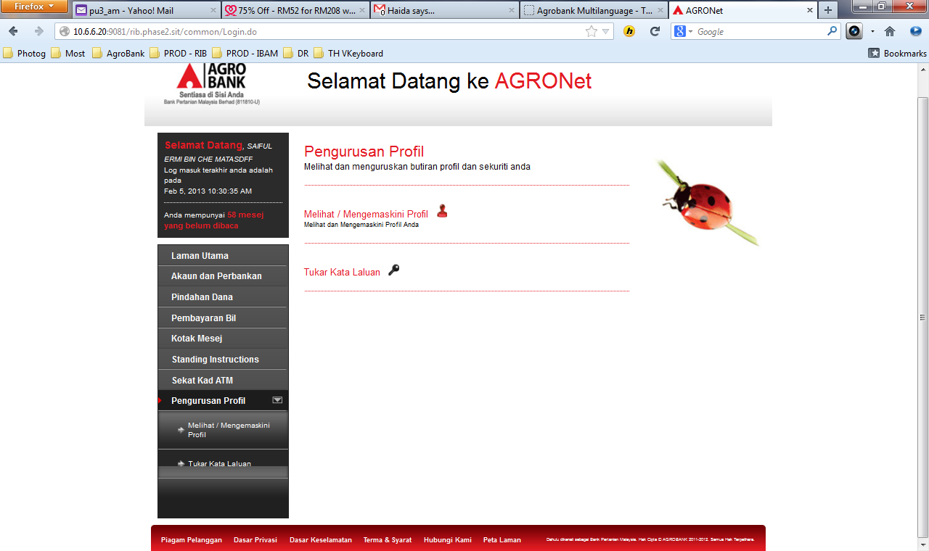

1. Change “Change Password” to ***Tukar Kata Laluan*** for Langkah ½ dan 2/2
2. Change error message from *Kata Laluan Baru dan Kata Laluan Lama tidak semestinya sama.*to ***Laluan Baru dan Kata Laluan Lama hendaklah berbeza.***

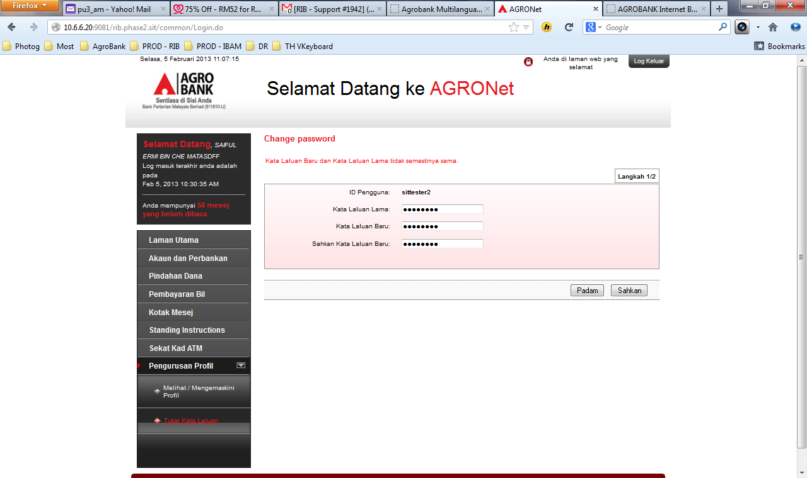

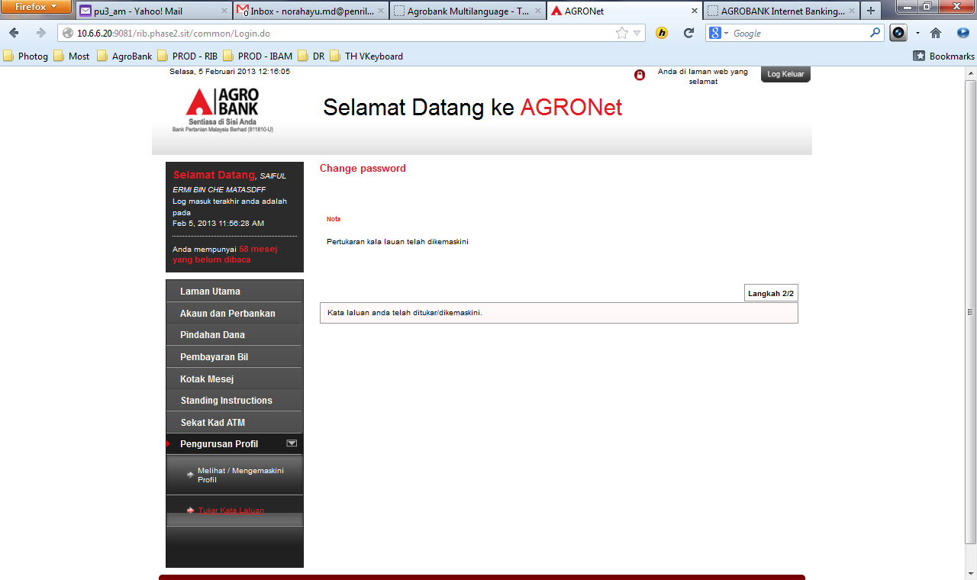

**ENG Locale**

1. Change Profile Management landing page description in English.

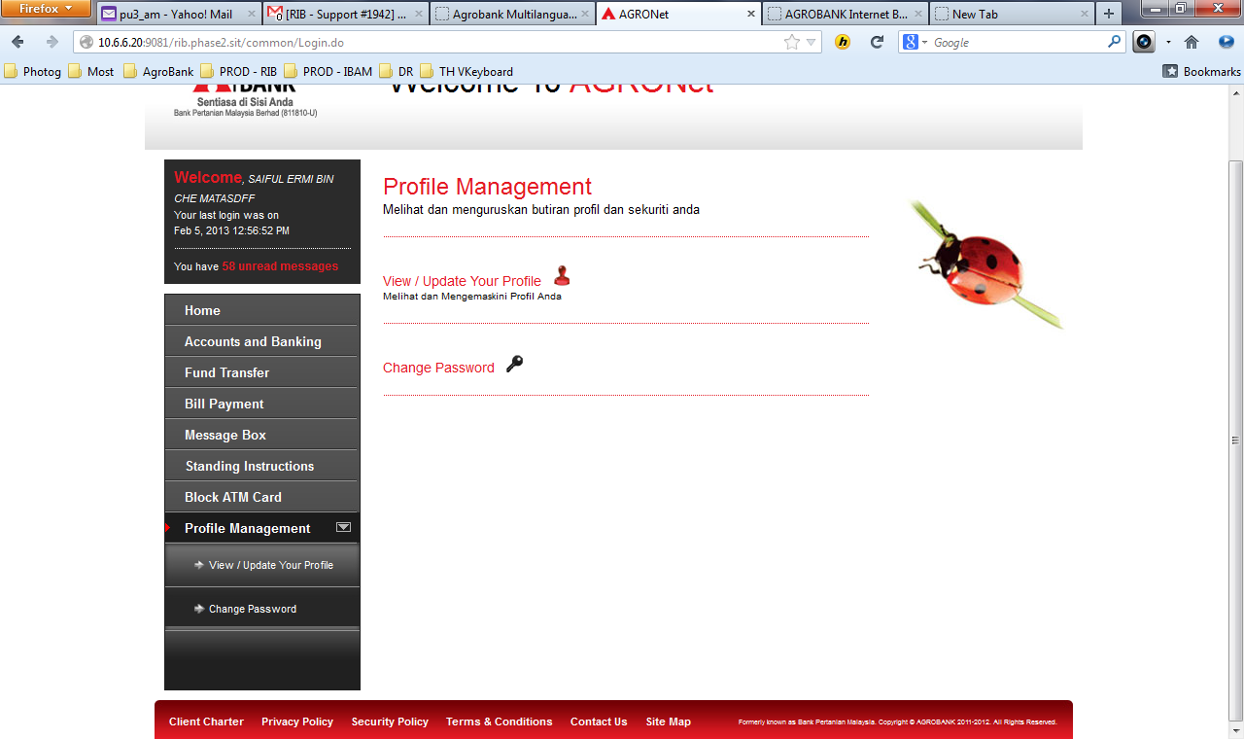

## Header

1. Change BM |ENG locale icon to English | [Bahasa Malaysia](http://www.bankislam.com.my/bm/Pages/PersonalBanking.aspx)

