Title : ISSUE RESOLUTION  Mandatory Change  Nice to have/Preferences |  |  | Project : Internet Banking  Application : Internet Banking
Issue Number : EB130027 |  | Issue Title : Cannot Add/ Delete Favorite 3rd party and Interbank account transfer
Issue Description :
Cannot perform add/delete favorite 3rd party and interbank account transfer

Testing scenario is
- Perform own account transfer
- Then perform add or delete Favorite Account, system show the transaction status as following

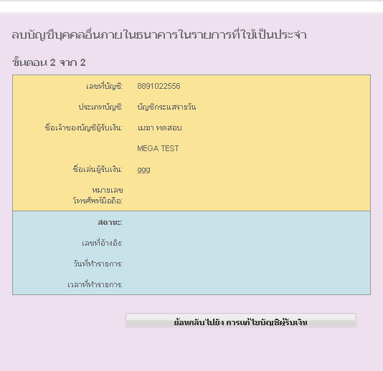
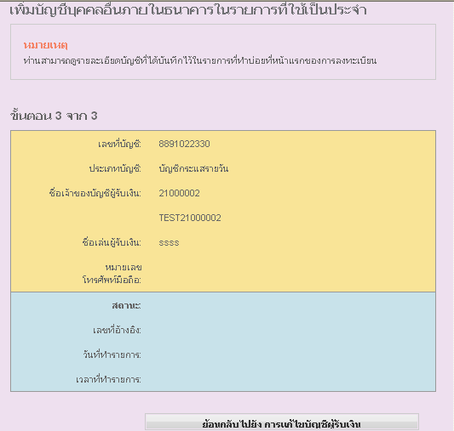

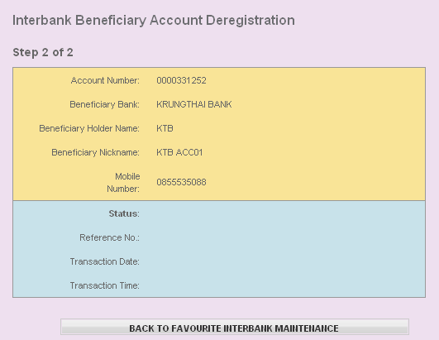

Recommendation & Rationale:

Resolution : |  |  |  |  | Man-days:
Raised By: พงศ์พันธ์  Date : 04/03/2556 | Review by :  Date: |  |  | Cross Reference :

