Title : ISSUE RESOLUTION  Mandatory Change  Nice to have/Preferences |  |  | Project : Internet Banking  Application : Internet Banking
Issue Number : EB130025 |  | Issue Title : To correct ‘Updated By’ field in BIB User Maintenance
Issue Description :
The value of field ‘Updated By’ is incorrect. From the attach, the listing show ‘สมเกียรติ สินไชย’ but after click to view detail, it shows ’สโรชิน มั่นบรรจง’ (different name).
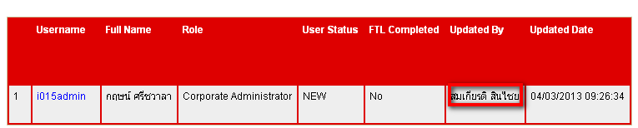
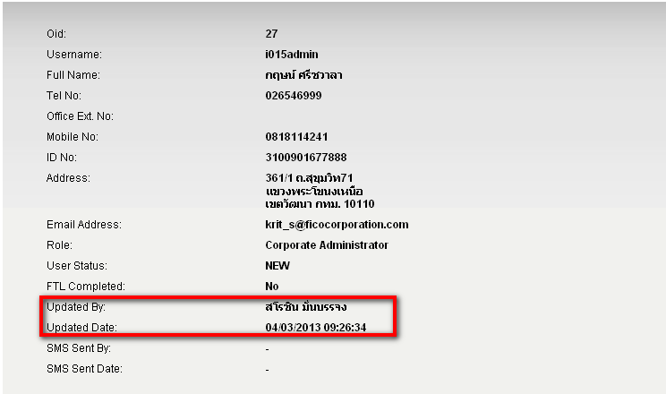

Recommendation & Rationale:

Resolution : |  |  |  |  | Man-days:
Raised By: พงศ์พันธ์  Date : 04/03/2556 | Review by :  Date: |  |  | Cross Reference :

