Title : ISSUE RESOLUTION  Mandatory Change  Nice to have/Preferences |  |  | Project : Internet Banking  Application : Internet Banking
Issue Number : EB130026 |  | Issue Title : To change from “หมำยเหตุ” to “หมายเหตุ”
Issue Description :
To correct Thai word of ‘Remark’ from ‘หมำยเหตุ’ to ‘หมายเหตุ’
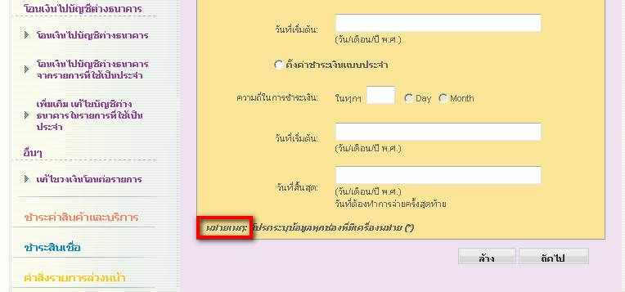

Recommendation & Rationale:

Resolution : |  |  |  |  | Man-days:
Raised By: พงศ์พันธ์  Date : 04/03/2556 | Review by :  Date: |  |  | Cross Reference :

