# BIB Navigation

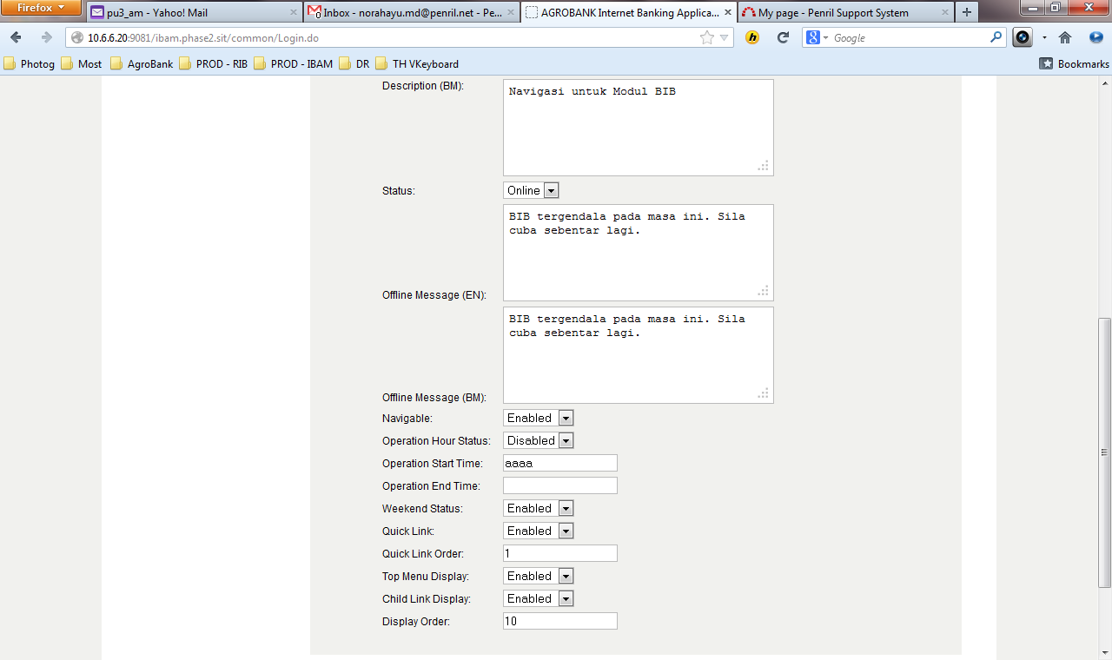

255

512

**Input Specification:**

| No | Field | Field Type | Validation Rule | Description | M/O |
| --- | --- | --- | --- | --- | --- |
|  | Description | Textarea | Max Length: 512  Text | Contains the description of that BIB Navigation in English language | O |
|  | Offline Message | Textarea | Max Length: 255  Text | Show the message when this node is offline in English language  “Internet Banking Services is temporary offline for maintenance. Please try again later.” | O |
|  | Operation Start Time | Text | Match Length: 4  Numeric  Format: 24 HHMM | Specify when that particular navigation starts to be available | M if item 9 is Enable |
|  | Operation End Time | Text | Match Length: 4  Numeric  Format: 24 HHMM | Specify when that particular navigation starts to be unavailable | M if item 9 is Enable |

## Parent Navigable Services Code

***(IBAM>BIB>BIB Navigation)***

**EDIT**

1. Add validation. Name field is required.
2. Description – Change max length field to 512
3. Offline Status – Change max length field to 255
4. Offline Message is required when Offline status is chosen.
5. Operation Start Time & Operation End Time
   * Add validation to Numeric only.
   * Add validation Operation Hour Start cannot be the same as Operation Hour End.
   * Add validation to Operation Start Time & Operation End Time when Operation Hour is enabling.
   * Change Operation Start Time & Operation End Time HHmm format before Confirmation page. Validation display on the Confirmation page.
   * Cannot be less than 4 digits.
6. Quick Link Order & Display Order
   * Add validation to Numeric only.
7. Enter Non Numeric to Quick Link Order. Page dies after click on “Confirm” button at Confirmation Page.
8. Enter Non Numeric to Display Order. Page dies after click on “Confirm” button at Confirmation Page.
9. Display Order is M. Add validation. Display Order is required when the field is empty.

## Navigable Services Code

***(IBAM>BIB>BIB Navigation>BIB)***

**EDIT**

1. Add validation. Name field is required.
2. Description – Change max length field to 512
3. Offline Status – Change max length field to 255
4. Offline Message is required when Offline status is chosen.
5. Operation Start Time & Operation End Time
   * Add validation to Numeric only.
   * Add validation Operation Hour Start cannot be the same as Operation Hour End.
   * Add validation to Operation Start Time & Operation End Time when Operation Hour is enabling.
   * Change Operation Start Time & Operation End Time HHmm format before Confirmation page. Validation display on the Confirmation page.
   * Cannot be less than 4 digits.
6. Quick Link Order & Display Order
   * Add validation to Numeric only.
7. Enter Non Numeric to Quick Link Order. Page dies after click on “Confirm” button at Confirmation Page.
8. Enter Non Numeric to Display Order. Page dies after click on “Confirm” button at Confirmation Page.
9. Display Order is M. Add validation. Display Order is required when the field is empty.

## Services List Code

**(*IBAM>BIB>BIB Navigation>BIB*)**

**EDIT**

1. Add validation. Name field is required.
2. Description – Change max length field to 512
3. Offline Status – Change max length field to 255
4. Offline Message is required when Offline status is chosen.
5. Operation Start Time & Operation End Time
   * Add validation to Numeric only.
   * Add validation Operation Hour Start cannot be the same as Operation Hour End.
   * Add validation to Operation Start Time & Operation End Time when Operation Hour is enabling.
   * Change Operation Start Time & Operation End Time HHmm format before Confirmation page. Validation display on the Confirmation page.
   * Cannot be less than 4 digits.
6. Quick Link Order & Display Order
   * Add validation to Numeric only.
7. Enter Non Numeric to Quick Link Order. Page dies after click on “Confirm” button at Confirmation Page.
8. Enter Non Numeric to Display Order. Page dies after click on “Confirm” button at Confirmation Page.
9. Display Order is M. Add validation. Display Order is required when the field is empty.

## Sub Navigable Services Code

**(*IBAM>BIB>BIB Navigation>BIB>Navigable Code hyperlink*)**

1. Click On “Sub Navigable Service Code” Hyperlink

* Page blank

**DETAILS**

1. Click On “Details” Hyperlink
2. Click On “Back” button
   * Page die after click on “Back” button

**EDIT**

1. Description – Change max length field to 512
2. Offline Status – Change max length field to 255
3. Quick Link Order & Display Order
   * Add validation to Numeric only.
4. Enter Non Numeric to Quick Link Order. Page dies after click on “Confirm” button at Confirmation Page.
5. Enter Non Numeric to Display Order. Page dies after click on “Confirm” button at Confirmation Page.
6. Display Order is M. Add validation. Display Order is required when the field is empty.
7. Click On “Confirm” button
   * Page dies after click on “Back” button on the result page.

## Sub Services List Code

**(*IBAM>BIB>BIB Navigation>BIB>Navigable Code hyperlink*)**

**EDIT**

1. Add validation. Name field is required.
2. Description – Change max length field to 512
3. Offline Status – Change max length field to 255
4. Offline Message is required when Offline status is chosen.
5. Operation Start Time & Operation End Time
   * Add validation to Numeric only.
   * Add validation Operation Hour Start cannot be the same as Operation Hour End.
   * Add validation to Operation Start Time & Operation End Time when Operation Hour is enabling.
   * Change Operation Start Time & Operation End Time HHmm format before Confirmation page. Validation display on the Confirmation page.
   * Cannot be less than 4 digits.
6. Quick Link Order & Display Order
   * Add validation to Numeric only.
7. Enter Non Numeric to Quick Link Order. Page dies after click on “Confirm” button at Confirmation Page.
8. Enter Non Numeric to Display Order. Page dies after click on “Confirm” button at Confirmation Page.
9. Display Order is M. Add validation. Display Order is required when the field is empty.