
Issue Form (PROD)
Originator's Name: Chooi So Fun  Project: Internet Banking  Project Manager: Malarvili / Chris Gunn  Module : IB  Date Raised: 10.08.10  Phase : IB  Functional Area : KFHOnline InfoSite | Issue ID Number: C006  Related Issue ID Number:  Classification:  Priority: Critical/High/Medium/Low  Assigned to: Vendor / IT / PMO SA / UPA  Actual Closed Date:
Status: Open/Assigned/Investigated/Resolved/Approved/Deferred/No Action (Circle one)
Description :  At KFHOnline Homepage, to change the existing links of “View More” for Highlights and News section respectively.  (Refer to below attachment for details) |  | Impact:
Findings/Root Caused (Description): |  | Resolution:
Estimated Impact :

Recommendation:

Accepted :  (Vendor / IT / PMO SA / UPA)  Date: | Accepted (KFHMB Tester):  Date:

Home Page
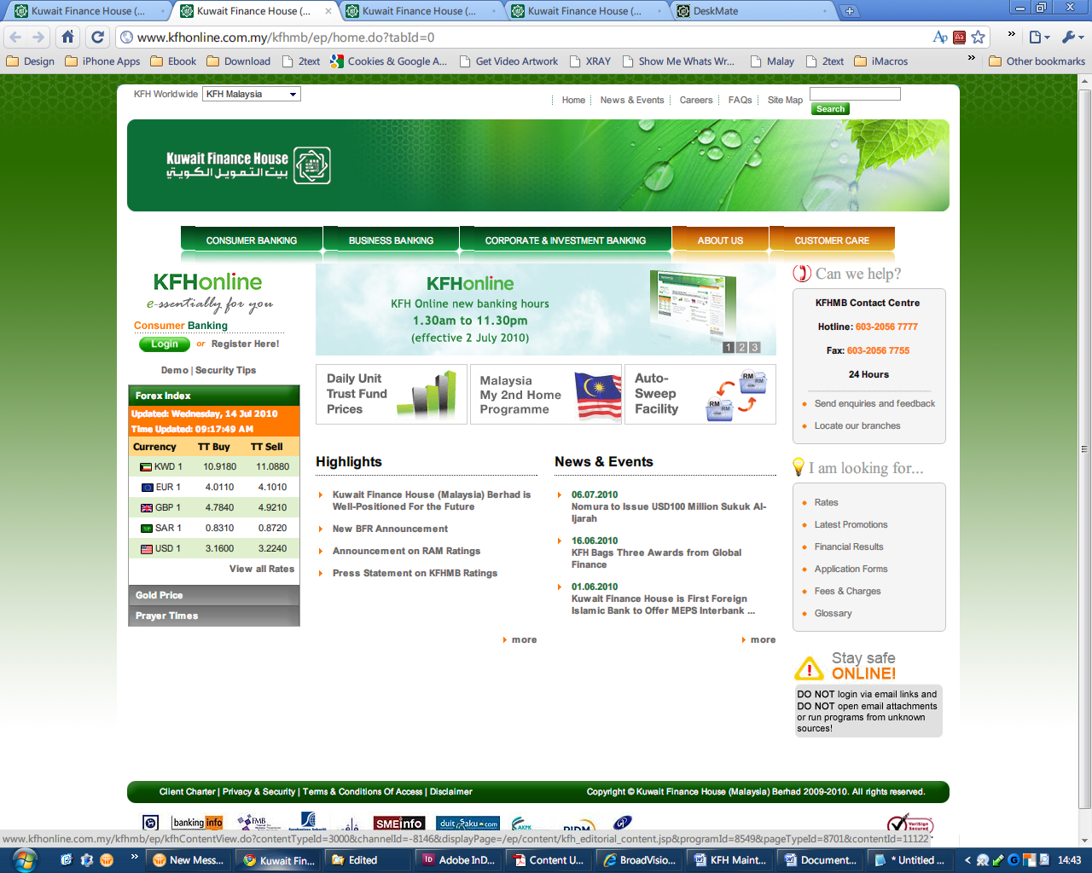
View More Link: Highlights
Current:
http://www.kfhonline.com.my/kfhmb/ep/programView.do?contentTypeId=3001&channelId=-8006&displayPage=%2Fep%2Fprogram%2Fhighlight_kfh_tools_program.jsp&programId=8764&pageTypeId=8469&field=DISPLAY_ORDER

New link:
http://www.kfhonline.com.my/kfhmb/ep/programView.do?contentTypeId=3001&channelId=-8006&displayPage=/ep/program/highlight_kfh_tools_program.jsp&programId=8764&pageTypeId=8469
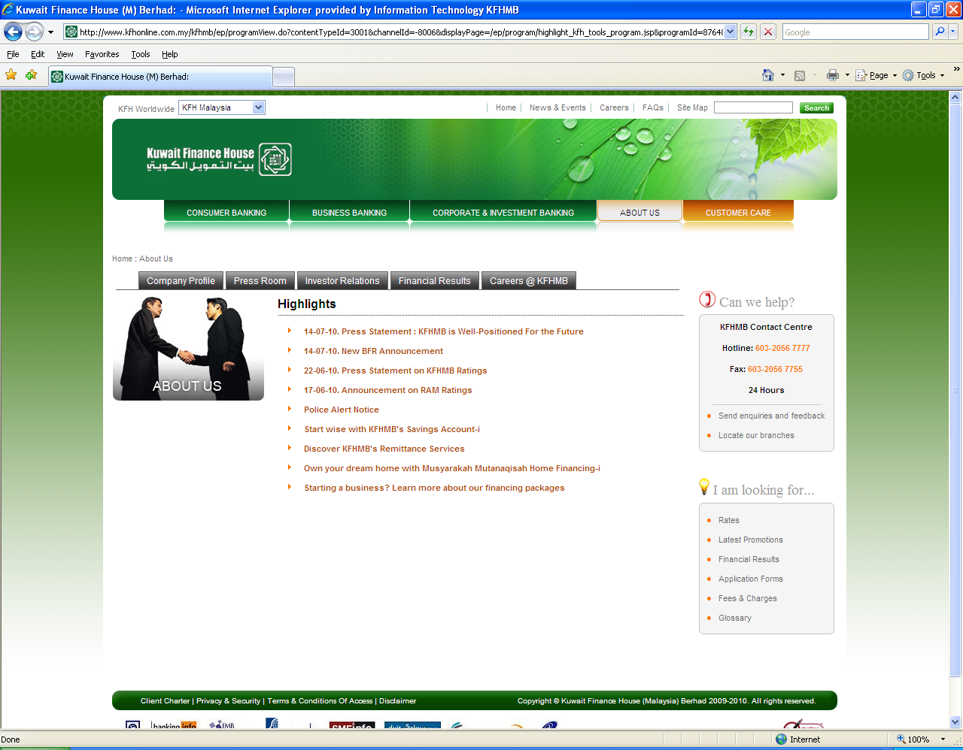
View More Link: News
Current:
http://www.kfhonline.com.my/kfhmb/ep/programView.do?contentTypeId=3000&channelId=-8006&displayPage=%2Fep%2Fprogram%2Fnews_and_events_editorial_program.jsp&programId=8616&pageTypeId=8469&field=PUB_DATE

New link:
http://www.kfhonline.com.my/kfhmb/ep/programView.do?contentTypeId=3001&channelId=&displayPage=%2Fep%2Fprogram%2Fhighlight_kfh_tools_program.jsp&programId=10525&pageTypeId=8622
