Title : CHANGE REQUEST |  |  |  | Project : Internet Banking  Application : Internet banking
Change Number : EB130031 |  | Change Request Title : To change Column in BIB Trxn History
- To display columns in BIB Transaction History into same format as RIB by displaying cheque number and move ‘channel’ column to the right (For current account)
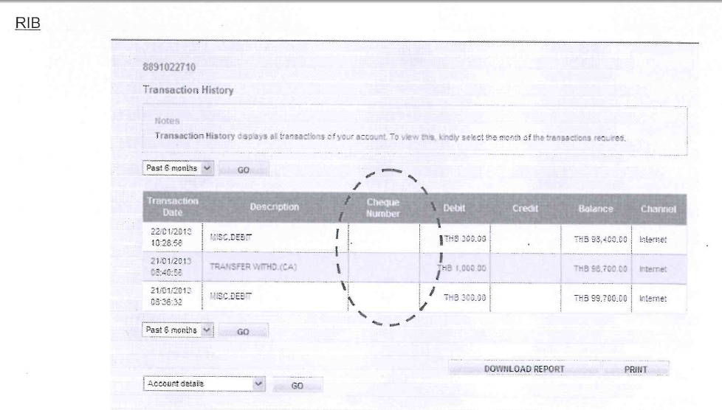

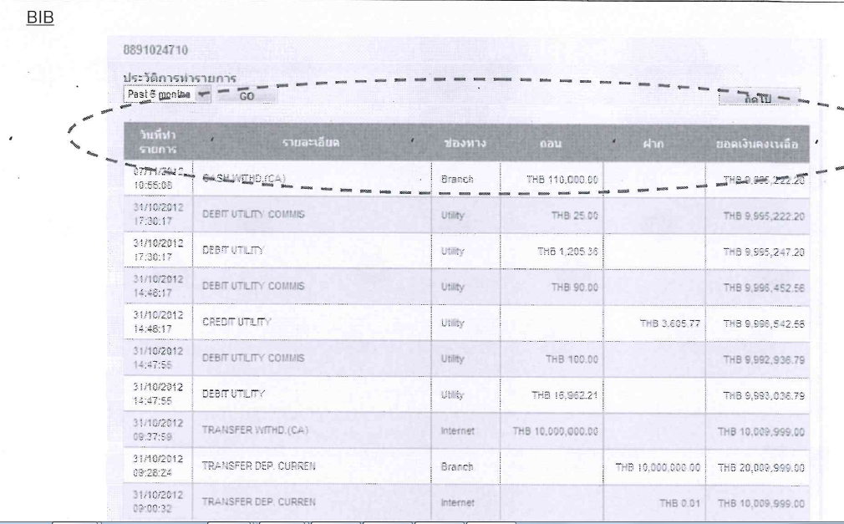

- For Saving account, to move ‘channel’ column to the right. (Same format as RIB)

Technical Documentation
Document/Program Description |  |  | Document/  Program ID |  | Responsibility | New Version ID
Change Control
Priority : Work Estimate : | Cost Estimate: |  |  |  | Cross Reference :
Job Completed by : Date: | Change Approved by : Date: |  |  |  | Change Accepted by : Date:

