CR#EB130031 –To Change Column in BIB Transaction History

## Current Account

1. Add column for Cheque Number
2. Move column Channel to the last column on the right.

**Existing**

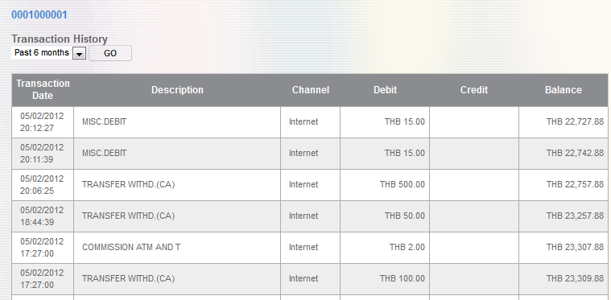

**To-Be**

1. Transaction History

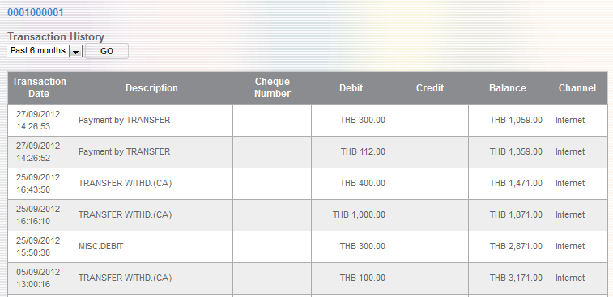

1. Print Transaction History

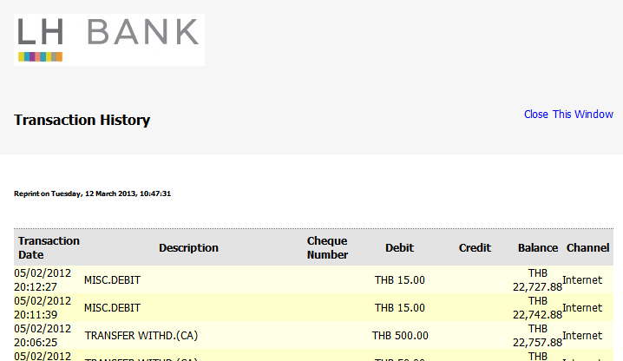

## Savings Account

1. Move column Channel to the last column on the right.

**Existing**



**To-be**

1. Transaction History

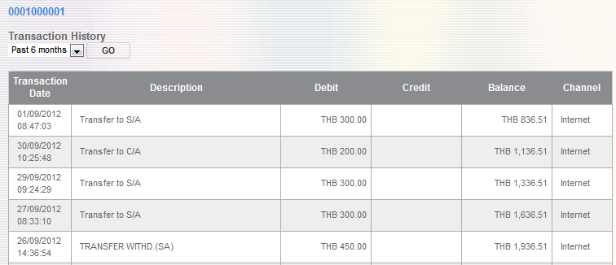

1. Print Transaction History

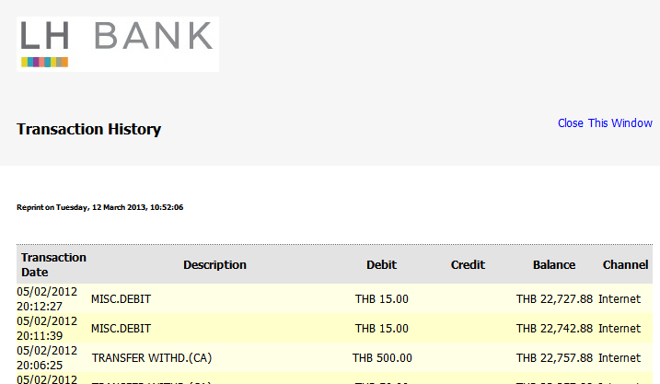

|  |  |
| --- | --- |
| Effort(man-days) | 0.5 man-day |
| Affected Area | BIB  User Manual – BIB |