**Testing Bill Payment using Account 2000491000113822 – Result: Successful**

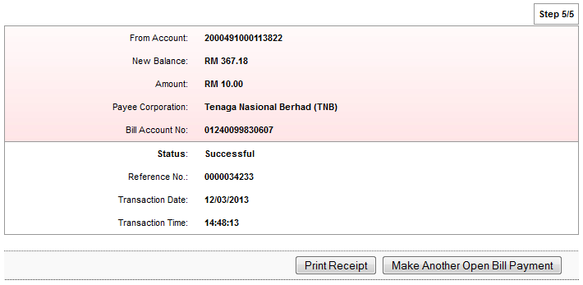

**Pusat Pungutan Zakat Kuala Lumpur – Result: Successful**

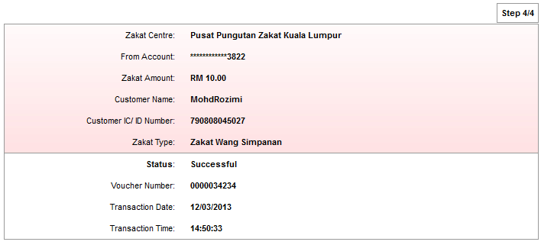

**Lembaga Zakat Selangor – Result: Unsuccessful**

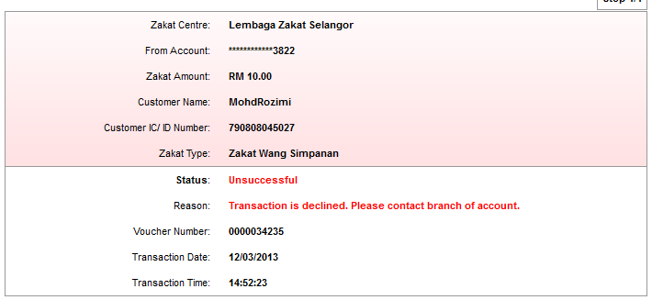

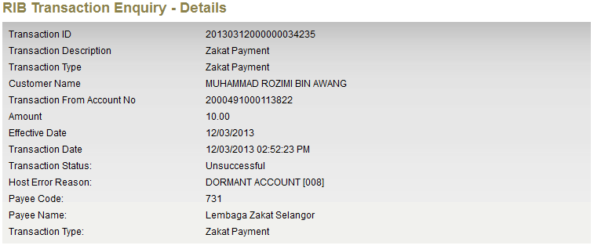

**Pusat Zakat Negeri Sembilan – Result: Unsuccessful**

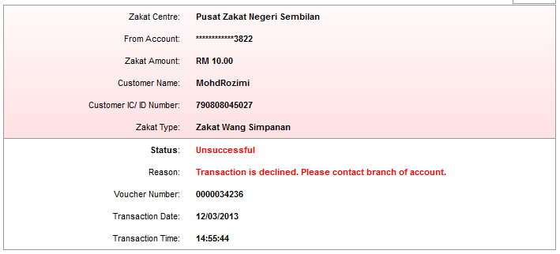

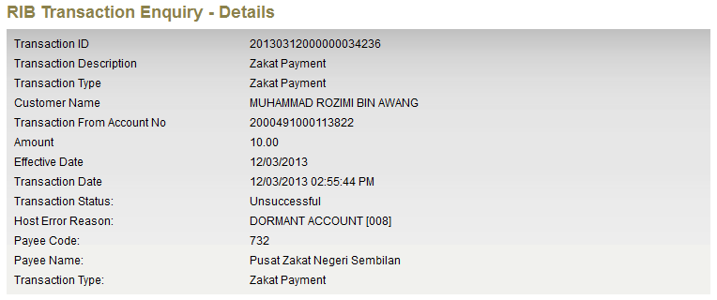

**Pusat Zakat Melaka – Result: Unsuccessful**

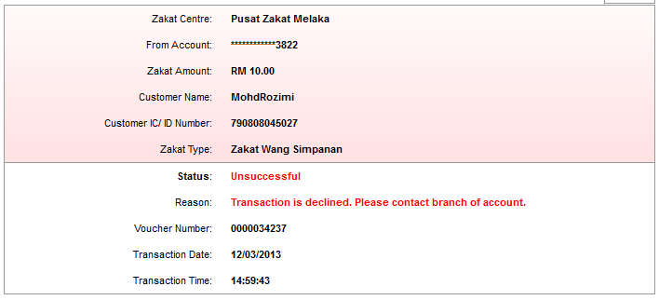

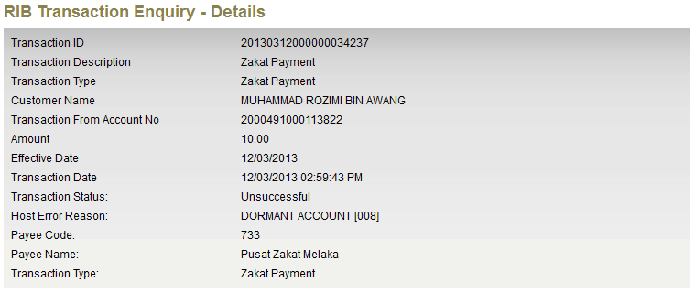

**Jabatan Zakat Negeri Kedah – Result: Unsuccessful**

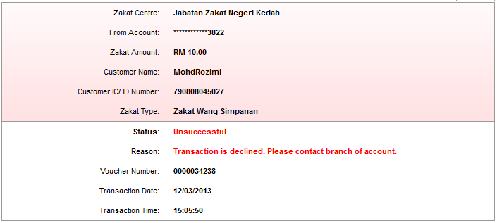

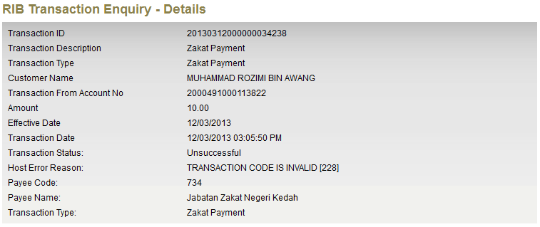

**Majlis Agama Islam Negeri Johor – Result: Unsuccessful**

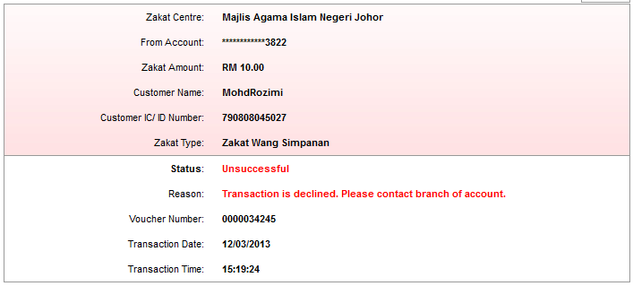

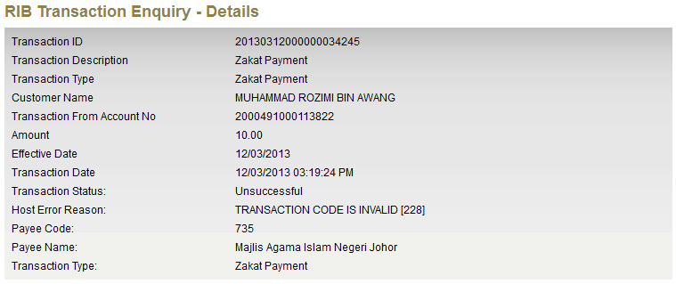

**Majlis Islam Sarawak – Result: Unsuccessful**

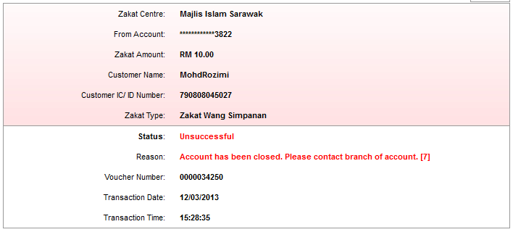

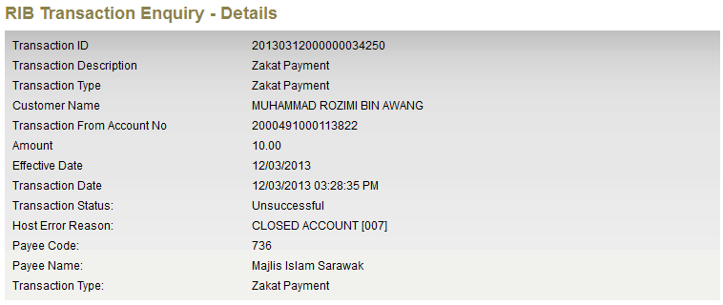

**Pusat Kutipan Zakat Pahang – Result: Unsuccessful**

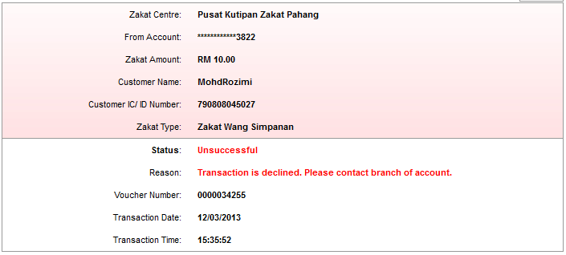

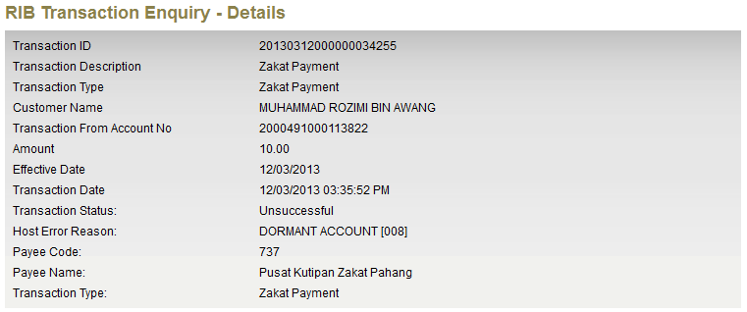

**Majlis Ugama Zakat Sabah – Result: Unsuccessful**

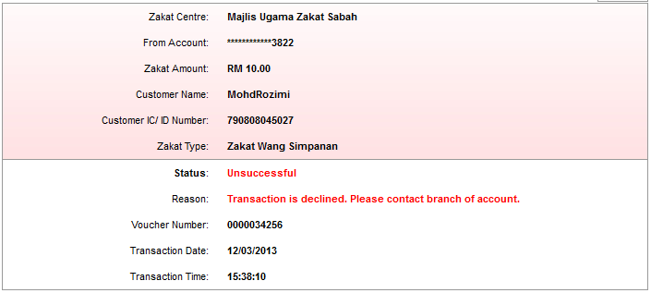

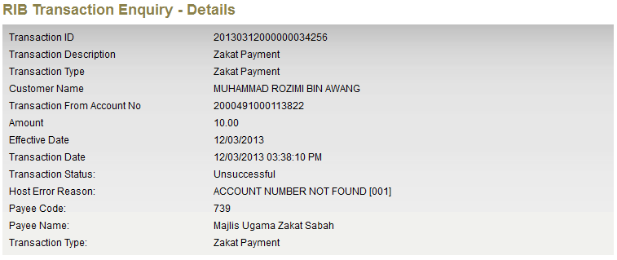

**Majlis Agama Islam Perak – Result: Unsuccessful**

