Content – Product Type

## *Create Category*

1. Error Message not same with Category label. *Error Message: Category Name (BM) cannot be as similar as Category Name (EN).*

|  |  |
| --- | --- |
|  |  |

#### Create Content List

1. Below is the field that NOT meet max length requirement.

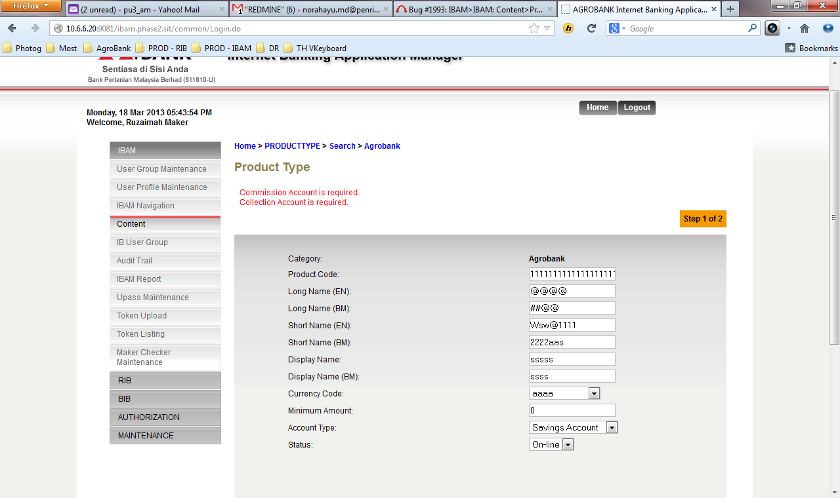

|  |  |  |  |  |  |
| --- | --- | --- | --- | --- | --- |
| **No** | **Field** | **Field Type** | **Rule** | **Description** | **Required** |
|  | Product Code | Text Box | 1-64 alphanumeric | Shows the product code |  |
|  | Long Name | Text Box | ~~1-255 alpha~~ 1-64 alpha |  |  |
|  | Short Name | Text Box | 1-64 alpha |  |  |
|  | Display Name | Text Box | 1-64 alpha |  |  |
|  | Currency Code | Text Box | 1-64 alpha |  |  |
|  | Minimum Amount | Text Box | 1-64 numeric |  |  |
|  | Account Type | Text Box | Dropdown list | CA, SA, FD, Loan |  |
|  | Account Status | Text Box | Dropdown list | Offline and Online |  |

1. Error message display in the system but there was NO field either.
2. Change Status to Account Status
3. Long Name, Short Name & Display Name can include numeric & special char