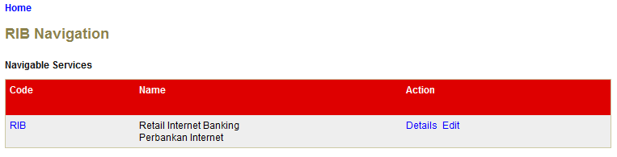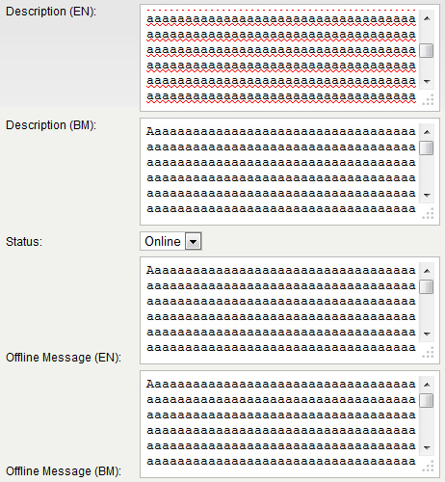

**Input 1700 characters to these fields. Then click on Confirm button**

Click on Edit hyperlink

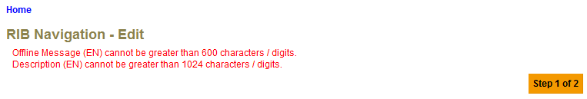

**Issues/Bugs**

1. No error message for Description (BM) and Offline Message (BM).
2. Change the max length in the validation.xml for the fields as table below.

|  |  |  |
| --- | --- | --- |
| **Fields** | **Current Error Message** | **Requested Error Message** |
| Description (EN) | Description (EN) cannot be greater than 1024 characters / digits | **Description (EN) cannot be greater than 512 characters / digits** |
| Description (BM) | *No error message* | **Description (BM) cannot be greater than 512 characters / digits** |
| Offline Message (EN) | Offline Message (EN) cannot be greater than 600 characters / digits. | **Offline Message (EN) cannot be greater than 255 characters / digits** |
| Offline Message (BM) | *No error message* | **Offline Message (BM) cannot be greater than 255 characters / digits** |



Click on RIB hyperlink

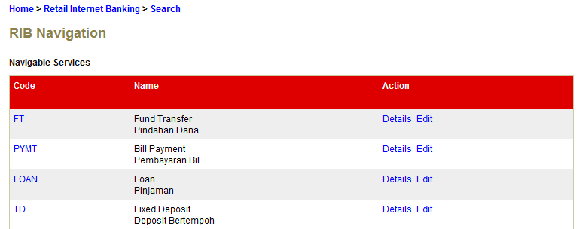

Click on Edit hyperlink

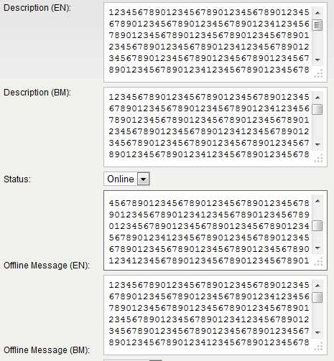

**Input 1700 characters to these fields. Then click on Confirm button**

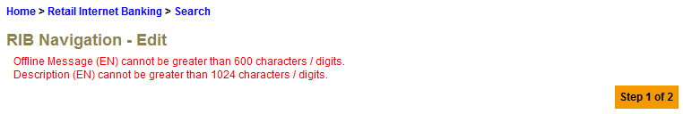

**Issues/Bugs**

1. No error message for Description (BM) and Offline Message (BM).
2. Change the max length in the validation.xml for the fields as table below.

|  |  |  |
| --- | --- | --- |
| **Fields** | **Current Error Message** | **Requested Error Message** |
| Description (EN) | Description (EN) cannot be greater than 1024 characters / digits | **Description (EN) cannot be greater than 512 characters / digits** |
| Description (BM) | *No error message* | **Description (BM) cannot be greater than 512 characters / digits** |
| Offline Message (EN) | Offline Message (EN) cannot be greater than 600 characters / digits. | **Offline Message (EN) cannot be greater than 255 characters / digits** |
| Offline Message (BM) | *No error message* | **Offline Message (BM) cannot be greater than 255 characters / digits** |

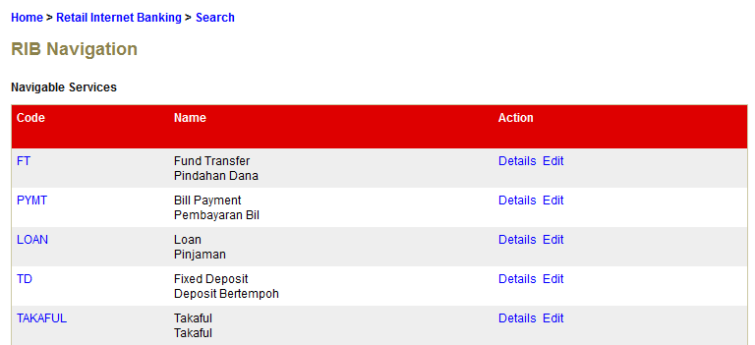

Click on FT code hyperlink

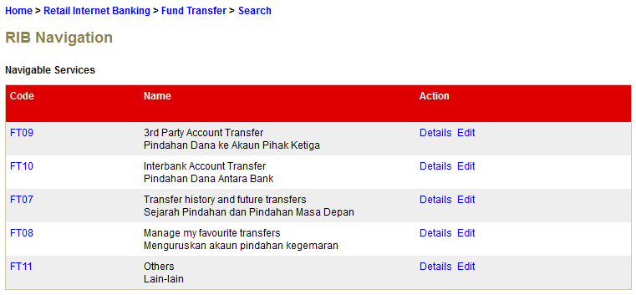

Click on Edit hyperlink

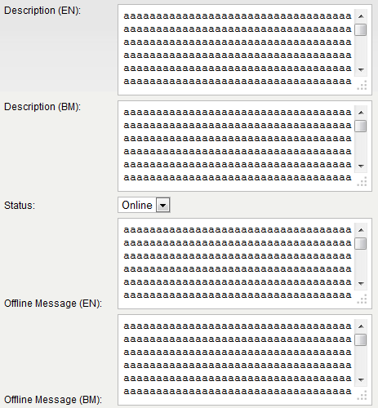

**Input 1700 characters to these fields. Then click on Confirm button**

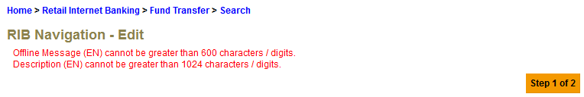**Issues/Bugs**

1. No error message for Description (BM) and Offline Message (BM).
2. Change the max length in the validation.xml for the fields as table below.

|  |  |  |
| --- | --- | --- |
| **Fields** | **Current Error Message** | **Requested Error Message** |
| Description (EN) | Description (EN) cannot be greater than 1024 characters / digits | **Description (EN) cannot be greater than 512 characters / digits** |
| Description (BM) | *No error message* | **Description (BM) cannot be greater than 512 characters / digits** |
| Offline Message (EN) | Offline Message (EN) cannot be greater than 600 characters / digits. | **Offline Message (EN) cannot be greater than 255 characters / digits** |
| Offline Message (BM) | *No error message* | **Offline Message (BM) cannot be greater than 255 characters / digits** |

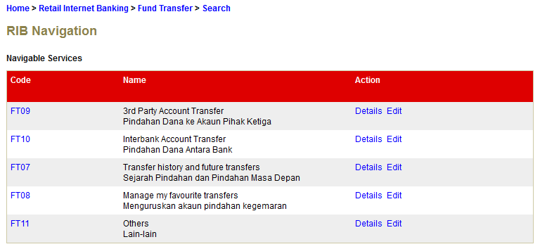

Click on FT09 code hyperlink

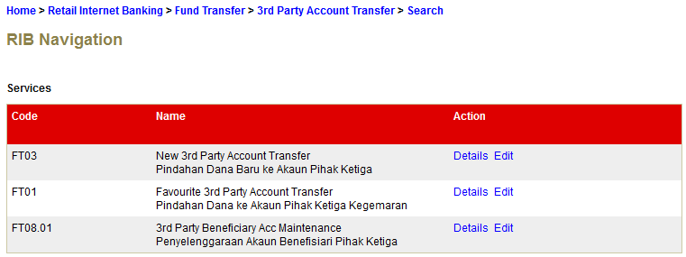

Click on Edit hyperlink

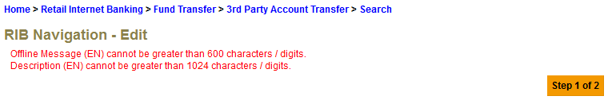**Issues/Bugs**

**Input 1700 characters to these fields. Then click on Confirm button**

1. No error message for Description (BM) and Offline Message (BM).
2. Change the max length in the validation.xml for the fields as table below.

|  |  |  |
| --- | --- | --- |
| **Fields** | **Current Error Message** | **Requested Error Message** |
| Description (EN) | Description (EN) cannot be greater than 1024 characters / digits | **Description (EN) cannot be greater than 512 characters / digits** |
| Description (BM) | *No error message* | **Description (BM) cannot be greater than 512 characters / digits** |
| Offline Message (EN) | Offline Message (EN) cannot be greater than 600 characters / digits. | **Offline Message (EN) cannot be greater than 255 characters / digits** |
| Offline Message (BM) | *No error message* | **Offline Message (BM) cannot be greater than 255 characters / digits** |