

USER REQUIREMENT SPECIFICATION (URS) DOCUMENT

(IE0000025C)

Zakat Payment Module in AGRONet

Authors

Name | Designation & contact email | Remark
Halimah Mohammad Shukor | Virtual Banking, EBD

Amendment Record

Version | Date | Status | Description of Revision
0.1 | 05.02.2013 | New
1.0 |  |  | Signed off
1.0 | 14.03.2013 |  | Ammended on 2 items :  - To follow IC Type a per Fund Transfer in IBG, pg 9  - To make Address Line 1 to be Mandatory. Line 2 and Line is Optional, pg 10.
Table of Contents

1.0 INTRODUCTION/SYSTEM OVERVIEW 4
2.0 PROBLEM STATEMENT 4
3.0 OBJECTIVE 4
4.0 SCOPE OF WORK 4
5.0 BUSINESS PROCESS FLOW 4
6.0 REQUIREMENT DEFINITION 7
7.0 ACCESS MATRIX & AUTHORIZATION 7
8.0 INTERFACES 8
9.0 LIST OF TRANSACTION CODE 9
10.0 FILE/DATA 9
11.0 GENERAL LEDGER ACCOUNT 9
12.0 INTEGRATION WITH OTHER CHANNELS 9
13.0 REPORT 9
14.0 FORMS AND VOUCHERS 9
15.0 FUTURE REQUIREMENTS 9

- INTRODUCTION/ SYSTEM OVERVIEW

Currently, Zakat Payment Module in Branch Deliver System (BDS) covers 10 states which consist of Kuala Lumpur, Selangor, Negeri Sembilan, Melaka, Johor, Kedah, Sabah, Sarawak, Perak and Pahang. The enhancement will enable AGRONet user to make a zakat payment as well as calculate the amount of zakat to be paid online.

- PROBLEM STATEMENT

Not Applicable

- OBJECTIVE

The objective of this Change Request (IE0000025C) is to add Zakat Module in AGRONet which consist of Zakat Payment and Zakat Calculator.

- SCOPE OF WORK

The scopes cover development of Zakat Module in AGRONet(Payment and calculator).

- BUSINESS PROCESS FLOW

  - Below are the lists of commission type for all Zakat Negeri that being offered over the counter (OTC):

No | Zakat Negeri | Commission Type
1 | Kuala Lumpur | Upfront Collection
2 | Selangor | Upfront Collection
3 | Negeri Sembilan | Upfront Collection
4 | Melaka | Upfront Collection
5 | Kedah | Upfront Collection
6 | Johor | Upfront Collection
7 | Sarawak | Upfront Collection
8 | Pahang | Upfront Collection
9 | Sabah | Upfront Collection
10 | Perak | Month End Collection

  - Below is the process flow involved for Zakat Payment Module:

    - Zakat Payment

Start

Login
AGRONet

Select
Zakat Module

Select
Zakat Payment Transaction

Performed Transaction

Transaction
Successful

Print Receipt

End

    - Zakat Calculator

Start

Login
AGRONet

Select
Zakat Module

Select
Zakat Calculator

Performed Calculation

Calculation
Successful

End

- REQUIREMENT DEFINITION

Module | Remarks
Zakat | - Requirements:  - Able to perform Zakat payment and Zakat Calculator that had been live.  - Below are list of Zakat payment that required to be develop in Retail Internet Banking:  - Lembaga Zakat Selangor  - Pusat Pungutan Zakat Kuala Lumpur  - Pusat Zakat Negeri Sembilan  - Pusat Zakat Melaka  - Jabatan Zakat Negeri Kedah  - Majlis Agama Islam Negeri Johor  - Majlis Islam Sarawak  - Pusat Kutipan Zakat Pahang  - Majlis Ugama Zakat Sabah  - Majlis Agama Islam Perak  - Operational:  - Remain as per current operational which is branch maintain the reports and checking.  - Accounting Entry:  - Create new branch code for IB which is 8551  - Additional entry need to be done to cater for IB branch

Table below illustrate the functional requirement:

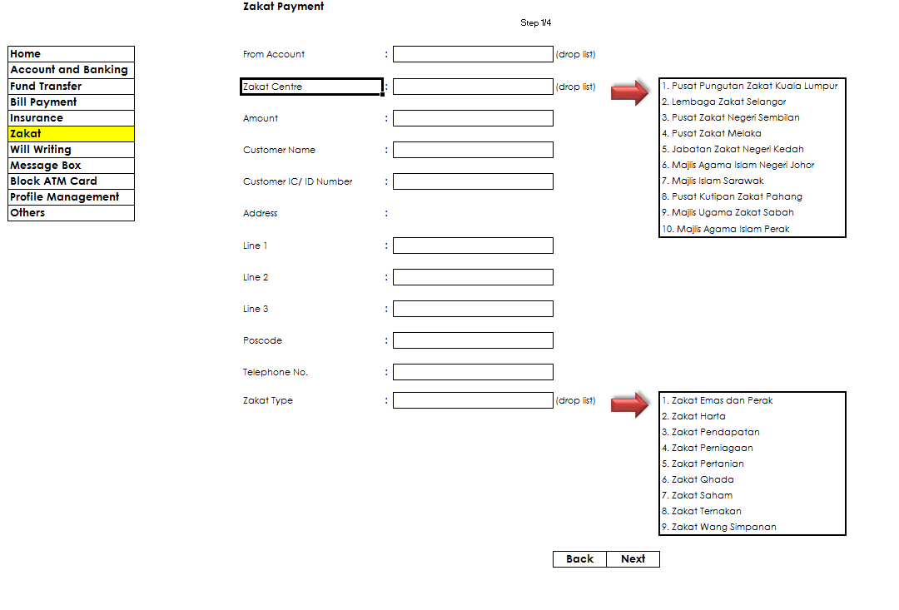
6.1 | Type of Zakat  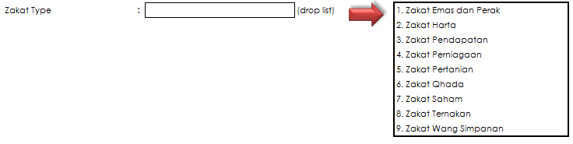
6.2 | Zakat Amount
 | System will not perform any checking on amount. It is customers to declare the zakat amount to pay and not determined by “Pusat Pungutan Zakat”.
6.3 | Mode of Payment
 | Transaction through Internet Banking which involved debiting customer account immediately and crediting the respective zakat collection account with the branch.
6.4 | Sample of Commission Calculation
 | As per existing in BDS module.

- ACCESS MATRIX & AUTHORIZATION

Not applicable

- INTERFACES

Below is the list of interfaces involved:
  - Host
  - GL

- LIST OF TRANSACTION CODE

Penril to provide Transactin Code for RIB.

- FILE/DATA

No | Field Name | Length | Decimal | Data | Start | End | ZAKAT
 |  |  |  | Format | Position | Position | Description | Remark (Mandatory)
1 | Payee Code | 10 |  | A | 1 | 10 | 730 - Zakat Kuala Lumpur  731 - Zakat Selangor  732 - Zakat Negeri Sembilan  733 - Zakat Melaka  734 - Zaakt Kedah  735 - Zakat Johor  736 - Zakat Sarawak  737 - Zakat Pahang  738 - Zakat Sabah  739 - Zakat Perak | YES
2 | Payee Product Code | 20 |  | A | 11 | 30 | Not Applicable
3 | Payee Account Number  (Penerima Account) | 19 | 0 | A | 31 | 49 | automatically populated based on zakat negeri selection | YES
4 | Bill Type / Zakat Type | 20 |  | A | 50 | 69 | ZK01 - Zakat Emas dan Perak  ZK02 - Zakat Harta  ZK03 - Zakat Pendapatan  ZK04 - Zakat Perniagaan  ZK05 - Zakat Pertanian  ZK06 - Zakat Qhada  ZK07 - Zakat Saham  ZK08 - Zakat Tenakan  ZK09 - Zakat Wang Simpanan | YES
5 | Bill Account Number | 20 |  | A | 70 | 89 | Not Applicable
6 | Bill Reference Number | 20 |  | A | 90 | 109 | Not Applicable
7 | Bill Date | 8 | 0 | A | 110 | 117 | Not Applicable
8 | Transaction Amount | 15 | 2 | A | 118 | 132 | To follow existing flow in BDS | YES
9 | Premium Amount | 15 | 2 | A | 133 | 147 | Not Applicable
10 | Charges / Commission Amount | 15 | 2 | A | 148 | 162 | 1.5 % from Gross Amount  'To follow existing flow in BDS.  (Commission setting is done at IBAM level)
11 | CIF Number | 19 | 0 | A | 163 | 181 | IB will not send this info | automativally populated
12 | Debit Account Number | 19 | 0 | A | 182 | 200 |  | YES
13 | Transfer Account Type | 1 |  | A | 201 | 201 | Not Applicable
14 | Customer IC/ID Number | 20 |  | A | 202 | 221 |  | YES
15 | Customer Name | 40 |  | A | 222 | 261 |  | YES
16 | Date of Birth | 8 | 0 | A | 262 | 269 | Not Applicable
No | Field Name | Length | Decimal | Data | Start | End | ZAKAT
 |  |  |  | Format | Position | Position | Description | Remark (Mandatory)
17 | Customer Address 1 | 40 |  | A | 270 | 309 |  | YES
18 | Customer Address 2 | 40 |  | A | 310 | 349 |  | NO
19 | Customer Address 3 | 40 |  | A | 350 | 389 |  | NO
20 | Voucher Number /  Coupon Number | 15 |  | A | 390 | 404 | Vocher No is IB Ref No, X(10) | YES
21 | Mobile Number /  Telephone Number | 15 |  | A | 405 | 419 |  | NO
22 | Cover Note Number | 15 |  | A | 420 | 434 | Not Applicable
23 | Certificate Number /  Receipt Number | 15 |  | A | 435 | 449 | Not Applicable
24 | Transaction Mode | 1 |  | A | 450 | 450 | Not Applicable
25 | Cheque Number | 10 | 0 | A | 451 | 460 | Not Applicable
26 | Cheque Amount | 15 | 2 | A | 461 | 475 | Not Applicable
27 | Routing Number | 9 | 0 | A | 476 | 484 | Not Applicable
28 | GL Reference Number | 19 | 0 | A | 485 | 503 | Not Applicable
29 | Loan Account Number | 19 | 0 | A | 504 | 522 | Not Applicable
30 | Beneficiary Name | 40 |  | A | 523 | 562 | Not Applicable
31 | Depositor Name | 40 |  | A | 563 | 602 | Not Applicable
32 | No Siri Borang | 15 |  | A | 603 | 617 | Not Applicable
33 | SSPN Account Number | 15 |  | A | 618 | 632 | Not Applicable
34 | No Penyata Pemungut | 15 |  | A | 633 | 647 | Not Applicable
35 | Return Reason Code | 10 |  | A | 648 | 657 | Not Applicable
36 | PPT Name | 20 |  | A | 658 | 677 | Not Applicable
37 | PPT Area | 20 |  | A | 678 | 697 | Not Applicable
38 | 101 Amount | 15 | 2 | A | 698 | 712 | Not Applicable
39 | 102 Amount | 15 | 2 | A | 713 | 727 | Not Applicable
40 | 103 Amount | 15 | 2 | A | 728 | 742 | Not Applicable
41 | 104 Amount | 15 | 2 | A | 743 | 757 | Not Applicable
42 | 701 Amount | 15 | 2 | A | 758 | 772 | Not Applicable
43 | Effective Date | 8 | 0 | A | 773 | 780 | Not Applicable
No | Field Name | Length | Decimal | Data | Start | End | ZAKAT
 |  |  |  | Format | Position | Position | Description | Remark (Mandatory)
44 | Expired Date | 8 | 0 | A | 781 | 788 | Not Applicable
45 | Number of Children | 2 | 0 | A | 789 | 790 | Not Applicable
46 | ID Type | 2 |  | A | 791 | 792 | -New IC  -Old IC  -Others | YES
47 | System Generated Txns Ref # | 22 |  | A | 793 | 814 | Not Applicable
48 | Customer Address 4 | 40 |  | A | 815 | 854 | Not Applicable
49 | State Code | 3 |  | A | 855 | 857 | Not Applicable
50 | Country Code | 3 |  | A | 858 | 860 | Not Applicable
51 | Passport Country Code | 3 |  | A | 861 | 863 | Not Applicable

- GENERAL LEDGER ACCOUNT

As per existing.

- INTEGRATION WITH OTHER CHANNELS

Not Applicable

- REPORTS

For Internet Banking reconciliation purposes, DDI300P report is required for IB branch code which is 8551 for all Zakat payment transaction.

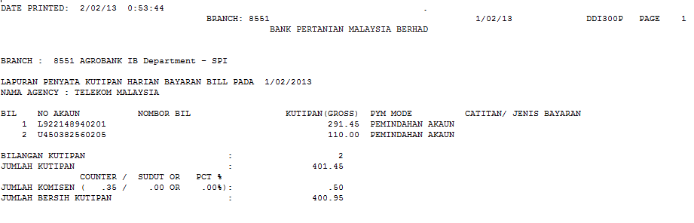

Below is the report for back end processing for below Zakat Negeri.
No | Zakat Negeri | Remarks | Distribution
1 | Kuala Lumpur | To develop daily & monthly report | Accounting Branch of Collection Account & HQ & Agency
2 | Selangor | To develop daily & monthly report | Accounting Branch of Collection Account & HQ & Agency
3 | Negeri Sembilan | To develop daily & monthly report | Accounting Branch of Collection Account & HQ & Agency
4 | Melaka | To develop daily & monthly report | Accounting Branch of Collection Account & HQ & Agency
5 | Kedah | To develop daily & monthly report | Accounting Branch of Collection Account & HQ & Agency
6 | Johor | To develop daily & monthly report | Accounting Branch of Collection Account & HQ & Agency
7 | Sarawak | To develop daily & monthly report | Accounting Branch of Collection Account & HQ & Agency
8 | Pahang | To develop daily & monthly report | Accounting Branch of Collection Account & HQ & Agency
9 | Sabah | Already implemented monthly report | Already implemented
10 | Perak | Already implemented monthly report | Already implemented

BANK PERTANIAN MALAYSIA BERHAD |  |  |  |  |  | REPORT ID
BANK NAME | : | LAPORAN PENYATA KUTIPAN HARIAN PUSAT ZAKAT NEGERI XXXXXXXXX
BIL |  | CAWANGAN | NAMA PEMBAYAR | ALAMAT PEMBAYAR | CARA BAYARAN | JUMLAH ZAKAT
 |  | 8551 |  |  | DEBIT ACCOUNT
 |  |  | NO K/P | NO TELEFON | JENIS ZAKAT | RESIT ZAKAT
 |  |  |  |  |  | IB VOUCHER NO
BIL TRANSAKSI | :
JUMLAH KUTIPAN | :

DATE PRINTED | : | [DD/MM/YY] | HH:MM:SS | REPORT DATE: | [DD/MM/YY]
 |  |  |  | BRANCH: | [BRANCH CODE]
 |  |  |  | BANK PERTANIAN MALAYSIA BERHAD
BRANCH | : | []
REPORT NAME | : | [LAPORAN RINGKASAN BULANAN BAYARAN BIL ZAKAT BAGI BULAN XX /XXXX]
BIL | CAWANGAN AGROBANK | KUTIPAN |  |  |  | PELARASAN
BIL | CAWANGAN AGROBANK | BIL TRANSAKSI | JUMLAH KUTIPAN | JUMLAH KOMISYEN | JUMLAH BERSIH KUTIPAN | BIL TRANSAKSI | JUMLAH KUTIPAN | JUMLAH KOMISYEN | JUMLAH BERSIH KUTIPAN
[] | []  Branch 8551 indicates transactions coming from IB | [] | [] | [] | [] | []  Not Applicable for IB | []  Not Applicable for IB | []  Not Applicable for IB | []  Not Applicable for IB
JUMLAH BESAR
JUMLAH BERSIH KUTIPAN ZAKAT |  | []
JUMLAH BERSIH PELARASAN |  | []
JUMLAH PERLU DIBAYAR |  | []
 |  |  |  | **END OF REPORT**

Text file format:
No | Zakat Negeri | Remarks
1 | Kuala Lumpur | Not Applicable
2 | Selangor | Not Applicable
3 | Negeri Sembilan | Not Applicable
4 | Melaka | Not Applicable
5 | Kedah | Not Applicable
6 | Johor | Not Applicable
7 | Sarawak | Not Applicable
8 | Pahang | Not Applicable
9 | Sabah | Not Applicable
10 | Perak | As per below format

a) Header Record
Field Name | Format | Column |  |  | Description
PAYEE_CODE | X(03) | 1 | to | 3 | Payee Corporation Code. Given by Agrobank.  Default to 739
PAYEE_NAME | X(30) | 4 | to | 33 | Payee Corporation Name
PAYMENT_DATE | 9(08) | 34 | to | 41 | Transaction Day (DDMMYYYY)
INSTITUTION | X(07) | 42 | to | 48 | Default to AGROBANK
FILLER | X(151) | 49 | to | 279 | Filler
HEADER_IDENTIFIER | X(1) | 280 | to | 280 | Default to '0'
TOTAL |  | 280
b) Payment Record

Field Name | Format | Column |  |  | Description
PAYEE_CODE | X(03) | 1 | to | 3 | Payee Corporation Code. Given by Agrobank.  Default to 739
NAME | X(25) | 4 | to | 28 | Customer Name
IC_NUMBER | X(12) | 29 | to | 40 | Old IC/New IC
AMOUNT | 9(9)V99 | 41 | to | 51 | Transaction Amount
BILL_NUM | X(30) | 52 | to | 81 | Default to voucher no  (start from position 52) – in BDS, X(8), in IB X(10)
BILL_REF | X(14) | 82 | to | 95 | Default to Zakat Type  (start from position 82)
DETAILED ADDRESS | X(160) | 96 | to | 255 | Customer Address
FILLER | X(16) | 256 | to | 271 | Filler
TRX_DATE | 9(08) | 272 | to | 279 | Process Date (DDMMYYYY)
DETAIL_IDENTIFIER | X(01) | 280 | to | 280 | Default to '1'
TOTAL |  | 280
c) Trailer Record

Field Name | Format | Column |  |  | Description
PAYEE CODE | PIC X(03) | 1 | to | 3 | Payee Corporation Code. Given by Agrobank.  Default to 739
GRAND_TOTAL _ITEM | PIC 9(07) | 4 | to | 10 | Grand Total Item Count of payment Record
GRAND_TOTAL_AMOUNT | PIC 9(11)V99 | 11 | to | 23 | Grand Total Amount in Payment Record
HASH_TOTAL | PIC 9(08) | 24 | to | 31 | Used for security verification. Sum of :  a) Voucher Number (last 4 digit,ignore alphabet)  b) Grand Total Amount (exclusive of decimal point)  c) Grand Total Item (note : Alphabet in Voucher Number will be translated to '0'
FILLER | PIC X(169) | 32 | to | 279 | Filler
TRAILER_IDENTIFIER | PIC X(200) | 280 | to | 280 | Default to '9'
TOTAL |  | 280
Example of Hash Total
Voucher No |  | 0000311590 |  |  | Therefore, 1590 = 6
Last 4 digit of Voucher No |  | 6
Grand Total Amount |  | RM 200
Grand Total Trx |  | 25
Hash Total |  | 6 + 200 + 25 = 231

- FORMS AND VAUCHAR

Not applicable

- FUTURE REQUIREMENTS

Not applicable

