User Group Maintenance

# Create

Step to re-produce

1. Create New User Group and pending for approval.
2. After being approved, all selected access matrix disappear and need to choose again.
3. Maker can re-perform a **same** action as long as the action not approved yet.

# Edit / Delete

1. Group still can be deleted even though it tight together with another User Profile.
2. Edit / Delete in Pending List & Approval List display Group ID instead of Group Name. Refer screen attached.

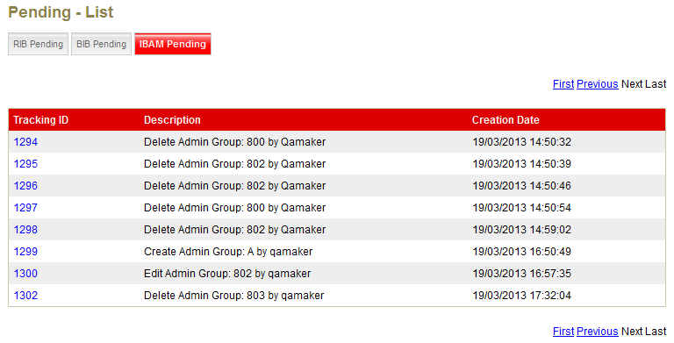

1. Maker can re-perform a **same** action as long as the action not approved yet and the rest of the same action will die after authorize it.

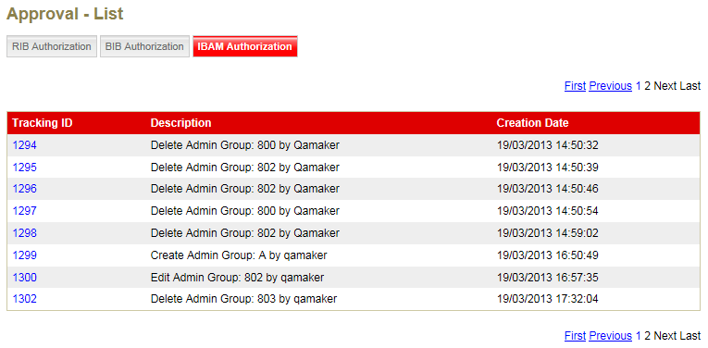

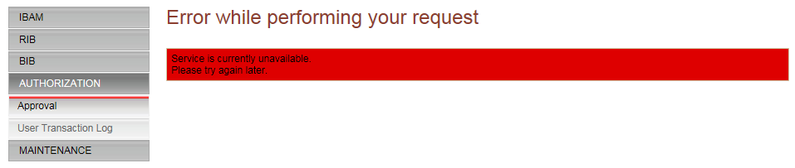

# User transaction Log

1. To edit/break **Before State & after State** Description to be meaningful and easy to read.

