**User Group Creation Confirmation Page***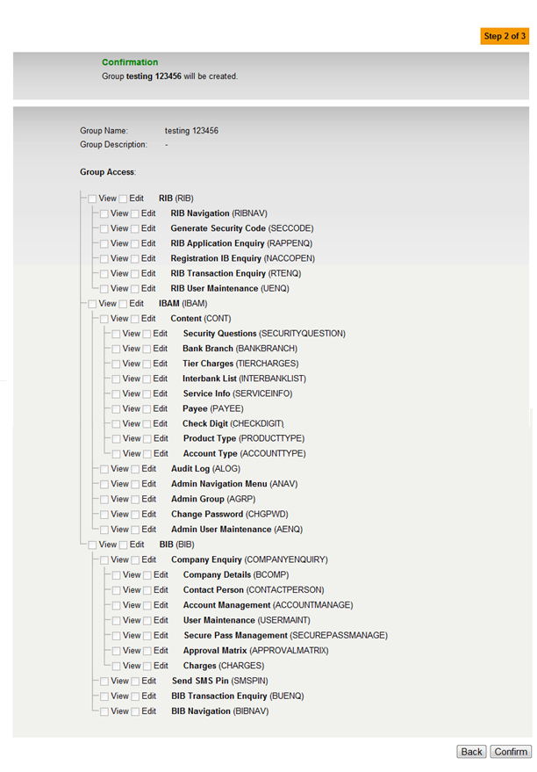*

**User Group Creation Result Page**

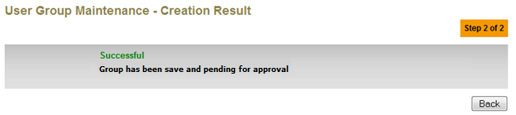

**User Group Edit Confirmation Screen**



**User Group Edit Result Screen**

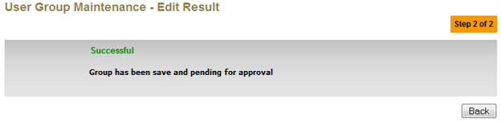

**Delete User Group Confirmation Screen**

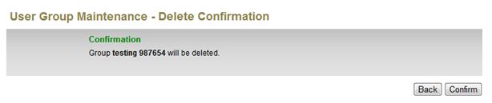

**Delete User Group Result Screen**

