## IBAM>RIB>RIB Navigation

* Login as maker and make changes to RIB Navigation.

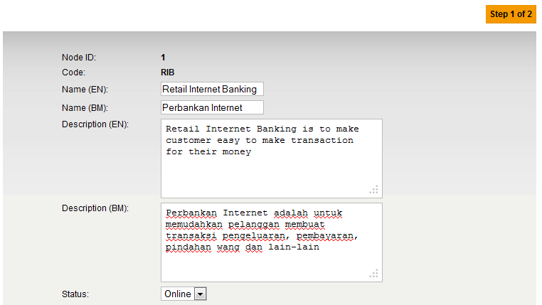

Kindly change the button name to **Next** instead Confirm

User edits the description for both EN and BM language

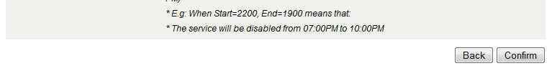

**Edit Page:**

1. change to 
2. Once user click on the **Next** button, it should display the confirmation page before go to the result page.

**Confirm Page:**

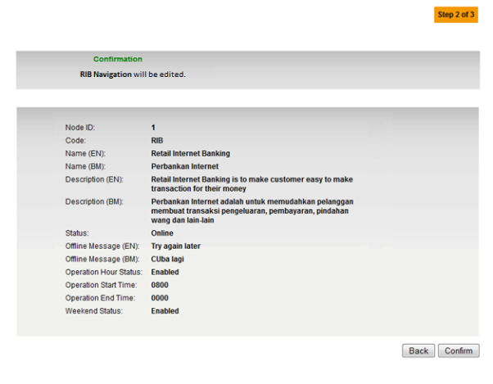

**Result Page:**

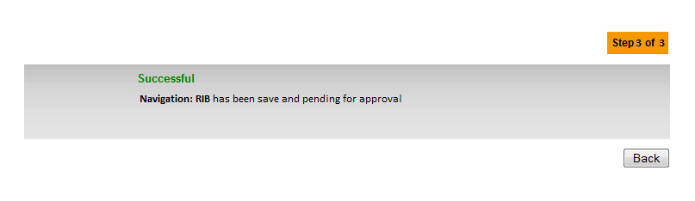

## RIB Navigation>Navigable Services

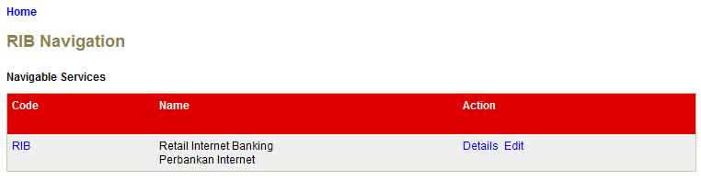

Click on RIB Code hyperlink

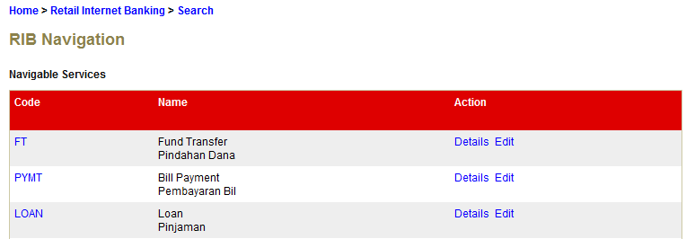

Click on Edit hyperlink

**Edit Page:**

1. change to 
2. Once user click on the **Next** button, it should display the confirmation page before go to the result page.

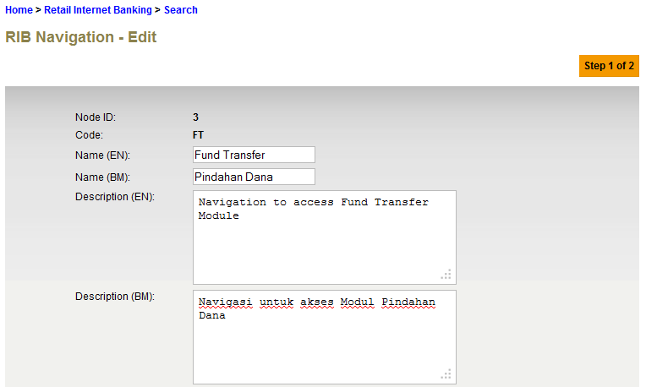

Kindly change the button name to **Next** instead Confirm



**Confirm Page:**

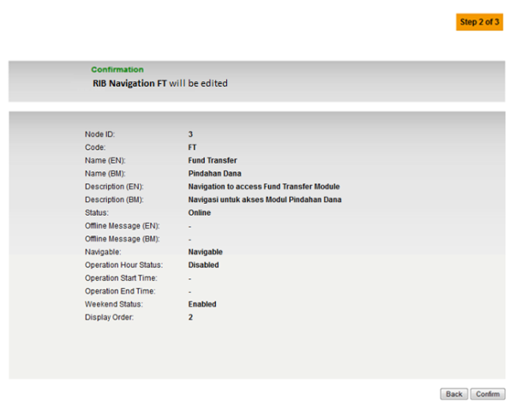

**Result Page:**

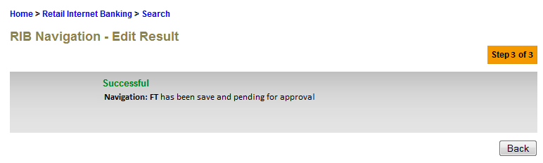

## RIB Navigation>Navigable Service>Sub Navigable



Click on FT Code hyperlink

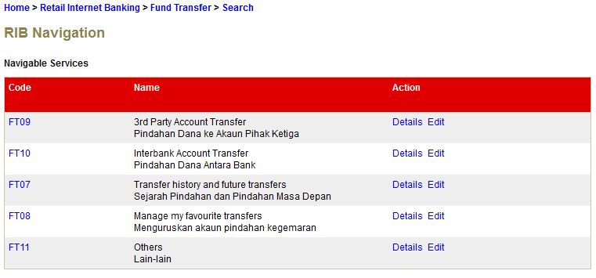

Click on Edit hyperlink

**Edit Page:**

1. change to 
2. Once user click on the **Next** button, it should display the confirmation page before go to the result page.

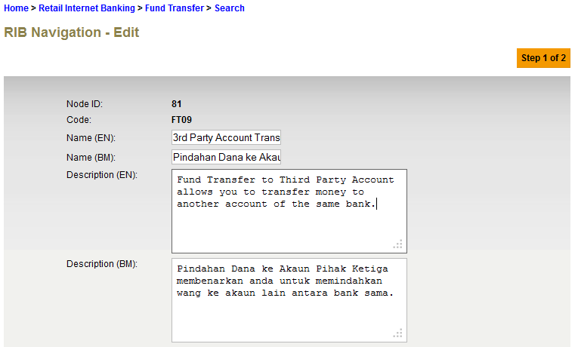

Kindly change the button name to **Next** instead Confirm



**Confirm Page:**

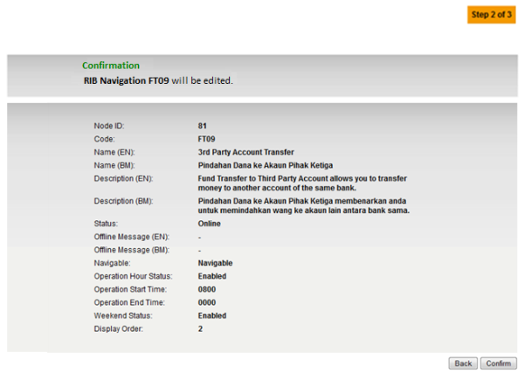

**Result Page:**

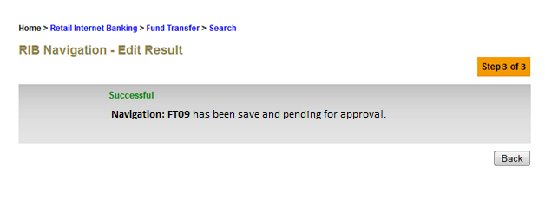

## RIB Navigation>Navigable Service>Sub Navigable>Sub



Click on FT09 Code hyperlink

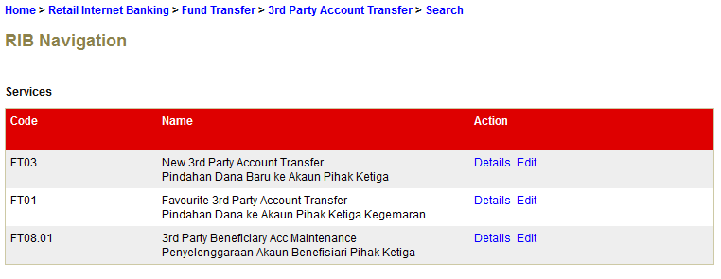

Click on Edit hyperlink

**Edit Page:**

1. change to 
2. Once user click on the **Next** button, it should display the confirmation page before go to the result page.

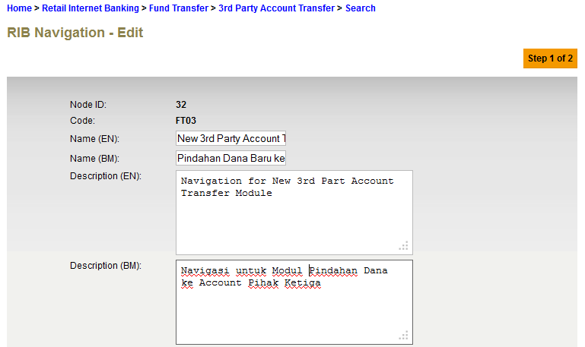

Kindly change the button name to **Next** instead Confirm



**Confirm Page:**

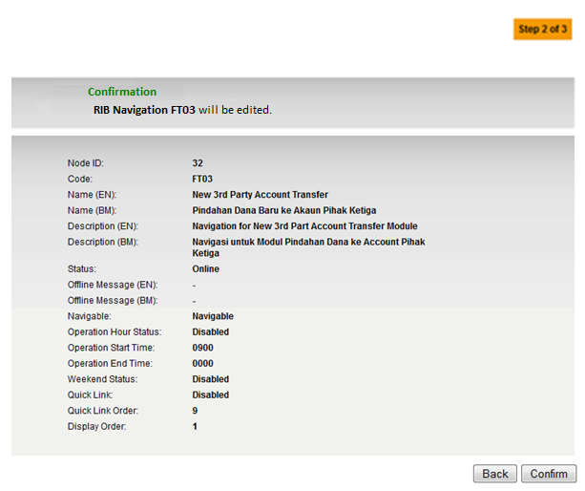

**Result Page:**

