**LOGIN AS MAKER**

* Login as maker and access RIB Navigation
* Edit RIB Navigation for fields **Name(EN)**, **Name(BM)**, **Description(EN),Description(BM),** **Offline Message(EN)** and **Offline Message(BM)**
* Pending for approval

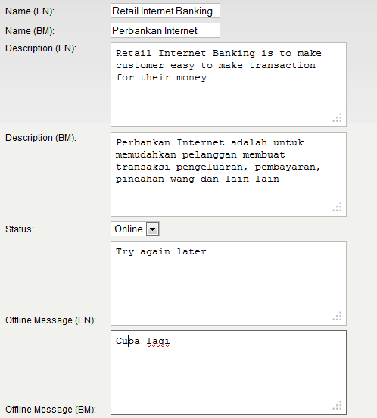

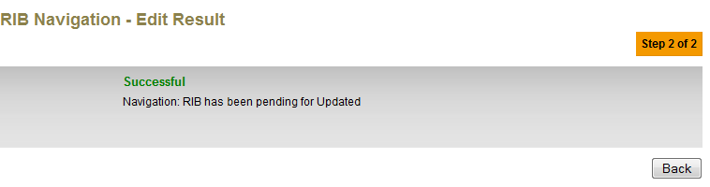

* Maker click on AUTHORIZATION module and access to Pending link
* Click on Tracking ID
* **The details is not show the label and details for BM**

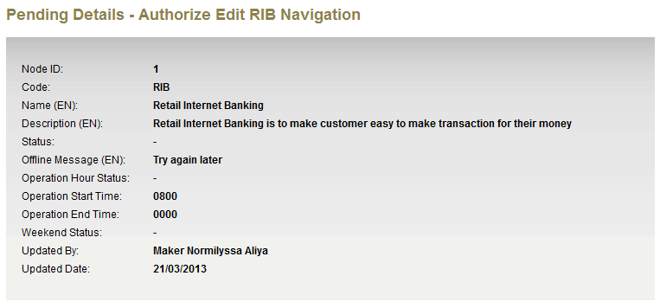

?

The details should showing as below screen shot.

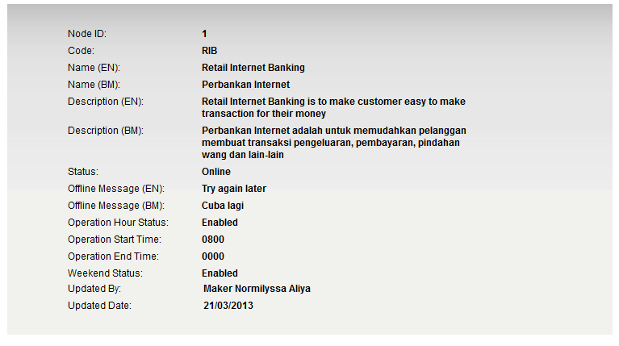

**LOGIN AS CHECKER**

* Checker click on AUTHORIZATION and access to Approval link
* Click on Tracking ID
* **The details is not show the label and details for BM**

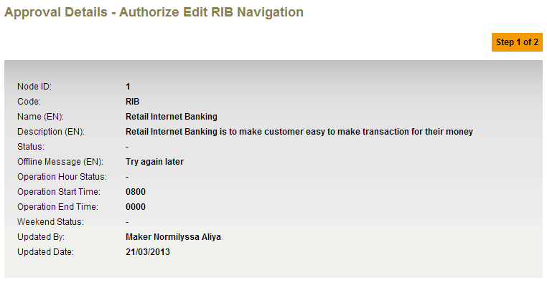

?

The details should showing as below screen shot.

