## User Profile Maintenance

## Create User Profile

This feature allows administrator to create new IBAM User.

### Process Flows



Diagram 12: Create User Profile Maintenance Flow Diagram

There are 2 participants involved in this process which is Admin and IBAM. The following are the steps to create a new IBAM User:

### Screen Flow

***Step 1:***

1. Administrator can access to User Profile Creation Screen by clicking on the “User Profile Maintenance” link at the left navigation menu followed by clicking the “Create” button.

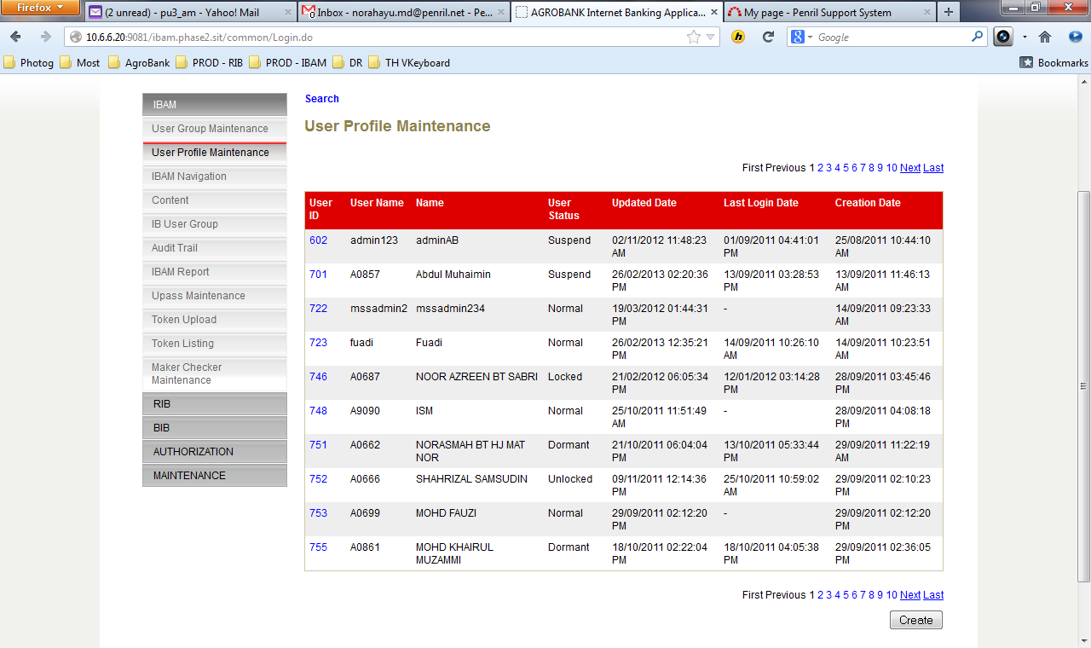

**Figure 1: User Profile Maintenance List Screen**

**Action:**

| No | Action | Type | Description |
| --- | --- | --- | --- |
| 1. | Create | Button | Contains an action to create a New ‘User Profile’.  Shows the ‘Create User Details’ page. |

***Step 2:***

1. On the User Profile Details Screen, input preferred Username, Name, Email, Office No., Mobile No., select a Group, input Password and Confirm Password and click on the “Next” button.

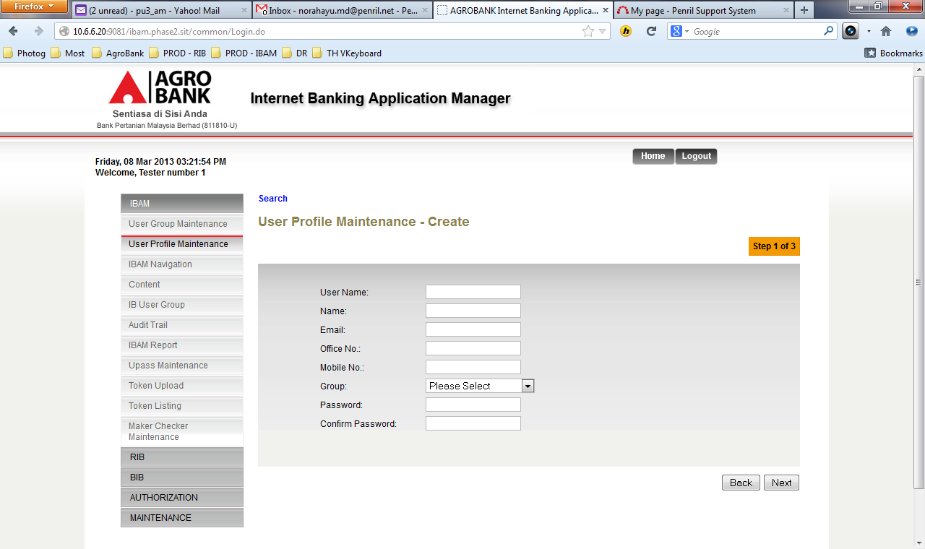

**Figure 2: User Profile Creation Screen**

**Specification:**

| No | Field | Field Type | Validation Rule | Description | Compulsory |
| --- | --- | --- | --- | --- | --- |
| 1. | User Name | Text | Min Length: 6  Max Length: 16  Username must consist single or combination of alphabet and numeric or alphanumeric. Underscore is accepted. | The unique name you use to identify yourself on IBAM | Yes |
| 2. | Name | Text | Max length: 64  Alphabet with allowed special character space@./ | User’s full name | Yes |
| 3. | Email | Text | Max length: 40  Email, comply to format: <value>@<value>.<value> | The user’s email address.  Example:  user@agrobank.com.my | Yes |
| 4. | Office No. | Numeric | Min length: 9  Max length: 10  Numeric | The user's office number  Example:  0362012622 | Yes |
| 5. | Mobile No. | Numeric | Min length: 11  Max length: 12  Numeric | The 10 -11 digits mobile number  Example:  60123456789 | Yes |
| 6. | Group | Dropdown List | Must select one of the group categories. | The Group that this user belong to | Yes |
| 7. | Password | Text, Masked | Min Length: 8  Max Length: 12  Must be a combination of numeric and alphabet format and cannot include these special character ["<>'%;&+] with a range between 8 to 12 characters. | Default password for the new user. | Yes |

**Action:**

| No | Action | Type | Description |
| --- | --- | --- | --- |
| 1. | Back | Button | Contains an action to let the IBAM system go back to previous page (User Profile Maintenance List). |
| 2. | Next | Button | Contains an action to let the IBAM system go next page (User Profile Maintenance List). |

**List of available messages for the screen:**

| No. | Event | Error Description in English | Error Description in BM |
| --- | --- | --- | --- |
| 1. | Did not fill in any of the mandatory fields. | Username is required.  Name is required  Email is required  Office No is required  Mobile No is required  Group is required  Password is required  Confirm Password is required |  |
| 2. | Fill in Username less than 6 char. | Username cannot be less than 6 characters / digits. |  |
| 3. | Fill in Username with special character. | Username cannot include special character except underscore. |  |
| 4. | Fill in Name with more than 64 characters | Full Name cannot be greater than 64 characters. |  |
| 5. | Fill in an invalid email address. | Email format invalid. |  |
| 6. | Fill in less than 9 char. To Office No. | Office No. must be 9 characters / digits. |  |
| 7. | Fill in Office No contains alphabet | Office No is not numeric |  |
| 8. | Fill in Mobile No contains alphabet | Mobile No is not numeric |  |
| 9. | Fill in less than 11 char. To Mobile No. | Mobile No. must be 11 to 12 characters / digits. |  |
| 10. | Did not select Group. | Group is required. |  |
| 11. | Fill in less than 8 characters to Password | Password cannot be less than 8 characters / digits |  |
| 12. | Fill in password contains with one of the criteria below:   * Un-allowed Special character * Digit only * Lower case alphabets only * Upper case alphabets only * Lower and upper case alphabets * Digit and lower case alphabets * Digit and upper case alphabets | Password must contain a mixture of numeric and alphabet format. Cannot include these special character ["<>'%;&+] |  |
| 13. | Fill in Password same as Username. | Password cannot be the same as Username. |  |
| 14. | Password and confirm password does not match | Confirm Password must be the same as Password |  |

***Step 3:***

1. IBAM system display Create User Profile Confirmation Page.
2. User click on “Confirm” button.

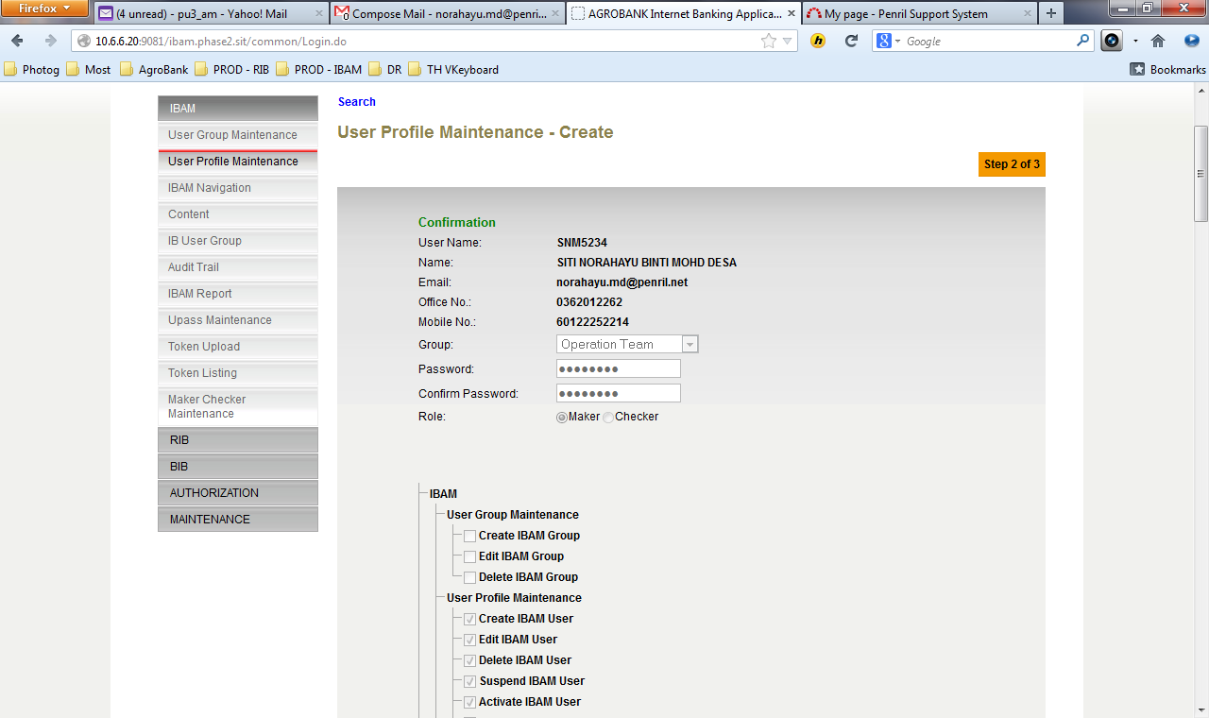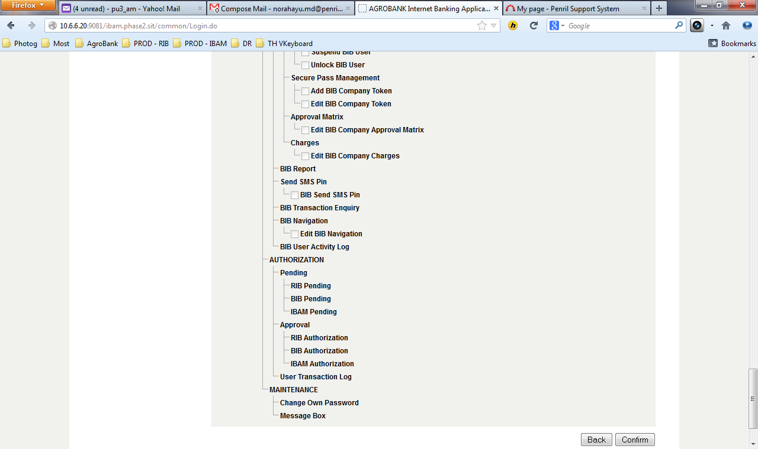

**Figure 19: Create User Profile Confirmation Screen**

**Action:**

| No | Action | Type | Description |
| --- | --- | --- | --- |
| 1. | Back | Button | Contains an action to let the IBAM system go back to previous page. |
| 2. | Confirm | Button | Contains an action to create a ‘New User Profile’.  Shows the ‘Create User Profile’ result page. |

***Step 4:***

1. IBAM validates user details and save the New User to IB Database and displays result page.
2. IBAM shows Successful message and pending for Authorization approval process.
3. Once approved IBAM will shows New User under User Profile Maintenance list.

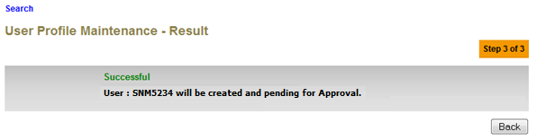

**Figure 20: User Profile Creation Result Screen**

**Action:**

| No | Action | Type | Description |
| --- | --- | --- | --- |
| 1 | Back | Button | Contains an action to let the IBAM system go back to previous page (User Profile Maintenance List). |

## Search User Profile

This feature allows Administrator to search for another user details.

### Process Flow

**Diagram 10: Search User Profile Flow Diagram**

There are 2 participants involved in this process which is Admin and IBAM. The following are the steps to create a new IBAM User

### Screen Flow

***Step 1:***

1. Administrator can access to User Profile Maintenance List Screen by clicking on the “User Profile Maintenance” link on the left navigation menu.
2. User Profile Maintenance list screen will be shown.
3. Administrator can start search for IBAM User by clicking the “Search” link or select a specific user from the list on the screen.

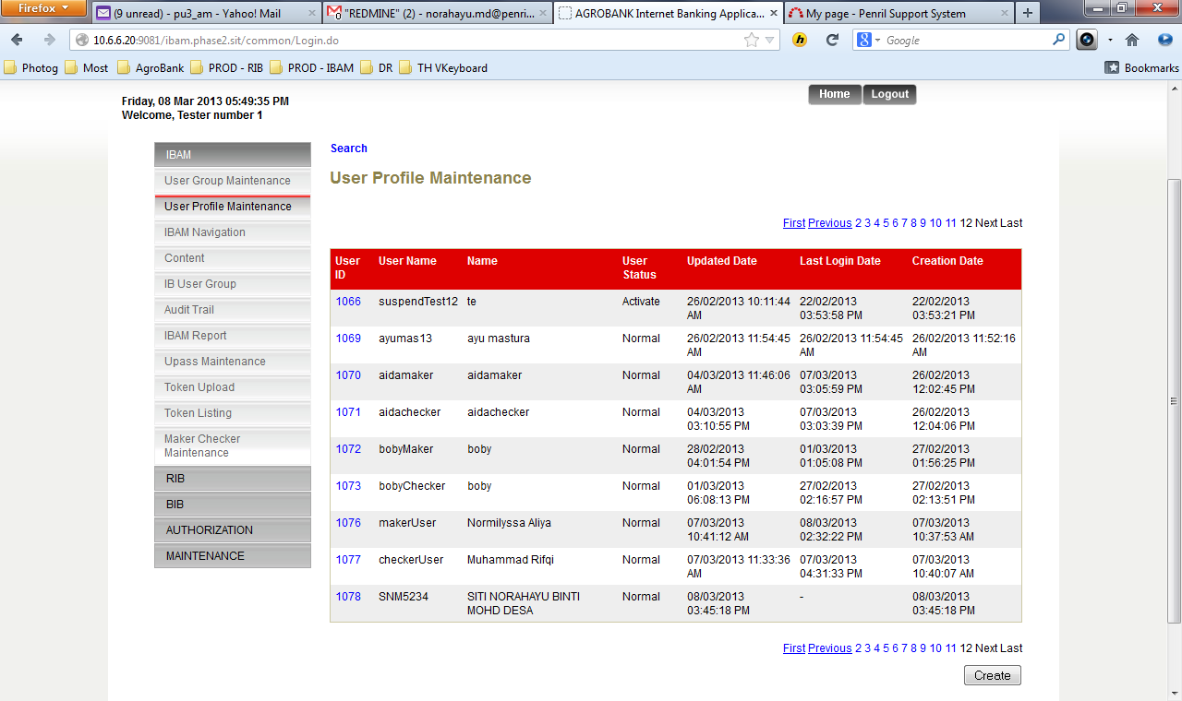

**Figure 24: User Profile Maintenance List Screen**

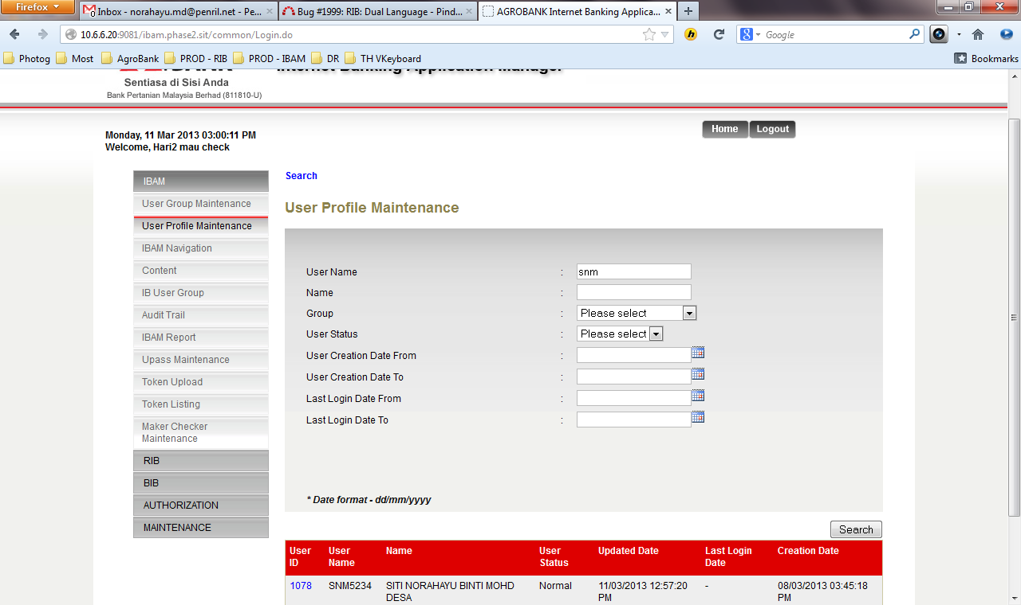

**Figure 24: User Profile Search Result Screen**

**Specification:**

| No | Field | Field Type | Validation Rule | Description | Compulsory |
| --- | --- | --- | --- | --- | --- |
| 1. | User Name | Text | Min Length: 6  Max Length: 16  User Name must consist at least 1 alphabet and 1 numeric | The user login name | No |
| 2. | Full Name | Text | Max length: 64  Alphanumeric with Space and Thai character. | The user name | No |
| 3. | Group | Text | Must select one of the group categories. | The group name that user belong | No |
| 4. | User Status | Text | One of status must be selected. | The user current status | No |
| 5. | User Creation Date From | Text | Gregorian calendar format & time  (DD/MM/YYYY HH:MM:SS) | The date search range, start date.  The date when the user profile being created | No |
| 6. | User Creation Date To | Text | Gregorian calendar format & time  (DD/MM/YYYY HH:MM:SS) | The date search range, end date.  The date when the user profile being created | No |
| 7. | Last Login Date From | Text | Gregorian calendar format & time  (DD/MM/YYYY HH:MM:SS) | The date search range, start date.  The user last login date. | No |
| 8. | Last Login Date To | Text | Gregorian calendar format & time  (DD/MM/YYYY HH:MM:SS) | The date search range, end date  The user last login date. | No |

**Action:**

| No | Action | Type | Description |
| --- | --- | --- | --- |
| 1. | Search | Button | Contains an action to search and existing ‘User Profile’ in the list. Show ‘User Profile Maintenance Enquiry’ page. |
| 2. | Click on “User ID” | Hyperlink | Show the User Profile Enquiry Details. |

**List of available messages for the screen:**

|  |  |  |  |
| --- | --- | --- | --- |
| No. | Event | Error Description in English | Error Description in BM |
| 1. | Fill in Username with special character. | Username cannot include special character. |  |
| 2. | Fill in Full Name with special character. | Full Name cannot include special character. |  |
| 3. | Fill in Full Name with more than 64 characters | Full Name cannot be greater than 64 characters. |  |
| 4. | Fill in invalid Date or Time format | User Creation Date To is an invalid date/time format  Last Login Date From is an invalid date/time format  Last Login Date To is an invalid date/time format  User Creation Date From is an invalid date/time format |  |
| 5. | Fill in User Creation Date From greater than Creation Date To | From date cannot be greater than to date. |  |
| Fill in Last Login Date From greater than Last Login Date To |

***Step 2:***

1. IBAM display User Profile Details Screen of the selected User ID.

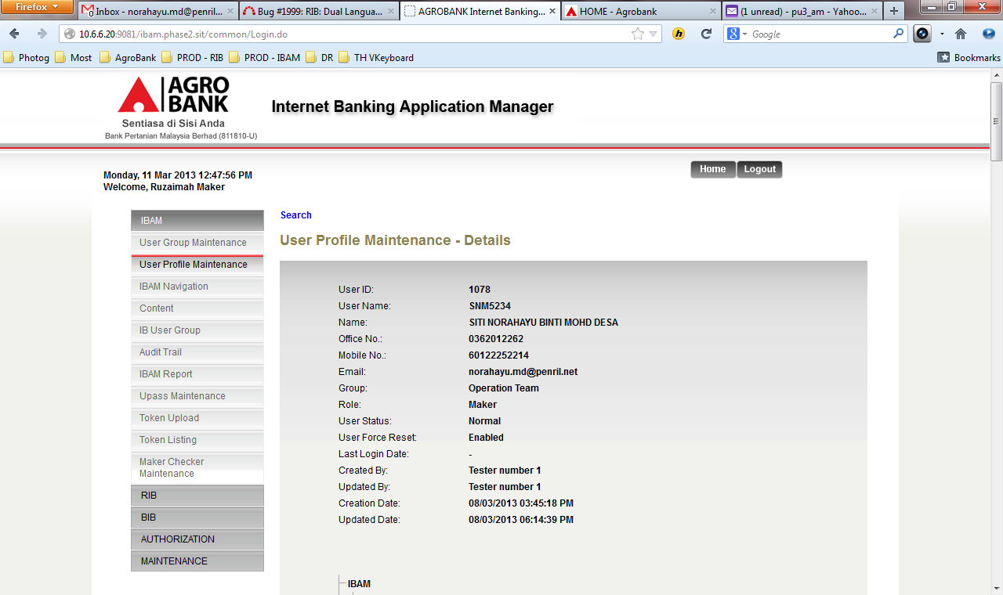

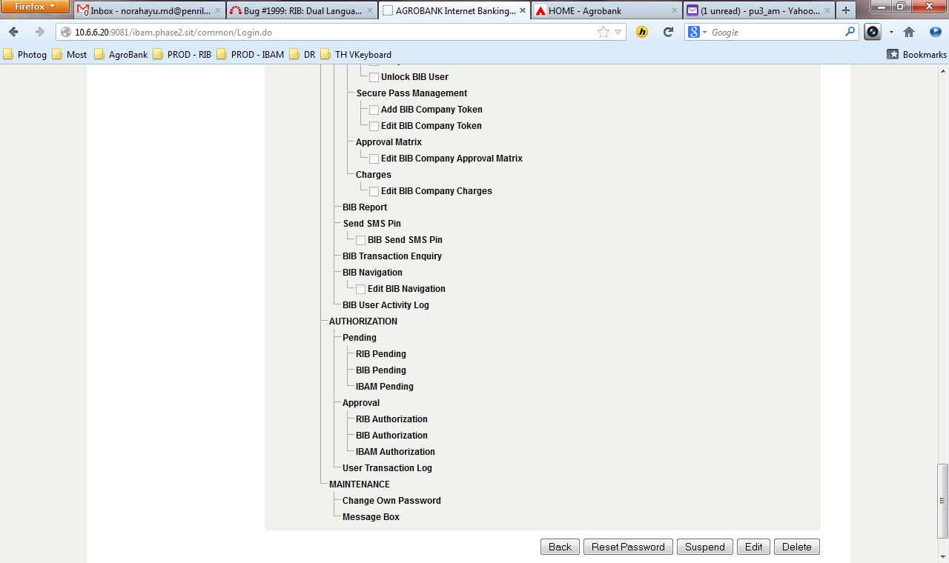

**Figure 24: User Profile Details Screen**

**Action:**

| No | Action | Type | Description |
| --- | --- | --- | --- |
| 1. | Back | Button | Goes back to User Profile maintenance list page. |

## Edit User Profile

This feature allows Admin to edit and update another user details.

### Process Flow



**Diagram 11: Edit User Profile Flow Diagram**

There are 2 participants involved in this process which is User Profile and IBAM. The following are the steps to edit and update a user details:

### Screen Flow

***Step 1:***

1. IBAM User can access to Admin Enquiry Screen by clicking on the “User Profile Maintenance” link on the left navigation menu.
2. Admin Enquiry Screen will be shown.
3. IBAM User can select a specific user from the list on the screen.

**

**Figure 24: User Profile Enquiry Screen**

**Action:**

| No | Action | Type | Description |
| --- | --- | --- | --- |
| 1. | Search | Button | Contains an action to search and existing ‘User Profile’ in the list. Show ‘User Profile Maintenance Enquiry’ page. |
| 2. | Click on “User ID” | Hyperlink | Show the User Profile Enquiry Details. |

***Step 2:***

1. Admin Details Screen of the IBAM User Name will be shown. Admin can clicks on the “Edit” button to access the IBAM User Details Edit Screen.

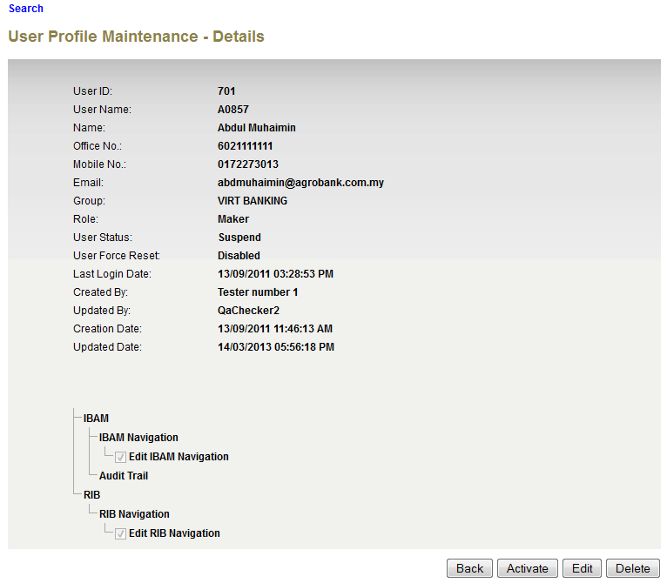

**Figure 25: User Profile Details Screen**

**Action:**

| No | Action | Type | Description |
| --- | --- | --- | --- |
| 1. | Back | Button | Brings the user to show back the list of user registered in the IBAM System. |
| 2. | Edit | Button | Brings the user to admin edit page, in order to be able to modify their details. Show ‘User Profile Maintenance Edit’ page. |

***Step 3:***

1. IBAM display IBAM User Details Edit Screen.
2. Admin edits details and clicks on the “Next” button.

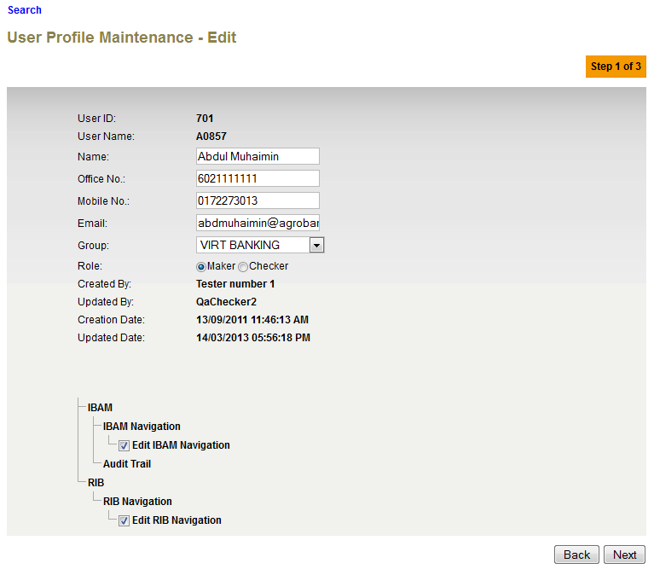

**Figure 26: User Profile Edit Details Screen**

**Specification:**

| No | Field | Field Type | Validation Rule | Description | Compulsory |
| --- | --- | --- | --- | --- | --- |
| 1. | Name | Text | Max length: 64  Alphabet with allowed special character (space@./) | User’s full name | Yes |
| 2. | Office No. | Text | Min length: 9  Max length: 10  Numeric | The user's office number  Example:  0362012622 | Yes |
| 3. | Mobile No. | Text | Min length: 11  Max length: 12  Numeric | The 11-12 digits mobile number  Example:  60123456789 | Yes |
| 4. | Email | Text | Max length: 40  Email, compy to format: <value>@<value>.<value> | The user’s email address.  Example:  user@agrobank.com.my | Yes |
| 5. | Group | Dropdown List | Must select one of the group categories. | The Group that this user belong to | Yes |

**Action:**

| No | Action | Type | Description |
| --- | --- | --- | --- |
| 1. | Next | Button | Contains an action to validate the updated details of ‘User Profile’.  Shows the ‘User Profile” Edit Confirm page. |
| 2. | Back | Button | Contains an action to let the IBAM system go back to previous page (User Profile Maintenance List). |

**List of available messages for the screen**:

|  |  |  |  |
| --- | --- | --- | --- |
| **No.** | **Event** | **Error Description in English** | **Error Description in BM** |
| 1. | Fill in an invalid email address. | Email format invalid. |  |
| 2. | Fill in less than 9 char. To Office No. | Office No. must be 9-10 digits. |  |
| 3. | Fill in less than 11 char. To Mobile No. | Mobile No. must be 11-12 digits. |  |
| 4. | Fill in Office and/or Mobile No. with special character. | Office No. is not numeric. Mobile No. is not numeric. |  |
| 5. | Did not select Group. | Group is required. |  |

***Step 4:***

1. IBAM system display Edit User Profile Confirmation page.
2. IBAM User Click on “Confirm” button.
3. IBAM validates the updated details and display confirm screen for Administrator to confirm the updated details.

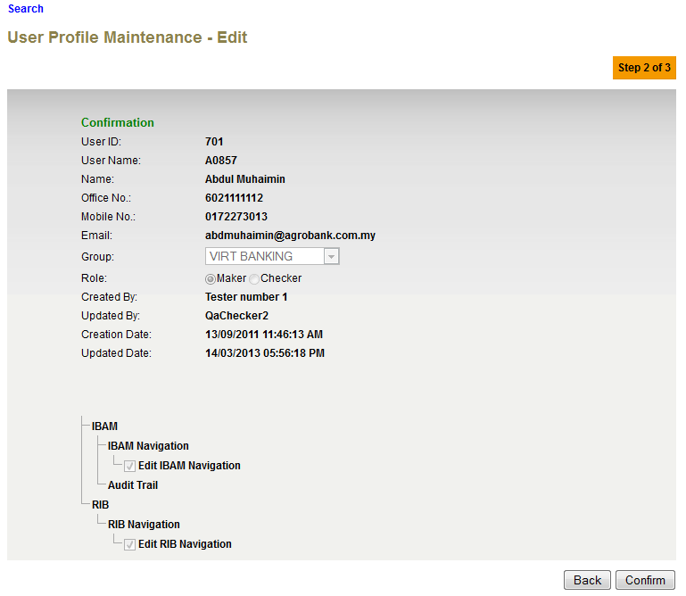

**Figure 27: User Profile Details Edit Confirm Screen**

**Action:**

| No | Action | Type | Description |
| --- | --- | --- | --- |
| 1. | Back | Button | Contains an action to let the IBAM system go back to previous page (User Profile Edit Screen). |
| 2. | Confirm | Button | Contains an action to save the updated details of ‘User Profile’.  Shows the ‘User Profile” Edit Result page. |
|  |  |  |  |

***Step 5:***

1. IBAM updates the edited details to IB Database and display the result to the IBAM user.
2. IBAM shows successful message and pending for Authorization approval process
3. Once approved IBAM will shows the update info under User Profile Details screen.

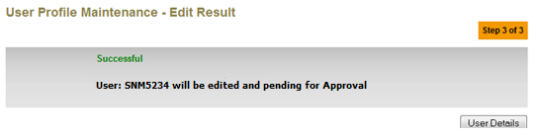

**Figure 28: User Profile Details Edit Result Screen**

**Action:**

| No | Action | Type | Description |
| --- | --- | --- | --- |
| 1. | User Details | Button | Shows the ‘User Profile Maintenance” detail page. |

## Delete User Profile

This feature allows Admin to delete another User from IBAM. All users are logically deleted (mark as deleted); the deleted User record(s) still remains in the database.

### Process Flow



**Diagram 12: Delete User Profile Flow Diagram**

There are 2 participants involved in this process which is User and IBAM. The following are the steps to delete an User Profile:

### Screen Flow

***Step 1:***

1. Admin access to User Profile Maintenance Screen.
2. IBAM display User Profile Maintenance Screen.
3. Admin selects IBAM user’s link to be deleted.
4. IBAM display IBAM user details page.

**

**Figure 29: Delete User Profile Enquiry Screen**

**Action:**

| No | Action | Type | Description |
| --- | --- | --- | --- |
| 1. | Click on ‘User ID’ | Hyperlink | Show the User Profile Details Screen |

***Step 2:***

1. Admin clicks on the delete button.
2. IBAM will go to Delete User Profile Confirmation page.

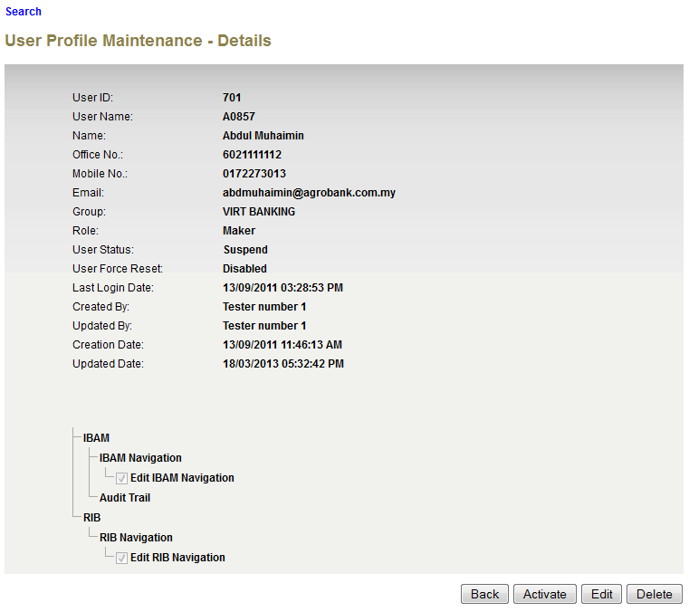

**Figure 30: Delete User Profile Maintenance Details Screen**

**Action:**

| No | Action | Type | Description |
| --- | --- | --- | --- |
| 1. | Back | Button | Brings the user to show back the list of user registered in the IBAM System. |
| 2. | Delete | Button | Deleted this currently displayed admin.  Show the Delete Admin Confirmation Page |

***Step 3:***

1. Admin clicks on the confirm button.
2. IBAM deletes the selected user(s) from IBAM (marked as deleted in database) and go to the result page.

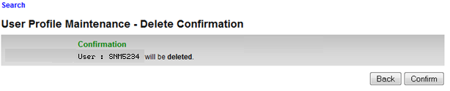

**Figure 31: Delete User Profile Confirmation Screen**

**Action:**

| No | Action | Type | Description |
| --- | --- | --- | --- |
| 1. | Back | Button | Brings the user back to User Profile Maintenance Details page. |
| 2. | Confirm | Button | Confirmation to delete displayed Admin ID and brings user to User Profile Result page. |

***Step 4:***

1. IBAM deletes the selected admin from IBAM and go to result page.
2. IBAM shows Successful message and pending for Authorization approval process.
3. Once approved IBAM User will deleted from the User Profile Maintenance List but not in Database.

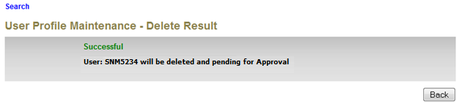

**Figure 32: Delete User Profile Result Screen**

**Action:**

| No | Action | Type | Description |
| --- | --- | --- | --- |
| 1. | Back | Button | Shows the ‘User Profile Maintenance” detail page. |

## Reset User Profile Password

This feature allows an authorized Admin to reset another user’s password when he/she forgot the password to access to IBAM.

Upon reset password, Status will change to ACTIVE and the Force Reset Password will be ENABLED after authorization done.

### Process Flow

**Diagram 13: Reset User Profile Password Diagram**

There are 2 participants involved in this process which is User and IBAM. The following are the steps to reset User Profile password:

### Screen Flow

***Step 1:***

1. IBAM User can access to User Profile Maintenance screen by clicking on the “User Profile Maintenance” link on the left navigation menu.
2. IBAM display the User Profile Maintenance Screen.
3. IBAM User click on a User ID hyperlink.



**Figure 33: Reset Password User Profile Maintenance Screen**

**Action:**

| No | Action | Type | Description |
| --- | --- | --- | --- |
| 1. | Click on “User ID” | Hyperlink | Show the details of the User Profile User that has been clicked |

***Step 2:***

1. IBAM display User Profile Details Screen of the selected User ID
2. IBAM Admin click on the “Reset Password” button.

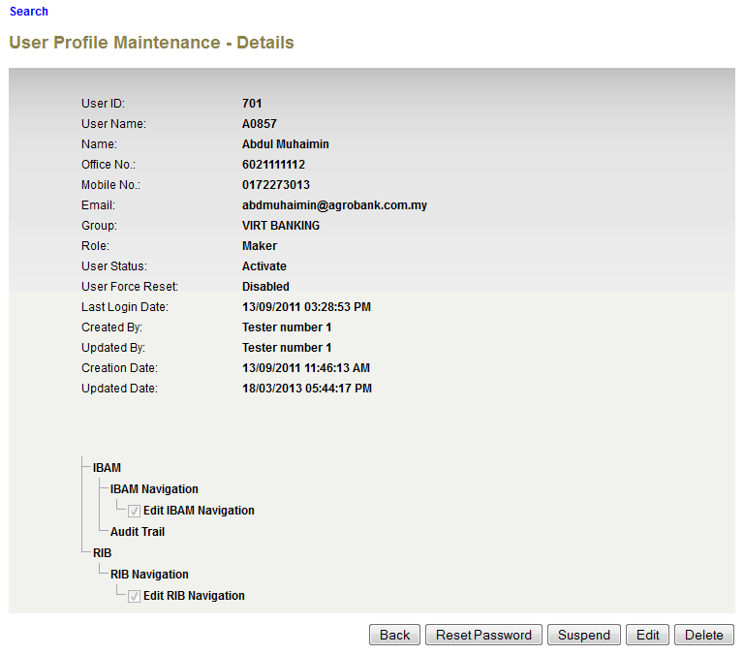

**Figure 34: Reset User Profile Password Details Screen**

**Action:**

| No | Action | Type | Description |
| --- | --- | --- | --- |
| 1. | Back | Button | Brings the user to show back the list of user registered in the IBAM System. |
| 2. | Reset Password | Button |  |

***Step 3:***

1. IBAM display User Profile Reset Password Details Screen of the selected Username
2. IBAM display Reset Password Screen.
3. IBAM User input New Password and Confirm Password and click on the “Confirm” button.

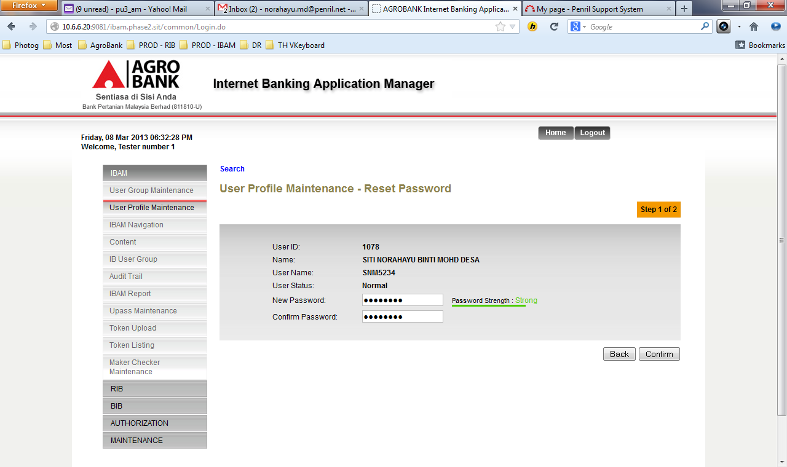

**Figure 35: Reset Password Screen**

**Specification:**

| No | Field | Field Type | Validation Rule | Description | M/O |
| --- | --- | --- | --- | --- | --- |
| 1. | New Password | Text | Min Length: 8  Max Length: 12  Must be a combination of numeric and alphabet format and cannot include these special character ["<>'%;&+] with a range between 8 to 12 characters. | Parameterized. | M |
| 2. | Confirm Password | Text | Must same as New Password | This password must be same to the New Password.  This is to ensure that user able to remember own newly creating password. | M |

**Action:**

| No | Action | Type | Description |
| --- | --- | --- | --- |
| 1. | Back | Button | Goes back to User Profile maintenance details |
| 2. | Confirm | Button | Action that accept the new password to be set  Show the User Profile Reset Password Result Page |

**List of available messages for the screen:**

|  |  |  |  |
| --- | --- | --- | --- |
| No. | Event | Error Description in English | Error Description in BM |
| 1. | Did not fill in the required field. | Confirm Password is required.  New Password is required. |  |
| 2. | Fill in less than 8 characters to New Password | Password cannot be less than 8 characters / digits. |  |
| 3. | Fill in password contains with one of the criteria below:   * Un-allowed Special character * Digit only * Lower case alphabets only * Upper case alphabets only * Lower and upper case alphabets * Digit and lower case alphabets * Digit and upper case alphabets | Password must contain a mixture of numeric and alphabet format. Cannot include these special character ["<>'%;&+] |  |
| 4. | Fill in Confirm Password different from New Password | Confirm Password must be the same as New Password. |  |
| 5. | Fill in Password same as Username. | Password cannot be the same as Username. |  |
| 6. | Fill in less than 8 char. to password and/or confirm password. | Confirm Password cannot be less than 8 characters / digits.  Password cannot be less than 8 characters / digits. |  |
| 7. | Fill in New Password same as old password | Your new password has previously been used. |  |

***Step 4:***

1. IBAM saves the new password to IB Database and display the result to the user.
2. IBAM shows successful message and pending for Authorization approval process
3. Once approved IBAM will force user to change password upon login.

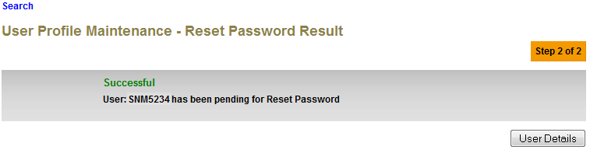

**Figure 36: User Profile Reset Password Result Screen**

**Action:**

| No | Action | Type | Description |
| --- | --- | --- | --- |
| 1. | User Details | Button | Shows the ‘User Profile Maintenance’ detail page. |

## Suspend Admin

This feature will allow an authorized IBAM user to suspend another IBAM user.

### Process Flow



**Diagram 14: Suspend User Profile Flow Diagram**

There are 2 participants involved in this process which is IBAM user and IBAM. The following are the steps:

### Screen Flow

***Step 1:***

1. Administrator can access to User Profile Maintenance Screen by clicking on the “User Profile Maintenance” link on the left navigation menu.
2. IBAM display the User Profile Maintenance list Screen
3. Administrator clicks on a User ID link to display User Profile details.
4. Administrator also can search particular ID by click Search hyperlink and IBAM will display the User Profile Enquiry Screen



**Figure 37: Suspend User Profile Maintenance Screen**

**Action:**

| No | Action | Type | Description |
| --- | --- | --- | --- |
| 1. | User ID | Hyperlink | In order to suspend a particular admin, the current admin must click on the User Name hyperlink to show the detail of that particular Admin. |
| 2. | Search | Button | Contains action that bring user to User Profile Enquiry page in order to search particular User Name. |

***Step 2:***

1. IBAM display Admin Details Screen of the selected User Name
2. IBAM User click on the “Suspend” button.

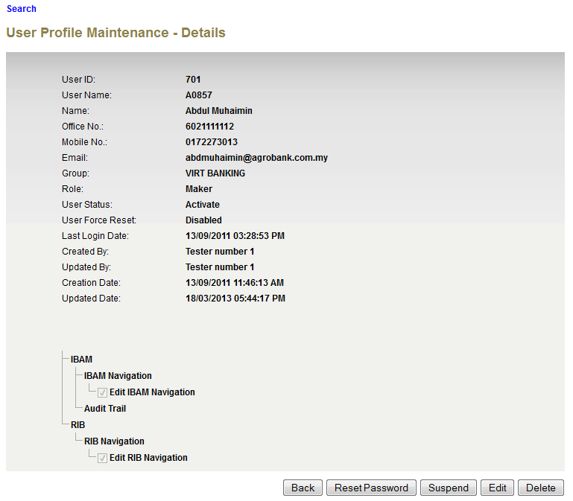

**Figure 39: Suspend User Profile Details Screen**

**Action:**

| No | Action | Type | Description |
| --- | --- | --- | --- |
| 1. | Suspend | Button | To change the user status to Suspended mode. Thus, that user would not have the access on the system. |
| 2. | Back | Button | Goes back to User Profile maintenance list page. |

***Step 3:***

1. IBAM system display Suspend User Profile Confirmation page.
2. IBAM user clicks on “Confirm” button.

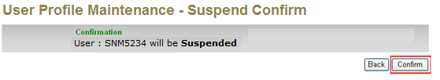

**Figure 40: Suspend User Profile Confirmation Screen**

**Action:**

| No | Action | Type | Description |
| --- | --- | --- | --- |
| 1. | Back | Button | Contains an action go back to previous page |
| 2. | Confirm | Button | To change the user status to Suspended mode.  Show Suspend User Profile Result page. |

***Step 4:***

1. IBAM saves the new Admin status to IB Database and display result.
2. IBAM shows Successful message and pending for Authorization approval process.
3. Once approved IBAM will shows New User Status at User Profile Maintenance List & Details.

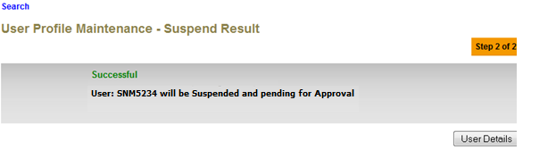

**Figure 41: Suspend User Profile Result Screen**

**Action:**

| No | Action | Type | Description |
| --- | --- | --- | --- |
| 1. | User Details | Button | Shows the ‘User Profile Maintenance” detail page. |

## Activate Admin

This feature will allow an authorized IBAM user to activate another suspended or locked User Profile.

### Process Flow



**Diagram 15: Activate User Profile Flow Diagram**

There are 2 participants involved in this process which is IBAM user and IBAM. The following are the steps:

### Screen Flow

***Step 1:***

1. IBAM Admin can access to User Profile Maintenance Screen by clicking on the “User Profile Maintenance” link on the left navigation menu.
2. IBAM display the User Profile Maintenance list Screen
3. IBAM Admin clicks on a User ID link to display User Profile details.
4. IBAM Admin also can search particular ID by click Search hyperlink and IBAM will display the User Profile Enquiry Screen



**Figure 42: Activate User Profile Maintenance Screen**

**Action:**

| No | Action | Type | Description |
| --- | --- | --- | --- |
| 1. | User ID | Hyperlink | In order to suspend a particular admin, the current admin must click on the User Name hyperlink to show the detail of that particular Admin. |
| 2. | Search | Button | Contains action that bring user to User Profile Enquiry page in order to search particular User Name.  Show the User Profile Maintenance Enquiry Page |

***Step 2:***

1. IBAM display Admin Details Screen of the selected suspended User Name
2. IBAM User clicks on the “Unlock” button on suspended user.

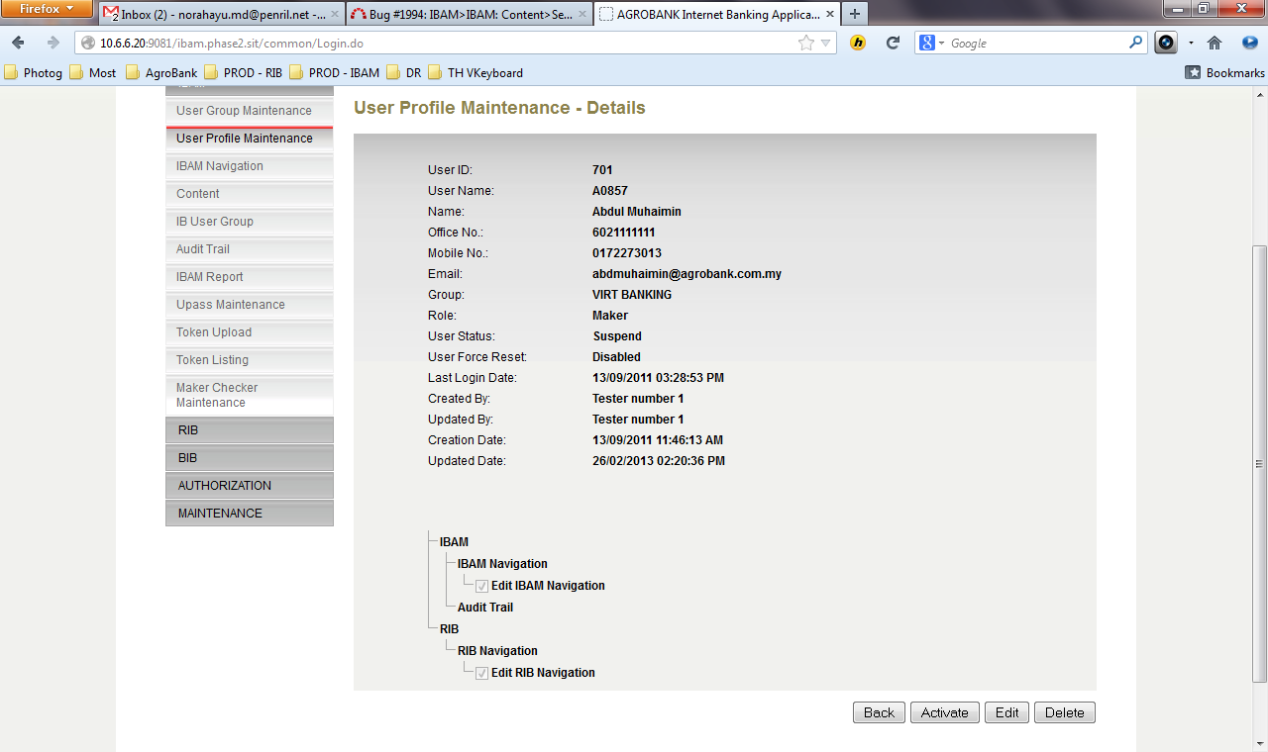

**Figure 44: Activate User Profile Details Screen**

**A**

**ction:**

| No | Action | Type | Description |
| --- | --- | --- | --- |
| 1. | Activate | Button | To change the user status to Active mode. Thus, that user would regain access on the system.  User that already in “Active” status cannot be activated / restored. |
| 2. | Back | Button | Goes back to User Profile maintenance list page. |

***Step 3:***

1. IBAM system display Active User Profile Confirmation page.
2. IBAM user click on “Confirm” button.

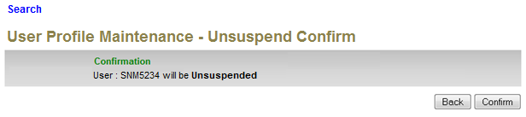

**Figure 45: Activate User Profile Status Confirmation Screen**

**Action:**

| No | Action | Type | Description |
| --- | --- | --- | --- |
| 1. | Back | Button | Contains an action to go back to previous page |
| 2. | Confirm | Button | To change the user status to Active mode. Thus, that user would regain access on the system.  Show Result page |

***Step 4:***

1. IBAM saves the new user status to IB Database
2. IBAM display the result screen with Successful message and pending for Authorization approval process.
3. Once approved IBAM will shows New User Status at User Profile Maintenance List & Details.

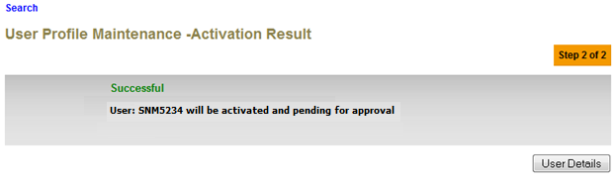

**Figure 46: Activate User Profile Result Screen**

**Action:**

| No | Action | Type | Description |
| --- | --- | --- | --- |
| 1. | User Details | Button | Shows the ‘User Profile Maintenance” detail page. |