Notices – Content List

1. Please update the field based on the highlighted requirement below.

**Specification:**

|  |  |  |  |  |  |
| --- | --- | --- | --- | --- | --- |
| No | Field | Field Type | Validation Rule | Description | Compulsory |
| 1. | Title | Text Box | 64 alphanumeric with special character but include following characters & < > ' " / | Title of promotion or announcement. | Yes |
| 2. | Abstract | Text Area | 255 characters  Free Input | A brief of the article. | Yes |
| 3. | Description | Text Area | 512 characters  Free Input | Description of the article. | Yes |
| 4. | External Link | Text Box | 64 free input but cannot include special characters except space, left single quote and - / @ & ' . : ; | External URL Link | No |
| 5. | Start Date | Text Box | DD/MM/YYYY using calendar/date picker | Search based on date from | No |
| 6. | End Date | Text Box | DD/MM/YYYY using calendar/date picker | Search based on date to | No |
| 7. | Publishing Type | Drop box (Announcement; Promotion) | 1 number | Indicate type of notice | No |
| 8. | Status | Drop down (Default of Off-line) | 1 number | Specify whether that the content is accessible (online) or not (offline). | No |

1. To change Description (EN) field to Text Area instead of TinyMCE.

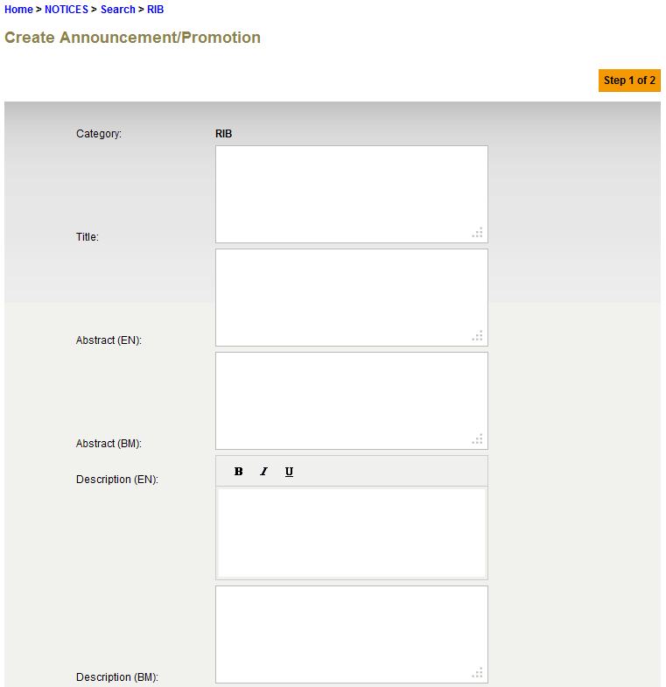

1. Start Date cannot greater than End Date.