Title : ISSUE RESOLUTION  Mandatory Change  Nice to have/Preferences |  |  | Project : Internet Banking  Application : Internet Banking
Issue Number : EB130040 |  | Issue Title : Not enough field to input customer address
Issue Description :
- To extend length of Address field in IBAM- Company Contact person to be 55 characters
- To extend length of Address field in IBAM- User Maintenance-Corporate Admin to be 55 characters
- To allow special characters / (slash) – (dash) , (comma) in address field
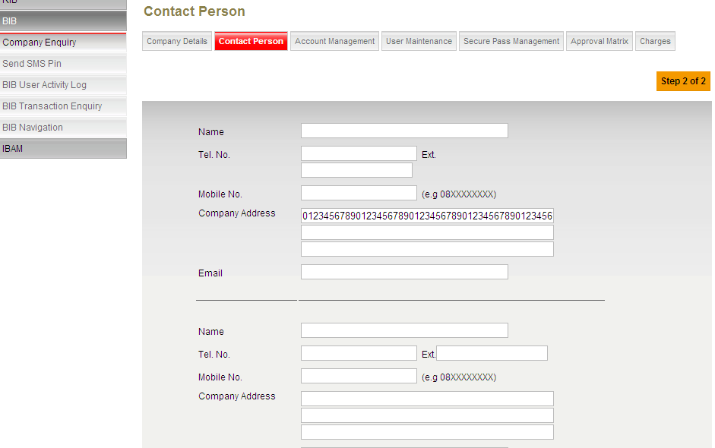

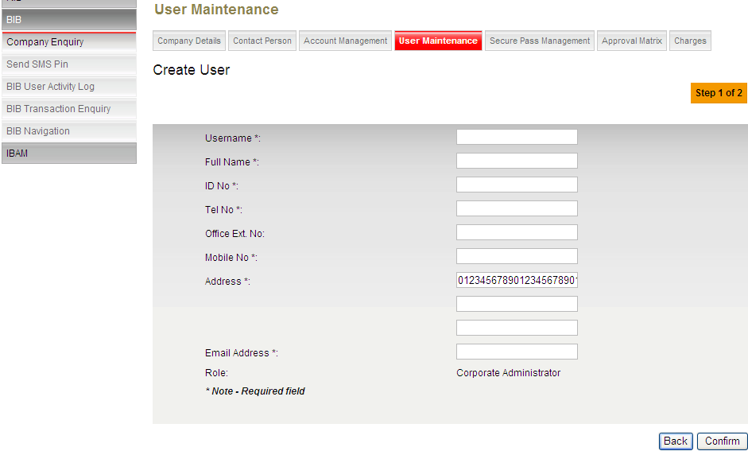

Recommendation & Rationale:

Resolution : |  |  |  |  | Man-days:
Raised By: พงศ์พันธ์  Date : 12/03/2556 | Review by :  Date: |  |  | Cross Reference :

