Title : ISSUE RESOLUTION  Mandatory Change  Nice to have/Preferences |  |  | Project : Internet Banking  Application : Internet Banking
Issue Number : EB130044 |  | Issue Title : To correct Reprint Receipt format and number of record displayed in Online Trxn History
Issue Description :
- To change the receipt format in ‘Reprint Receipt’ function to be same as transaction receipt

Receipt – After transaction - Correct
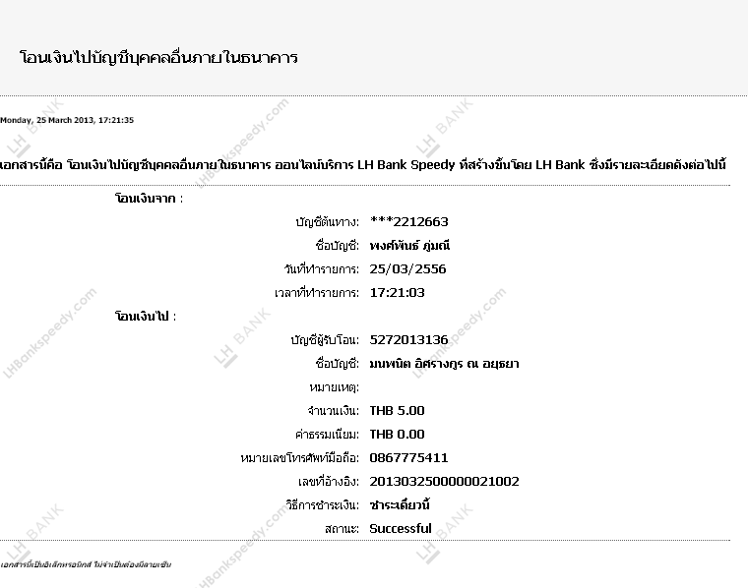

Reprint receipt in Online Trxn History – Not correct
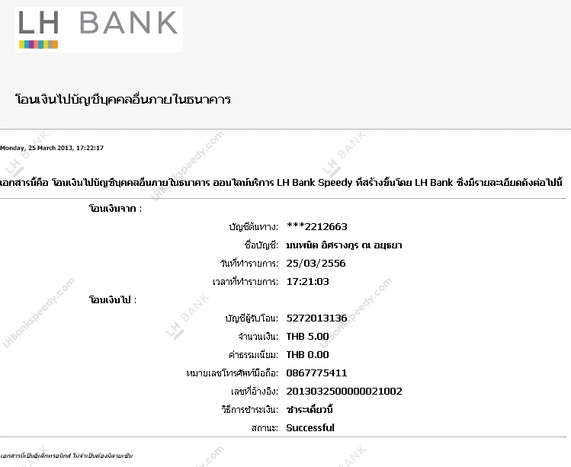

- To display last 6 months transaction in Online Trxn History

Recommendation & Rationale:

Resolution : |  |  |  |  | Man-days:
Raised By: พงศ์พันธ์  Date : 26/03/2556 | Review by :  Date: |  |  | Cross Reference :

