Section 4: Authorization

In **Authorization** module, there are Two (2) sub-modules or functionalities. Only IBAM Checker and Maker User are able to access this module.

# Authorization

# Pending

Allow IBAM Maker User to view the pending task have not been approve by Checker.

## Process Flow



Diagram 28: Authorization - Pending Flow Diagram

## Screen Flow

***Step 1:***

1. IBAM Maker User select Authorization menu and select Pending.
2. IBAM System shows the Pending Listing page.
3. Admin User selects the RIB Pending, BIB Pending or IBAM Pending tab and click on Tracking ID link.

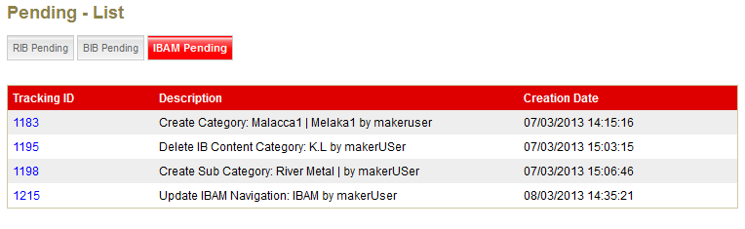

Figure 61: Authorization - Pending Listing Screen

**Display Specification:**

| **No** | **Field** | **Format** | **Description** |
| --- | --- | --- | --- |
|  | Description | Text | The description of the pending authorizes. |
|  | Creation Date | DD/MM/YYYY HH:MM:SS | Creation date and time of the action make by maker. |

**Action:**

| **No** | **Action** | **Type** | **Description** |
| --- | --- | --- | --- |
|  | Tracking ID | Hyperlink | Go to Authorization- Pending details page |

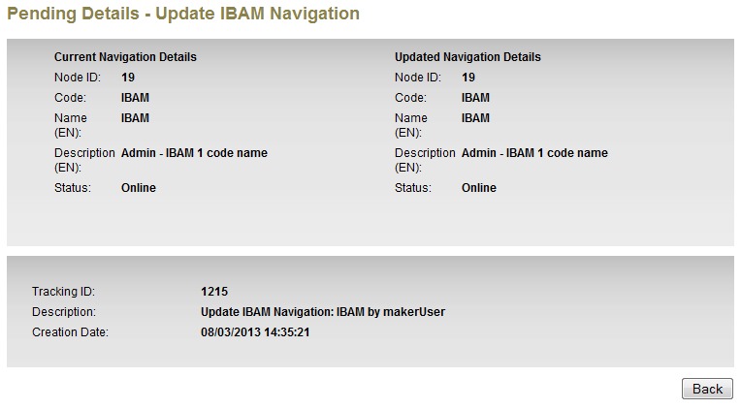

Figure 62: Authorization - Pending Details Screen

**Display Specification:**

| **No** | **Field** | **Format** | **Description** |
| --- | --- | --- | --- |
|  | Tracking ID | Numeric | An unique ID for the activity |
|  | Description | Text | The description of the pending authorizes. |
|  | Creation Date | DD/MM/YYYY HH:MM:SS | Creation date and time of the action make by maker. |

**Action:**

| **No** | **Action** | **Type** | **Description** |
| --- | --- | --- | --- |
|  | Back | Button | Go to Authorization- Pending Listing page |

# Approval

Allow IBAM Checker User to approve or reject the pending task.

## Process Flow



Diagram 29: Authorization - Approval Flow Diagram

## Screen Flow

***Step 1:***

1. IBAM Maker User select Authorization menu and select Approval.
2. IBAM display Approval List screen for RIB, BIB and IBAM.
3. User can choose which application to view by click the tab navigation. Each tab will display the Approval listing.
4. User can view the details by click on the Tracking ID.

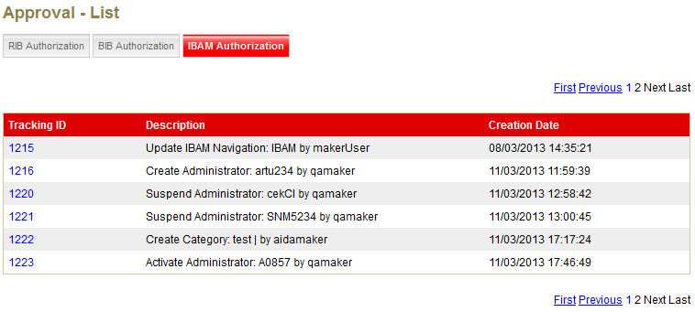

Figure 63: Authorization – Approval List Screen

**Display Specification:**

| **No** | **Field** | **Format** | **Description** |
| --- | --- | --- | --- |
|  | Description | Text | The description of the pending authorizes. |
|  | Creation Date | DD/MM/YYYY HH:MM:SS | Creation date and time of the action make by maker. |

**Action:**

| **No** | **Action** | **Type** | **Description** |
| --- | --- | --- | --- |
|  | Tracking ID | Hyperlink | Go to Authorization- Pending details page |

***Step 2:***

1. Checker user click on Aproval Tracking ID.
2. IBAM display the Transaction details page.
3. User reviews the details and makes an action either to Approve or Reject the item.
4. Once user (administrator) click Submit button the system will save it to IB database.

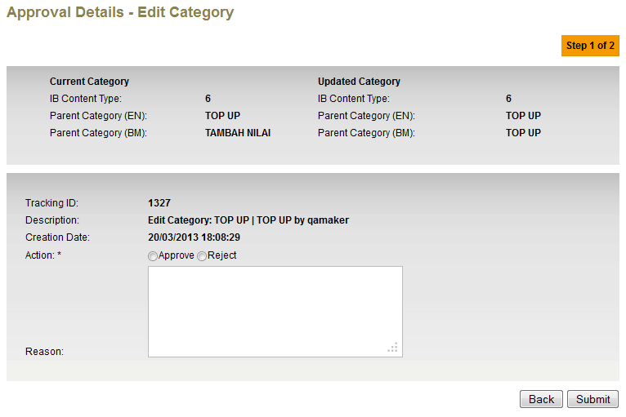

Figure 64: Authorization – Approval Details Screen

**Input Specification:**

| **No** | **Field** | **Field Type** | **Validation Rule** | **Description** | **M/O** |
| --- | --- | --- | --- | --- | --- |
|  | Action | Radio button | Must selected one of the selection | The action of the checker for this activity.   * Approve * Reject | M |
|  | Reason | Text |  | The reason of checker for selected action. | O |

**Display Specification:**

| **No** | **Field** | **Format** | **Description** |
| --- | --- | --- | --- |
|  | Tracking ID | Numeric | An unique ID for the activity |
|  | Description | Text | The description of the pending authorizes. |
|  | Creation Date | DD/MM/YYYY HH:MM:SS | Creation date and time of the action make by maker. |

**Action:**

| **No** | **Action** | **Type** | **Description** |
| --- | --- | --- | --- |
|  | Back | Button | Go to Authorization- Approval Listing page |
|  | Submit | Button | Go to Authorization –Approval result page |

**List of available messages for the screen:**

| **No.** | **Event** | **Error Description in English** | **Error Description in BM** |
| --- | --- | --- | --- |
| 1. | Did not choose the Action | Action is required. |  |
| 2. | User input more than 200 characters | Reason cannot be more than 200 characters. |  |

***Step 3:***

1. IBAM System shows the successful message, stating that the pending item have been approved or rejected.
2. Once approved, the pending item will be updated.

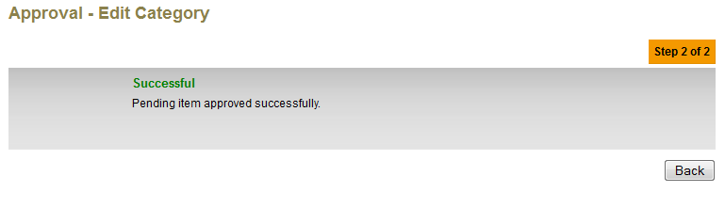

Figure 65: Authorization – Approval Result Screen

**Display Specification:**

| **No** | **Field** | **Format** | **Description** |
| --- | --- | --- | --- |
|  | Status | Text | Successful / Unsuccessful |
|  | Description | Text | The result message |

**Action:**

| **No** | **Action** | **Type** | **Description** |
| --- | --- | --- | --- |
|  | Back | Button | Back to Authorization- Approval Listing page |

# User Transaction Log

Allow IBAM Maker and Checker User to view all transaction that has been approved, rejected or still pending.

## Process Flow

Diagram 30: Authorization – User Transaction Log Flow Diagram

## Screen Flow

***Step 1:***

1. IBAM User select Authorization menu and select User Transaction Log.
2. IBAM display User Transaction Log searching screen.

Search Transaction based on Global Search:

1. IBAM User clicks on Search button.
2. IBAM display all User Transaction ID based on Transaction date.

Search Transaction based on Field Specific Search:

1. User select Date From, Date To, Category and Status then click on Search button
2. IBAM display list of User Transaction Log based on field input filtering.

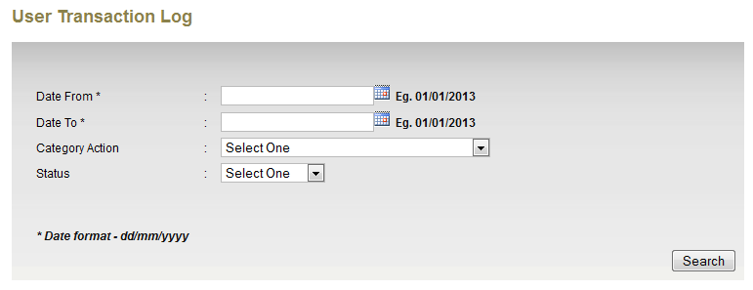

Figure 66: Authorization – User Transaction Log Search Screen

**Input Specification:**

| **No** | **Field** | **Field Type** | **Validation Rule** | **Description** | **M/O** |
| --- | --- | --- | --- | --- | --- |
| 1. | Date From | Text | DD/MM/YYYY using calendar/date picker | Search log based on date from | O |
| 2. | Date To | Text | DD/MM/YYYY using calendar/date picker | Search log based on date to | O |
| 3. | Category Action | Drop Down List |  | Search log based on the category | O |
| 4. | Status | Drop Down List | Successful/Unsuccessful  Approved/Rejected  Pending | Search log based on status | O |

**Action:**

| **No** | **Action** | **Type** | **Description** |
| --- | --- | --- | --- |
| 1. | Search | Button | Contains an action to search the logs for the Approval Items. |

**List of available messages for the screen:**

| **No.** | **Event** | **Error Description in English** | **Error Description in BM** |
| --- | --- | --- | --- |
| 1. | Enter invalid date format for Date From | Date From is an invalid date/time format |  |
| 2. | Enter invalid date format for Date To | Date To is an invalid date/time format |  |
| 3. | Select Date From greater than Date To | From date cannot be greater than to date. |  |

***Step 2:***

1. IBAM display Transaction Log List based on search criteria.
2. User click on the Activity ID to view the details of the transaction.

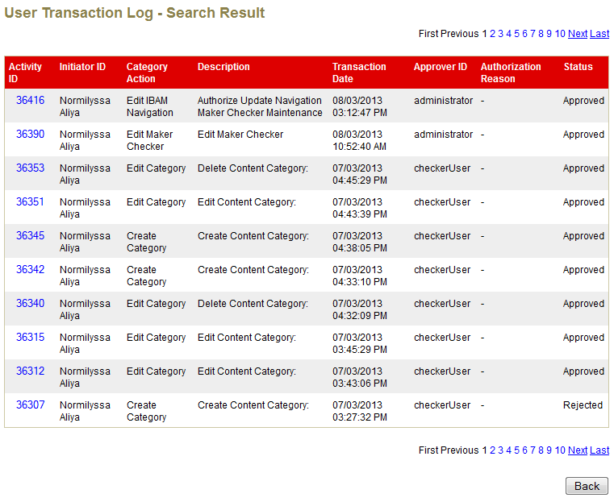

Figure 67: Authorization – User Transaction Log List Screen

**Display Fields:**

|  |  |  |  |
| --- | --- | --- | --- |
| **No** | **Field** | **Format** | **Description** |
|  | Activity ID | Numeric | Shows the ID of the log |
|  | Initiator ID | Text | Shows the user who had done that particular activity |
|  | Category Action | Text | Shows the category of the activity |
|  | Description | Text | Shows the description of the activity |
|  | Transaction Date | dd/mm/yyyy hh:mm:ss | Shows the created date of the activity |
|  | Approver ID | Text | Shows the ID of the approver |
|  | Administrator Reason | Text | Shows the reason of the approval action from the approver |
|  | Status | Text | Shows the status of the approval activity |

**Action:**

|  |  |  |  |
| --- | --- | --- | --- |
| **No** | **Action** | **Type** | **Description** |
|  | Activity ID | Hyperlink | Shows the log details page for the selected activity ID |
|  | Back | Button | Go back to previous page where the ‘User Transaction Log Search’ page is shown. |

***Step 3:***

1. IBAM display User Transaction Log details.

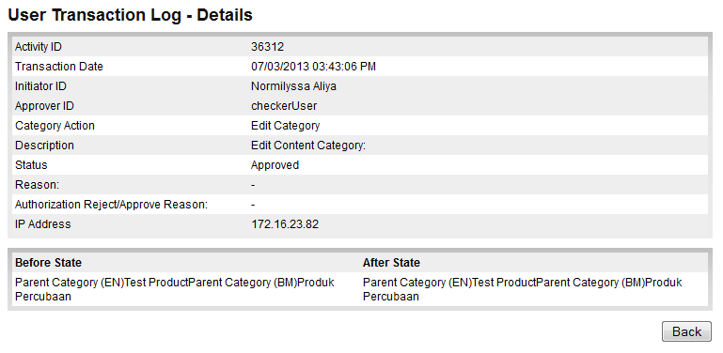

***Figure 68: Authorization – User Transaction Log Details Screen***

**Display Fields:**

|  |  |  |  |
| --- | --- | --- | --- |
| **No** | **Field** | **Format** | **Description** |
|  | Activity ID | Numeric | Shows the ID of the log |
|  | Transaction Date | Date Time | Shows the created date of the activity |
|  | Initiator ID | Text | Shows the user who had done that particular activity |
|  | Approver ID | Text | Shows the ID of the approver |
|  | Category Action | Text | Shows the category of the activity |
|  | Description | Text | Shows the description of the activity |
|  | Status | Text | Shows the status of the approval activity |
|  | Reason | Text | Shows the reason if activity is unsuccessful (optional). |
|  | Authorization Reject/Approve Reason | Text | Shows the reason of the approval action from the approver |
|  | IP Address | Alphanumeric | Shows the IP Address for the user who had done that particular activity |
|  | Before State | Text | Shows the previous details for the particular activity |
|  | After State | Text | Shows the after changes details for the particular activity |

**Action:**

|  |  |  |  |
| --- | --- | --- | --- |
| **No** | **Action** | **Type** | **Description** |
| 1. | Back | Button | Go back to previous page where the ‘User Transaction Log’ List page is shown. |