# User Group Maintenance

## User Group Access Matrix

Below is the Sample User Group Access Matrix:-

| No. | Function | Root ID / Super Admin | IBAM Admin | IB Services Admin | RIB Admin | BIB Admin |
| --- | --- | --- | --- | --- | --- | --- |
| **IBAM MANAGEMENT** | | | | | | |
|  | User Group Maintenance | | | | | |
| 1. Customer Interaction | ✓ | ✓ | ✓ |  |  |
| 1. Observation |  | ✓ | ✓ |  |  |
|  | User Profile Maintenance | | | | | |
| 1. Customer Interaction | ✓ | ✓ | ✓ |  |  |
| 1. Observation |  |   ✓ |   ✓ |  |  |
|  | IBAM Navigation | | | | | |
| 1. Customer Interaction | ✓ | ✓ |  |  |  |
| 1. Observation |  |  | ✓ |  |  |
|  | Audit Trail | | | | | |
| 1. Customer Interaction | ✓ | ✓ |  |  |  |
| 1. Observation |  |  |  |  |  |
|  | Change Own Passwords | | | | | |
| 1. Customer Interaction | ✓ | ✓ | ✓ | ✓ | ✓ |
| 1. Observation |  |  |  |  |  |
| 6. | IBAM Report | | | | | |
|  | 1. Customer Interaction |  |  |  |  |  |
| 1. Observation |  |  |  |  |  |
| 7. | Token Management | | | | | |
|  | 1. Customer Interaction |  |  |  |  |  |
|  | 1. Observation |  |  |  |  |  |
| 8. | Upass Maintenance | | | | | |
|  | 1. Customer Interaction |  |  |  |  |  |
|  | 1. Observation |  |  |  |  |  |
| **IB COMMON SERVICES MANAGEMENT** | | | | | | |
|  | IB Navigation | | | | | |
| 1. Customer Interaction | ✓ |  | ✓ |  |  |
| 1. Observation |  |  |  |  |  |
|  | IB Content | | | | | |
| 1. Customer Interaction | ✓ |  | ✓ |  |  |
| 1. Observation |  |  |  |  |  |
| **RIB MANAGEMENT** | | | | | | |
|  | RIB User Enquiry | | | | | |
| 1. Customer Interaction | ✓ |  |  | ✓ |  |
| 1. Observation |  |  |  |  |  |
|  | RIB Transaction Enquiry | | | | | |
| 1. Customer Interaction | ✓ |  |  | ✓ |  |
| 1. Observation |  |  |  |  |  |
| **BIB MANAGEMENT** | | | | | | |
|  | Company Management | | | | | |
| 1. Customer Interaction | ✓ |  |  |  | ✓ |
| 1. Observation |  |  |  |  |  |
|  | BIB Transaction Enquiry | | | | | |
| 1. Customer Interaction | ✓ |  |  |  | ✓ |
| 1. Observation |  |  |  |  |  |

Table : Sample User Group Maintenance Access Matrix

## Create User Group

This feature allows authorized IBAM administrator to create a new User Group.

### Process Flow



Diagram : Create User Group Flow Diagram

There are 2 participants involved in this process which is Admin and IBAM. The following are the steps on how to create User Group:

### Screen Flow

***Step 1:***

1. User access to User Group Maintenance Screen.
2. IBAM display User Group Maintenance Screen and show the current user group list.
3. User click on the Create button to make new user group.

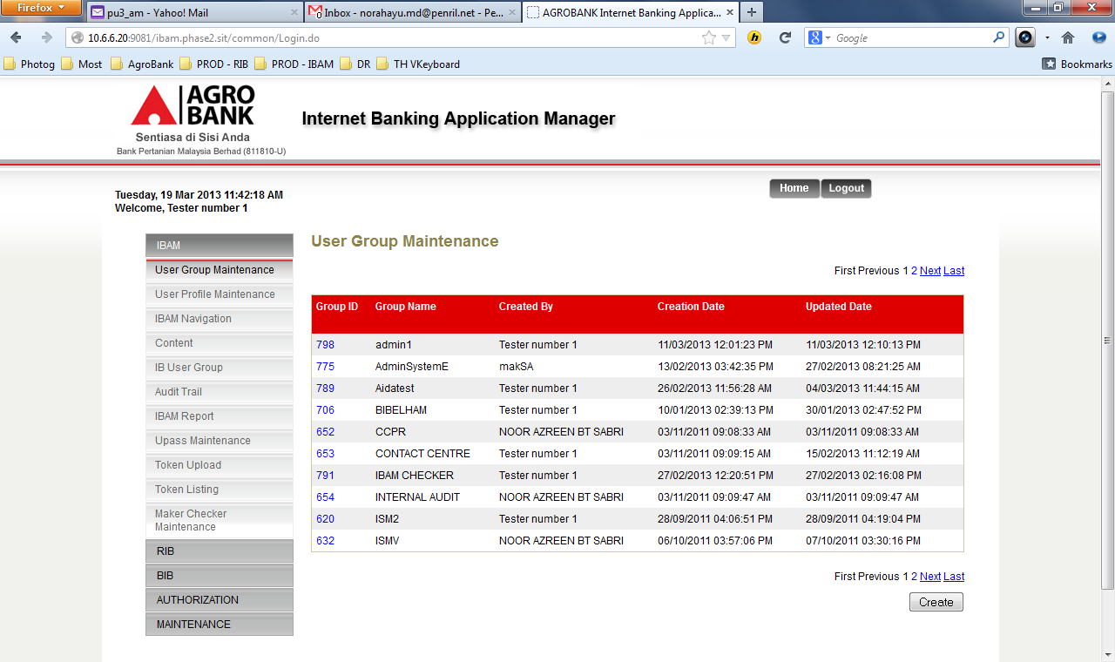

Figure : Current User Group List

**Action:**

| No | Action | Type | Description |
| --- | --- | --- | --- |
| 1. | Create | Button | Show the ‘User Group Creation’ page |
|  | Click on “Group ID” | Hyperlink | Show the details of a Group Access that has been clicked |

Table User Group List Action

***Step 2:***

1. IBAM System shows the User Group creation page.
2. User keys in the group name, description, select the group mode and the content that can be accessed / viewed inside their group based on the Access Matrix Table.
3. User clicks Next button.

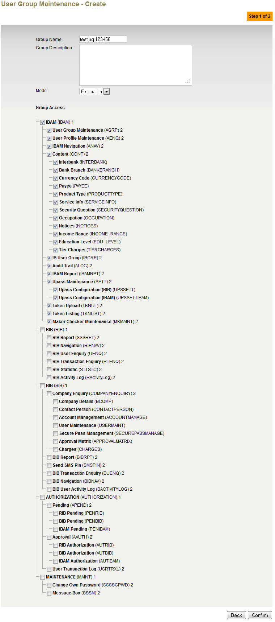

Figure : User Group Creation Page

**Input Specification:**

| No | Field | Field Type | Validation Rule | Description | Compulsory |
| --- | --- | --- | --- | --- | --- |
|  | Group Name | Text | Max length: 30  Alphanumeric with spaces | Identifier for the user group. Group Name must be unique. | Yes |
|  | Group Description | Text | Max length: 255  Text | Description of the group name. | No |
|  | Mode | Drop down List | - | Access Matrix Selection Mode | Yes |
|  | Group Access | Check Box | - | Allows particular group of admin to have access on 1 or more sub-module in admin or no access at all. | No |

Table : Create User Group Specification

**Action:**

| No | Action | Type | Description |
| --- | --- | --- | --- |
|  | Confirm | Button | Contains an action to let the IBAM system go to the next page |
|  | Back | Button | Contains an action to let the IBAM system go back to previous page (User Group List). |

Table : Create User Group Action

**List of available messages for the screen:**

|  |  |  |
| --- | --- | --- |
| **No.** | **Event** | **Error Description in English** |
|  | Fill in group name with special character. | Group Name cannot include special character except space. |
|  | Did not fill in the group name. | Group Name is required. |
|  | Fill in Group Description with more than 255 characters | Group Description cannot be greater than 255 characters. |

Table : Create Group Name Error message list

***Step 3:***

1. IBAM System shows the create user group Confirmation page
2. User click on “Confirm” button
3. All the information will stored into database.

*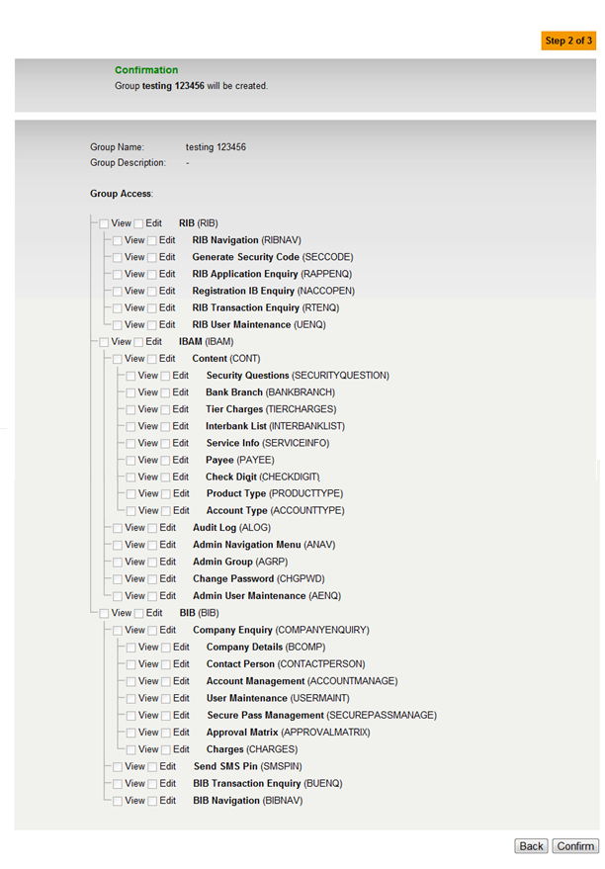***Figure 8: User Group Creation Confirmation Page**

**Action:**

| No | Action | Type | Description |
| --- | --- | --- | --- |
|  | Back | Button | Contains an action to let the IBAM system go back to previous page. |
|  | Confirm | Button | Contains an action to create a ‘User Group’ with preferred Access Control Matrix that has been defined in that page.  Shows the ‘successful message’ page |

Table : Create User Group Confirmation Action

***Step 4:***

1. IBAM shows Successful message and pending for Authorization approval process.
2. Once approved IBAM will shows New User under User Group Maintenance list.

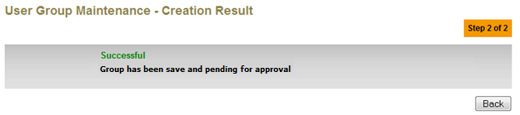

Figure : User Group Successful Creation Page

**Action:**

| No | Action | Type | Description |
| --- | --- | --- | --- |
|  | Back | Button | Contains an action to let the IBAM system go back to previous page (User Group List). |

Table : Create User Group Result Action

## Edit User Group

This feature allows authorized IBAM administrator to edit User Group.

### Process Flow



Diagram 8: Edit User Group Flow Diagram

There are 2 participants involved in this process which is Admin and IBAM. The following are the steps on how to edit user group:

### Screen Flow

***Step 1:***

1. Admin can access to User Group Maintenance Screen by clicking on the “User Group Maintenance” link on the left navigation menu.
2. IBAM display IBAM User Group Maintenance Screen.
3. Admin click on the “Edit” button to go to the edit page.

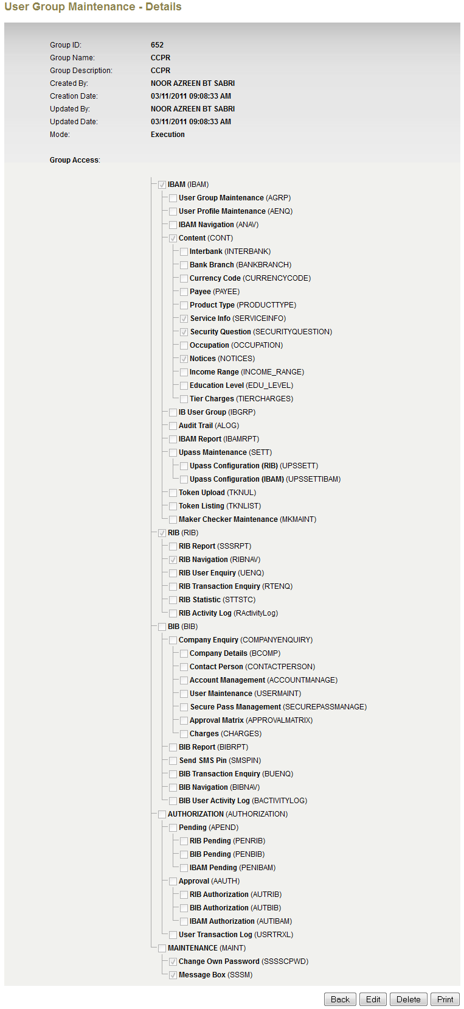

Figure : User Group Maintenance Screen

**Action:**

| No | Action | Type | Description |
| --- | --- | --- | --- |
|  | Edit | Button | Contains an action to edit an existing ‘User Group’ with preferred Access Control Matrix that has been defined in that page.  Display Group Access Edit Screen. |
|  | Back | Button | Contains an action to let the IBAM system go back to previous page (User Group List). |

Table : Edit User Group Action

***Step 2:***

1. IBAM system display Group Edit Screen.
2. User edits User Group Settings and clicked the “Confirm” button.

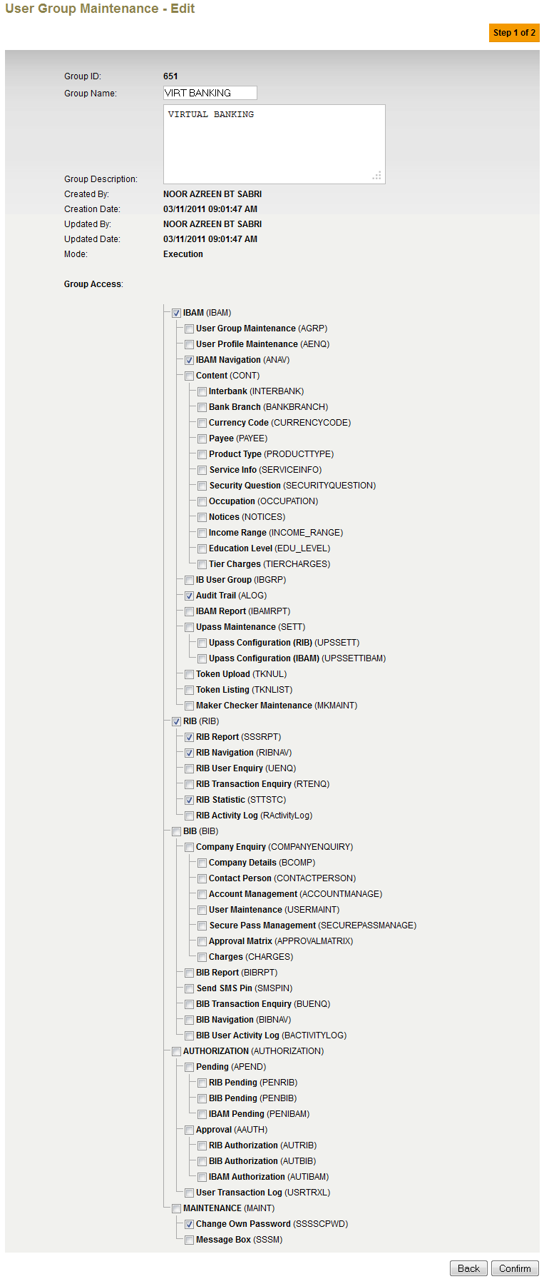

Figure : User Group Edit Screen

**Input Specification:**

| No | Field | Field Type | Validation Rule | Description | Compulsory |
| --- | --- | --- | --- | --- | --- |
|  | Group Name | Text | Max length: 64  Alphanumeric and spaces | Identifier for the User Group. Group Name must be unique. | Yes |
|  | Group Description | Text | Max length: 255  Text | Description of the group name. | No |
|  | Group Access | Check Box | - | Allows particular group of admin to have access on 1 or more sub-module in admin or no access at all. | Yes |

Table : Edit User Group Input Specification

**Action:**

| No | Action | Type | Description |
| --- | --- | --- | --- |
|  | Confirm | Button | Contains an action to go to confirmation page. |
|  | Back | Button | Contains an action to let the IBAM system go back to previous page (User Group Details). |

Table : Edit User Group Action

**List of available messages for the screen:**

|  |  |  |
| --- | --- | --- |
| **No.** | **Event** | **Error Description in English** |
|  | Fill in group name with special character. | Group Name cannot include special character except space and underscore |
|  | Did not fill in the group name. | Group Name is required. |
|  | Fill in Group Description with more than 255 characters | Group Description cannot be greater than 255 characters. |
|  | Fill in duplicate Group Name | Group name already exist |

Table : Edit User Group Error message list

***Step 3:***

1. IBAM system display User Group Edit Confirmation Screen.
2. User click on “Confirm” button

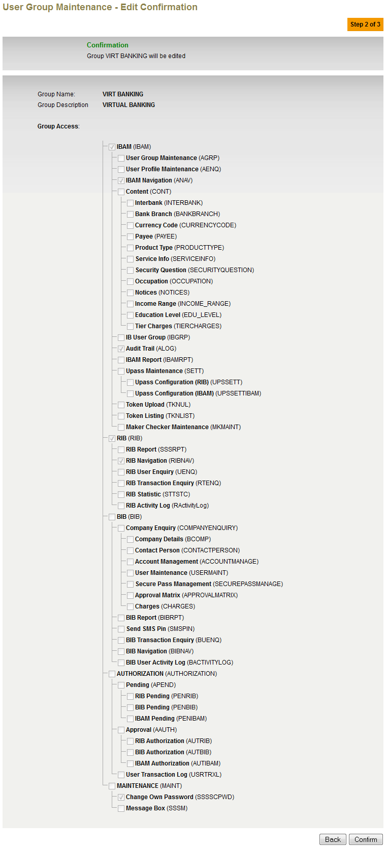

Figure : User Group Edit Confirmation Screen

**Action:**

| No | Action | Type | Description |
| --- | --- | --- | --- |
|  | Confirm | Button | Contains an action to create a ‘User Group’ with preferred Access Control Matrix that has been defined in that page.  Shows the ‘successful message’ page |
|  | Back | Button | Contains an action to let the IBAM system go back to previous page (User Group Details). |

Table : Edit User Group Action

***Step 4:***

1. IBAM saves the edited User Group Settings and display the successful result page.
2. IBAM shows Successful message and pending for Authorization approval process.
3. Once approved IBAM will shows update information under User Group Maintenance list.

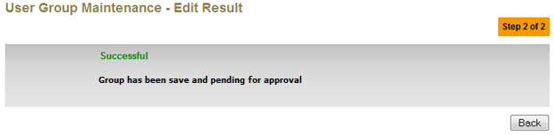

Figure : User Group Edit Result Screen

**Action:**

| No | Action | Type | Description |
| --- | --- | --- | --- |
|  | Back | Button | Contains an action to let the IBAM system go back to previous page (User Group List). |

Table : Edit User Group Result Action

## Delete User Group

This feature allows authorized IBAM administrator to delete User Group.

### Process Flow

 Diagram : Delete User Group Flow Diagram

There are 2 participants involved in this process which is IBAM User and IBAM System. The following are the steps on how to delete User Group:

### Screen Flow

***Step 1:***

1. User can access to User Group Maintenance Screen by clicking on the “User Group Maintenance” link on the left navigation menu.
2. IBAM display IBAM User Group Maintenance Screen.
3. Admin click on the “Delete” button to go to the Delete User Group Confirmation page.



Figure : User Group Maintenance Screen

**Action:**

| No | Action | Type | Description |
| --- | --- | --- | --- |
|  | Delete | Button | Contains an action to delete an existing ‘User Group ’.  Display Delete User Group Confirmation Screen. |
|  | Back | Button | Contains an action to let the IBAM system go back to User Group List. |

Table : Delete User Group Action

***Step 2:***

1. IBAM display Delete User Group Confirmation Screen.
2. Admin delete User Group and clicked the “Confirm” button.

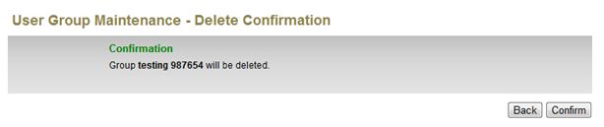

Figure : Delete User Group Confirmation Screen

**Action:**

| No | Action | Type | Description |
| --- | --- | --- | --- |
|  | Back | Button | Contains an action to let the IBAM system go back to User Group Details Screen. |
|  | Confirm | Button | Contains an action to delete User Group.  Shows Delete User Group Result Screen. |

Table : Delete User Group Confirmation Action

***Step 3:***

1. IBAM System deletes the User Group and display the result page.
2. IBAM shows Successful message and pending for Authorization approval process.
3. Once approved IBAM will deleted user group under User Group Maintenance list.

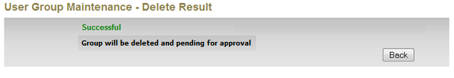

Figure : Delete User Group Result Screen

**Action:**

| No | Action | Type | Description |
| --- | --- | --- | --- |
| 1. | Back | Button | Contains an action to let the IBAM system go back to User Group List page. |

Table : Delete User Group Result Action