User Group Maintenance

# Create

1. Group ID at After State (User Transaction Log)not tally with User Group Maintenance Details

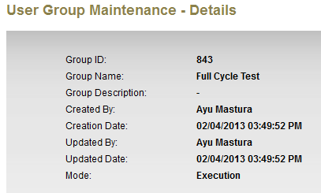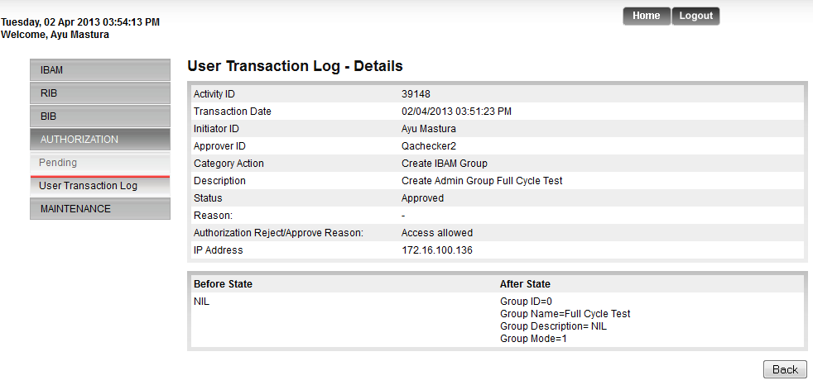

1. Mode Not display at confirmation page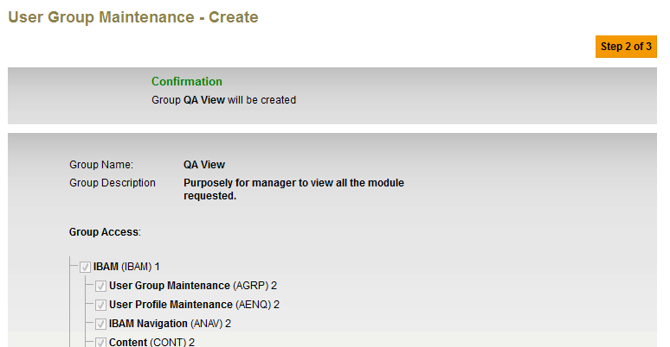

**Mode: ???????????**

1. Sort Navigation Name into a group.

