**Upass Maintenance**

1. **IBAM**
   1. **Screen Flow**

***Step 1:***

* 1. IBAM Maker User access to Upass Maintenance screen and select IBAM for Upass Application
  2. Click on Next button to proceed
  3. IBAM will show the details of the Upass Application

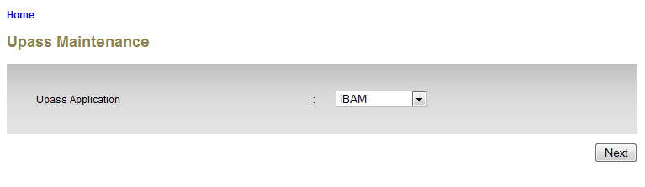

**Display Specification:**

| **No** | **Field** | **Format** | **Description** |
| --- | --- | --- | --- |
|  | Upass Application | Drop down list | The Upass Application module name |

**Action:**

| **No** | **Action** | **Type** | **Description** |
| --- | --- | --- | --- |
|  | Next | Button | Go to Details page |

**List of available messages for the screen:**

| **No.** | **Event** | **Error Description in English** | **Error Description in BM** |
| --- | --- | --- | --- |
| 1. | Did not choose the Upass Application | Upass Application is required. |  |

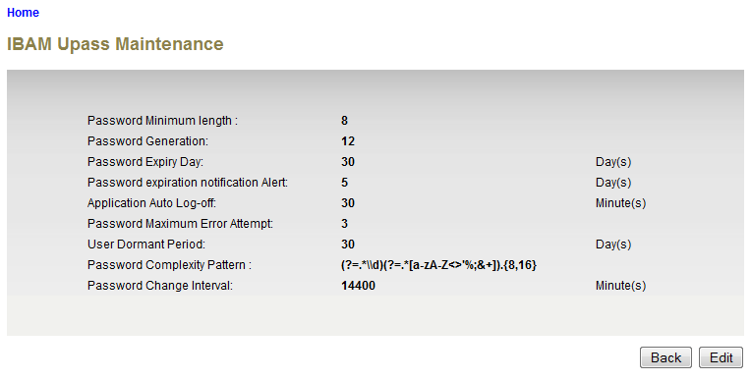

**Display Specification:**

| **No** | **Field** | **Format** | **Description** |
| --- | --- | --- | --- |
|  | Password Minimum Length | Numeric | The minimum length of the password |
|  | Password Generation | Numeric | Password Generation for the password can be used again |
|  | Password Expiry Day | Numeric | The password expiry day |
|  | Password Expiration Notification Alert | Numeric | The day of password expiration notification alert |
|  | Application Auto Log-Off | Numeric | Time for the application to auto log-off |
|  | Password Maximum Error Attempt | Numeric | The maximum password error attempt |
|  | User Dormant Period | Numeric | The period that the user become dormant |
|  | Password Complexity Pattern | Text | The complexity pattern of the password |
|  | Password Change Interval | Numeric | The password change interval |

**Action:**

| **No** | **Action** | **Type** | **Description** |
| --- | --- | --- | --- |
|  | Back | Button | Go to Upass Application selection page |
|  | Edit | Button | Go to edit page |

***Step 2:***

* 1. Click on Edit button to proceed
  2. IBAM will show the details of the Upass Application that can be edited

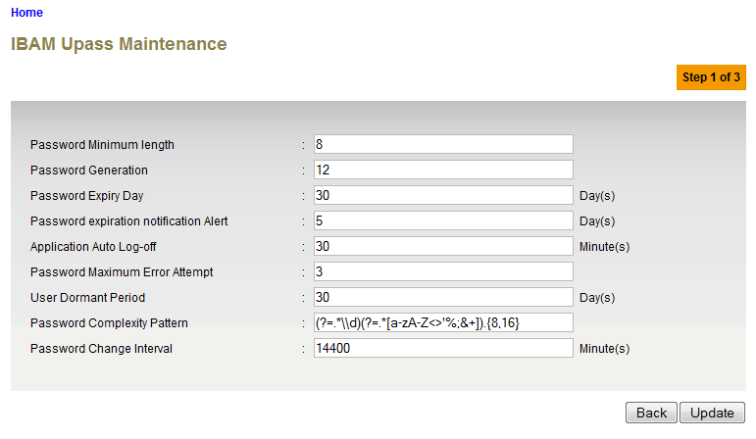

**Specification:**

| **No** | **Field** | **Field Type** | **Validation Rule** | **Description** | **Compulsory** |
| --- | --- | --- | --- | --- | --- |
| 1. | Password Minimum Length | Numeric | Max Length: 2  Numeric | The minimum length of the password | Yes |
| 2. | Password Generation | Numeric | Max length: 2  Numeric | Password Generation for the password can be used again | Yes |
| 3. | Password Expiry Day | Numeric | Max length: 2  Numeric | The password expiry day | Yes |
| 4. | Password Expiration Notification Alert | Numeric | Max length: 4  Numeric | The day of password expiration notification alert | Yes |
| 5. | Application Auto Log-Off | Numeric | Max length: 2  Numeric | Time for the application to auto log-off | Yes |
| 6. | Password Maximum Error Attempt | Numeric | Max length: 2  Numeric | The maximum password error attempt | Yes |
| 7. | User Dormant Period | Numeric | Max Length: 2  Numeric | The period that the user become dormant | Yes |
| 8. | Password Complexity Pattern | Text | Alphabet, numeric or special character | The complexity pattern of the password | No |
| 9. | Password Change Interval | Numeric | Max Length: 5  Numeric | The password change interval | Yes |

**Action:**

| No | Action | Type | Description |
| --- | --- | --- | --- |
| 1. | Back | Button | Contains an action to let the IBAM system go back to previous page (Upass Maintenance Details page). |
| 2. | Update | Button | Contains an action to let the IBAM system go next page (Upass Maintenance Confirm Page). |

**List of available messages for the screen:**

| No. | Event | Error Description in English | Error Description in BM |
| --- | --- | --- | --- |
| 1. | Did not fill in any of the mandatory fields. | Password Minimum length is required.  Password Generation is required.  Password Expiry Day is required.  Password expiration notification Alert is required.  Application Auto Log-off is required.  Password Maximum Error Attempt is required.  User Dormant Period is required.  Password Change Interval is required. |  |
| 2. | Fill in each field with alphabet | Password Minimum length is not numeric.  Password Generation is not numeric.  Password Expiry Day is not numeric.  Password expiration notification Alert is not numeric.  Application Auto Log-off is not numeric.  Password Maximum Error Attempt is not numeric.  User Dormant Period is not numeric.  Password Change Interval is not numeric. |  |

***Step 3:***

1. IBAM system display confirmation page.
2. User click on “Confirm” button.

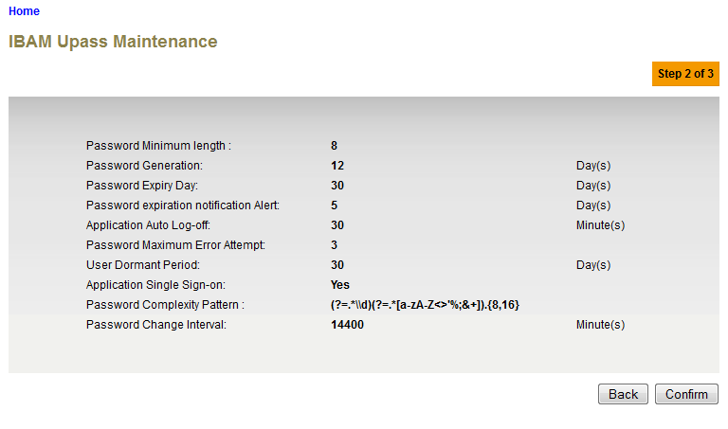

**Action:**

| No | Action | Type | Description |
| --- | --- | --- | --- |
| 1. | Back | Button | Contains an action to let the IBAM system go back to previous page. |
| 2. | Confirm | Button | Contains an action to update the Upass Maintenance  Shows the ‘Upass Maintenance” result page. |

***Step 4:***

1. IBAM validates upass maintenance details and save the updates to IB Database and displays result page.
2. IBAM shows Successful message and pending for Authorization approval process.
3. Once approved IBAM will shows the updated details under Upass Maintenance list.

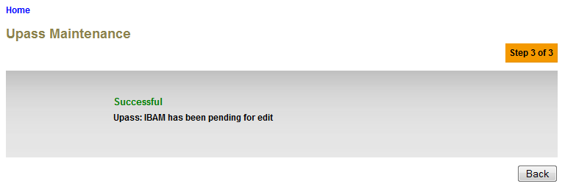**Action:**

| **No** | **Action** | **Type** | **Description** |
| --- | --- | --- | --- |
| 1 | Back | Button | Contains an action to let the IBAM system go back to previous page (Upass Maintenance selection page). |

1. **RIB/BIB**
   1. **Screen Flow**

***Step 1:***

* 1. IBAM Maker User access to Upass Maintenance screen and select RIB/BIB for Upass Application
  2. Click on Next button to proceed
  3. IBAM will show the details of the Upass Application

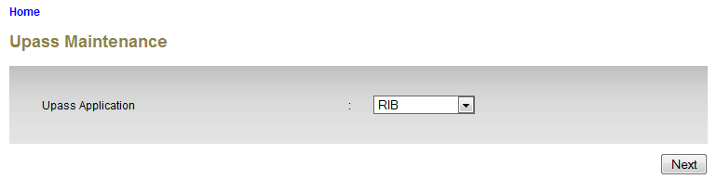

**Display Specification:**

| **No** | **Field** | **Format** | **Description** |
| --- | --- | --- | --- |
|  | Upass Application | Drop down list | The Upass Application module name |

**Action:**

| **No** | **Action** | **Type** | **Description** |
| --- | --- | --- | --- |
|  | Next | Button | Go to Details page |

**List of available messages for the screen:**

| **No.** | **Event** | **Error Description in English** | **Error Description in BM** |
| --- | --- | --- | --- |
| 1. | Did not choose the Upass Application | Upass Application is required. |  |

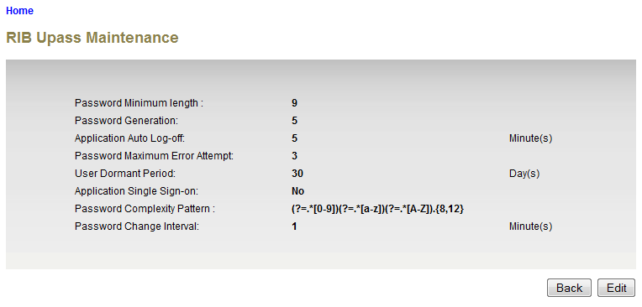

**Display Specification:**

| **No** | **Field** | **Format** | **Description** |
| --- | --- | --- | --- |
|  | Password Minimum Length | Numeric | The minimum length of the password |
|  | Password Generation | Numeric | Password Generation for the password can be used again |
|  | Application Auto Log-Off | Numeric | Time for the application to auto log-off |
|  | Password Maximum Error Attempt | Numeric | The maximum password error attempt |
|  | User Dormant Period | Numeric | The period that the user become dormant |
|  | Application Single Sign-on | Drop Down list | To control (YES/NO) single sign-on application |
|  | Password Complexity Pattern | Text | The complexity pattern of the password |
|  | Password Change Interval | Numeric | The password change interval |

**Action:**

| **No** | **Action** | **Type** | **Description** |
| --- | --- | --- | --- |
|  | Back | Button | Go to Upass Application selection page |
|  | Edit | Button | Go to edit page |

***Step 2:***

* 1. Click on Edit button to proceed
  2. IBAM will show the details of the Upass Application that can be edited

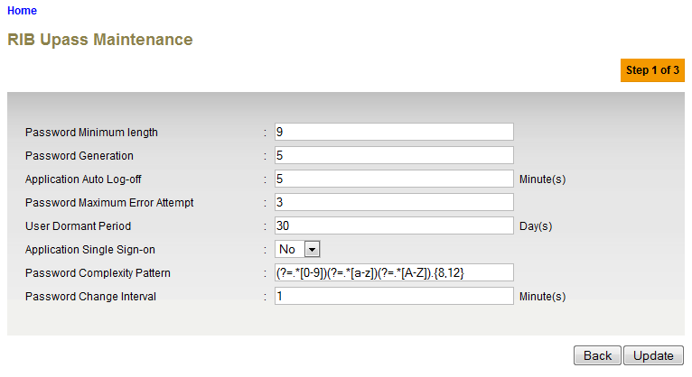

**Specification:**

| **No** | **Field** | **Field Type** | **Validation Rule** | **Description** | **Compulsory** |
| --- | --- | --- | --- | --- | --- |
| 1. | Password Minimum Length | Numeric | Max Length: 2  Numeric | The minimum length of the password | Yes |
| 2. | Password Generation | Numeric | Max length: 2  Numeric | Password Generation for the password can be used again | Yes |
| 3. | Application Auto Log-Off | Numeric | Max length: 2  Numeric | Time for the application to auto log-off | Yes |
| 4. | Password Maximum Error Attempt | Numeric | Max length: 2  Numeric | The maximum password error attempt | Yes |
| 5. | User Dormant Period | Numeric | Max Length: 2  Numeric | The period that the user become dormant | Yes |
| 6. | Password Complexity Pattern | Text | Alphabet, numeric or special character | The complexity pattern of the password | No |
| 7. | Application Single Sign-On | Drop Down List |  | To control (YES/NO) single sign-on application | No |
| 8. | Password Change Interval | Numeric | Max Length: 5  Numeric | The password change interval | Yes |

**Action:**

| No | Action | Type | Description |
| --- | --- | --- | --- |
| 1. | Back | Button | Contains an action to let the IBAM system go back to previous page (Upass Maintenance Details page). |
| 2. | Update | Button | Contains an action to let the IBAM system go next page (Upass Maintenance Confirm Page). |

**List of available messages for the screen:**

| No. | Event | Error Description in English | Error Description in BM |
| --- | --- | --- | --- |
| 1. | Did not fill in any of the mandatory fields. | Password Minimum length is required.  Password Generation is required.  Password Expiry Day is required.  Password expiration notification Alert is required.  Application Auto Log-off is required.  Password Maximum Error Attempt is required.  User Dormant Period is required.  Password Change Interval is required. |  |
| 2. | Fill in each field with alphabet | Password Minimum length is not numeric.  Password Generation is not numeric.  Password Expiry Day is not numeric.  Password expiration notification Alert is not numeric.  Application Auto Log-off is not numeric.  Password Maximum Error Attempt is not numeric.  User Dormant Period is not numeric.  Password Change Interval is not numeric. |  |

***Step 3:***

1. IBAM system display confirmation page.
2. User click on “Confirm” button.

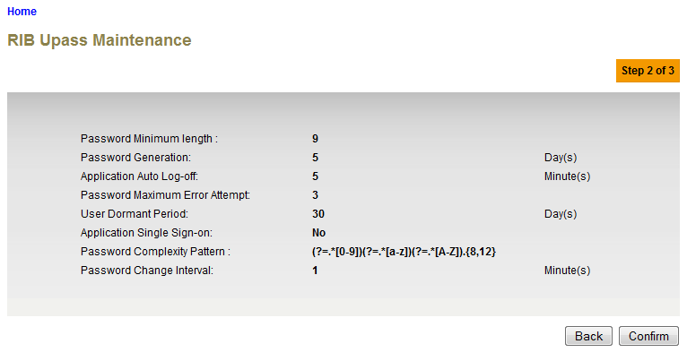

**Action:**

| No | Action | Type | Description |
| --- | --- | --- | --- |
| 1. | Back | Button | Contains an action to let the IBAM system go back to previous page. |
| 2. | Confirm | Button | Contains an action to update the Upass Maintenance  Shows the ‘Upass Maintenance” result page. |

***Step 4:***

1. IBAM validates upass maintenance details and save the updates to IB Database and displays result page.
2. IBAM shows Successful message and pending for Authorization approval process.
3. Once approved IBAM will shows the updated details under Upass Maintenance list.

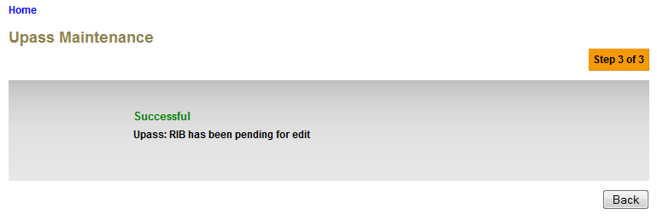

**Action:**

| **No** | **Action** | **Type** | **Description** |
| --- | --- | --- | --- |
| 1 | Back | Button | Contains an action to let the IBAM system go back to previous page (Upass Maintenance selection page). |