1. From the RIB Transaction Enquiry, there are have **10 New 3rd Party Account Transfer** transactions for that day (**14/03/2013**)

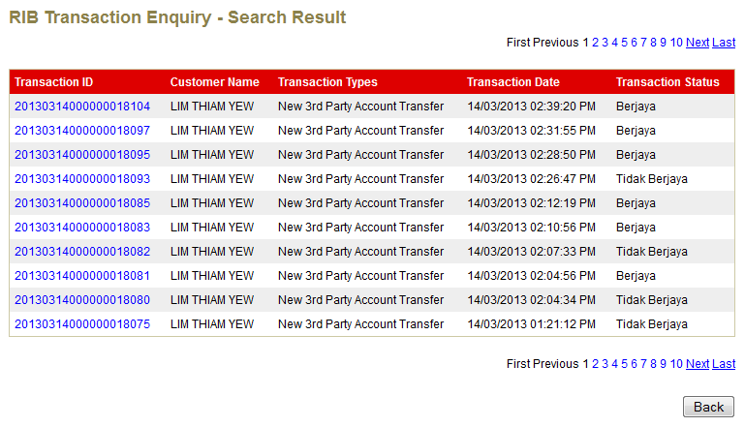

1. I try to search the report for **3rd Party Fund Transfers** for **March 2013** transactions

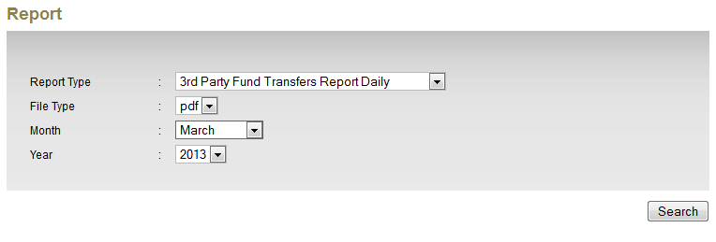

1. Choose **14/03/2013** report

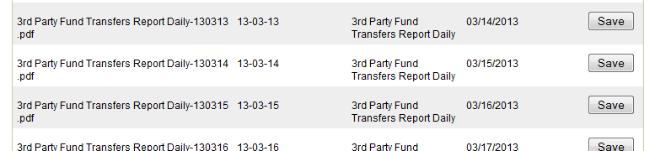

1. The report display incorrect data.
   1. Total records 2 instead of 10 records
   2. The transaction id is incorrect

