# User Profile Maintenance

## Create User Profile

This feature allows administrator to create new IBAM User.

### Process Flow



Diagram 11: Create User Profile Maintenance Flow Diagram

There are 2 participants involved in this process which is Admin and IBAM. The following are the steps to create a new IBAM User:

### Screen Flow

***Step 1:***

1. Administrator can access to User Profile Creation Screen by clicking on the “User Profile Maintenance” link at the left navigation menu followed by clicking the “Create” button.

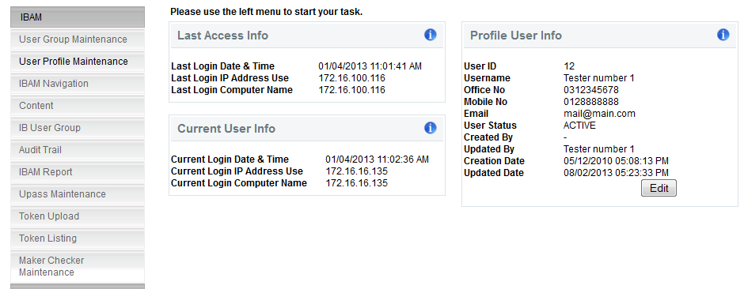**Figure 25: User Profile Maintenance Navigation**

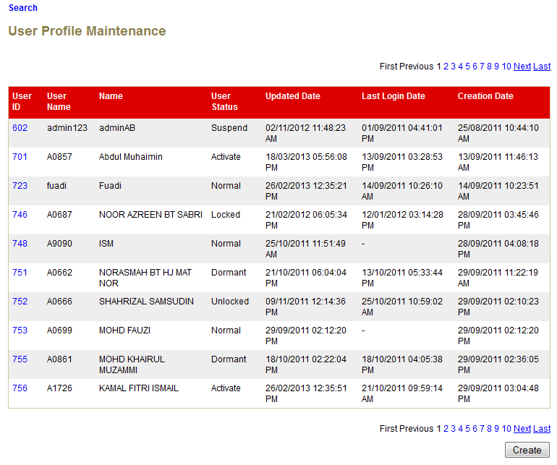

**Figure 26: User Profile Maintenance List Screen**

**Action:**

| No | Action | Type | Description |
| --- | --- | --- | --- |
|  | Create | Button | Contains an action to create a New ‘User Profile’.  Shows the ‘Create User Details’ page. |

***Step 2:***

1. IBAM System shows the Admin User Profile creation page.
2. Admin input preferred Username, Name, Email, Office No., Mobile No., select a Group, input Password and Confirm Password and click on the “Next” button to confirm.

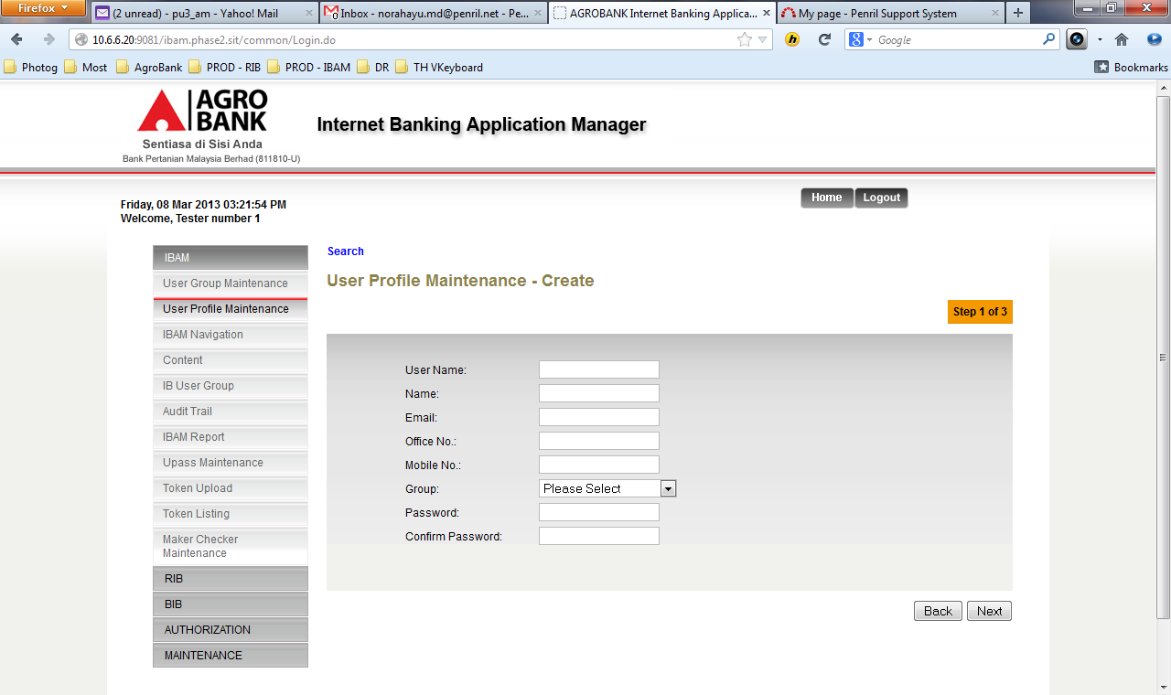

Figure27: User Profile Creation Screen

**Specification:**

| No | Field | Field Type | Validation Rule | Description | Compulsory |
| --- | --- | --- | --- | --- | --- |
|  | User Name | Text | Min Length: 6  Max Length: 16  Username must consist single or combination of alphabet and numeric or alphanumeric. Underscore is accepted. | The unique name you use to identify yourself on IBAM | Yes |
|  | Name | Text | Max length: 64  Alphabet with allowed special character space@./ | User’s full name | Yes |
|  | Email | Text | Max length: 40  Email, comply to format: <value>@<value>.<value> | The user’s email address.  Example:  user@agrobank.com.my | Yes |
|  | Office No. | Numeric | Min length: 9  Max length: 10  Numeric | The user's office number  Example:  0362012622 | Yes |
|  | Mobile No. | Numeric | Min length: 11  Max length: 12  Numeric | The 10 -11 digits mobile number  Example:  60123456789 | Yes |
|  | Group | Dropdown List | Must select one of the group categories. | The Group that this user belong to | Yes |
|  | Password | Text, Masked | Min Length: 8  Max Length: 12  Must be a combination of numeric and alphabet format and cannot include these special character ["<>'%;&+] with a range between 8 to 12 characters. | Default password for the new user. | Yes |
|  | Confirm Password | Text, Masked | Must be same as Password | Confirm password must be exact match with Password | Yes |

**Action:**

| No | Action | Type | Description |
| --- | --- | --- | --- |
| 1. | Back | Button | Contains an action to let the IBAM system go back to previous page (User Profile Maintenance List). |
| 2. | Next | Button | Contains an action to let the IBAM system go next page (User Profile Maintenance List). |

**List of available messages for the screen:**

| **No.** | **Event** | **Error Description in English** | **Error Description in BM** |
| --- | --- | --- | --- |
|  | Did not fill in any of the mandatory fields. | Username is required.  Name is required  Email is required  Office No is required  Mobile No is required  Group is required  Password is required  Confirm Password is required |  |
|  | Fill in Username less than 6 char. | Username cannot be less than 6 characters / digits. |  |
|  | Fill in Username with special character. | Username cannot include special character except underscore. |  |
|  | Fill in Name with more than 64 characters | Full Name cannot be greater than 64 characters. |  |
|  | Fill in an invalid email address. | Email format invalid. |  |
|  | Fill in less than 9 char. To Office No. | Office No. must be 9 characters / digits. |  |
|  | Fill in Office No contains alphabet | Office No is not numeric |  |
|  | Fill in Mobile No contains alphabet | Mobile No is not numeric |  |
|  | Fill in less than 11 char. To Mobile No. | Mobile No. must be 11 to 12 characters / digits. |  |
|  | Did not select Group. | Group is required. |  |
|  | Fill in less than 8 characters to Password | Password cannot be less than 8 characters / digits |  |
|  | Fill in password contains with one of the criteria below:   * Un-allowed Special character * Digit only * Lower case alphabets only * Upper case alphabets only * Lower and upper case alphabets | Password must contain a mixture of numeric and alphabet format. Cannot include these special character ["<>'%;&+] |  |
|  | Fill in Password same as Username. | Password cannot be the same as Username. |  |
|  | Password and confirm password does not match | Confirm Password must be the same as Password |  |

***Step 3:***

1. IBAM system display Create User Profile Confirmation Page.
2. User click on “Confirm” button.

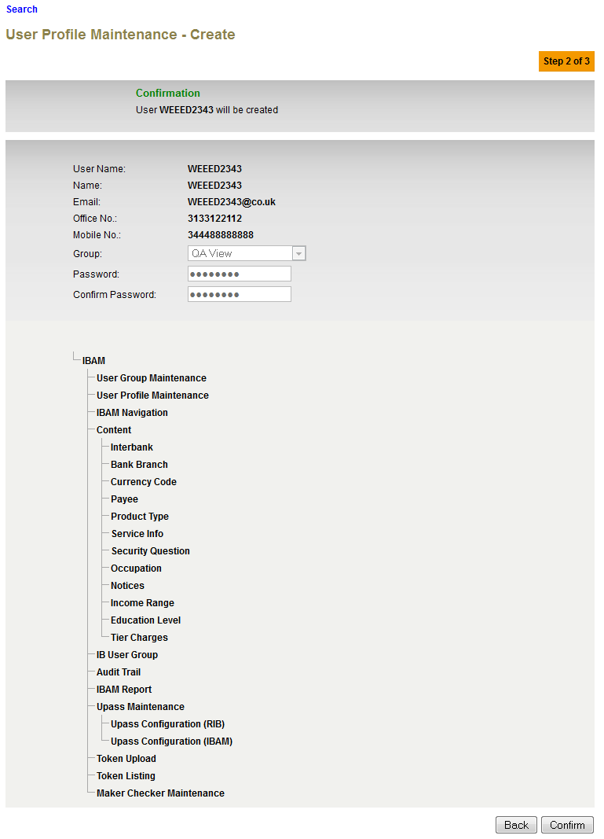

Figure 28: Create User Profile Confirmation Screen

Action:

| No | Action | Type | Description |
| --- | --- | --- | --- |
|  | Back | Button | Contains an action to let the IBAM system go back to previous page. |
|  | Confirm | Button | Contains an action to create a ‘New User Profile’.  Shows the ‘Create User Profile’ result page. |

***Step 4:***

1. IBAM validates user details and save the New User to IB Database and displays result page.
2. IBAM shows Successful message and pending for Authorization approval process.
3. Once approved IBAM will shows New User under User Profile Maintenance list.

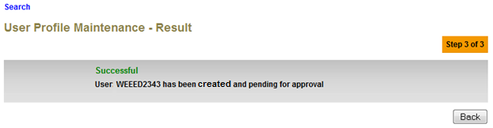

Figure 29: Create User Profile Result Screen with Authorization Proses

If User Profile Maintenance ‘disable’ from Maker Checker Maintenance

1. IBAM validates user details and save the New User to IB Database and displays result page.
2. IBAM shows Successful message and shows New User under User Profile Maintenance list.

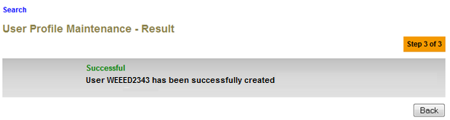

Figure 29: Create User Profile Result Screen without Authorization Proses

**Action:**

| No | Action | Type | Description |
| --- | --- | --- | --- |
|  | Back | Button | Contains an action to let the IBAM system go back to previous page (User Profile Maintenance List). |

### System Security Requirements:

Below table shows the requirement for the User ID and Password for AGROBANK:

|  |  |  |  |  |  |
| --- | --- | --- | --- | --- | --- |
| No | Field | Field Type | Rule | Description | Compulsory |
|  | User Name | Text Box | Single or combination of 6 – 16 chars of numeric, alpha or alphanumeric. Underscore is accepted. | The rule is not parameterized. | Yes |
|  | Maximum password expiration | Text Box | **30 days** system must force change | System wide support and can be parameterized via IBAM – Upass Maintenance | Yes |
|  | Minimum password length | Text Box | **8** characters minimum of alphanumeric | This is standard feature. |  |
|  | Inactive/Dormant ID for more than 30 days | - | User ID is disabled by system after 30 days if inactivity. | The number of days can be parameterized via IBAM – Upass Maintenance | - |
|  | Duplicate password control | - | For a minimum of **12** generations, same passwords cannot be repeated. | The number of generations can be parameterized via IBAM – Upass Maintenance | - |
|  | Last sign on information display | - | - | Preferably system to display the last sign on information to user upon sign on to system.  This is a standard feature. | - |
|  | First time sign on password must be forced change | - | * **8** characters minimum of alphanumeric. * Password cannot be the same as previous. | First time sign on-user must be forced to change the defaulted passwords.  This is standard feature. | Yes |
|  | Changing of passwords by user | - | * **8** characters minimum of alphanumeric * See Rule No.5 | Users may change their passwords at any time they wish.  This is standard feature. | - |
|  | Passwords composition | - | Must be combination of alphanumeric, special characters, lower/upper case (if possible) | This is standard feature.  The password must be combination of at least 1 alphabet and 1 numeric value and case sensitive. | - |
|  | Deletion of User IDs from application | - | The same user id can be reuse even for deleted user. The deleted user will not show on user enquiry screen, but the deleted user record still stored in database. | - | - |

## Search User Profile

This feature allows Administrator to search for another user details.

### Process Flow

**Diagram 12: Search User Profile Flow Diagram**

There are 2 participants involved in this process which is Admin and IBAM. The following are the steps to Search an IBAM User

### Screen Flow

***Step 1:***

1. Administrator can access to User Profile Maintenance List Screen by clicking on the “User Profile Maintenance” link on the left navigation menu.
2. User Profile Maintenance list screen will be shown.
3. Administrator can start search for IBAM User by clicking the “Search” link or select a specific user from the list on the screen.



**Figure 30: User Profile Maintenance Navigation**

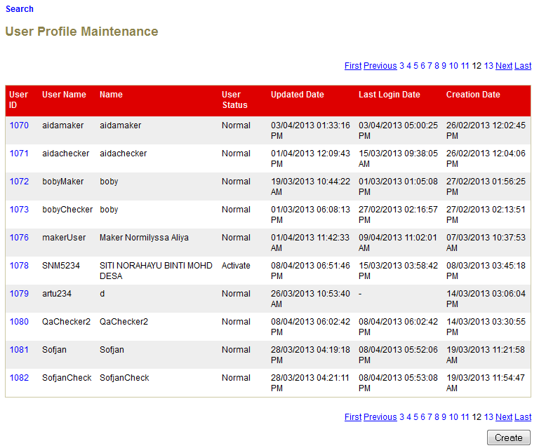

**Figure 31: User Profile Maintenance List Screen**

**Action:**

| No | Action | Type | Description |
| --- | --- | --- | --- |
| 1. | Search | Button | Contains an action to search and existing ‘User Profile’ in the list. Show ‘User Profile Maintenance Enquiry’ page. |
| 2. | Click on “User ID” | Hyperlink | Show the User Profile Enquiry Details. |

***Step 2:***

1. IBAM display User Profile Maintenance Field Specific Search screen.
2. Administrator enters specific user information to the required field and click “search” button.

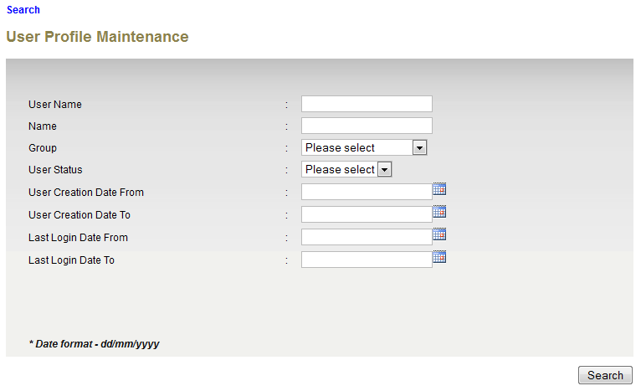

**Figure 32: User Profile Field Search Screen**

**Specification:**

| No | Field | Field Type | Validation Rule | Description | Compulsory |
| --- | --- | --- | --- | --- | --- |
| 1. | User Name | Text | Min Length: 6  Max Length: 16  User Name must consist at least 1 alphabet and 1 numeric | The user login name | No |
| 2. | Full Name | Text | Max length: 64  Alphanumeric with Space and Thai character. | The user name | No |
| 3. | Group | Text | Must select one of the group categories. | The group name that user belong | No |
| 4. | User Status | Text | One of status must be selected. | The user current status | No |
| 5. | User Creation Date From | Text | Gregorian calendar format & time  (DD/MM/YYYY HH:MM:SS) | The date search range, start date.  The date when the user profile being created | No |
| 6. | User Creation Date To | Text | Gregorian calendar format & time  (DD/MM/YYYY HH:MM:SS) | The date search range, end date.  The date when the user profile being created | No |
| 7. | Last Login Date From | Text | Gregorian calendar format & time  (DD/MM/YYYY HH:MM:SS) | The date search range, start date.  The user last login date. | No |
| 8. | Last Login Date To | Text | Gregorian calendar format & time  (DD/MM/YYYY HH:MM:SS) | The date search range, end date  The user last login date. | No |

**Action:**

| No | Action | Type | Description |
| --- | --- | --- | --- |
| 1. | Search | Button | Contains an action to search specific ‘User Profile’ in the list. Show ‘User Profile Maintenance Search’ result page. |

**List of available messages for the screen:**

|  |  |  |  |
| --- | --- | --- | --- |
| No. | Event | Error Description in English | Error Description in BM |
| 1. | Fill in Username with special character. | Username cannot include special character. |  |
| 2. | Fill in Full Name with special character. | Full Name cannot include special character. |  |
| 3. | Fill in Full Name with more than 64 characters | Full Name cannot be greater than 64 characters. |  |
| 4. | Fill in invalid Date or Time format | User Creation Date To is an invalid date/time format  Last Login Date From is an invalid date/time format  Last Login Date To is an invalid date/time format  User Creation Date From is an invalid date/time format |  |
| 5. | Fill in User Creation Date From greater than Creation Date To | From date cannot be greater than to date. |  |
| Fill in Last Login Date From greater than Last Login Date To |

***Step 3:***

1. IBAM display User Profile Search List Screen of the selected User ID.
2. Admin click on the User ID link to display on the User Profile details.

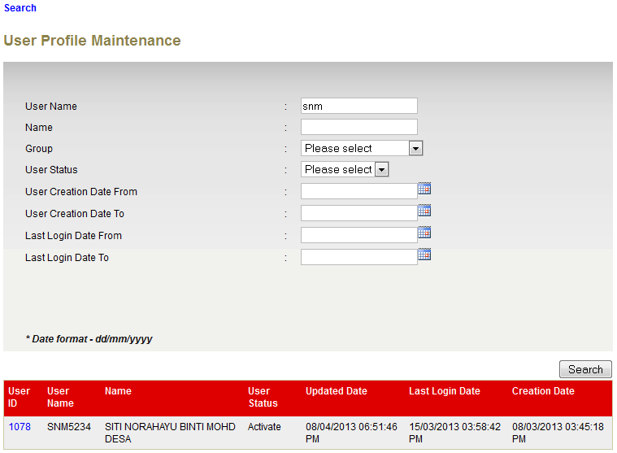**Figure 33: Search User Profile Result Screen**

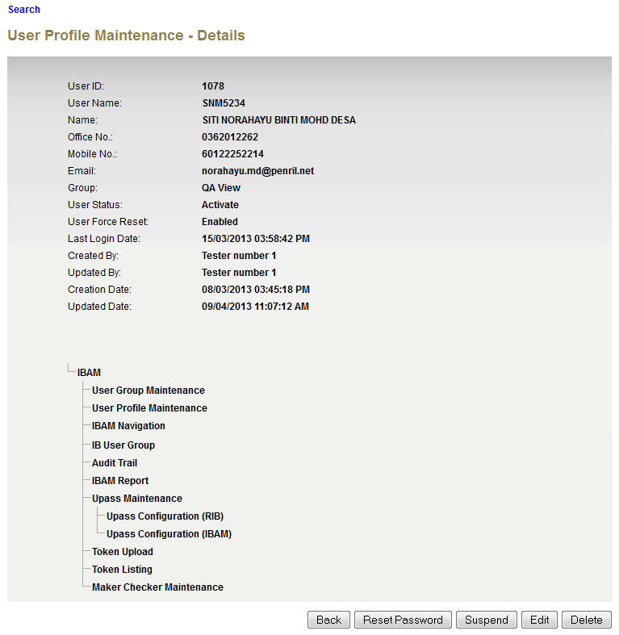

**Figure 34: User Profile Details Screen**

**Action:**

| No | Action | Type | Description |
| --- | --- | --- | --- |
| 1. | Back | Button | Goes back to User Profile maintenance list page. |
| 2. | Click on “User ID” | Hyperlink | Show the User Profile Enquiry Details. |

## Edit User Profile

This feature allows Admin to edit and update another user details.

### Process Flow



Diagram 13: Edit User Profile Flow Diagram

There are 2 participants involved in this process which is User Profile and IBAM. The following are the steps to edit and update a user details:

### Screen Flow

***Step 1:***

1. IBAM User can access to Admin Enquiry Screen by clicking on the “User Profile Maintenance” link on the left navigation menu.
2. Refer to ***2.3.2 Search User Profile step-by-step*** to select on the specific user to be edited.
3. IBAM display User Profile List Screen. Admin click on the selected User ID link to display on the User Profile details.



**Figure 25: User Profile Maintenance Navigation**



Figure 35: User Profile Maintenance List Screen

**Action:**

| No | Action | Type | Description |
| --- | --- | --- | --- |
|  | Click on “User ID” | Hyperlink | Show the User Profile Enquiry Details. |

***Step 2:***

1. IBAM display User Profile Details Screen of the selected User.
2. Admin can clicks on the “Edit” button to access the IBAM User Details Edit Screen.

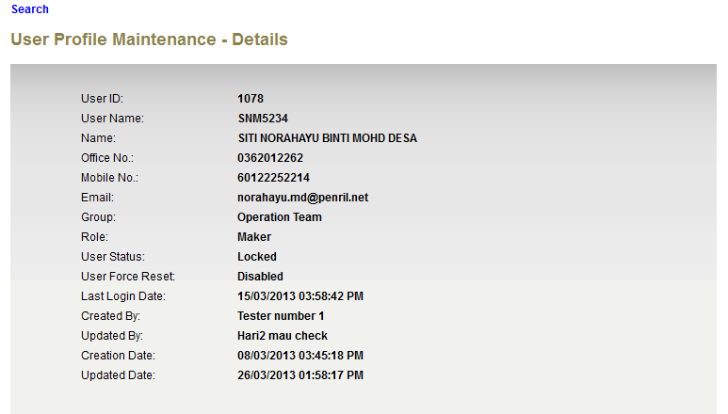

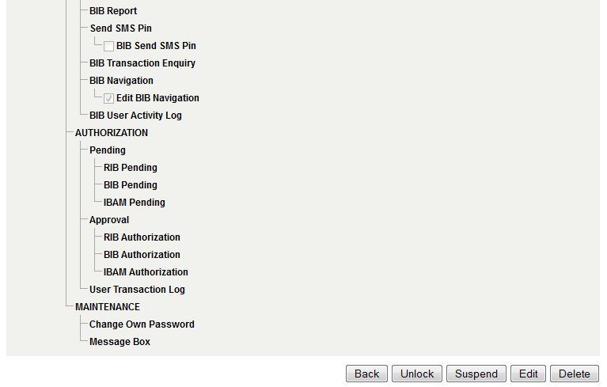

**Figure 36: User Profile Details Screen**

**Action:**

| No | Action | Type | Description |
| --- | --- | --- | --- |
|  | Back | Button | Brings the user to show back the list of user registered in the IBAM System. |
|  | Edit | Button | Brings the user to admin edit page, in order to be able to modify their details. Show ‘User Profile Maintenance Edit’ page. |

***Step 3:***

1. IBAM display IBAM User Details Edit Screen.
2. Admin edits details and clicks on the “Next” button.
3. IBAM validates the updated details and display confirm screen for Administrator to confirm the updated details.

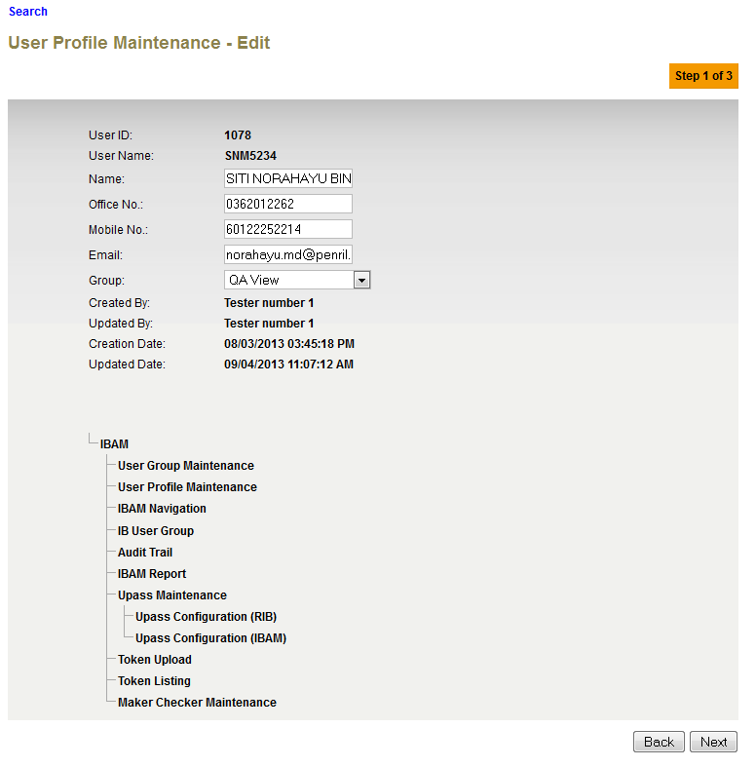

Figure 37: Edit User Profile Edit Details Screen

**Specification:**

| No | Field | Field Type | Validation Rule | Description | Compulsory |
| --- | --- | --- | --- | --- | --- |
|  | Name | Text | Max length: 64  Alphabet with allowed special character (space@./) | User’s full name | Yes |
|  | Office No. | Text | Min length: 9  Max length: 10  Numeric | The user's office number  Example:  0362012622 | Yes |
|  | Mobile No. | Text | Min length: 11  Max length: 12  Numeric | The 11-12 digits mobile number  Example:  60123456789 | Yes |
|  | Email | Text | Max length: 40  Email, compy to format: <value>@<value>.<value> | The user’s email address.  Example:  user@agrobank.com.my | Yes |
|  | Group | Dropdown List | Must select one of the group categories. | The Group that this user belong to | Yes |

**Action:**

| No | Action | Type | Description |
| --- | --- | --- | --- |
| 1. | Next | Button | Contains an action to validate the updated details of ‘User Profile’.  Shows the ‘User Profile” Edit Confirm page. |
| 2. | Back | Button | Contains an action to let the IBAM system go back to previous page (User Profile Maintenance List). |

**List of available messages for the screen:**

|  |  |  |
| --- | --- | --- |
| **No.** | **Event** | **Error Description in English** |
|  | Fill in an invalid email address. | Email format invalid. |
|  | Fill in less than 9 char. To Office No. | Office No. must be 9-10 digits. |
|  | Fill in less than 11 char. To Mobile No. | Mobile No. must be 11-12 digits. |
|  | Fill in Office and/or Mobile No. with special character. | Office No. is not numeric. Mobile No. is not numeric. |
|  | Did not select Group. | Group is required. |

***Step 4:***

1. IBAM system display Edit User Profile Confirmation page.
2. IBAM User Click on “Confirm” button.

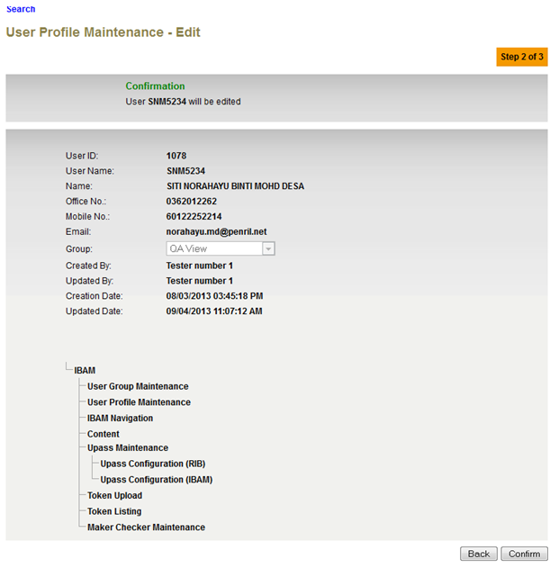

Figure 38: Edit User Profile Confirmation Screen

**Action:**

| No | Action | Type | Description |
| --- | --- | --- | --- |
| 1. | Back | Button | Contains an action to let the IBAM system go back to previous page (User Profile Edit Screen). |
| 2. | Confirm | Button | Contains an action to save the updated details of ‘User Profile’.  Shows the ‘User Profile” Edit Result page. |
|  |  |  |  |

***Step 5:***

1. IBAM updates the edited details to IB Database and display the result to the IBAM user.
2. IBAM shows successful message and pending for Authorization approval process
3. Once approved IBAM will shows the update info under User Profile Details screen.

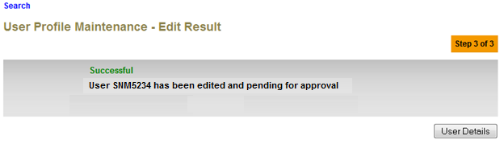

Figure 39: Edit User Profile Result Screen with Authorization Proses

If User Profile Maintenance Maker Checker Permission set as ‘Disable’

1. IBAM updates the edited details to IB Database and display the result to the IBAM user
2. IBAM shows successful message and shows the update info under User Profile Details screen.

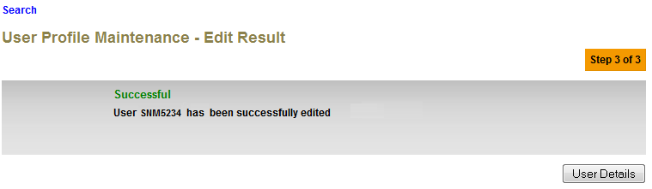

Figure 39: Edit User Profile Result Screen without Authorization Proses

**Action:**

| No | Action | Type | Description |
| --- | --- | --- | --- |
| 1. | User Details | Button | Shows the ‘User Profile Maintenance” detail page. |

## Delete User Profile

This feature allows Admin to delete another User from IBAM. All users are logically deleted (mark as deleted); the deleted User record(s) still remains in the database.

### Process Flow



Diagram 14: Delete User Profile Flow Diagram

There are 2 participants involved in this process which is User and IBAM. The following are the steps to delete an User Profile:

### Screen Flow

***Step 1:***

1. IBAM User can access to Admin Enquiry Screen by clicking on the “User Profile Maintenance” link on the left navigation menu.
2. Refer to ***2.3.2 Search User Profile step-by-step*** to select on the specific user to be deleted.
3. IBAM display User Profile List Screen. Admin click on the selected User ID link to display on the User Profile details.



**Figure 30: User Profile Maintenance Navigation**



Figure 40: User Profile Maintenance List Screen

**Action:**

| No | Action | Type | Description |
| --- | --- | --- | --- |
|  | Click on ‘User ID’ | Hyperlink | Show the User Profile Details Screen |

***Step 2:***

1. IBAM display User Profile Details Screen of the selected User.
2. Admin clicks on the delete button.
3. IBAM will go to Delete User Profile Confirmation page.

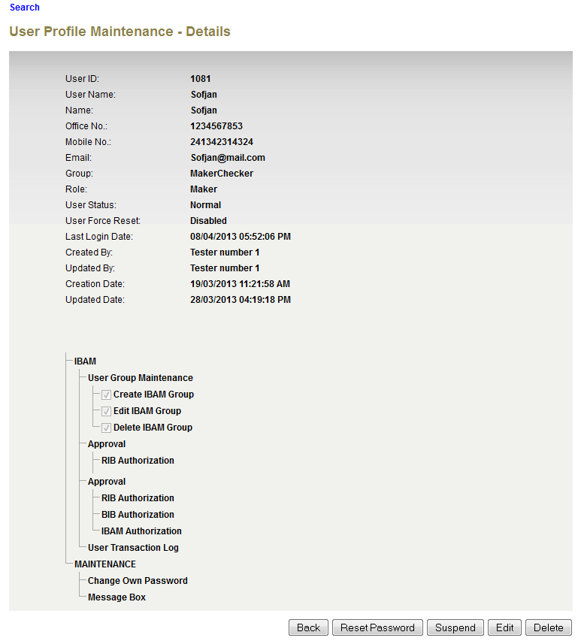

**Figure 41: User Profile Details Screen**

**Action:**

| No | Action | Type | Description |
| --- | --- | --- | --- |
| 1. | Back | Button | Contains an action to let the IBAM system go back to User Profile Maintenance List page. |
| 2. | Delete | Button | Deleted this currently displayed admin.  Show the Delete Admin Confirmation Page |

***Step 3:***

1. Admin clicks on the confirm button.
2. IBAM deletes the selected user(s) from IBAM (marked as deleted in database) and go to the result page.

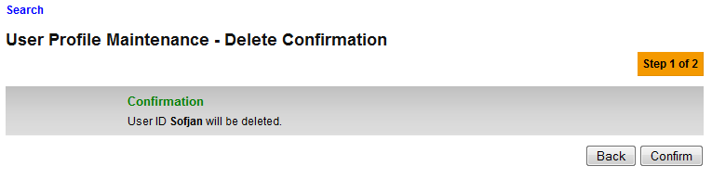

Figure 42: Delete User Profile Confirmation Screen

**Action:**

| No | Action | Type | Description |
| --- | --- | --- | --- |
|  | Back | Button | Contains an action to let the IBAM system go back to User Profile Details page. |
|  | Confirm | Button | Confirmation to delete displayed Admin ID and brings user to User Profile Result page. |

***Step 4:***

1. IBAM deletes the selected admin from IBAM and go to result page.
2. IBAM shows Successful message and pending for Authorization approval process.
3. Once approved IBAM User will deleted from the User Profile Maintenance List.

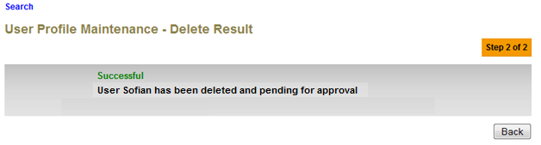

Figure 43: Delete User Profile Result Screen with Authorization Proses

If User Profile Maintenance Maker Checker Permission set as ‘Disable’

1. IBAM deletes the selected admin from IBAM and go to result page.
2. IBAM shows Successful message and IBAM User will deleted from the User Profile Maintenance List but not in Database.

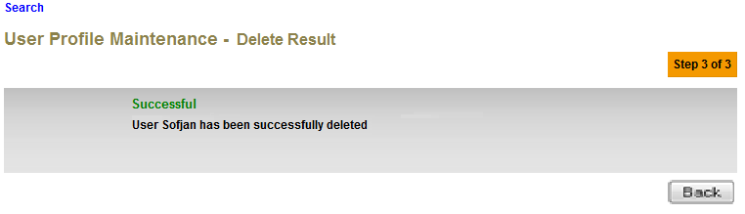

Figure 43: Delete User Profile Result Screen without Authorization Proses

**Action:**

| No | Action | Type | Description |
| --- | --- | --- | --- |
| 1. | Back | Button | Contains an action to let the IBAM system go back to User Profile Maintenance List page. |

## Reset User Profile Password

This feature allows an authorized Admin to reset another user’s password when he/she forgot the password to access to IBAM.

Upon reset password, Status will change to ACTIVE and the Force Reset Password will be ENABLED after authorization done.

### Process Flow

Diagram 15: Reset User Profile Password Diagram

There are 2 participants involved in this process which is User and IBAM. The following are the steps to reset User Profile password:

### Screen Flow

***Step 1:***

1. IBAM User can access to Admin Enquiry Screen by clicking on the “User Profile Maintenance” link on the left navigation menu.
2. Refer to ***2.3.2 Search User Profile step-by-step*** to select on the specific user.
3. IBAM display User Profile List Screen. Admin click on the selected User ID link to display on the User Profile details.



**Figure 30: User Profile Maintenance Navigation**

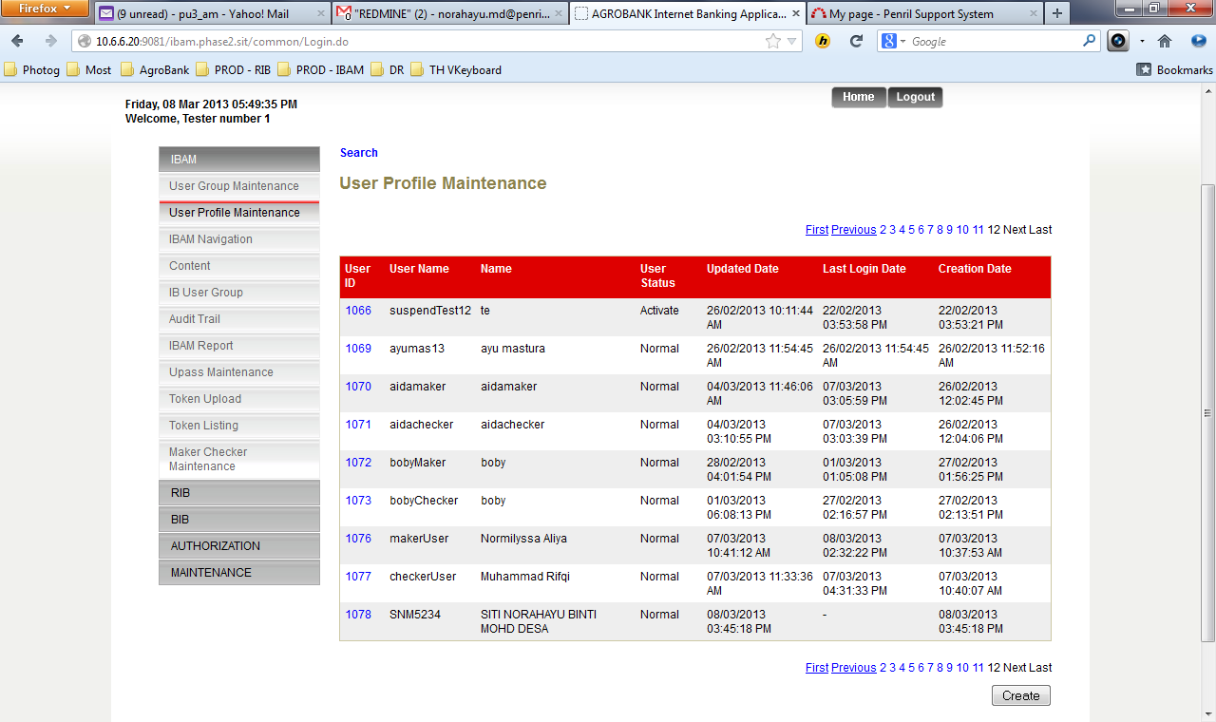

Figure 44: User Profile Maintenance List Screen

**Action:**

| No | Action | Type | Description |
| --- | --- | --- | --- |
| 1. | Click on “User ID” | Hyperlink | Show the details of the User Profile User that has been clicked |

***Step 2:***

1. IBAM display User Profile Details Screen of the selected User.ID
2. IBAM Admin click on the “Reset Password” button.

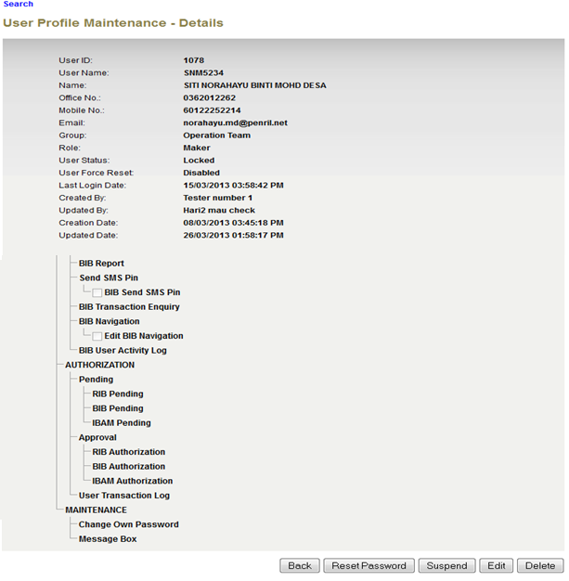

**Figure 45: User Profile Details Screen**

**Action:**

| No | Action | Type | Description |
| --- | --- | --- | --- |
|  | Back | Button | Contains an action to let the IBAM system go back to User Profile Maintenance List page. |
|  | Reset Password | Button | Reset a particular admin password. |

***Step 3:***

1. IBAM display Reset Password Screen.
2. IBAM User input New Password and Confirm Password and click on the “Confirm” button.

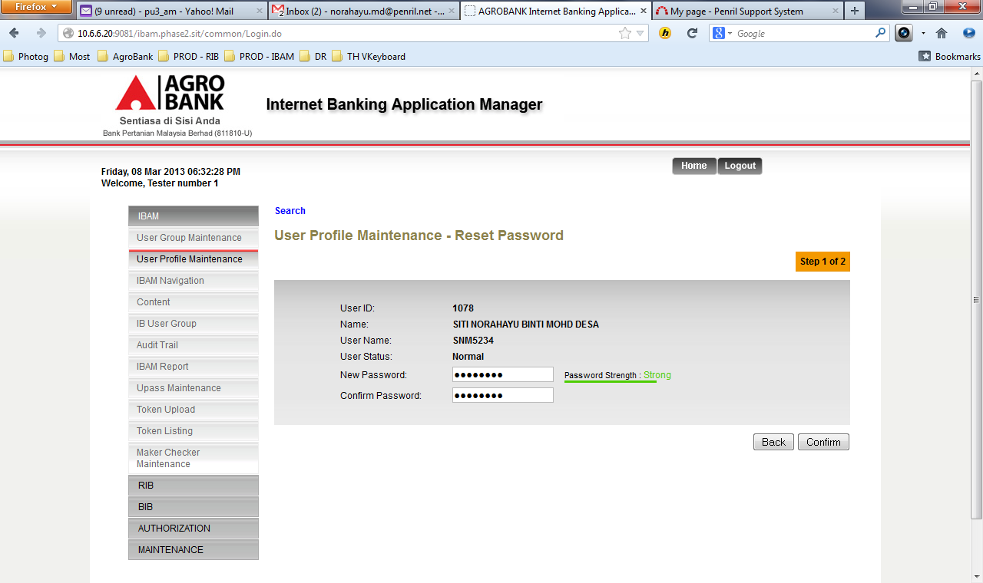

Figure 46: Reset Password User Profile Screen

**Specification:**

| No | Field | Field Type | Validation Rule | Description | Compulsory |
| --- | --- | --- | --- | --- | --- |
|  | New Password | Text, Masked | Min Length: 8  Max Length: 12  Must be a combination of numeric and alphabet format and cannot include these special character ["<>'%;&+] with a range between 8 to 12 characters. | Default password for the new user. | Yes |
|  | Confirm Password | Text, Masked | Must be same as Password | Confirm password must be exact match with Password | Yes |

**Action:**

| No | Action | Type | Description |
| --- | --- | --- | --- |
|  | Back | Button | Contains an action to let the IBAM system go back to User Profile Details page. |
|  | Confirm | Button | Action that accept the new password to be set  Show the User Profile Reset Password Result Page |

**List of available messages for the screen:**

|  |  |  |  |
| --- | --- | --- | --- |
| **No.** | **Event** | **Error Description in English** | **Error Description in BM** |
|  | Did not fill in the required field. | Confirm Password is required.  New Password is required. |  |
|  | Fill in less than 8 characters to New Password | Password cannot be less than 8 characters / digits. |  |
|  | Fill in password contains with one of the criteria below:   * Un-allowed Special character * Digit only * Lower case alphabets only * Upper case alphabets only * Lower and upper case alphabets | Password must contain a mixture of numeric and alphabet format. Cannot include these special character ["<>'%;&+] |  |
|  | Fill in Confirm Password different from New Password | Confirm Password must be the same as New Password. |  |
|  | Fill in Password same as Username. | Password cannot be the same as Username. |  |
|  | Fill in less than 8 char. to password and/or confirm password. | Confirm Password cannot be less than 8 characters / digits.  Password cannot be less than 8 characters / digits. |  |
|  | Fill in New Password same as old password | Your new password has previously been used. |  |

***Step 4:***

1. IBAM saves the new password to IB Database and display the result to the user.
2. IBAM shows successful message and pending for Authorization approval process
3. Once approved IBAM will force user to change password upon login.

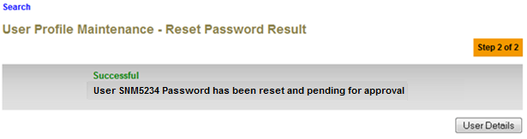

Figure 47: Reset Password User Profile Result Screen with Authorization Proses

If User Profile Maintenance Maker Checker Permission set as ‘Disable’

1. IBAM saves the new password to IB Database and display the result to the user.
2. IBAM shows successful message and will force user to change password upon login.

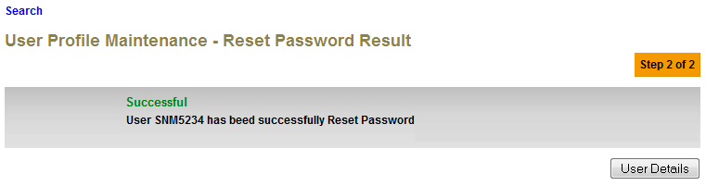

Figure 47: Reset Password User Profile Result Screen without Authorization Proses

**Action:**

| No | Action | Type | Description |
| --- | --- | --- | --- |
| 1. | User Details | Button | Shows the ‘User Profile Maintenance’ detail page. |

## Suspend Admin

This feature will allow an authorized IBAM user to suspend another IBAM user.

### Process Flow

Diagram 16: Suspend User Profile Flow Diagram

There are 2 participants involved in this process which is IBAM user and IBAM. The following are the steps:

### Screen Flow

***Step 1:***

1. IBAM User can access to Admin Enquiry Screen by clicking on the “User Profile Maintenance” link on the left navigation menu.
2. Refer to ***2.3.2 Search User Profile step-by-step*** to select on the specific user.
3. IBAM display User Profile List Screen. Admin click on the selected User ID link to display on the User Profile details.



**Figure 30: User Profile Maintenance Navigation**



Figure 48: Suspend User Profile Maintenance Screen

**Action:**

| No | Action | Type | Description |
| --- | --- | --- | --- |
| 1. | Click on “User ID” | Hyperlink | Show the details of the User Profile User that has been clicked |











***Step 2:***

1. IBAM display Admin Details Screen of the selected User Name
2. IBAM User clicks on the “Suspend” button.





Figure 49: User Profile Details Screen

**Action:**

| No | Action | Type | Description |
| --- | --- | --- | --- |
|  | Suspend | Button | To change the user status to Suspended mode. Thus, that user would not have the access on the system. |
|  | Back | Button | Contains an action to let the IBAM system go back to User Profile Maintenance List page. |

***Step 3***

1. IBAM system display Suspend User Profile Confirmation page.
2. IBAM user clicks on “Confirm” button.

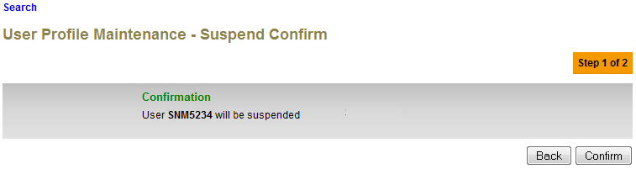

Figure 50: Suspend User Profile Confirmation Screen

**Action:**

| No | Action | Type | Description |
| --- | --- | --- | --- |
|  | Back | Button | Contains an action to let the IBAM system go back to User Profile Details page. |
|  | Confirm | Button | To change the user status to Suspended mode.  Show Suspend User Profile Result page. |

***Step 4:***

1. IBAM saves the new Admin status to IB Database and display result.
2. IBAM shows Successful message and pending for Authorization approval process.
3. Once approved IBAM will shows New User Status at User Profile Maintenance List & Details.

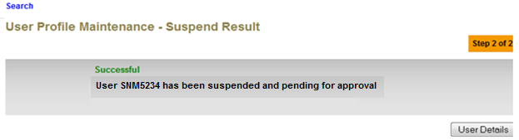

Figure 51: Suspend User Profile Result Screen with Authorization Proses

If User Profile Maintenance Maker Checker Permission set as ‘Disable’

1. IBAM saves the new Admin status to IB Database and display result.
2. IBAM shows Successful message and will shows New User Status at User Profile Maintenance List & Details.

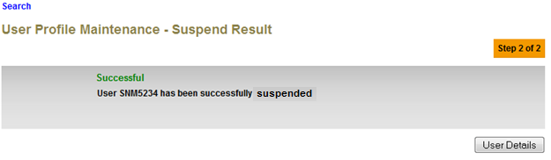

Figure 51: Suspend User Profile Result Screen without Authorization Proses

**Action:**

| No | Action | Type | Description |
| --- | --- | --- | --- |
| 1. | User Details | Button | Shows the ‘User Profile Maintenance” detail page. |

=

## Activate Admin

This feature will allow an authorized IBAM user to activate Admin User with status Suspend or Dormant.

### Process Flow

**Diagram 16: Activate User Profile Flow Diagram**

There are 2 participants involved in this process which is IBAM user and IBAM. The following are the steps:

### Screen Flow

***Step 1:***

1. IBAM User can access to Admin Enquiry Screen by clicking on the “User Profile Maintenance” link on the left navigation menu.
2. Refer to ***2.3.2 Search User Profile step-by-step*** to select on the specific user.
3. IBAM display User Profile List Screen. Admin click on the selected User ID link to display on the User Profile details.



**Figure 30: User Profile Maintenance Navigation**

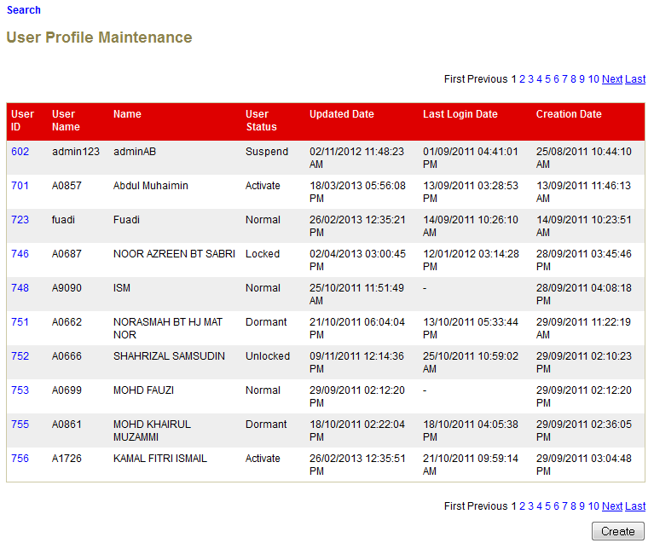

Figure 52: User Profile Maintenance List Screen

**Action:**

| No | Action | Type | Description |
| --- | --- | --- | --- |
| 1. | User ID | Hyperlink | In order to activate a particular admin, the current admin must click on the User Name hyperlink to show the detail of that particular Admin. |











***Step 2:***

1. IBAM display Admin Details Screen of the selected suspended or dormant User Name
2. IBAM User clicks on the “Activate” button on suspended user.

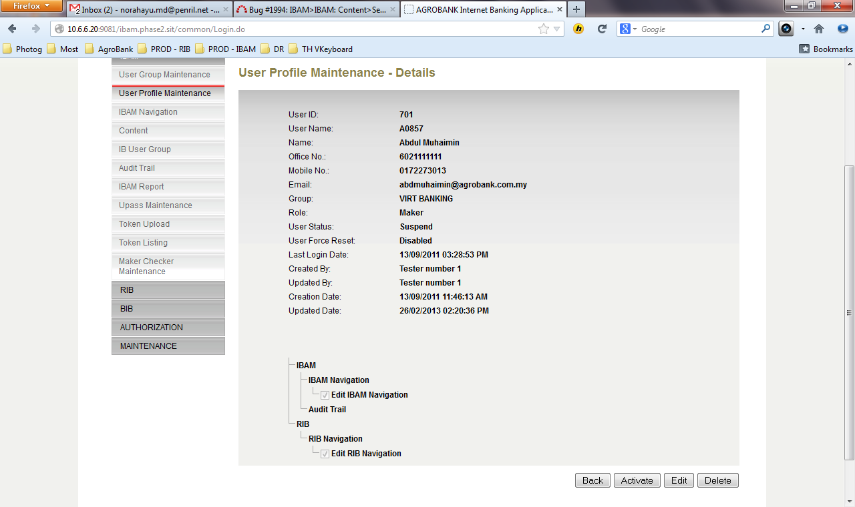

Figure 53: User Profile Details Screen

**Action:**

| No | Action | Type | Description |
| --- | --- | --- | --- |
|  | Activate | Button | To change the user status to Active mode. Thus, that user would regain access on the system.  User that already in “Active” status cannot be activated / restored. |
|  | Back | Button | Contains an action to let the IBAM system go back to User Profile Maintenance List page. |

***Step 3:***

1. IBAM system display Activate User Profile Confirmation page.
2. IBAM user clicks on “Confirm” button.

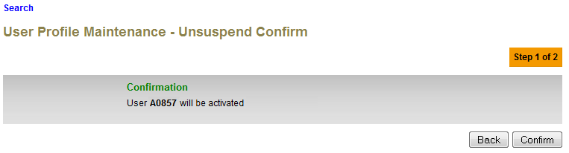

Figure 54: Activate User Profile Confirmation Screen

**Action:**

| No | Action | Type | Description |
| --- | --- | --- | --- |
|  | Back | Button | Contains an action to let the IBAM system go back to User Profile Details page. |
|  | Confirm | Button | To change the user status from Suspend or Dormant to Active mode. Thus, that user would regain access on the system.  IBAM will show Result page. |

***Step 4:***

1. IBAM saves the new user status to IB Database
2. IBAM display the result screen with Successful message and pending for Authorization approval process.
3. Once approved IBAM will shows New User Status at User Profile Maintenance List & Details.

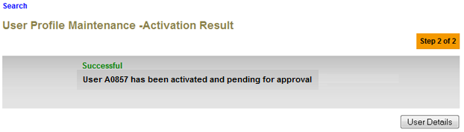

Figure 55: Activate User Profile Result Screen with Authorization Proses

If User Profile Maintenance Maker Checker Permission set as ‘Disable’

1. IBAM saves the new Admin status to IB Database and display result.
2. IBAM shows Successful message and will shows New User Status at User Profile Maintenance List & Details.

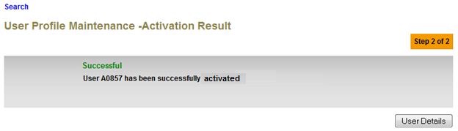

Figure 55: Activate User Profile Result Screen without Authorization Proses

**Action:**

| No | Action | Type | Description |
| --- | --- | --- | --- |
| 1. | User Details | Button | Shows the ‘User Profile Maintenance” detail page. |

## Unlock Admin

This feature will allow an authorized IBAM user to unlock Admin User which status Locked.

### Process Flow

Diagram 17: Unlock User Profile Flow Diagram

There are 2 participants involved in this process which is IBAM user and IBAM. The following are the steps:

### Screen Flow

***Step 1:***

1. IBAM User can access to Admin Enquiry Screen by clicking on the “User Profile Maintenance” link on the left navigation menu.
2. Refer to ***2.3.2 Search User Profile step-by-step*** to select on the specific user.
3. IBAM display User Profile List Screen. Admin click on the selected User ID link to display on the User Profile details.



**Figure 30: User Profile Maintenance Navigation**



Figure 56: User Profile Maintenance List Screen

**Action:**

| No | Action | Type | Description |
| --- | --- | --- | --- |
| 1. | User ID | Hyperlink | In order to unlock a particular admin, the current admin must click on the User Name hyperlink to show the detail of that particular Admin. |











***Step 2:***

1. IBAM display Admin Details Screen of the selected locked User Name
2. IBAM User clicks on the “Unlock” button.

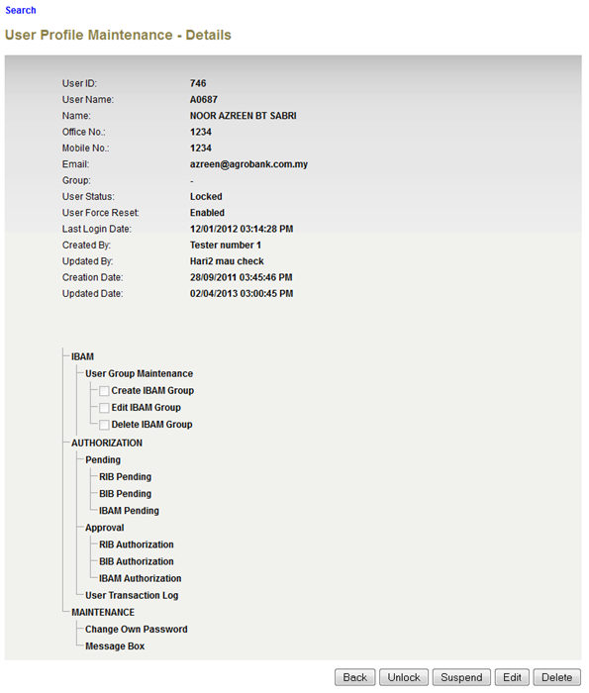

Figure 57: User Profile Details Screen

**Action:**

| No | Action | Type | Description |
| --- | --- | --- | --- |
| 1. | Unlock | Button | To change the user status to Unlock mode. Thus, that user would regain access on the system. |
|  | Back | Button | Contains an action to let the IBAM system go back to User Profile Maintenance List page. |

***Step 3:***

1. IBAM system display Unlock User Profile Confirmation page.
2. IBAM user clicks on “Confirm” button.

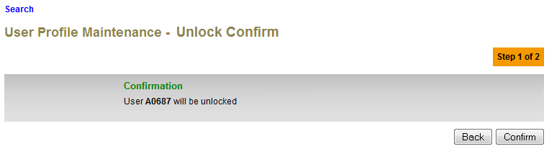

Figure 58: Unlock User Profile Confirmation Screen

**Action:**

| No | Action | Type | Description |
| --- | --- | --- | --- |
| 1. | Back | Button | Contains an action to let the IBAM system go back to User Profile Details page. |
| 2. | Confirm | Button | To change the user status from Locked to Unlock mode. Thus, that user would regain access on the system.  IBAM will show Result page. |

***Step 4:***

1. IBAM saves the new user status to IB Database
2. IBAM display the result screen with Successful message and pending for Authorization approval process.
3. Once approved IBAM will shows New User Status at User Profile Maintenance List & Details.

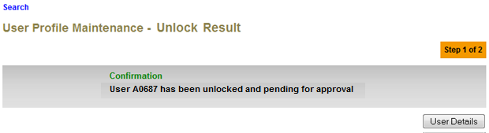

Figure 59: Unlock User Profile Result Screen with Authorization Proses

If User Profile Maintenance Maker Checker Permission set as ‘Disable’

1. IBAM saves the new Admin status to IB Database and display result.
2. IBAM shows Successful message and will shows New User Status at User Profile Maintenance List & Details.

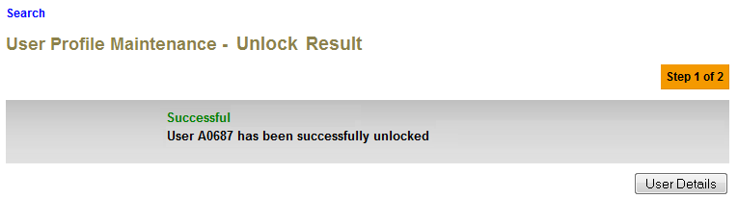

Figure 59: Unlock User Profile Result Screen without Authorization Proses

**Action:**

| No | Action | Type | Description |
| --- | --- | --- | --- |
| 1. | User Details | Button | Shows the ‘User Profile Maintenance” detail page. |