# BIB Navigation

## Edit BIB Navigation for Parent Category

This feature allows IBAM user to edit the navigation menu that will be displayed in Business Internet Banking for **Parent Category**

### Process Flow



Diagram : BIB Navigation for Parent Category Editing Flow Diagram

There are 2 participants involved in this process which is User and IBAM. The following are the steps to update secure pass list:

### Screen Flow

***Step 1:***

1. Admin Usercan access to BIB Navigation Screen by clicking on the “BIB Navigation” link on the left navigation menu.
2. BIB Navigation list screen will be shown.
3. Admin User selects the ‘BIB’ Code hyperlink.
4. IBAM System shows the navigable service for IBS. The Business Internet Banking is the Parent service of the BIB module.
5. Admin user clicks on the **Edit** link.

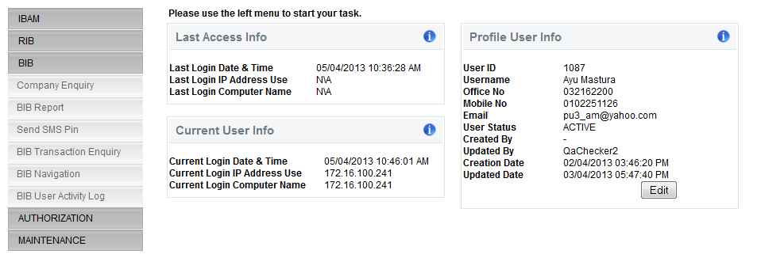

**Figure 30: BIB Navigation Tab**

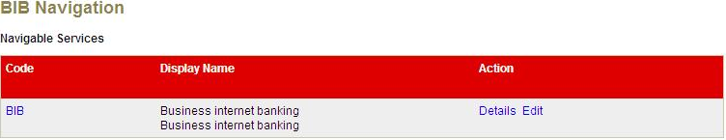

Figure 156: BIB Navigation for Parent Category Screen

**Action:**

| No | Action | Type | Description |
| --- | --- | --- | --- |
|  | Edit | Hyperlink | Leads to ‘BIB Navigation - Edit’ details page. |
|  | Details | Hyperlink | Shows the BIB Navigation details page. |

***Step 2:***

1. IBAM System shows the Parent Category edit page.
2. User can edit the name, description, offline message on the corresponding status (online/offline), navigable option, operation hour, operation start and end time and weekend status
3. User click on the **Confirm** button after the details had been completed.

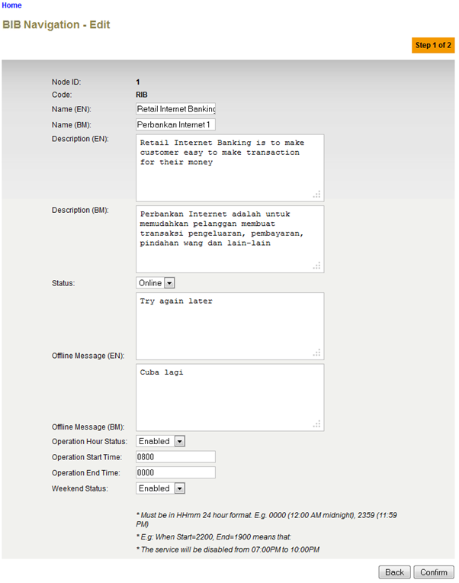

**Figure 54: BIB Navigation for Parent Category Edit Screen**

**Specification:**

| No | Field | Field Type | Validation Rule | Description | Compulsory |
| --- | --- | --- | --- | --- | --- |
|  | Name | Text | Max Length: 64  Alphanumeric with Space and Symbol | The title of a specific BIB Navigation in English language | Yes |
|  | Description | Text area | Max Length: 512  Text | Contains the description of that BIB Navigation in English language | No |
|  | Status | Dropdown List | Defaulted to Offline | Specify whether that Navigation is accessible (online) or not (offline). | Yes |
|  | Offline Message | Text area | Max Length: 255  Text | Show the message when this node is offline in English language  “Internet Banking Services is temporary offline for maintenance. Please try again later.” | No |
|  | Navigable | Dropdown List | Enabled/Disabled | Specify whether that navigation is viewable / navigable or not | Yes |
|  | Operation Hour Status | Dropdown List | Enabled/Disabled | Specify whether operation hour is enabled or disabled | Yes |
|  | Operation Start Time | Text | Match Length: 4  Numeric  Format: 24 HHMM | Specify when that particular navigation starts to be available | Yes if item 9 is Enable |
|  | Operation End Time | Text | Match Length: 4  Numeric  Format: 24 HHMM | Specify when that particular navigation starts to be unavailable | Yes if item 9 is Enable |
|  | Weekend Status | Dropdown List | Enabled/Disabled | Specify whether that navigation will be displayed during weekend time or not. | Yes |

**Action:**

| No | Action | Type | Description |
| --- | --- | --- | --- |
|  | Confirm | Button | Save any changes made. Shows the ‘successful message’ page |
|  | Back | Button | Leads back to ‘BIB Navigation’ page. |

**List of available messages for the screen:**

|  |  |  |
| --- | --- | --- |
| **No.** | **Event** | **Error Description in English** |
|  | Did not fill in the required field | Name is required. |
|  | Fill in Name with special symbols. | Display Name cannot include special symbols |
|  | Fill in fields below with alphabets and/or special symbols.   * Operation Start Time * Operation End Time | Operation End Time is not numeric.  Operation Start Time is not numeric. |
|  | Did not fill in field below when Operation Hour Status is enabled   * Operation Start Time * Operation End Time | Operation End Time is required.  Operation Start Time is required. |
|  | Fill in fields below with incorrect HHMM format   * Operation Start Time * Operation End Time | Operation Start Time must be in HHMM format  Operation End Time must be in HHMM format |

***Step 3:***

1. IBAM System shows the Parent category Confirmation page
2. User click on “Confirm” button

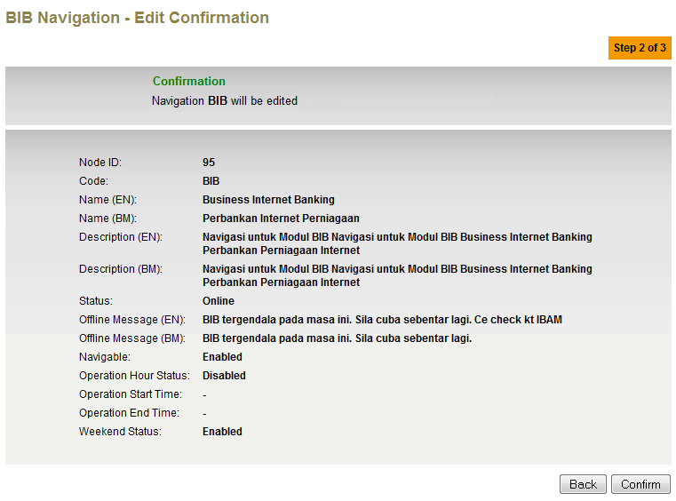

**Figure 54: BIB Navigation for Parent Category Confirmation Screen**

**Action:**

| No | Action | Type | Description |
| --- | --- | --- | --- |
|  | Confirm | Button | Save any changes made. Shows the ‘successful message’ page |
|  | Back | Button | Leads back to ‘BIB Navigation’ page. |

***Step 4:***

1. IBAM System validates save the updated data to IB Database and displays result page.
2. IBAM shows Successful message and pending for Authorization approval process.
3. Once approved IBAM will shows the changes that will be occurred on the Parent Category in BIB Navigation.

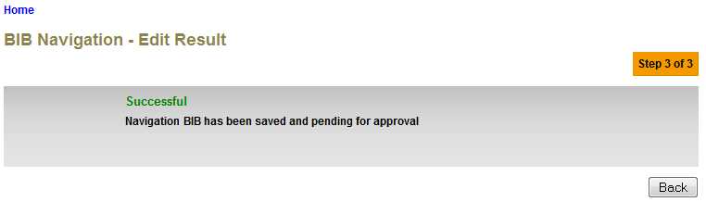

**Figure 54: BIB Navigation for Parent Category Result Screen with Authorization Process**

If BIB Navigation ‘disable’ from Maker Checker Maintenance

1. IBAM System saves the changes on the database which result on the changes that will be occurred on the Parent Category in BIB Navigation without Authorization.

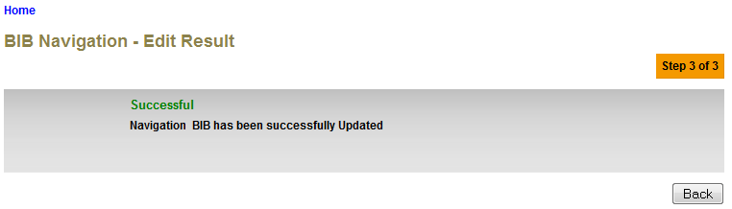**Figure 54: BIB Navigation for Parent Category Result Screen without Authorization Process**

**Action:**

| No | Action | Type | Description |
| --- | --- | --- | --- |
| 1. | Back | Button | Goes back to the BIB Navigation page. |

## Edit BIB Navigation for Sub Category / Sub Child Category

This feature allows IBAM user to edit the navigation menu that will be displayed in Business Internet Banking for **Parent Category.**

### Process Flow



Diagram : BIB Navigation for Sub Category/ Sub Child Category Editing Flow Diagram

There are 2 participants involved in this process which is User and IBAM. The following are the steps to update secure pass list:

### Screen Flow

***Step 1:***

1. Admin User selects the ‘BIB Navigation’ module.
2. IBAM System shows the navigable service for IBS. The Business Internet Banking is the Parent Category service of the BIB module.
3. Admin User selects the ‘BFT’ module
4. IBAM System shows the navigable service for IBS. The Business Internet Banking is the Sub Category service of the BIB module.
5. Admin user clicks on the **Edit** link.



**Figure 30: BIB Navigation Tab**



Figure 156: BIB Navigation for Parent Category Screen

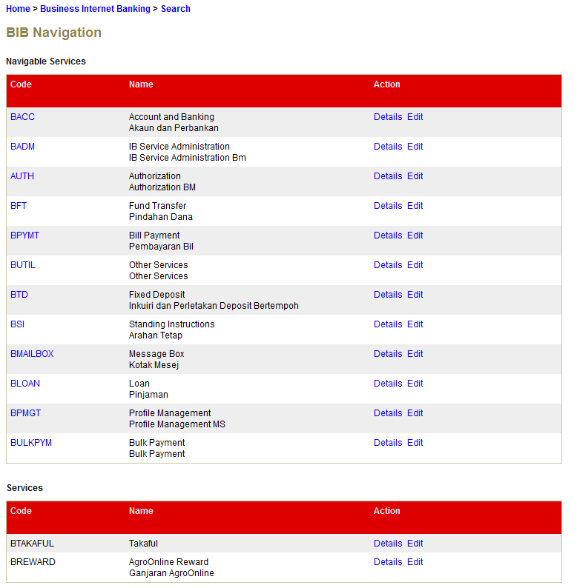

Figure 156: BIB Navigation for Sub Category / Sub Child Category Screen

**Action:**

| No | Action | Type | Description |
| --- | --- | --- | --- |
|  | Edit | Hyperlink | Leads to ‘BIB Navigation - Edit’ details page. |
|  | Details | Hyperlink | Shows the BIB Navigation details page. |

***Step 2:***

1. IBAM System shows the Sub Category / Sub Child Category edit page.
2. User can edit the name, description, offline message on the corresponding status (online/offline), navigable option, operation hour, operation start and end time, weekend status and display order.
3. User click on the **Confirm** button after the details had been completed.

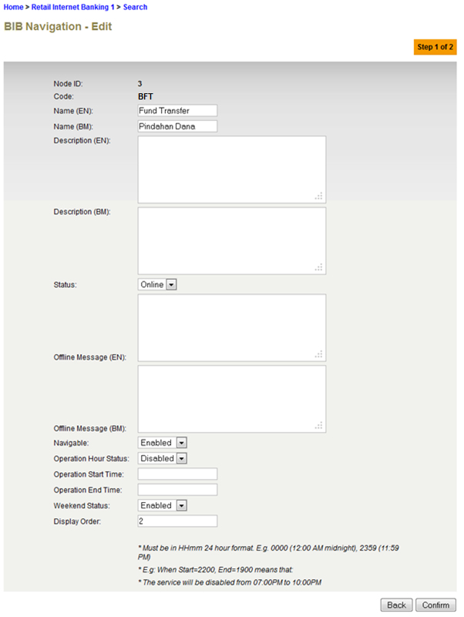

Figure : BIB Navigation for Sub Category / Sub Child Category Edit Screen

**Specification:**

| No | Field | Field Type | Validation Rule | Description | Compulsory |
| --- | --- | --- | --- | --- | --- |
|  | Name | Text | Max Length: 64  Alphanumeric with Space and Symbol | The title of a specific BIB Navigation in English language | Yes |
|  | Description | Text area | Max Length: 512  Text | Contains the description of that BIB Navigation in English language | No |
|  | Status | Dropdown List | Defaulted to Offline | Specify whether that Navigation is accessible (online) or not (offline). | Yes |
|  | Offline Message | Text area | Max Length: 255  Text | Show the message when this node is offline in English language  “Internet Banking Services is temporary offline for maintenance. Please try again later.” | No |
|  | Navigable | Dropdown List | Enabled/Disabled | Specify whether that navigation is viewable / navigable or not | Yes |
|  | Operation Hour Status | Dropdown List | Enabled/Disabled | Specify whether operation hour is enabled or disabled | Yes |
|  | Operation Start Time | Text | Match Length: 4  Numeric  Format: 24 HHMM | Specify when that particular navigation starts to be available | Yes if item 9 is Enable |
|  | Operation End Time | Text | Match Length: 4  Numeric  Format: 24 HHMM | Specify when that particular navigation starts to be unavailable | Yes if item 9 is Enable |
|  | Weekend Status | Dropdown List | Enabled/Disabled | Specify whether that navigation will be displayed during weekend time or not. | Yes |
|  | Display Order | Text | Max Length: 2  Numeric | Specify the order of the navigation in IB | Yes |

**Action:**

| No | Action | Type | Description |
| --- | --- | --- | --- |
|  | Confirm | Button | Save any changes made. Shows the ‘successful message’ page |
|  | Back | Button | Leads back to ‘BIB Navigation’ page. |

**List of available messages for the screen:**

|  |  |  |
| --- | --- | --- |
| **No.** | **Event** | **Error Description in English** |
|  | Did not fill in the required field | Name is required.  Display Order is required. |
|  | Fill in Name with special symbols. | Display Name cannot include special symbols |
|  | Fill in fields below with alphabets and/or special symbols.   * Display Order * Operation Start Time * Operation End Time | Operation End Time is not numeric.  Display Order is not numeric.  Operation Start Time is not numeric. |
|  | Did not fill in field below when Operation Hour Status is enabled   * Operation Start Time * Operation End Time | Operation End Time is required.  Operation Start Time is required. |
|  | Fill in fields below with incorrect HHMM format   * Operation Start Time * Operation End Time | Operation Start Time must be in HHMM format  Operation End Time must be in HHMM format |

***Step 3:***

1. IBAM System shows the Sub Category / Sub Child Category Confirmation page
2. User click on “Confirm” button

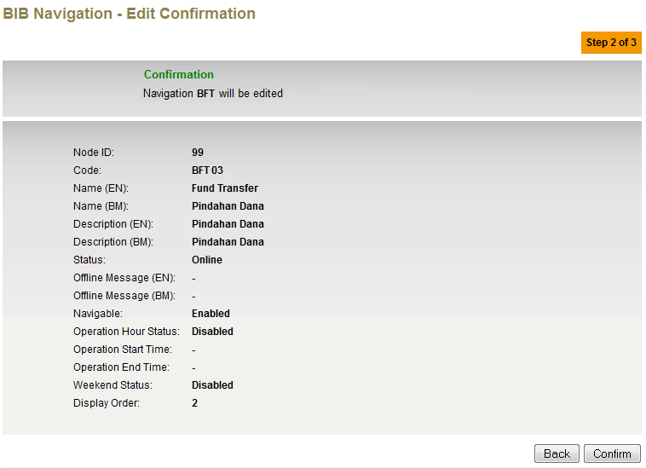

**Figure 54: BIB Navigation for Sub Category / Sub Child Category Confirmation Screen**

**Action:**

| No | Action | Type | Description |
| --- | --- | --- | --- |
|  | Confirm | Button | Save any changes made. Shows the ‘successful message’ page |
|  | Back | Button | Leads back to ‘BIB Navigation’ page. |

***Step 4:***

1. IBAM System validates save the updated data to IB Database and displays result page.
2. IBAM shows Successful message and pending for Authorization approval process.
3. Once approved IBAM will shows the changes that will be occurred on the Sub Category / Sub Child Category in BIB Navigation.

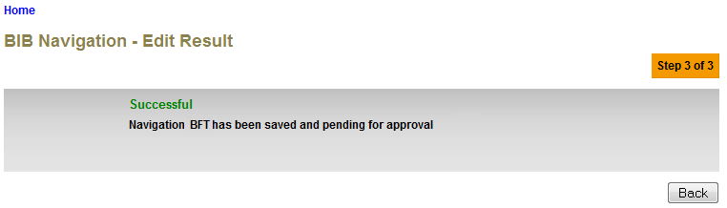

**Figure 54: BIB Navigation for Sub Category / Sub Child Category** **Result Screen with Authorization Process**

If BIB Navigation ‘disable’ from Maker Checker Maintenance

1. IBAM System saves the changes on the database which result on the changes that will be occurred on the Sub Category / Sub Child Category in BIB Navigation without Authorization.

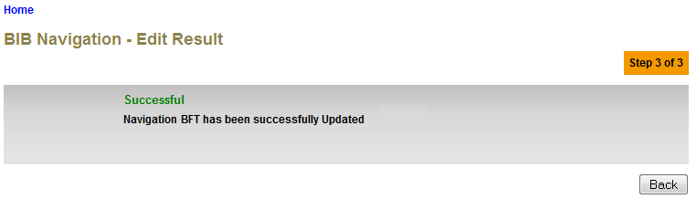

**Figure 54: BIB Navigation for Sub Category / Sub Child Category** **Result Screen without Authorization Process**

**Action:**

| No | Action | Type | Description |
| --- | --- | --- | --- |
| 1. | Back | Button | Goes back to the BIB Navigation page. |

## Edit BIB Navigation for Services

This feature allows IBAM user to edit the navigation menu that will be displayed in Business Internet Banking for **Parent Category.**

### Process Flow



Diagram : BIB Navigation for Services Editing Flow Diagram

There are 2 participants involved in this process which is User and IBAM. The following are the steps to update secure pass list:

### Screen Flow

***Step 1:***

1. Admin Usercan access to BIB Navigation Screen by clicking on the “BIB Navigation” link on the left navigation menu.
2. BIB Navigation list screen will be shown.
3. Admin User selects the ‘BIB’ Code hyperlink.
4. IBAM System shows the navigable service list for BIB
5. Admin User selects the ‘BFT’ Code hyperlink.
6. IBAM System shows the navigable service list for BFT.
7. Admin user clicks on the **Edit** link.



**Figure 30: BIB Navigation Tab**



Figure 156: BIB Navigation for Parent Category Screen



Figure 156: BIB Navigation for Sub Category / Sub Child Category Screen

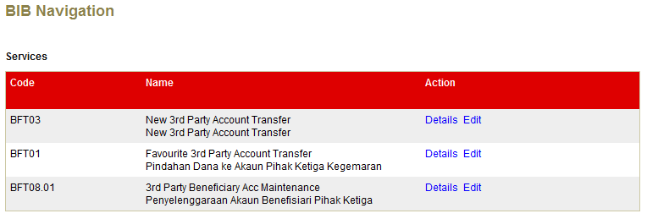

Figure 156: BIB Navigation for Services Screen

**Action:**

| No | Action | Type | Description |
| --- | --- | --- | --- |
|  | Edit | Hyperlink | Leads to ‘BIB Navigation - Edit’ details page. |
|  | Details | Hyperlink | Shows the BIB Navigation details page. |
|  | Click on “Code” | Hyperlink | Show the Navigation Enquiry Details. |

***Step 2:***

1. IBAM System shows the BIB navigation edit page.
2. User can edit the name, description, offline message on the corresponding status (online/offline), navigable option, operation hour, operation start and end time, weekend status, Quick Link, Quick Link Order and Display Order.
3. User click on the **Confirm** button after the details had been completed.

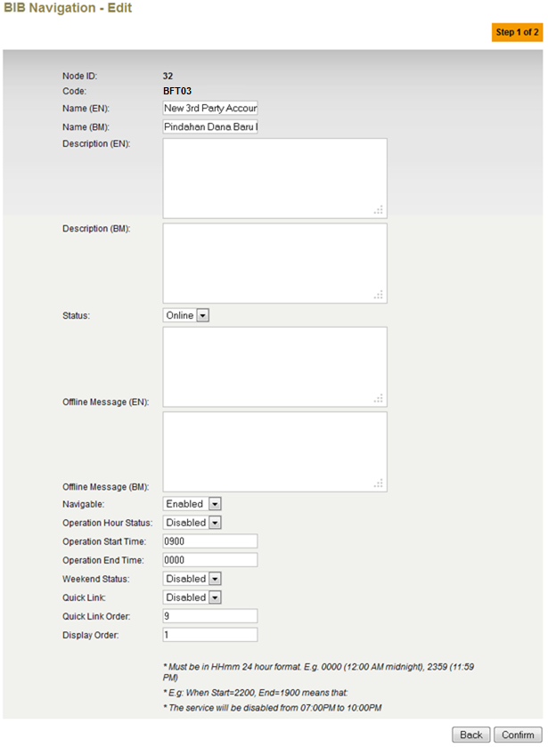

**Figure 54: BIB Navigation for Services Edit Screen**

**Specification:**

| No | Field | Field Type | Validation Rule | Description | Compulsory |
| --- | --- | --- | --- | --- | --- |
|  | Name | Text | Max Length: 64  Alphanumeric with Space and Symbol | The title of a specific BIB Navigation in English language | Yes |
|  | Description | Text area | Max Length: 512  Text | Contains the description of that BIB Navigation in English language | No |
|  | Status | Dropdown List | Defaulted to Offline | Specify whether that Navigation is accessible (online) or not (offline). | Yes |
|  | Offline Message | Text area | Max Length: 255  Text | Show the message when this node is offline in English language  “Internet Banking Services is temporary offline for maintenance. Please try again later.” | No |
|  | Navigable | Dropdown List | Enabled/Disabled | Specify whether that navigation is viewable / navigable or not | Yes |
|  | Operation Hour Status | Dropdown List | Enabled/Disabled | Specify whether operation hour is enabled or disabled | Yes |
|  | Operation Start Time | Text | Match Length: 4  Numeric  Format: 24 HHMM | Specify when that particular navigation starts to be available | Yes if item 9 is Enable |
|  | Operation End Time | Text | Match Length: 4  Numeric  Format: 24 HHMM | Specify when that particular navigation starts to be unavailable | Yes if item 9 is Enable |
|  | Weekend Status | Dropdown List | Enabled/Disabled | Specify whether that navigation will be displayed during weekend time or not. | Yes |
|  | Quick Link | Dropdown List | Enabled/Disabled | Specify whether that navigation want to be displayed as shortcut in IB page or not. | Yes |
|  | Quick Link Order | Text | Max Length: 2  Numeric | Specify the order of that navigation in IB ‘quick link’ Dropdown List | Yes if item 13 is enable |
|  | Display Order | Text | Max Length: 2  Numeric | Specify the order of the navigation in IB | Yes |

**Action:**

| No | Action | Type | Description |
| --- | --- | --- | --- |
|  | Confirm | Button | Save any changes made. Shows the ‘successful message’ page |
|  | Back | Button | Leads back to ‘BIB Navigation’ page. |

**List of available messages for the screen:**

|  |  |  |
| --- | --- | --- |
| **No.** | **Event** | **Error Description in English** |
|  | Did not fill in the required field | Name is required.  Display Order is required.  Quick Link Order is required. |
|  | Fill in Name with special symbols. | Name cannot include special symbols |
|  | Fill in fields below with alphabets and/or special symbols.   * Quick Link Order * Display Order * Operation Start Time * Operation End Time | Operation End Time is not numeric.  Display Order is not numeric.  Quick Link Order is not numeric.  Operation Start Time is not numeric. |
|  | Did not fill in field below when Operation Hour Status is enabled   * Operation Start Time * Operation End Time | Operation End Time is required.  Operation Start Time is required. |
|  | Fill in fields below with incorrect HHMM format   * Operation Start Time * Operation End Time | Operation Start Time must be in HHMM format  Operation End Time must be in HHMM format |

***Step 3:***

1. IBAM System shows the Services Confirmation page
2. User click on “Confirm” button

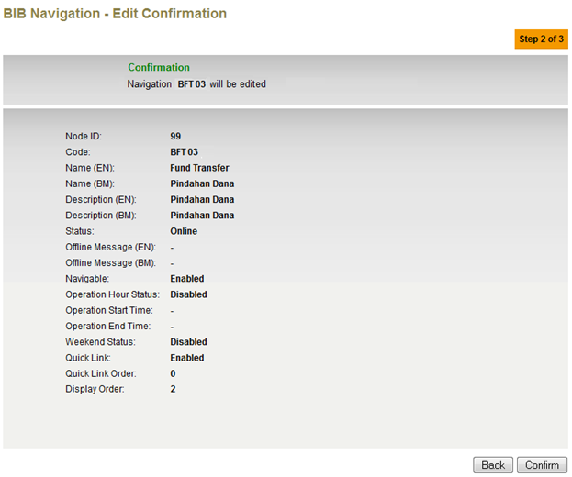

**Figure 54: BIB Navigation for Services Confirmation Screen**

**Action:**

| No | Action | Type | Description |
| --- | --- | --- | --- |
|  | Confirm | Button | Save any changes made. Shows the ‘successful message’ page |
|  | Back | Button | Leads back to ‘BIB Navigation’ page. |

***Step 4:***

1. IBAM System validates save the updated data to IB Database and displays result page.
2. IBAM shows Successful message and pending for Authorization approval process.
3. Once approved IBAM will shows the changes that will be occurred on the Services in BIB Navigation.

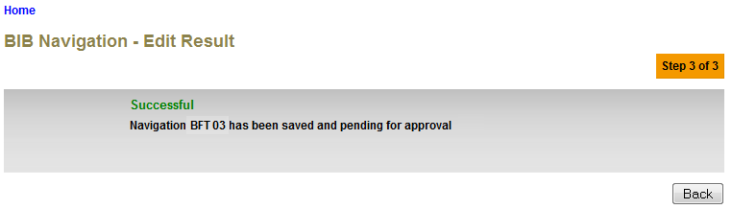

**Figure 54: BIB Navigation for Services Result Screen with Authorization Process**

If BIB Navigation ‘disable’ from Maker Checker Maintenance

1. IBAM System saves the changes on the database which result on the changes that will be occurred on the Sub Category / Sub Child Category in BIB Navigation without Authorization.

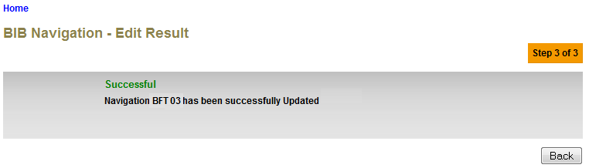

**Figure 54: BIB Navigation for Services Result Screen without Authorization Process**

**Action:**

| No | Action | Type | Description |
| --- | --- | --- | --- |
| 1. | Back | Button | Goes back to the BIB Navigation page. |

## Search BIB Navigation

This feature allows IBAM user to search for another navigation menu

### Process Flow

Diagram : Search BIB Navigation Flow Diagram

There are 2 participants involved in this process which is Admin and IBAM. The following are the steps to create a new IBAM User

### Screen Flow

***Step 1:***

1. Admin Usercan access to BIB Navigation Screen by clicking on the “BIB Navigation” link on the left navigation menu.
2. BIB Navigation list screen will be shown.
3. Admin User click on the Parent Code hyperlink
4. Sub Navigation list screen will be shown
5. Admin User can start search for Sub Navigation service by clicking the “Search” hyperlink on top of the title



**Figure 30: BIB Navigation Tab**

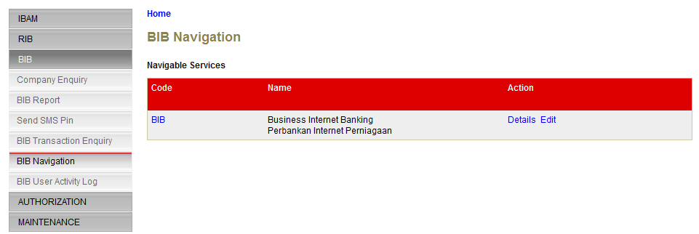

**Figure 31: BIB Navigation Parent Category List Screen**

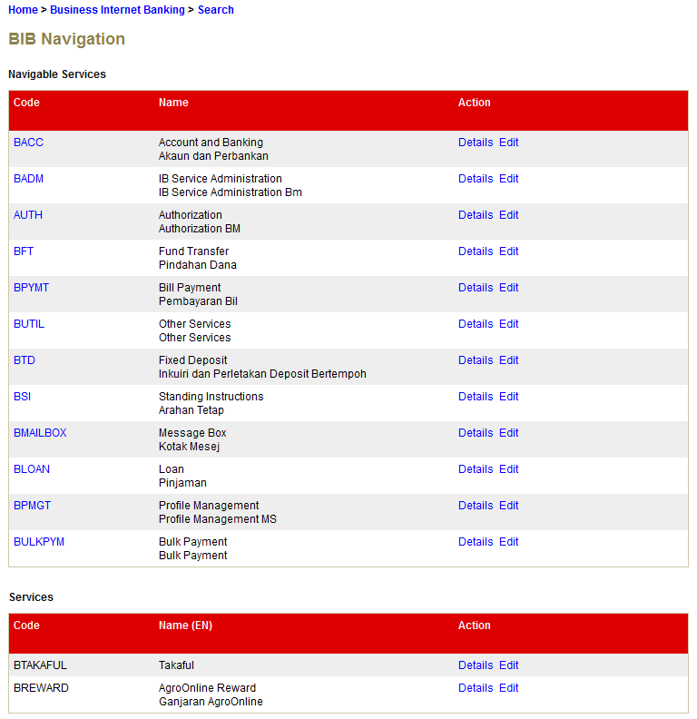

**Figure 31: BIB Navigation Sub Category List Screen**

***Step 2:***

1. IBAM display BIB Navigation Field Specific Search screen.
2. Admin User enters specific user information to the required field and click “search” button.

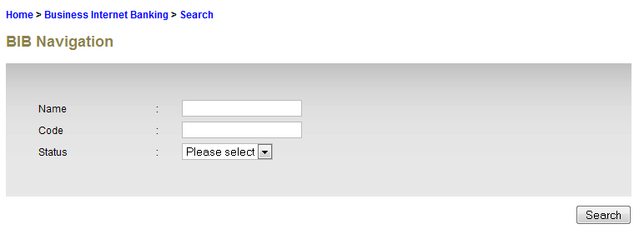

**Figure 32: BIB Navigation Field Search Screen**

**Specification:**

| No | Field | Field Type | Validation Rule | Description | Compulsory |
| --- | --- | --- | --- | --- | --- |
| 1. | Name | Text | Max Length: 64  Alphanumeric with Space and Symbol | The title of a specific BIB Navigation in English language | No |
| 2. | Code | Text | Max Length: 16 |  | No |
|  | Status | Dropdown List | Defaulted to Offline | Specify whether that Navigation is accessible (online) or not (offline). | No |

**Action:**

| No | Action | Type | Description |
| --- | --- | --- | --- |
|  | Search | Hyperlink | Contains an action to search and existing ‘User Profile’ in the list. Show ‘User Profile Maintenance Enquiry’ page. |

***Step 3:***

1. IBAM display BIB Navigation List Screen of the selected Name/Code.
2. Admin User clicks on the Code hyperlink to display on the Navigation details.

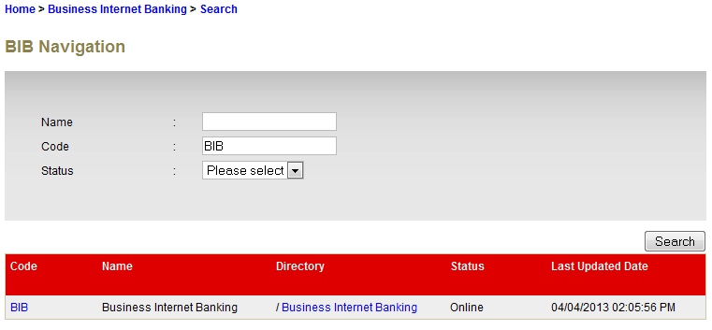

Figure 156: BIB Navigation Search Result Screen

***Step 4:***

1. IBAM System shows the BIB navigation details page.
2. User click on the **Back** button after the view.

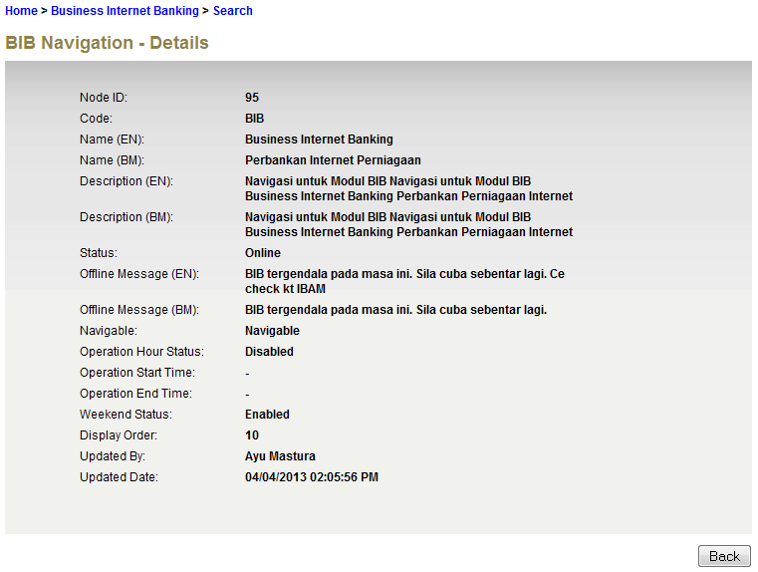

**Action:**

| No | Action | Type | Description |
| --- | --- | --- | --- |
| 1. | Back | Button | Goes back to the BIB Navigation page. |
| 2 | Click on “Code” | Hyperlink | Show the Navigation Enquiry Details. |

## BIB Navigation Configuration

| No | Requirement | Configuration |
| --- | --- | --- |
|  | Module accessible in BIB | Navigable = **Enabled**  Status = **Online** |
|  | Module not accessible in BIB | Navigable = ***Disabled***  Status = ***Offline*** |
|  | Module appears in BIB, but not allowed to service customer | Navigable = **Enabled**  Status = ***Offline*** |
|  | Module accessible in BIB for a specified timeframe.  Example:  Bulk Payment only accepts transaction from 8a.m. till 4p.m. | Navigable = **Enabled**  Status = **Online**  Operation Hour Status = **Enabled**  Weekend Status = **Enabled**  Operation Start Time = **0800**  Operation End Time = **1600** |
|  | Module accessible in BIB for a specified timeframe but not accessible on weekend  Example:  Bulk Payment only accepts transaction from 8a.m. till 4p.m., Monday - Friday | Navigable = **Enabled**  Status = **Online**  Operation Hour Status = **Enabled**  Weekend Status = ***Disabled***  Operation Start Time = **0800**  Operation End Time = **1600** |