UPM – Edit

1. Add on User value and remove details wording in result page without Authorization Proses.

**Expected Result:** User **gabby10** has been successfully edited

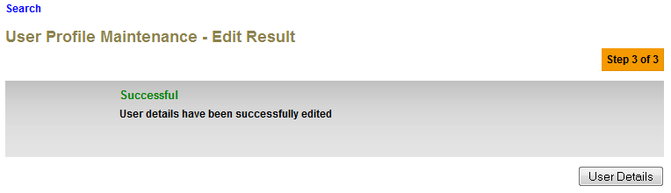

1. Remove Double Colon in front of User.

**Expected Result: User artu234 has been edited and pending for approval**

