UPM - Suspend

1. No needs to review details in Confirmation page. View the Confirmation Message only.
2. Bold the user value. **Expected Result:** User **V1000** will be suspended.

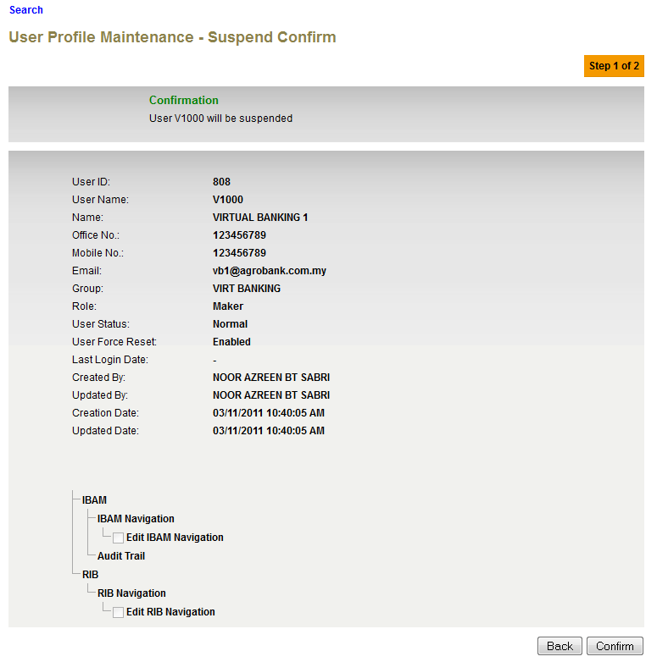

1. Add on User value and remove details wording in result page without Authorization Proses.

**Expected Result:** User **gabby10** has been successfully activated

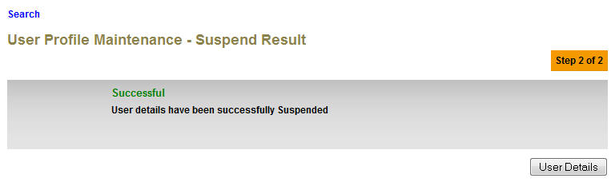

1. Remove Double Colon in front of User.

**Expected Result: User V2000 has been suspended and pending for approval**

