UPM – Unlock

1. No needs to review details in Confirmation page.
2. Add on Confirmation Message

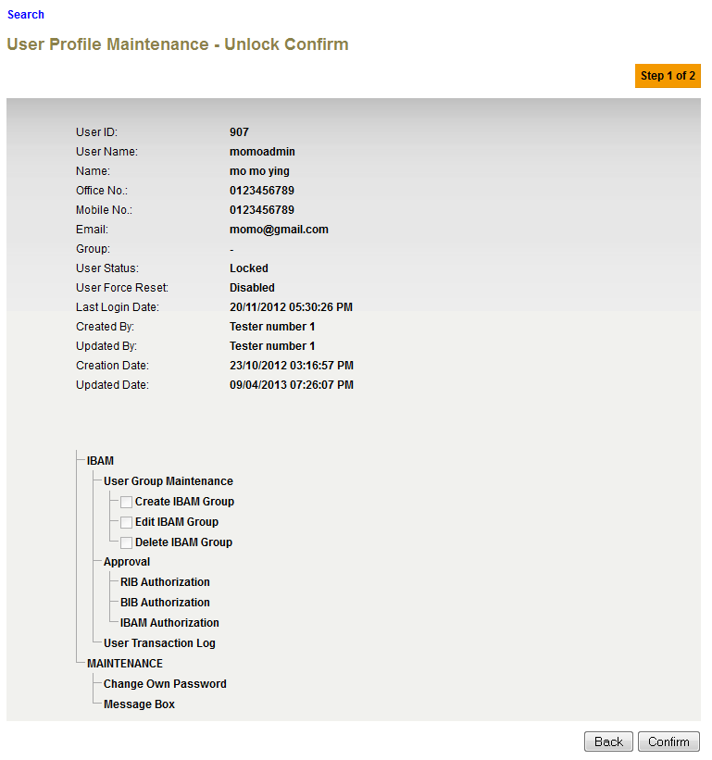

1. Add on User value and remove details wording at result page without Authorization Proses.

**Expected Result:** User **gabby10** has been successfully unlocked

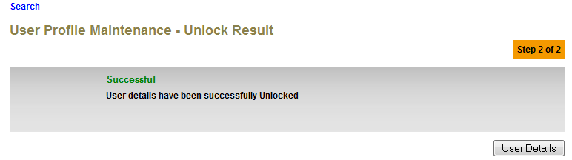

1. Remove Double Colon in front of User.

**Expected Result: User momoadmin has been unlock and pending for approval**

