# Upass Maintenance

This feature allows administrator to update the Upass Application for IBAM, RIB and BIB.

## Process Flow

Diagram xx: Upass Maintenance Diagram

There are 2 participants involved in this process which is Admin and IBAM. The following are the step to view to update the IBAM, RIB and BIB upass application

## Screen Flow

## View & Edit Upass for IBAM

***Step 1:***

* 1. Administrator can access to Upass Application Screen by clicking on the “Upass Maintenance” link at the left navigation menu.
  2. Admin select IBAM from the Upass Application dropdown list and click on Next button.

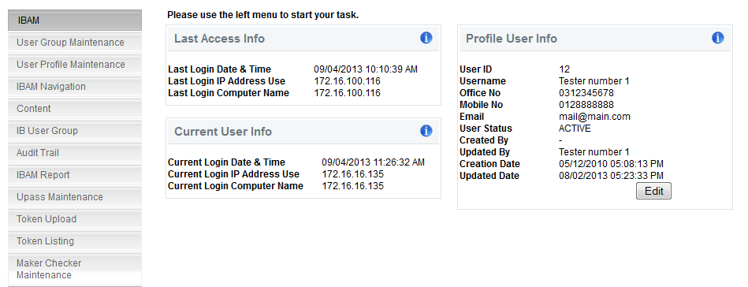

**Figure xx: Upass Maintenance Navigation**

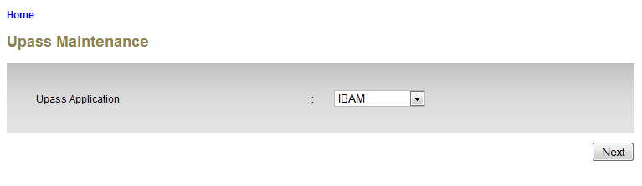

**Figure xx: Upass Application Screen**

**Display Specification*:***

| **No** | **Field** | **Format** | **Description** |
| --- | --- | --- | --- |
|  | Upass Application | Drop down list | The Upass Application module name |

**Action:**

| **No** | **Action** | **Type** | **Description** |
| --- | --- | --- | --- |
|  | Next | Button | Go to Details page |

**List of available messages for the screen:**

| **No.** | **Event** | **Error Description in English** | **Error Description in BM** |
| --- | --- | --- | --- |
| 1. | Did not choose the Upass Application | Upass Application is required. |  |

***Step 2:***

1. IBAM display the details of the Upass Application for IBAM.
2. Admin click on “Edit” button to go to IBAM Upass Maintenance Edit page.

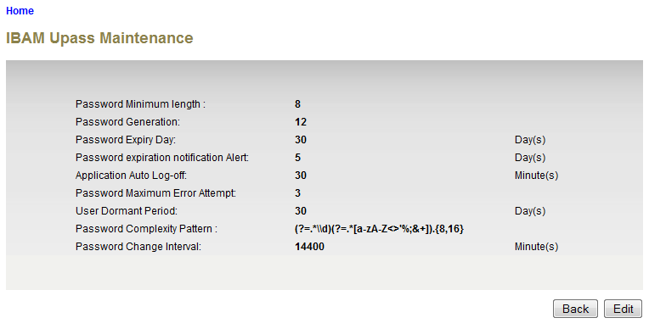

**Figure xx: IBAM Upass MaintenanceDetails Screen**

**Display Specification:**

| **No** | **Field** | **Format** | **Description** |
| --- | --- | --- | --- |
|  | Password Minimum Length | Numeric | The minimum length of the password |
|  | Password Generation | Numeric | Password Generation for the password can be used again |
|  | Password Expiry Day | Numeric | The password expiry day |
|  | Password Expiration Notification Alert | Numeric | The day of password expiration notification alert |
|  | Application Auto Log-Off | Numeric | Time for the application to auto log-off |
|  | Password Maximum Error Attempt | Numeric | The maximum password error attempt |
|  | User Dormant Period | Numeric | The period that the user become dormant |
|  | Password Complexity Pattern | Text | The complexity pattern of the password |
|  | Password Change Interval | Numeric | The password change interval |

**Action:**

| **No** | **Action** | **Type** | **Description** |
| --- | --- | --- | --- |
|  | Back | Button | Contains an action to let the IBAM system go back to previous page (Upass Application selection page). |
|  | Edit | Button | Contains an action to let the IBAM system go to IBAM Upass Maintenance Edit page. |

***Step 3:***

1. IBAM display IBAM Upass Maintenance Edit Screen.
2. Admin edits details and clicks on the “Update” button.
3. IBAM validates the updated details and display confirm screen for Administrator to confirm the updated details.

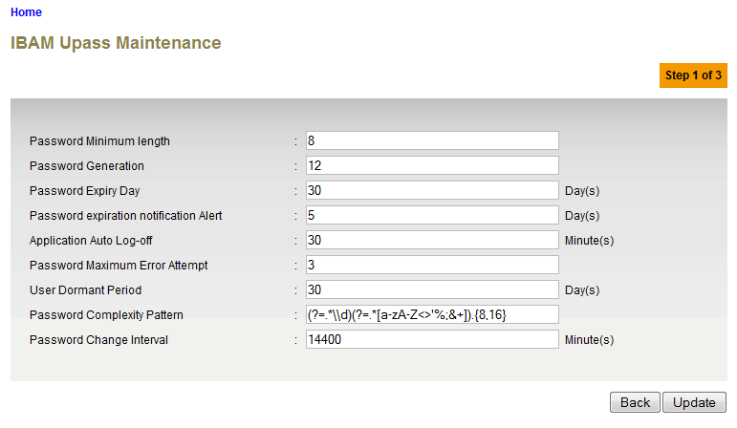

**Figure xx: IBAM Upass Maintenance Edit Screen**

**Specification:**

| **No** | **Field** | **Field Type** | **Validation Rule** | **Description** | **Compulsory** |
| --- | --- | --- | --- | --- | --- |
| 1. | Password Minimum Length | Numeric | Max Length: 2  Numeric | The minimum length of the password | Yes |
| 2. | Password Generation | Numeric | Max length: 2  Numeric | Password Generation for the password can be used again | Yes |
| 3. | Password Expiry Day | Numeric | Max length: 2  Numeric | The password expiry day | Yes |
| 4. | Password Expiration Notification Alert | Numeric | Max length: 4  Numeric | The day of password expiration notification alert | Yes |
| 5. | Application Auto Log-Off | Numeric | Max length: 2  Numeric | Time for the application to auto log-off | Yes |
| 6. | Password Maximum Error Attempt | Numeric | Max length: 2  Numeric | The maximum password error attempt | Yes |
| 7. | User Dormant Period | Numeric | Max Length: 2  Numeric | The period that the user become dormant | Yes |
| 8. | Password Complexity Pattern | Text | Alphabet, numeric or special character | The complexity pattern of the password | No |
| 9. | Password Change Interval | Numeric | Max Length: 5  Numeric | The password change interval | Yes |

**Action:**

| No | Action | Type | Description |
| --- | --- | --- | --- |
| 1. | Back | Button | Contains an action to let the IBAM system go back to previous page (Upass Maintenance Details page). |
| 2. | Update | Button | Contains an action to let the IBAM system go next page (Upass Maintenance Confirmation Page). |

**List of available messages for the screen:**

| No. | Event | Error Description in English | Error Description in BM |
| --- | --- | --- | --- |
| 1. | Did not fill in any of the mandatory fields. | Password Minimum length is required.  Password Generation is required.  Password Expiry Day is required.  Password expiration notification Alert is required.  Application Auto Log-off is required.  Password Maximum Error Attempt is required.  User Dormant Period is required.  Password Change Interval is required. |  |
| 2. | Fill in each field with alphabet | Password Minimum length is not numeric.  Password Generation is not numeric.  Password Expiry Day is not numeric.  Password expiration notification Alert is not numeric.  Application Auto Log-off is not numeric.  Password Maximum Error Attempt is not numeric.  User Dormant Period is not numeric.  Password Change Interval is not numeric. |  |

***Step 4:***

1. IBAM system display confirmation page.
2. User click on “Confirm” button.

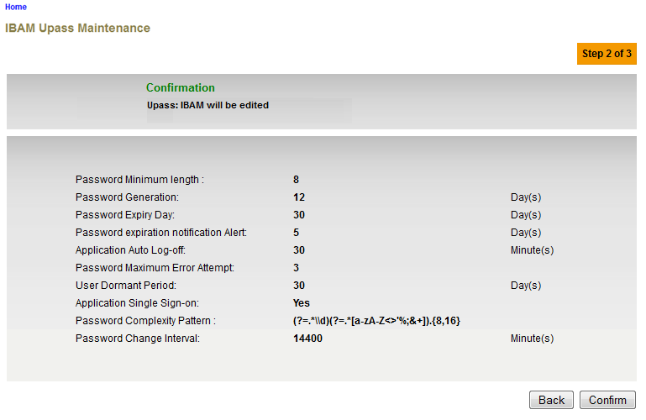

**Figure xx: IBAM Upass Maintenance Confirmation Screen**

**Action:**

| No | Action | Type | Description |
| --- | --- | --- | --- |
| 1. | Back | Button | Contains an action to let the IBAM system go back to previous page. |
| 2. | Confirm | Button | Contains an action to update the Upass Maintenance  Shows the ‘Upass Maintenance” result page. |

***Step 5:***

1. IBAM validates upass maintenance details and save the updates to IB Database and displays result page.
2. IBAM shows Successful message and pending for Authorization approval process.
3. Once approved IBAM will shows the updated information under Upass Maintenance Details screen and impact the system upass application.

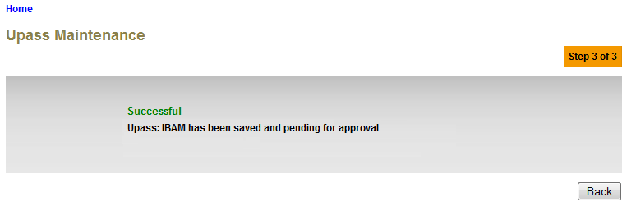**Figure xx: IBAM Upass Maintenance Result Screen with Authorization Process**

If Upass Maintenance Maker Checker Permission set as ‘Disable’

1. IBAM updates the edited details to IB Database and display the result to the IBAM user
2. IBAM shows successful message and shows the update info under Upass Maintenance details screen and impact the system upass application.

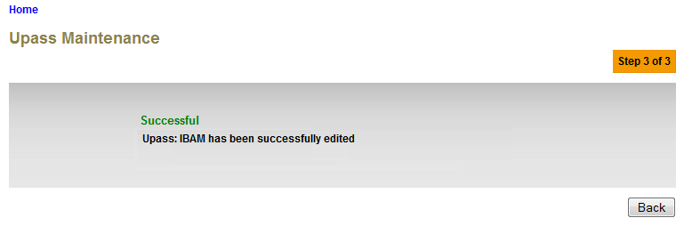**Figure xx: IBAM Upass Maintenance Result Screen without Authorization Process**

**Action:**

| No | Action | Type | Description |
| --- | --- | --- | --- |
| 1. | Back | Button | Contains an action to let the IBAM system go back to previous page (Upass Maintenance selection page). |

## View & Edit Upass for RIB

***Step 1:***

1. Administrator can access to Upass Application Screen by clicking on the “Upass Maintenance” link at the left navigation menu.
2. Admin select RIB from the Upass Application dropdown list and click on Next button.



**Figure xx: Upass Maintenance Navigation**

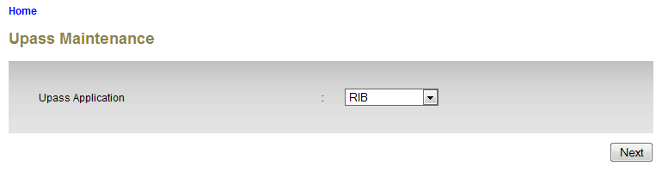**Figure xx: Upass Application Screen**

**Display Specification:**

| **No** | **Field** | **Format** | **Description** |
| --- | --- | --- | --- |
|  | Upass Application | Drop down list | The Upass Application module name |

**Action:**

| **No** | **Action** | **Type** | **Description** |
| --- | --- | --- | --- |
|  | Next | Button | Go to Details page |

**List of available messages for the screen:**

| **No.** | **Event** | **Error Description in English** | **Error Description in BM** |
| --- | --- | --- | --- |
| 1. | Did not choose the Upass Application | Upass Application is required. |  |

***Step 2:***

1. IBAM display the details of the Upass Application for RIB.
2. Admin click on “Edit” button to go to RIB Upass Maintenance Edit page.

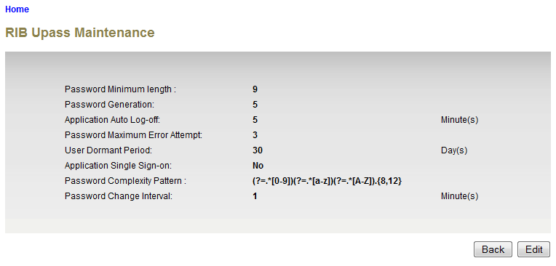

**Figure xx: RIB Upass Maintenance Details Screen**

**Display Specification:**

| **No** | **Field** | **Format** | **Description** |
| --- | --- | --- | --- |
|  | Password Minimum Length | Numeric | The minimum length of the password |
|  | Password Generation | Numeric | Password Generation for the password can be used again |
|  | Application Auto Log-Off | Numeric | Time for the application to auto log-off |
|  | Password Maximum Error Attempt | Numeric | The maximum password error attempt |
|  | User Dormant Period | Numeric | The period that the user become dormant |
|  | Application Single Sign-on | Drop Down list | To control (YES/NO) single sign-on application |
|  | Password Complexity Pattern | Text | The complexity pattern of the password |
|  | Password Change Interval | Numeric | The password change interval |

**Action:**

| **No** | **Action** | **Type** | **Description** |
| --- | --- | --- | --- |
|  | Back | Button | Contains an action to let the IBAM system go back to previous page (Upass Application selection page). |
|  | Edit | Button | Contains an action to let the IBAM system go to RIB Upass Maintenance Edit page. |

***Step 3:***

1. IBAM display RIB Upass Maintenance Edit Screen.
2. Admin edits details and clicks on the “Update” button.
3. IBAM validates the updated details and display confirm screen for Administrator to confirm the updated details.

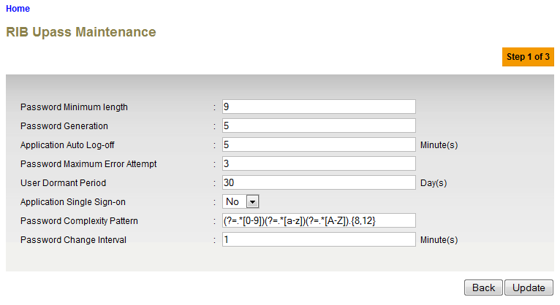

**Figure xx: RIB Upass Maintenance Edit Screen**

**Specification:**

| **No** | **Field** | **Field Type** | **Validation Rule** | **Description** | **Compulsory** |
| --- | --- | --- | --- | --- | --- |
| 1. | Password Minimum Length | Numeric | Max Length: 2  Numeric | The minimum length of the password | Yes |
| 2. | Password Generation | Numeric | Max length: 2  Numeric | Password Generation for the password can be used again | Yes |
| 3. | Application Auto Log-Off | Numeric | Max length: 2  Numeric | Time for the application to auto log-off | Yes |
| 4. | Password Maximum Error Attempt | Numeric | Max length: 2  Numeric | The maximum password error attempt | Yes |
| 5. | User Dormant Period | Numeric | Max Length: 2  Numeric | The period that the user become dormant | Yes |
| 6. | Password Complexity Pattern | Text | Alphabet, numeric or special character | The complexity pattern of the password | No |
| 7. | Application Single Sign-On | Drop Down List |  | To control (YES/NO) single sign-on application | No |
| 8. | Password Change Interval | Numeric | Max Length: 5  Numeric | The password change interval | Yes |

**Action:**

| No | Action | Type | Description |
| --- | --- | --- | --- |
| 1. | Back | Button | Contains an action to let the IBAM system go back to previous page (RIB Upass Maintenance Details page). |
| 2. | Update | Button | Contains an action to let the IBAM system go next page (RIB Upass Maintenance Confirm Page). |

**List of available messages for the screen:**

| No. | Event | Error Description in English | Error Description in BM |
| --- | --- | --- | --- |
| 1. | Did not fill in any of the mandatory fields. | Password Minimum length is required.  Password Generation is required.  Application Auto Log-off is required.  Password Maximum Error Attempt is required.  User Dormant Period is required.  Password Change Interval is required. |  |
| 2. | Fill in each field with alphabet | Password Minimum length is not numeric.  Password Generation is not numeric.  Application Auto Log-off is not numeric.  Password Maximum Error Attempt is not numeric.  User Dormant Period is not numeric.  Password Change Interval is not numeric. |  |

***Step 4:***

1. IBAM system display confirmation page.
2. User click on “Confirm” button.

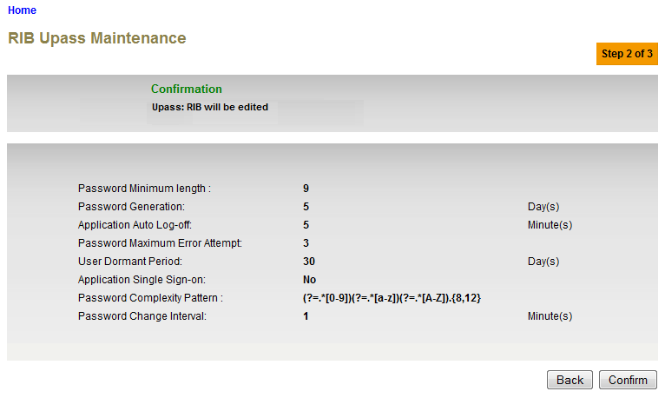

**Figure xx: RIB Upass Maintenance Confirmation Screen**

**Action:**

| No | Action | Type | Description |
| --- | --- | --- | --- |
| 1. | Back | Button | Contains an action to let the IBAM system go back to previous page. |
| 2. | Confirm | Button | Contains an action to update the Upass Maintenance  Shows the ‘Upass Maintenance” result page. |

***Step 5:***

1. IBAM validates upass maintenance details and save the updates to IB Database and displays result page.
2. IBAM shows Successful message and pending for Authorization approval process.
3. Once approved IBAM will shows the updated information under RIB Upass Maintenance Details screen and impact the RIB system upass application.

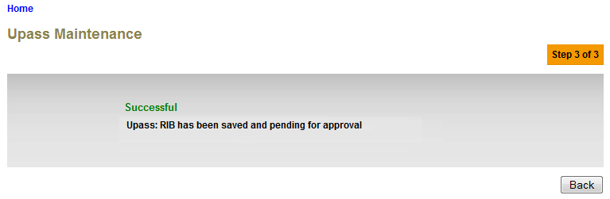**Figure xx: RIB Upass Maintenance Result Screen with Authorization Process**

If Upass Maintenance Maker Checker Permission set as ‘Disable’

1. IBAM updates the edited details to IB Database and display the result to the IBAM user
2. IBAM shows successful message and shows the update info under RIB Upass Maintenance details screen and impact the RIB system upass application.

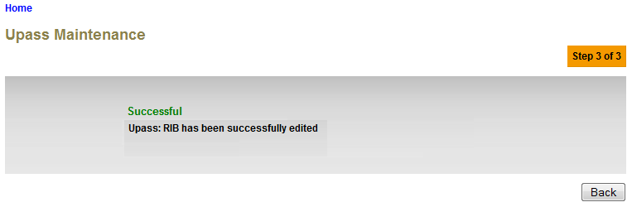**Figure xx: RIB Upass Maintenance Result Screen without Authorization Process**

**Action:**

| No | Action | Type | Description |
| --- | --- | --- | --- |
| 1. | Back | Button | Contains an action to let the IBAM system go back to previous page (Upass Maintenance selection page). |

## View & Edit Upass for BIB

***Step 1:***

1. Administrator can access to Upass Application Screen by clicking on the “Upass Maintenance” link at the left navigation menu.
2. Admin select BIB from the Upass Application dropdown list and click on Next button.



**Figure xx: Upass Maintenance Navigation**

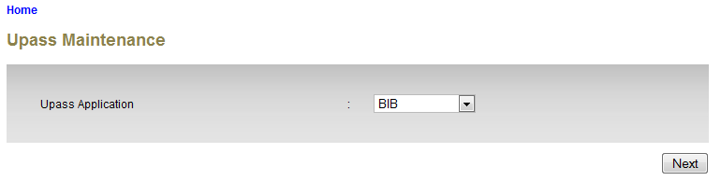**Figure xx: Upass Application Screen**

**Display Specification:**

| **No** | **Field** | **Format** | **Description** |
| --- | --- | --- | --- |
|  | Upass Application | Drop down list | The Upass Application module name |

**Action:**

| **No** | **Action** | **Type** | **Description** |
| --- | --- | --- | --- |
|  | Next | Button | Go to Details page |

**List of available messages for the screen:**

| **No.** | **Event** | **Error Description in English** | **Error Description in BM** |
| --- | --- | --- | --- |
| 1. | Did not choose the Upass Application | Upass Application is required. |  |

***Step 2:***

1. IBAM display the details of the Upass Application for BIB.
2. Admin click on “Edit” button to go to IBAM Upass Maintenance Edit page.

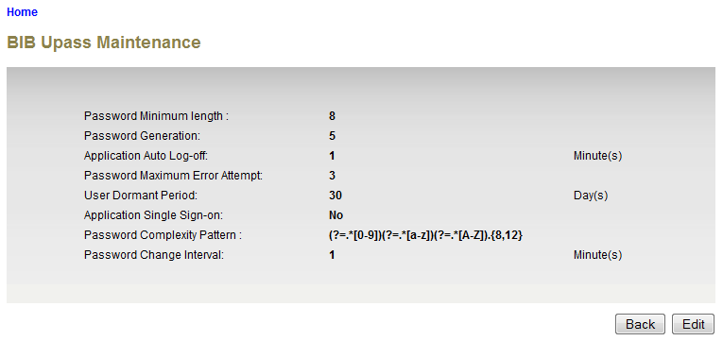

**Figure xx: BIB Upass Maintenance Details Screen**

**Display Specification:**

| **No** | **Field** | **Format** | **Description** |
| --- | --- | --- | --- |
|  | Password Minimum Length | Numeric | The minimum length of the password |
|  | Password Generation | Numeric | Password Generation for the password can be used again |
|  | Application Auto Log-Off | Numeric | Time for the application to auto log-off |
|  | Password Maximum Error Attempt | Numeric | The maximum password error attempt |
|  | User Dormant Period | Numeric | The period that the user become dormant |
|  | Application Single Sign-on | Drop Down list | To control (YES/NO) single sign-on application |
|  | Password Complexity Pattern | Text | The complexity pattern of the password |
|  | Password Change Interval | Numeric | The password change interval |

**Action:**

| **No** | **Action** | **Type** | **Description** |
| --- | --- | --- | --- |
| 1. | Back | Button | Contains an action to let the IBAM system go back to previous page (Upass Application selection page). |
| 2. | Edit | Button | Contains an action to let the IBAM system go to BIB Upass Maintenance Edit page. |

***Step 3:***

1. IBAM display BIB Upass Maintenance Edit Screen.
2. Admin edits details and clicks on the “Update” button.
3. IBAM validates the updated details and display confirm screen for Administrator to confirm the updated details.

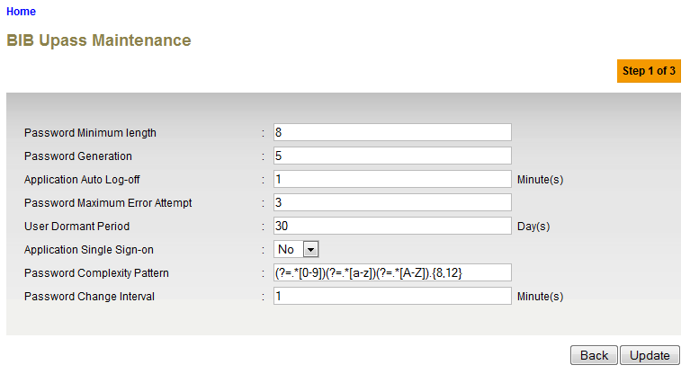

**Figure xx: RIB Upass Maintenance Edit Screen**

**Specification:**

| **No** | **Field** | **Field Type** | **Validation Rule** | **Description** | **Compulsory** |
| --- | --- | --- | --- | --- | --- |
| 1. | Password Minimum Length | Numeric | Max Length: 2  Numeric | The minimum length of the password | Yes |
| 2. | Password Generation | Numeric | Max length: 2  Numeric | Password Generation for the password can be used again | Yes |
| 3. | Application Auto Log-Off | Numeric | Max length: 2  Numeric | Time for the application to auto log-off | Yes |
| 4. | Password Maximum Error Attempt | Numeric | Max length: 2  Numeric | The maximum password error attempt | Yes |
| 5. | User Dormant Period | Numeric | Max Length: 2  Numeric | The period that the user become dormant | Yes |
| 6. | Password Complexity Pattern | Text | Alphabet, numeric or special character | The complexity pattern of the password | No |
| 7. | Application Single Sign-On | Drop Down List |  | To control (YES/NO) single sign-on application | No |
| 8. | Password Change Interval | Numeric | Max Length: 5  Numeric | The password change interval | Yes |

**Action:**

| No | Action | Type | Description |
| --- | --- | --- | --- |
| 1. | Back | Button | Contains an action to let the IBAM system go back to previous page (BIB Upass Maintenance Details page). |
| 2. | Update | Button | Contains an action to let the IBAM system go next page (BIB Upass Maintenance Confirm Page). |

**List of available messages for the screen:**

| No. | Event | Error Description in English | Error Description in BM |
| --- | --- | --- | --- |
| 1. | Did not fill in any of the mandatory fields. | Password Minimum length is required.  Password Generation is required.  Application Auto Log-off is required.  Password Maximum Error Attempt is required.  User Dormant Period is required.  Password Change Interval is required. |  |
| 2. | Fill in each field with alphabet | Password Minimum length is not numeric.  Password Generation is not numeric.  Application Auto Log-off is not numeric.  Password Maximum Error Attempt is not numeric.  User Dormant Period is not numeric.  Password Change Interval is not numeric. |  |

***Step 4:***

1. IBAM system display confirmation page.
2. User click on “Confirm” button.

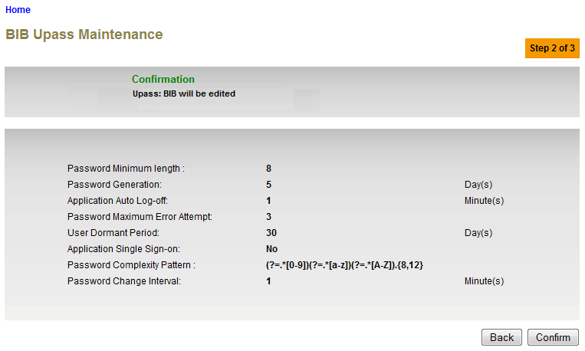

**Figure xx: BIB Upass Maintenance Confirmation Screen**

**Action:**

| No | Action | Type | Description |
| --- | --- | --- | --- |
| 1. | Back | Button | Contains an action to let the IBAM system go back to previous page. |
| 2. | Confirm | Button | Contains an action to update the Upass Maintenance  Shows the ‘Upass Maintenance” result page. |

***Step 5:***

1. IBAM validates upass maintenance details and save the updates to IB Database and displays result page.
2. IBAM shows Successful message and pending for Authorization approval process.
3. Once approved IBAM will shows the updated information under BIB Upass Maintenance Details screen and impact the BIB system upass application.

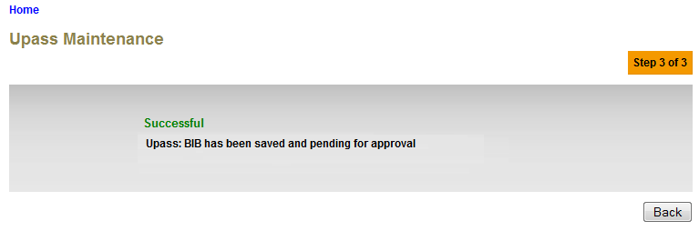**Figure xx: BIB Upass Maintenance Result Screen with Authorization Process**

If Upass Maintenance Maker Checker Permission set as ‘Disable’

1. IBAM updates the edited details to IB Database and display the result to the IBAM user
2. IBAM shows successful message and shows the update info under RIB Upass Maintenance details screen and impact the RIB system upass application.

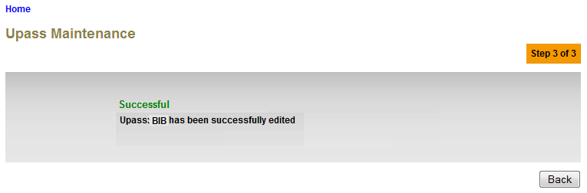**Figure xx: BIB Upass Maintenance Result Screen without Authorization Process**

**Action:**

| No | Action | Type | Description |
| --- | --- | --- | --- |
| 1. | Back | Button | Contains an action to let the IBAM system go back to previous page (Upass Maintenance selection page). |