UPM – Create

1. Fill the entire field and press ENTER key. Page back to the list
2. Add on Office no & Mobile no length example

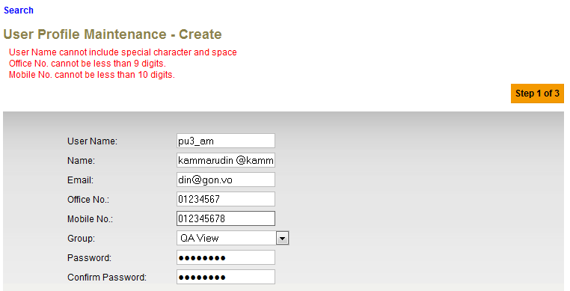

1. Add on User value and remove details wording in result page without Authorization Proses.

**Expected Result:** User **pu3am** has been successfully created

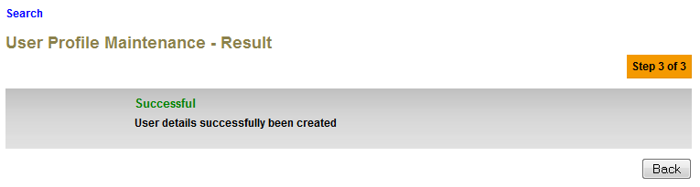

1. Change saved wording to created.

**Expected Result:** User **dsdwwww** has been created and pending for approval

