# BIB Navigation

# View & Edit BIB Navigation Parent Category

This feature allows IBAM user to view and edit the navigation menu that will be displayed in Business Internet Banking **Parent Category**

## Process Flow



Diagram 24: BIB Navigation Parent Category Editing Flow Diagram

There are 2 participants involved in this process which is User and IBAM. The following are the steps to view and edit the BIB Navigation parent category details:

## Screen Flow

***Step 1:***

1. Admin Usercan access to BIB Navigation Screen by clicking on the “BIB Navigation” link on the left navigation menu.
2. BIB Navigation list screen will be shown.
3. Admin User clicks on ‘BIB’ Code **Details** link. IBAM will show the Parent Category Details page.
4. Admin user clicks on the **Edit** link to edit on the Parent Category details.

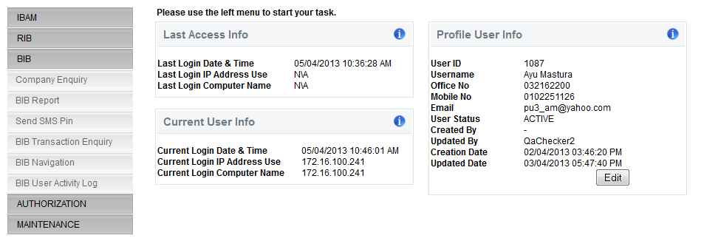

**Figure 156: BIB Navigation Side Navigation Menu**

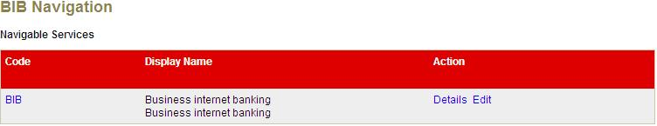

**Figure 157: BIB Navigation Parent Category Screen**

**Action:**

| No | Action | Type | Description |
| --- | --- | --- | --- |
|  | Edit | Hyperlink | Contains an action that leads to ‘BIB Navigation Parent Category- Edit’ details page. |
|  | Details | Hyperlink | Shows the BIB Navigation Parent Category details page. |

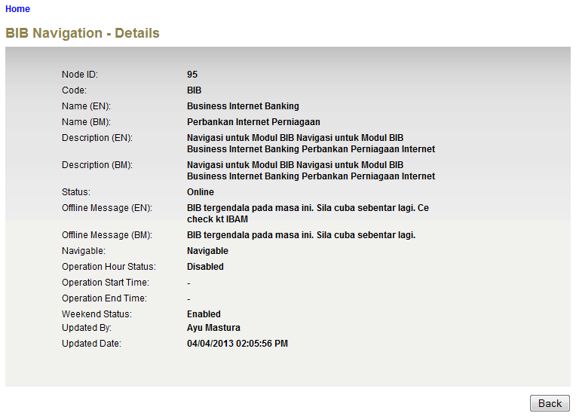

**Figure 158: BIB Navigation Parent Category Details Screen**

**Action:**

| No | Action | Type | Description |
| --- | --- | --- | --- |
| 1. | Back | Button | Contains an action to let the IBAM system go back to previous page (BIB Navigation Parent Category List). |

***Step 2:***

1. IBAM System shows the Parent Category edit page.
2. User can edit the name, description, offline message on the corresponding status (online/offline), navigable option, operation hour, operation start and end time and weekend status
3. User click on the **Next** button after the details had been completed.

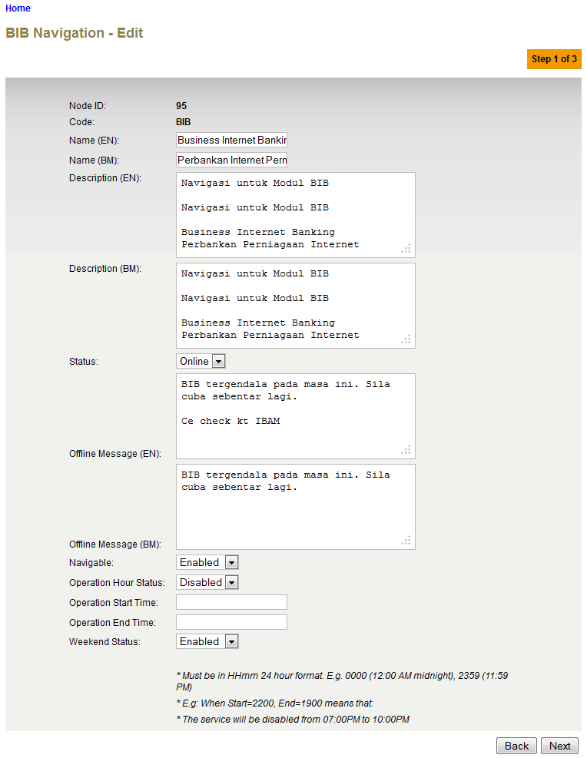

**Figure 159: BIB Navigation Parent Category Edit Screen**

**Specification:**

| No | Field | Field Type | Validation Rule | Description | Compulsory |
| --- | --- | --- | --- | --- | --- |
|  | Name | Text | Max Length: 64  Alphanumeric with Space and Symbol | The title of a specific BIB Navigation in English language | Yes |
|  | Description | Text area | Max Length: 512  Text | Contains the description of that BIB Navigation in English language | No |
|  | Status | Dropdown List | Defaulted to Offline | Specify whether that Navigation is accessible (online) or not (offline). | Yes |
|  | Offline Message | Text area | Max Length: 255  Text | Show the message when this node is offline in English language  “Internet Banking Services is temporary offline maintenance. Please try again later.” | No |
|  | Navigable | Dropdown List | Enabled/Disabled | Specify whether that navigation is viewable / navigable or not | Yes |
|  | Operation Hour Status | Dropdown List | Enabled/Disabled | Specify whether operation hour is enabled or disabled | Yes |
|  | Operation Start Time | Text | Match Length: 4  Numeric  Format: 24 HHMM | Specify when that particular navigation starts to be available | Yes if item 9 is Enable |
|  | Operation End Time | Text | Match Length: 4  Numeric  Format: 24 HHMM | Specify when that particular navigation starts to be unavailable | Yes if item 9 is Enable |
|  | Weekend Status | Dropdown List | Enabled/Disabled | Specify whether that navigation will be displayed during weekend time or not. | Yes |

**Action:**

| No | Action | Type | Description |
| --- | --- | --- | --- |
| 1. | Next | Button | Contains an action to validate the updated details of ‘BIB Navigation’ parent category.  Shows the ‘BIB Navigation Parent Category’ Edit Confirm page. |
| 2. | Back | Button | Contains an action to let the IBAM system go back to previous page (BIB Navigation Parent Category List). |

**List of available messages for the screen:**

|  |  |  |  |
| --- | --- | --- | --- |
| **No.** | **Event** | **Error Description in English** | **Error Description in BM** |
|  | Did not fill in the required field | Name is required. |  |
|  | Fill in Name with special symbols. | Display Name cannot include special symbols |  |
|  | Fill in fields below with alphabets and/or special symbols.   * Operation Start Time * Operation End Time | Operation End Time is not numeric.  Operation Start Time is not numeric. |  |
|  | Did not fill in field below when Operation Hour Status is enabled   * Operation Start Time * Operation End Time | Operation End Time is required.  Operation Start Time is required. |  |
|  | Fill in fields below with incorrect HHMM Format   * Operation Start Time * Operation End Time | Operation Start Time must be in HHMM Format  Operation End Time must be in HHMM Format |  |

***Step 3:***

1. IBAM System shows the Parent category Confirmation page
2. User click on **Confirm** button

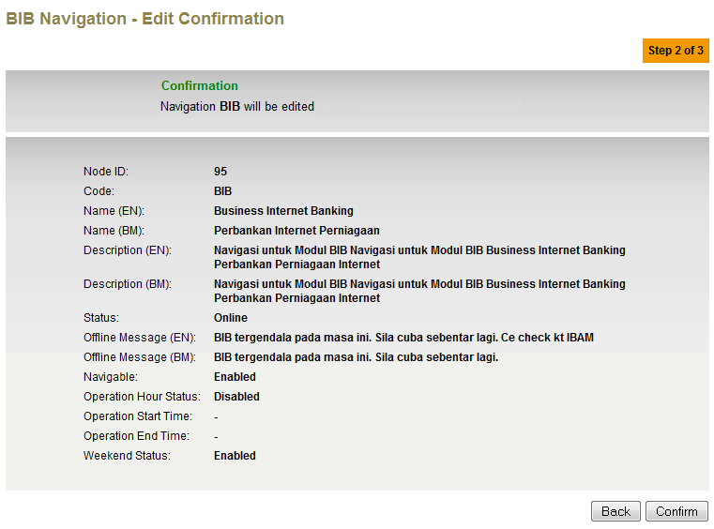

**Figure 160: BIB Navigation Parent Category Confirmation Screen**

**Action:**

| No | Action | Type | Description |
| --- | --- | --- | --- |
| 1. | Back | Button | Contains an action to let the IBAM system go back to previous page (BIB Navigation Parent Category Edit page) |
| 2. | Confirm | Button | Contains an action to save the updated details of ‘BIB Navigation’ parent category.  Shows the ‘BIB Navigation Parent Category’ Edit Result page. |

***Step 4:***

1. IBAM System validates save the updated data to IB Database and displays result page.
2. IBAM shows Successful message and pending for Authorization approval process.
3. Once approved IBAM will shows the changes that will be occurred on the Parent Category details in BIB Navigation.

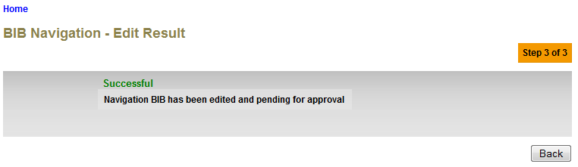

**Figure 161: BIB Navigation Parent Category Result Screen with Authorization Process**

If BIB Navigation Maker Checker Permission set as ‘Disable’

1. IBAM updates the edited details to IB Database and display the result to the IBAM user
2. IBAM shows successful message and shows the update info on the Parent Category details in BIB Navigation without Authorization.

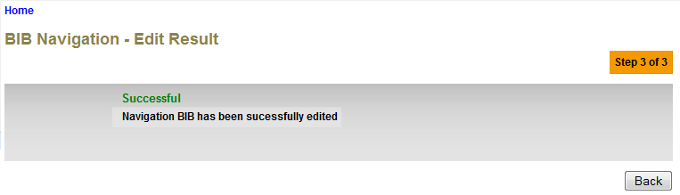**Figure 162: BIB Navigation Parent Category Result Screen without Authorization Process**

**Action:**

| No | Action | Type | Description |
| --- | --- | --- | --- |
| 1. | Back | Button | Contains an action to let the IBAM system go back to previous page (BIB Navigation Parent Category list). |

# View & Edit BIB Navigation Sub Category / Sub Child Category

This feature allows IBAM user to view and edit the navigation menu that will be displayed in Business Internet Banking **Sub Category or Sub Child Category**

## Process Flow



Diagram 24: BIB Navigation Sub Category/ Sub Child Category Editing Flow Diagram

There are 2 participants involved in this process which is User and IBAM. The following are the steps view and edit the BIB Navigation sub category or sub-child category details:

## Screen Flow

***Step 1:***

1. Admin Usercan access to BIB Navigation Screen by clicking on the “BIB Navigation” link on the left navigation menu.
2. IBAM System shows the navigable service for IBS. The Business Internet Banking is the Parent Category service of the BIB module.



**Figure 163: BIB Navigation Tab**



**Figure 164: BIB Navigation Parent Category Screen**

**Action:**

| No | Action | Type | Description |
| --- | --- | --- | --- |
| 1. | BIB ‘Parent Category’ | Hyperlink | Leads to ‘BIB Navigation – Sub Category list page. |

*To view and edit the details of BIB Sub Category:*

1. Admin User clicks on ‘Parent Category’ code (BIB) hyperlink *(as per Figure: 164)*. IBAM will show the sub category list under BIB.
2. Admin User clicks on ‘Sub Category’ (etc. BFT – Fund Transfer) Code **Details** link. IBAM will show the BFT Details page.
3. To edit the sub category details, Admin shall click on the Code **Edit** link.

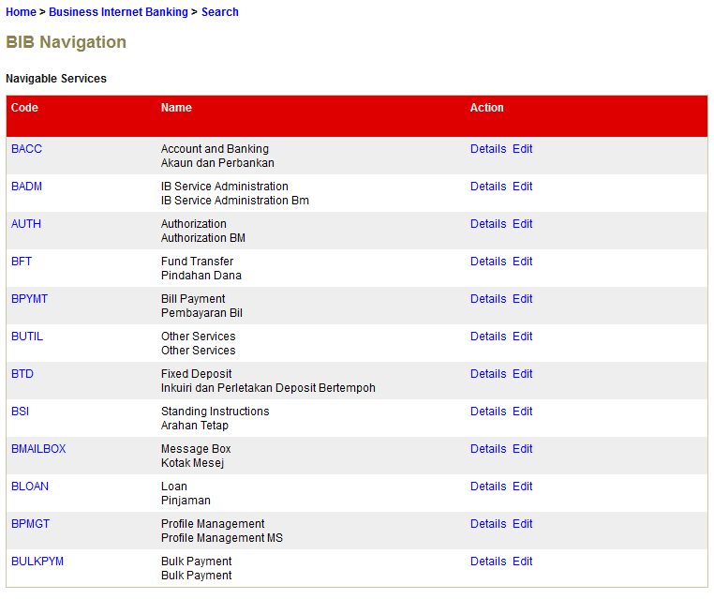

**Figure 165: BIB Navigation Sub Category List Screen**

**Action:**

| No | Action | Type | Description |
| --- | --- | --- | --- |
| 1. | BFT ‘Sub Category’ | Hyperlink | Leads to ‘BIB Navigation – Sub-Child Category list page. |
| 2. | Edit | Hyperlink | Leads to ‘BIB Navigation (Sub Category) - Edit’ details page. |
|  | Details | Hyperlink | Shows the BIB Navigation (Sub Category) details page. |

*To view and edit the details of BIB Sub Child Category:*

1. Admin User clicks on ‘Sub Category’ code (BFT) hyperlink *(as per Figure: 165*). IBAM will show the sub child category list under BFT
2. Admin User clicks on ‘Sub Child Category’ (etc. BFT09 – 3rd Party Account Transfer) Code **Details** link. IBAM will show the BFT09 Details page.
3. To edit the sub child category details, Admin shall click on the Code **Edit** link.

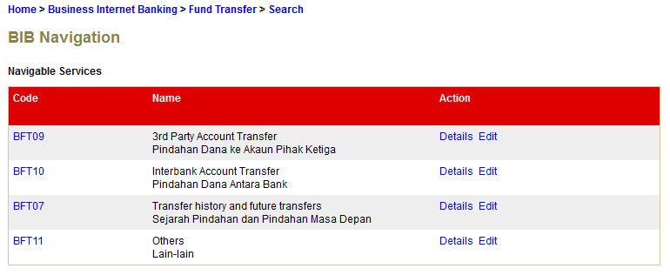

**Figure 166: BIB Navigation Sub-Child Category List Screen**

**Action:**

| No | Action | Type | Description |
| --- | --- | --- | --- |
|  | Edit | Hyperlink | Leads to ‘BIB Navigation (Sub-child Category) - Edit’ details page. |
|  | Details | Hyperlink | Shows the BIB Navigation (Sub-child Category) details page. |

***Step 2:***

1. IBAM System shows the Sub Category / Sub Child Category edit page.
2. User can edit the name, description, offline message on the corresponding status (online/offline), navigable option, operation hour, operation start and end time, weekend status and display order.
3. User click on the **Next** button after the details had been completed.

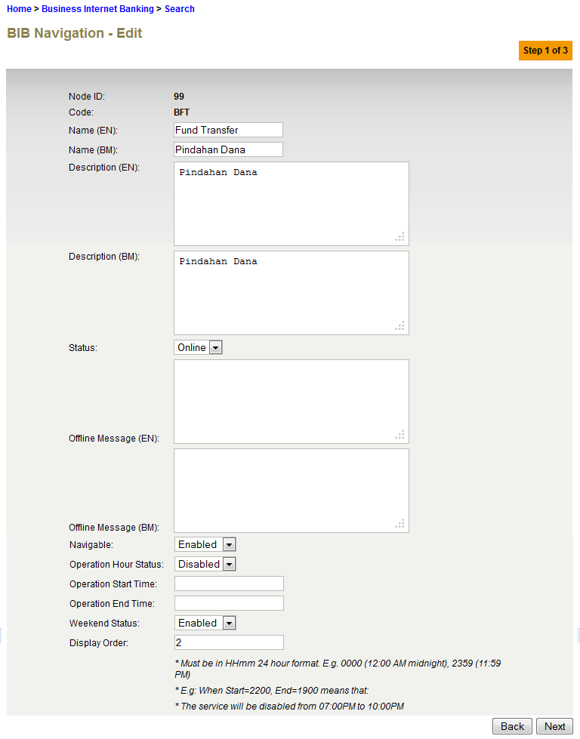

**Figure 167: BIB Navigation Sub Category / Sub Child Category Edit Screen**

**Specification:**

| No | Field | Field Type | Validation Rule | Description | Compulsory |
| --- | --- | --- | --- | --- | --- |
|  | Name | Text | Max Length: 64  Alphanumeric with Space and Symbol | The title of a specific BIB Navigation in English language | Yes |
|  | Description | Text area | Max Length: 512  Text | Contains the description of that BIB Navigation in English language | No |
|  | Status | Dropdown List | Defaulted to Offline | Specify whether that Navigation is accessible (online) or not (offline). | Yes |
|  | Offline Message | Text area | Max Length: 255  Text | Show the message when this node is offline in English language  “Internet Banking Services is temporary offline maintenance. Please try again later.” | No |
|  | Navigable | Dropdown List | Enabled/Disabled | Specify whether that navigation is viewable / navigable or not | Yes |
|  | Operation Hour Status | Dropdown List | Enabled/Disabled | Specify whether operation hour is enabled or disabled | Yes |
|  | Operation Start Time | Text | Match Length: 4  Numeric  Format: 24 HHMM | Specify when that particular navigation starts to be available | Yes if item 9 is Enable |
|  | Operation End Time | Text | Match Length: 4  Numeric  Format: 24 HHMM | Specify when that particular navigation starts to be unavailable | Yes if item 9 is Enable |
|  | Weekend Status | Dropdown List | Enabled/Disabled | Specify whether that navigation will be displayed during weekend time or not. | Yes |
|  | Display Order | Text | Max Length: 2  Numeric | Specify the order of the navigation in IB | Yes |

**Action:**

| No | Action | Type | Description |
| --- | --- | --- | --- |
| 1. | Next | Button | Contains an action to validate the updated details of ‘BIB Navigation’ sub category/sub-child category.  Shows the ‘BIB Navigation sub Category/sub-child category’ Profile Edit Confirm page. |
| 2. | Back | Button | Contains an action to let the IBAM systems go back to previous page (BIB Navigation Sub Category/Sub-child category List). |

**List of available messages for the screen:**

|  |  |  |  |
| --- | --- | --- | --- |
| **No.** | **Event** | **Error Description in English** | **Error Description in BM** |
|  | Did not fill in the required field | Name is required.  Display Order is required. |  |
|  | Fill in Name with special symbols. | Display Name cannot include special symbols |  |
|  | Fill in fields below with alphabets and/or special symbols.   * Display Order * Operation Start Time * Operation End Time | Operation End Time is not numeric.  Display Order is not numeric.  Operation Start Time is not numeric. |  |
|  | Did not fill in field below when Operation Hour Status is enabled   * Operation Start Time * Operation End Time | Operation End Time is required.  Operation Start Time is required. |  |
|  | Fill in fields below with incorrect HHMM Format   * Operation Start Time * Operation End Time | Operation Start Time must be in HHMM Format  Operation End Time must be in HHMM Format |  |

***Step 3:***

1. IBAM System shows the Sub Category / Sub Child Category Confirmation page
2. User click on **Confirm** button

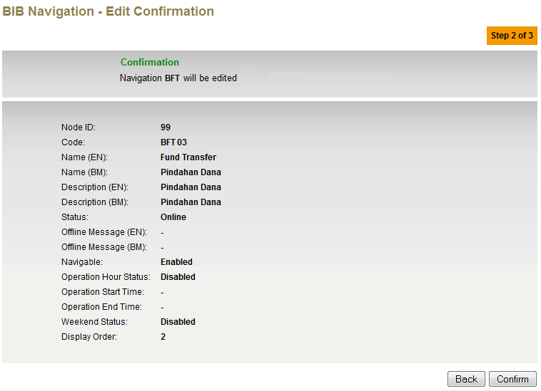

**Figure 168: BIB Navigation Sub Category / Sub-Child Category Confirmation Screen**

**Action:**

| No | Action | Type | Description |
| --- | --- | --- | --- |
| 1. | Back | Button | Contains an action to let the IBAM system go back to previous page (BIB Navigation Sub Category/Sub-child Category Edit page) |
| 2. | Confirm | Button | Contains an action to save the updated details of ‘BIB Navigation’ sub category/sub-child category.  Shows the ‘BIB Navigation Sub Category/Sub-child Category Profile’ Edit Result page. |

***Step 4:***

1. IBAM System validates save the updated data to IB Database and displays result page.
2. IBAM shows Successful message and pending for Authorization approval process.
3. Once approved IBAM will shows the changes that will be occurred on the Sub Category / Sub-Child Category details in BIB Navigation.

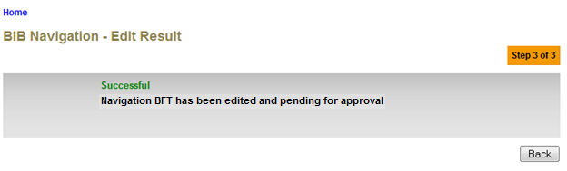

**Figure 169: BIB Navigation Sub Category / Sub-Child Category Result Screen with Authorization Process**

If BIB Navigation Maker Checker Permission set as ‘Disable’

1. IBAM updates the edited details to IB Database and display the result to the IBAM user
2. IBAM shows successful message and shows the update info on the Sub Category / Sub Child Category details in BIB Navigation without Authorization.

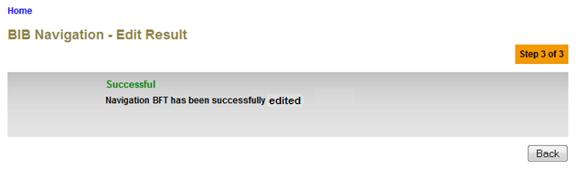

**Figure 170: BIB Navigation Sub Category / Sub-Child Category Result Screen without Authorization Process**

**Action:**

| No | Action | Type | Description |
| --- | --- | --- | --- |
| 1. | Back | Button | Contains an action to let the IBAM system go back to previous page (BIB Navigation Sub Category/Sub-child Category list page) |

# View & Edit BIB Navigation Services

This feature allows IBAM user to edit the navigation menu that will be displayed in Business Internet Banking **Services**

## Process Flow



Diagram 24: BIB Navigation Services Editing Flow Diagram

There are 2 participants involved in this process which is User and IBAM. The following are the steps to view and edit the BIB Navigation Services details:

## Screen Flow

***Step 1:***

1. Admin Usercan access to BIB Navigation Screen by clicking on the “BIB Navigation” link on the left navigation menu.
2. IBAM System shows the navigable service for IBS. The Business Internet Banking is the Parent Category service of the BIB module.

*To view and edit the Services details of BIB Parent Category:*

1. Admin User clicks on ‘Parent Category’ code (BIB) hyperlink. IBAM will show the Service list under parent category (BIB).

*To view and edit the Services details of BIB Sub Category:*

1. Admin User clicks on ‘Sub Category’ code (BFT) hyperlink. IBAM will show the Service list under sub category (BFT).

*To view and edit the Services details of BIB Sub Child Category:*

1. Admin User clicks on ‘Sub-Child Category’ code (BFT09) hyperlink. IBAM will show the Service list under sub-child category (BFT09).
2. Admin User clicks on ‘Services’ (etc. BTakaful – Takaful) Code **Details** link. IBAM will show the BTakaful Details page.
3. To edit the Services details, Admin shall click on the Code **Edit** link.



Figure 171: BIB Navigation Tab



Figure 172: BIB Navigation Parent Category Screen

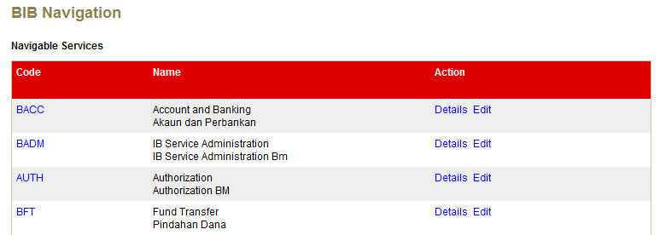

Figure 173: BIB Navigation Sub Category Screen

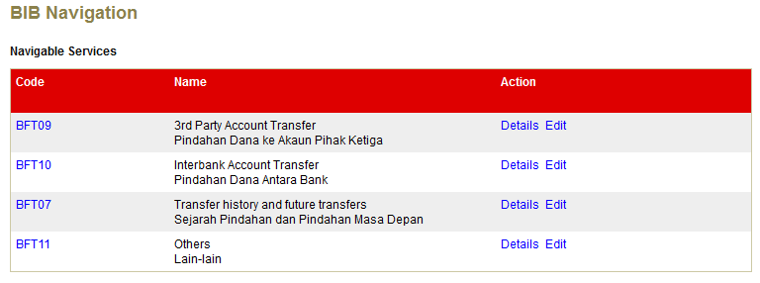

Figure 174: BIB Navigation Sub-child Category Screen

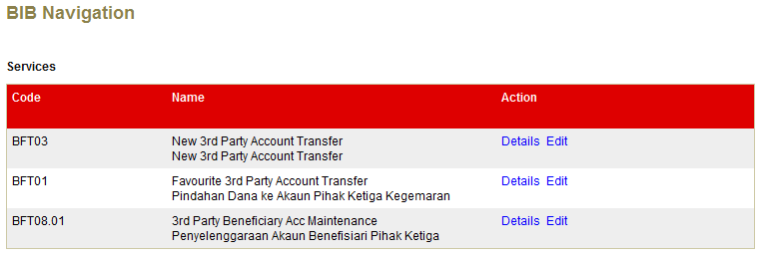

Figure 175: BIB Navigation Service List Screen

**Action:**

| No | Action | Type | Description |
| --- | --- | --- | --- |
| 1. | Click on “Code” ‘BIB’ | Hyperlink | Leads to ‘BIB Navigation’ Parent Category Service list page. |
| 2. | Click on “Code” ‘BFT’ | Hyperlink | Leads to ‘BIB Navigation’ Sub Category Service list page. |
| 3. | Click on “Code” ‘BFT09’ | Hyperlink | Leads to ‘BIB Navigation’ Sub-child Category Service list page. |
| 4. | Edit | Hyperlink | Leads to ‘BIB Navigation Service - Edit’ details page. |
| 5. | Details | Hyperlink | Shows ‘BIB Navigation Service - details’ page. |

***Step 2:***

1. IBAM System shows the BIB navigation services edit page.
2. User can edit the name, description, offline message on the corresponding status (online/offline), navigable option, operation hour, operation start and end time, weekend status, Quick Link, Quick Link Order and Display Order.
3. User click on the **Next** button after the details had been completed.

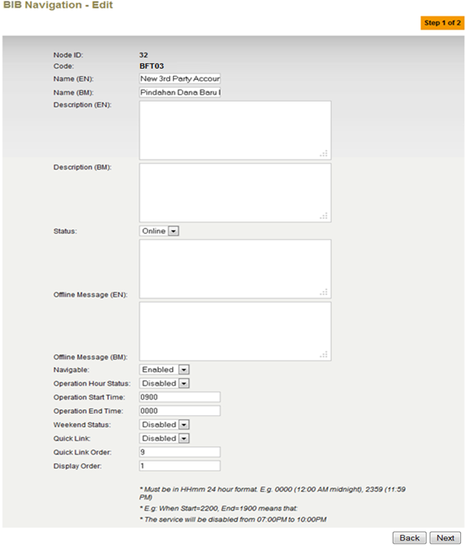

Figure 176: BIB Navigation Services Edit Screen

**Specification:**

| No | Field | Field Type | Validation Rule | Description | Compulsory |
| --- | --- | --- | --- | --- | --- |
|  | Name | Text | Max Length: 64  Alphanumeric with Space and Symbol | The title of a specific BIB Navigation in English language | Yes |
|  | Description | Text area | Max Length: 512  Text | Contains the description of that BIB Navigation in English language | No |
|  | Status | Dropdown List | Defaulted to Offline | Specify whether that Navigation is accessible (online) or not (offline). | Yes |
|  | Offline Message | Text area | Max Length: 255  Text | Show the message when this node is offline in English language  “Internet Banking Services is temporary offline maintenance. Please try again later.” | No |
|  | Navigable | Dropdown List | Enabled/Disabled | Specify whether that navigation is viewable / navigable or not | Yes |
|  | Operation Hour Status | Dropdown List | Enabled/Disabled | Specify whether operation hour is enabled or disabled | Yes |
|  | Operation Start Time | Text | Match Length: 4  Numeric  Format: 24 HHMM | Specify when that particular navigation starts to be available | Yes if item 9 is Enable |
|  | Operation End Time | Text | Match Length: 4  Numeric  Format: 24 HHMM | Specify when that particular navigation starts to be unavailable | Yes if item 9 is Enable |
|  | Weekend Status | Dropdown List | Enabled/Disabled | Specify whether that navigation will be displayed during weekend time or not. | Yes |
|  | Quick Link | Dropdown List | Enabled/Disabled | Specify whether that navigation want to be displayed as shortcut in IB page or not. | Yes |
|  | Quick Link Order | Text | Max Length: 2  Numeric | Specify the order of that navigation in IB ‘quick link’ Dropdown List | Yes if item 13 is enable |
|  | Display Order | Text | Max Length: 2  Numeric | Specify the order of the navigation in IB | Yes |

**Action:**

| No | Action | Type | Description |
| --- | --- | --- | --- |
| 1. | Next | Button | Contains an action to validate the updated details of ‘BIB Navigation’ services details.  Shows the ‘BIB Navigation Service’ Edit Confirm page. |
| 2. | Back | Button | Contains an action to let the IBAM systems go back to previous page (BIB Navigation Service List). |

**List of available messages for the screen:**

|  |  |  |  |
| --- | --- | --- | --- |
| **No.** | **Event** | **Error Description in English** | **Error Description in BM** |
|  | Did not fill in the required field | Name is required.  Display Order is required.  Quick Link Order is required. |  |
|  | Fill in Name with special symbols. | Name cannot include special symbols |  |
|  | Fill in fields below with alphabets and/or special symbols.   * Quick Link Order * Display Order * Operation Start Time * Operation End Time | Operation End Time is not numeric.  Display Order is not numeric.  Quick Link Order is not numeric.  Operation Start Time is not numeric. |  |
|  | Did not fill in field below when Operation Hour Status is enabled   * Operation Start Time * Operation End Time | Operation End Time is required.  Operation Start Time is required. |  |
|  | Fill in fields below with incorrect HHMM Format   * Operation Start Time * Operation End Time | Operation Start Time must be in HHMM format  Operation End Time must be in HHMM format |  |

***Step 3:***

1. IBAM System shows the Services Confirmation page
2. User click on **Confirm** button

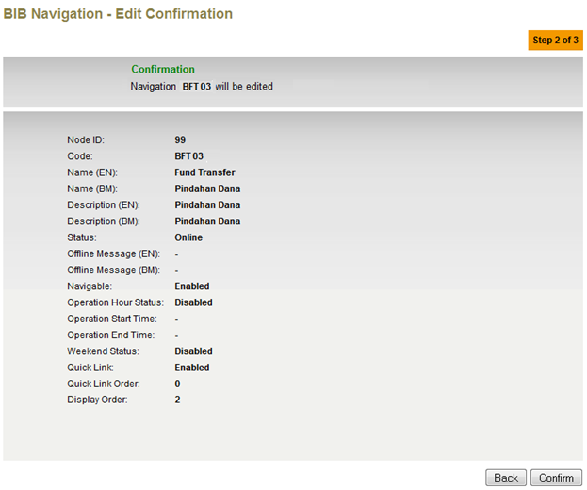

Figure 177: BIB Navigation Services Confirmation Screen

**Action:**

| No | Action | Type | Description |
| --- | --- | --- | --- |
| 1. | Back | Button | Contains an action to let the IBAM system go back to previous page (BIB Navigation Services Edit page) |
| 2. | Confirm | Button | Contains an action to save the updated details of ‘BIB Navigation’ Services.  Shows the ‘BIB Navigation Services’ Edit Result page. |

***Step 4:***

1. IBAM System validates save the updated data to IB Database and displays result page.
2. IBAM shows Successful message and pending for Authorization approval process.
3. Once approved IBAM will shows the changes that will be occurred on the Services details in BIB Navigation.

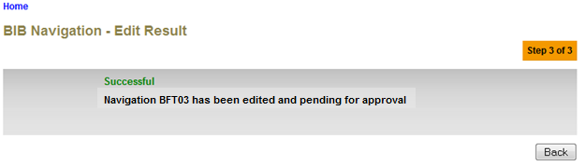

**Figure 178: BIB Navigation Services Result Screen with Authorization Process**

If BIB Navigation Maker Checker Permission set as ‘Disable’

1. IBAM updates the edited details to IB Database and display the result to the IBAM user
2. IBAM shows successful message and shows the update info on the Services details in BIB Navigation without Authorization.

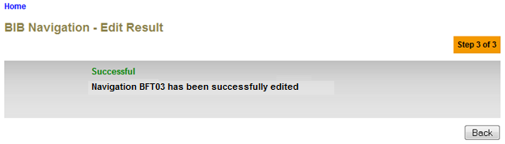

**Figure 179: BIB Navigation Services Result Screen without Authorization Process**

**Action:**

| No | Action | Type | Description |
| --- | --- | --- | --- |
| 1. | Back | Button | Contains an action to let the IBAM system go back to previous page (BIB Navigation Services list page) |

# Search BIB Navigation

This feature allows IBAM user to search for another Business Internet Banking navigation menu.

## Process Flow

Diagram 24: Search BIB Navigation Flow Diagram

There are 2 participants involved in this process which is Admin and IBAM. The following are the steps to search BIB navigation menu:

## Screen Flow

***Step 1:***

1. Admin Usercan access to BIB Navigation Screen by clicking on the “BIB Navigation” link on the left navigation menu.
2. IBAM System shows the navigable service for IBS. The Business Internet Banking is the Parent Category service of the BIB module.
3. Admin User clicks on the Parent Code hyperlink. Sub Category list screen will be shown
4. Admin User can start search Sub Navigation service by clicking the “**Search**” hyperlink on top of the title



**Figure 180: BIB Navigation Tab**

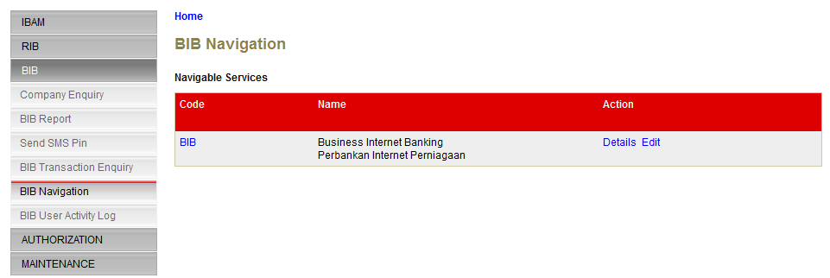

**Figure 181: BIB Navigation Parent Category List Screen**

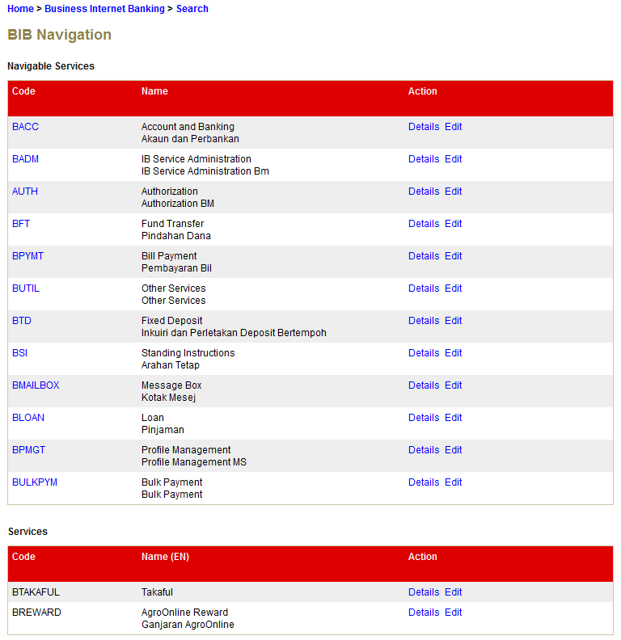

**Figure 182: BIB Navigation Sub Category List Screen**

***Step 2:***

1. IBAM display BIB Navigation Field Specific Search screen.
2. Admin User enters specific user information to the required field and click **Search** button.

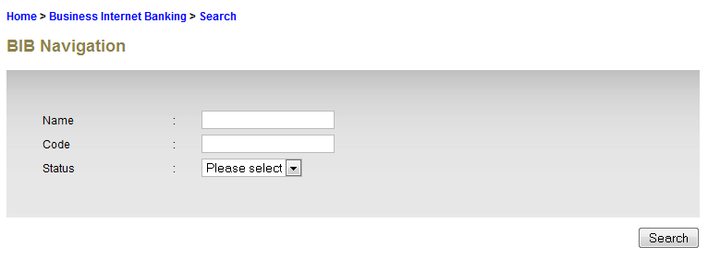

**Figure 183: BIB Navigation Field Search Screen**

**Specification:**

| No | Field | Field Type | Validation Rule | Description | Compulsory |
| --- | --- | --- | --- | --- | --- |
| 1. | Name | Text | Max Length: 64  Alphanumeric with Space and Symbol | The title of a specific BIB Navigation in English language | No |
| 2. | Code | Text | Max Length: 16 |  | No |
|  | Status | Dropdown List | Defaulted to Offline | Specify whether that Navigation is accessible (online) or not (offline). | No |

**Action:**

| No | Action | Type | Description |
| --- | --- | --- | --- |
|  | Search | Hyperlink | Contains an action to search and existing ‘BIB Navigation Menu in the list. Show ‘BIB Navigation Search’ result page. |

***Step 3:***

1. IBAM display BIB Navigation List Screen of the selected Name/Code.
2. Admin User clicks on the **Code** hyperlink to display on the Navigation enquiry details.

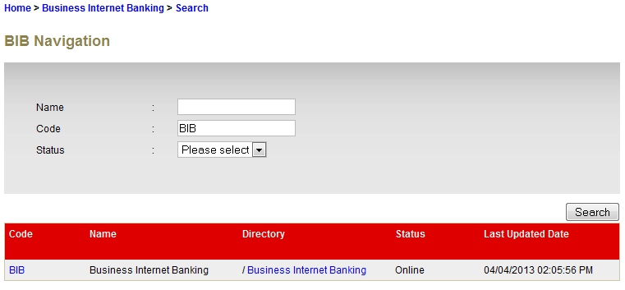

Figure 184: BIB Navigation Search Result Screen

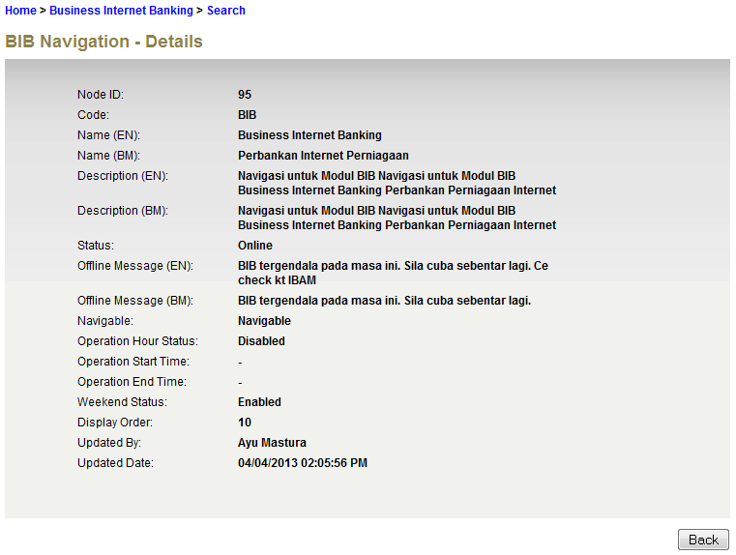

Figure 185: BIB Navigation Enquiry Details

**Action:**

| No | Action | Type | Description |
| --- | --- | --- | --- |
| 1. | Back | Button | Contains an action to let the IBAM system go back to previous page (BIB Navigation list page) |
| 2 | Click on “Code” | Hyperlink | Show the Navigation Enquiry Details. |

# BIB Navigation Configuration

| No | Requirement | Configuration |
| --- | --- | --- |
|  | Module accessible in BIB | Navigable = **Enabled**  Status = **Online** |
|  | Module not accessible in BIB | Navigable = ***Disabled***  Status = ***Offline*** |
|  | Module appears in BIB, but not allowed to service customer | Navigable = **Enabled**  Status = ***Offline*** |
|  | Module accessible in BIB a specified timeframe.  Example:  Bulk Payment only accepts transaction from 8a.m. till 4p.m. | Navigable = **Enabled**  Status = **Online**  Operation Hour Status = **Enabled**  Weekend Status = **Enabled**  Operation Start Time = **0800**  Operation End Time = **1600** |
|  | Module accessible in BIB a specified timeframe but not accessible on weekend  Example:  Bulk Payment only accepts transaction from 8a.m. till 4p.m., Monday - Friday | Navigable = **Enabled**  Status = **Online**  Operation Hour Status = **Enabled**  Weekend Status = ***Disabled***  Operation Start Time = **0800**  Operation End Time = **1600** |