# Create Category

|  |  |
| --- | --- |
| **Before Fixing** | **After Fixing** |
| * Error Message not same with Category label. Error Message: Category Name (BM) cannot be as similar as Category Name (EN). - **Failed** | **Passed** - System allowed to create same name for both Parent Category (EN) and Parent Category (BM) |
| * System not allows Parent Category (EN) & (BM) to be same name. | **Passed** - System allowed to create same name for both Parent Category (EN) and Parent Category (BM) |
| * - | **New bug/issue:**  Step to reproduce:-   * Different maker creating new Category with same name. * Checker approved both item.   Currently:  Same name display in the Category List (Refer Fig:1.0)  Expected:  When the checker try to approve the pending item, system should validate the pending item if already exist.  Error Message:  <Category name already exist > |

# 

**Fig: 1.0**

# Edit Category

|  |  |
| --- | --- |
| **Before Fixing** | **After Fixing** |
| * System not allows Parent Category (EN) & (BM) same name. Error Message: Category Name (BM) cannot be as similar as Category Name (EN) | **Passed** - System allowed to edit using same name for both Parent Category (EN) and Parent Category (BM) |
| * - | **New bugs:**  **Once checker rejected the pending item, the category cannot be edited. Error message appear “Category is pending for approval.”** |

# Delete Category

|  |  |
| --- | --- |
| **Before Fixing** | **After Fixing** |
| * - | **Re-order the button alignment.**  **Currently:**  **Updated:** |
| * - | **New bugs:**  **Once checker rejected the pending item, the category cannot be deleted. Error message appear “Category is pending for approval.”** |

# Create Sub Category

|  |  |
| --- | --- |
| **Before Fixing** | **After Fixing** |
| * NO button to create new Sub Category | **Passed** – There have a button to create new Sub Category |
| * - | **New bug/issue:**  Step to reproduce:-   * Different maker creating new Sub Category with same name. * Checker approved both item.   Currently:  Same name display in the Category List (Refer Fig:2.0)  Expected:  When the checker try to approve the pending item, system should validate the pending item if already exist.  Error Message:  <Category name already exist > |

# 

**Fig: 2.0**

# Edit Sub Category

|  |  |
| --- | --- |
| **Before Fixing** | **After Fixing** |
| * - | **New bugs:**  **Once checker rejected the pending item, the sub category cannot be edited. Error message appear “Category is pending for approval.”** |

# Delete Sub Category

|  |  |
| --- | --- |
| **Before Fixing** | **After Fixing** |
| * - | **New bugs:**  **Once checker rejected the pending item, the sub category cannot be deleted. Error message appear “Category is pending for approval.”** |

# Content Search

|  |  |
| --- | --- |
| **Before Fixing** | **After Fixing** |
| * Unable to search All & search field by field. System throws System Unavailable and Error Exception. | **Passed** – Content can be search by using searching function |

# Create Content List

|  |  |
| --- | --- |
| **Before Fixing** | **After Fixing** |
| * - | **New bug/issue:**  Step to reproduce:-   * Different maker creating new Content List with same name. * Checker approved both item.   Currently:  Same name display in the Content List (Refer Fig:3.0)  Expected:  When the checker try to approve the pending item, system should validate the pending item if already exist.  Error Message:  < Title has been used. > |

# 

**Fig: 3.0**

# Edit Content List

|  |  |
| --- | --- |
| **Before Fixing** | **After Fixing** |
|  | New bug/issue:  Add the input specification/error message for item below:   1. Abstract (BM) - Abstract (BM) cannot be greater than 120 characters / digits. 2. Description (BM) - Description (BM) cannot be greater than 500 characters / digits. |

**Fig: 1.0**

# Delete Content List

|  |  |
| --- | --- |
| **Before Fixing** | **After Fixing** |
| * - | * **New issue**   For the confirmation page, at the alert message kindly **BOLD** the Content Name (refer Fig:2.0 in Bug#1994-Content_ServiceInfo) |

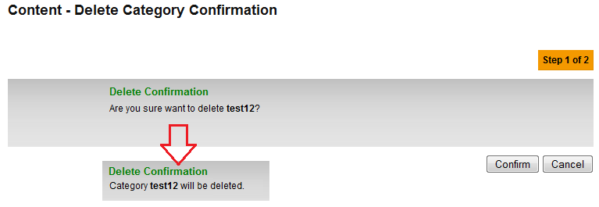

**Fig: 2.0**