Originator's Name: Chooi So Fun  Project: Banker’s Chq & Demand Draft  Project Manager: Malarvily Muniandy / Christopher Gunn  Owner: PDM / RCB  Date Raised: 16.08.10  Phase/Process:  Functional Area: Consumer | Issue ID Number: BCA-DDA-UAT-C007  Related ID Number:  Priority: High / Medium / Low  Assigned to:  Target Resolution Date:  Actual Closed Date:
Status : Open / Investigate / Retest / Re-Open / Closed / Sign-Off (Circle one)
Category : Bugs / Set-up / Clarification / Repeated / Internal CR / CR (Circle one)
Description:
Banker’s Cheque and Demand Draft Application (Step 1/2):
Prefill applicant profile incomplete:
a) Address 2 and Address 3 are missing.
b) Country incorrect
c) Insert State info before Postcode
(Refer to screen attached for further details).
Impact:

Investigation (Description):

Action:

Estimated Impact:

Recommendation:

Accepted (PENRIL/SA/IT):  Date: | Accepted (KFHMB):  Date:
Associated Risk Report: | Risk Report Accepted Date:
Associated Change Request Form: | Change Control Accepted on:

Applicant’s profile:
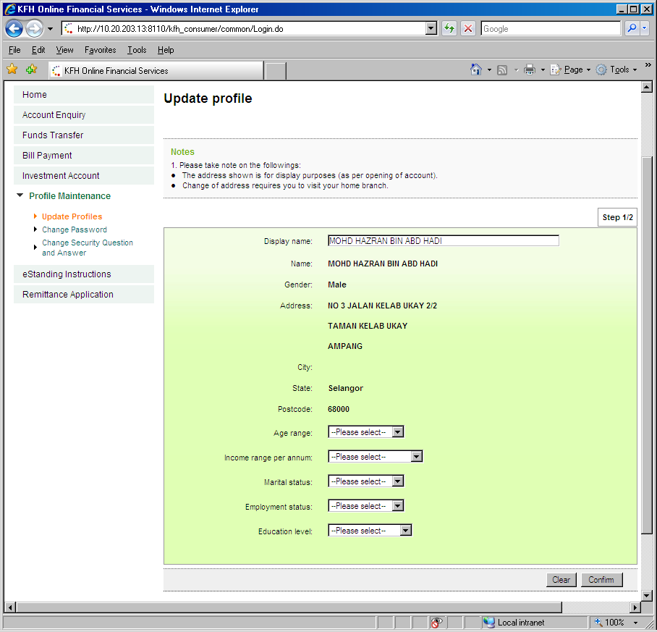
Info from Phoenix:
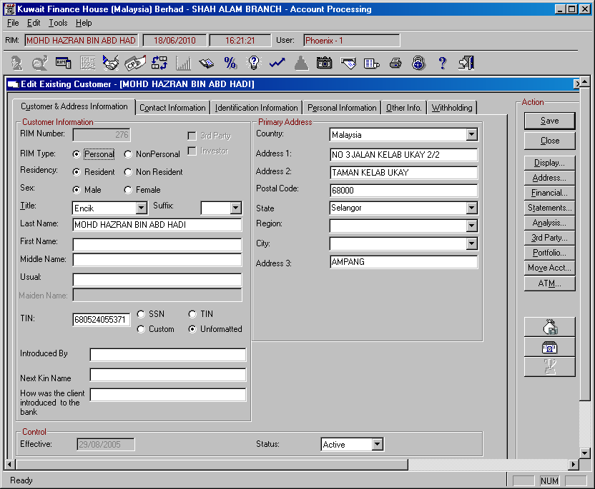

Banker’s Cheque Application (Step 1/5):
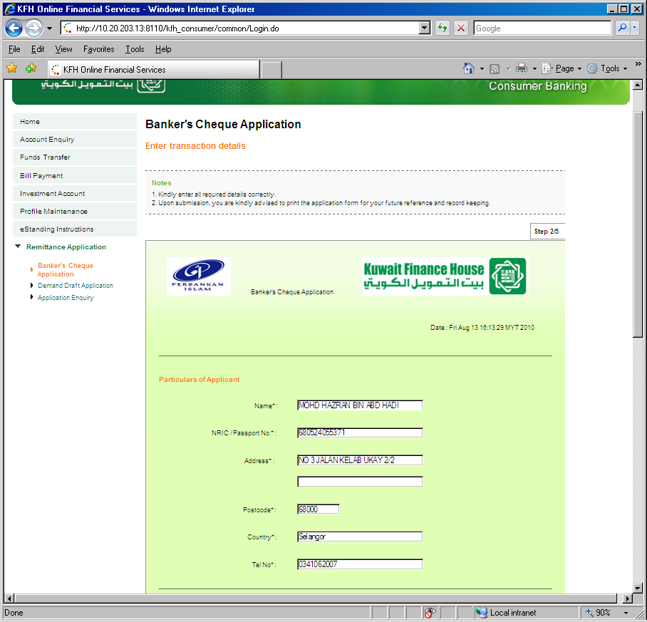
Insert 1 more row for address 3
Insert fields for “State” before “Postcode”
Demand Draft Application (Step 1/5)
