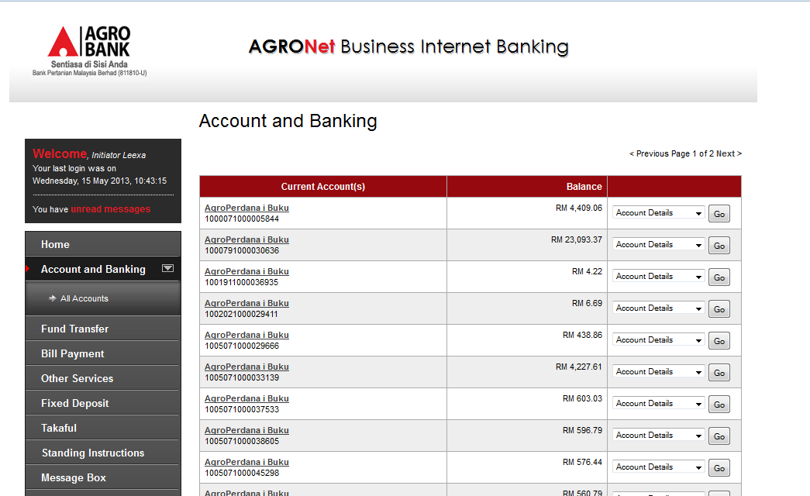

**1**

**3**

**2**

**Bugs/issues:**

1. No logout button
2. Change the font size and the font color – refer RIB layout below.
3. Click on Home button will logout the user

