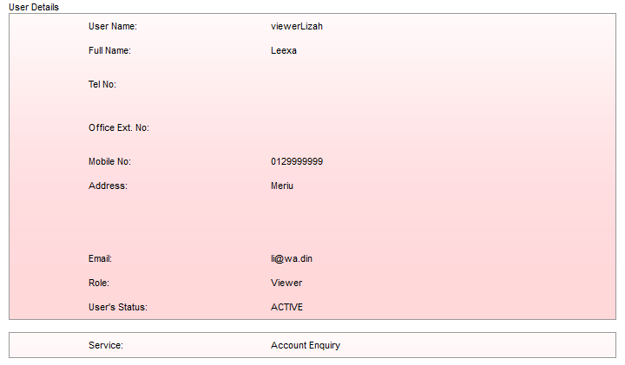

User: viewerLizah

Service Access: Account Enquiry

Login as viewerLizah

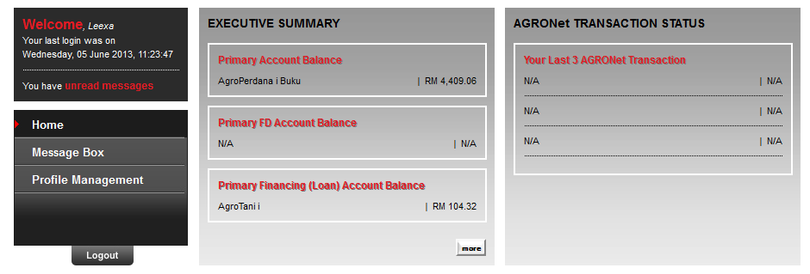

No Account and Banking module hyperlink in the Side Navigation